Supplemental Methods
Study variables
We examined demographic characteristics, including age, sex, race and ethnicity, and clinical characteristics such as cirrhosis, Charlson Comorbidity Index (CCI), advance care directives, hospice/palliative care, HCC treatment, and follow-up time. The HBV treatment rate was defined by receipt of at least one prescription for lamivudine, adefovir, telbivudine, emtricitabine, entecavir, tenofovir disoproxil fumarate, or tenofovir alafenamide. The HCV treatment rate consists of at least one prescription for antiviral (DAA) medications for HCV and was analysed only for patients with HCC index date in 2014 or after, since DAAs did not become available until 2014. We reported results for the following laboratory tests: platelets, international normalized ratio (INR), creatinine, alanine aminotransferase (ALT), aspartate aminotransferase (AST), total bilirubin, alkaline phosphate (ALP), albumin, alpha-fetoprotein and albumin-bilirubin (ALBI) score.

Supplemental Table 1: ICD codes

Diagnosis | ICD codes
HCV | 070.41, 070.44, 070.51, 070.54, 070.70, 070.71, B17.11, B18.2, B17.10, B19.20, B19.21, V02.62
HBV | 070.20, 070.22, 070.30, 070.32, B16.0, 070.42, 070.52, 070.23, 070.33, 070.31, 070.21, B16.2, B19.11, B18.1, B16.9, B19.10, V02.61, B17.0, B18.0, B16.1
ALD | 571.0, 571.1, 571.2, 571.3, K70.0, K70.10, K70.11, K70.2, K70.30, K70.31, K70.40, K70.41, K70.9
NAFLD | K76.0, K75.81, 571.8, 571.9, 571.5 with obesity or diabetes
Other* | 571.42, 576.1, 5716, 273.4, 275.01, 275.02, 275.03, 275.1, K75.4, K83.01, K74.3, K74.5, K74.4, E88.01, E83.110, E83.111, E83.118, E83.119, E83.00, E83.01, E83.09
Abbreviation: HCV, hepatitis C virus; HBV, hepatitis B virus; ALD, alcohol-associated liver disease; NAFLD, non-alcoholic fatty liver disease
*Other liver diseases: autoimmune hepatitis, primary sclerosing cholangitis, primary biliary cholangitis, hemochromatosis, alpha-1 antitrypsin deficiency, and Wilson’s disease

Supplemental Table 2: Laboratory characteristics of HCC patients by liver disease etiology

Characteristic  (mean±SD) | Total  N=20,662 | HCV  N=5,607 | HBV  N=589 | ALD  N=1,945 | NAFLD  N=8,168 | Cryptogenic  N=3,147 | Other*  N=1,206 | P-value
Platelet | 216±113 | 162±95 | 205±106 | 205±111 | 241±109 | 266±112 | 200±116 | <0.0001
INR | 1.2±0.6 | 1.2±0.4 | 1.2±0.4 | 1.3±0.5 | 1.3±0.7 | 1.3±0.8 | 1.2±0.5 | <0.0001
Creatinine | 1.1±0.6 | 1.1±0.7 | 1.1±0.7 | 1.1±0.6 | 1.1±0.7 | 1.0±0.5 | 1.0±0.6 | <0.0001
AST | 55±84 | 76±124 | 52±54 | 55±64 | 45±63 | 46±57 | 58±58 | <0.0001
ALT | 43±56 | 57±63 | 44±52 | 38±48 | 37±53 | 38±52 | 51±63 | <0.0001
Alkaline phosphatase | 167±177 | 146±125 | 139±172 | 160±140 | 168±180 | 187±216 | 228±265 | <0.0001
Total bilirubin | 1.0±1.2 | 1.2±1.2 | 1.0±1.1 | 1.2±1.3 | 0.8±1.0 | 0.8±1.0 | 1.5±1.8 | <0.0001
Albumin | 3.8±0.6 | 3.7±0.6 | 4.0±0.6 | 3.7±0.6 | 3.9±0.5 | 4.0±0.6 | 3.6±0.6 | <0.0001
AFP | 2,811±29,561 | 1,762±19,259 | 3,171±21,898 | 2,066±15,022 | 4,957±50,451 | 5,931±37,347 | 1,153±9,867 | 0.17
ALBI  1  2  3 | 57.1  42.9  0 | 46.6  53.4  0 | 67.8  32.3  0 | 51.8  48.2  0 | 62.2  37.8  0 | 67.3  32.7  0 | 44.4  55.6  0 | <0.001

* Other liver diseases: autoimmune hepatitis, primary sclerosing cholangitis, primary biliary cholangitis, hemochromatosis, alpha-1 antitrypsin deficiency, and Wilson’s disease.
Abbreviations: HCC, hepatocellular carcinoma; HCV, hepatitis C virus; HBV, hepatitis B virus; ALD, alcohol-associated liver disease; NAFLD, non-alcoholic fatty liver disease; INR, international normalized ratio; AST, aspartate aminotransferase; ALT, alanine aminotransferase; AFP, alpha-fetoprotein; ALBI, albumin-bilirubin grade for HCC

Supplemental Table 3: Baseline characteristics of HCC cohort by viral vs. nonviral liver disease etiology

Characteristic | Viral N=9,670  27.9% | Nonviral* N=25,03672.1% | P-value
Mean age (years±SD) | 64.3±9.5 | 69.9±12.0 | <0.0001
Sex (%)  Male  Female | 74.5  25.5 | 56.3  43.7 | <0.001
Race/ethnicity (%)  Caucasian  African American  Hispanic  Asian  Unknown | 52.5  15.6  15.0  9.1  7.8 | 65.8  10.1  13.2  2.9  7.9 | <0.001
Cirrhosis (%) | 91.7 | 66.7 | <0.001
Advance care directive (%) | 6.8 | 8.5 | <0.001
Hospice/palliative care (%) | 29.7 | 37.3 | <0.001
DCCI (±SD) | 7.3±4.3 | 9.7±3.9 | <0.0001
Liver transplant (%) | 10.6 | 2.0 | <0.001
Follow-up  (person-years) | 17,577 | 29,094 | –

*Nonviral liver diseases: non-alcoholic fatty liver disease, alcohol-associated liver disease, autoimmune hepatitis, primary sclerosing cholangitis, primary biliary cholangitis, hemochromatosis, alpha-1 antitrypsin deficiency, and Wilson’s disease.
Abbreviation: DCCI: Deyo Charlson Comorbidity Index

Supplemental Table 4: Baseline characteristics in HCC subgroup by sex

Characteristic | Male  N=21,298 | Female  N=13,397 | P-value
Mean age (years±SD) | 68.0±11.0 | 68.9±12.5 | <0.0001
Race/ethnicity  Caucasian  African American  Hispanic  Asian  Unknown | 62.3  11.0  14.1  5.0  7.7 | 61.7  12.8  13.2  4.2  8.1 | <0.001
Cirrhosis (%) | 77.8 | 67.1 | <0.001
Advance care directive (%) | 7.5 | 8.8 | <0.001
Hospice/palliative care (%) | 34.0 | 37.1 | <0.001
DCCI (±SD) | 8.9±4.2 | 9.3±4.0 | <0.0001
ALBI  1  2  3 | 53.8  46.2  0 | 62.2  37.8  0 | <0.001
Antiviral treatment (%)  HCV DAA*  HBV | 29.4  43.7 | 30.6  32.9 | 0.13  0.003
Liver transplant (%) | 5.3 | 2.9 | <0.001
Follow-up  (person-years) | 27,949 | 18,707 | –
*Includes only patients from 2014 and after
Abbreviation: HCC, hepatocellular carcinoma; DCCI, Deyo Charlson Comorbidity Index; HCV, hepatitis C virus; DAA, direct acting antiviral; HBV, hepatitis B virus; ALBI, albumin-bilirubin grade for HCC

Supplemental Table 5: Cox proportional hazards model for factors associated with HCC mortality - Alternative model with etiology as viral versus nonviral
Predictor | Univariable HR (95% CI) | P-value | Multivariable HR (95% CI) | P-value
Age | 1.03 (1.02-1.04) | <0.001 | 1.02 (1.01-1.03) | <0.001
Male | 1.06 (1.03-1.09) | <0.001 | 1.11 (1.07-1.15) | <0.001
Race/ethnicity  Asian  Caucasian  African American  Hispanic | Referent  1.69 (1.57-1.81)  1.73 (1.60-1.87)  1.54 (1.43-1.66) | <0.001  <0.001  <0.001 | Referent  1.47 (1.34-1.61)  1.52 (1.38-1.68)  1.28 (1.16-1.41) | <0.001  <0.001  <0.001
Time period  2003-2013  2014-2021 | Referent  1.05 (1.02-1.08) | <0.001 | Referent  1.08 (1.04-1.13) | <0.001
Etiology  Viral  Nonviral* | Referent  1.59 (1.54-1.64) | <0.001 | Referent  1.33 (1.27-1.40) | <0.001
Baseline DCCI | 1.05 (1.04-1.06) | <0.001 | 1.04 (1.03-1.05) | <0.001
Cirrhosis  No cirrhosis  Cirrhosis | Referent  1.10 (1.07-1.13) | <0.001 | Referent  1.21 (1.16-1.27) | <0.001
ALBI grade  1  2 | Referent  1.55 (1.50-1.61) | <0.001 | Referent  1.57 (1.51-1.63) | <0.001
HCC treatment  No transplant  Transplant | Referent  0.17 (0.15-0.19) | <0.001 | Referent  0.21 (0.18-0.25) | <0.001
* Nonviral liver diseases: non-alcoholic fatty liver disease, alcohol-associated liver disease, autoimmune hepatitis, primary sclerosing cholangitis, primary biliary cholangitis, hemochromatosis, alpha-1 antitrypsin deficiency, and Wilson’s disease
Abbreviation: HCC, hepatocellular carcinoma; ALBI, albumin-bilirubin grade for HCC

Supplemental Figure 1: Study flow chart

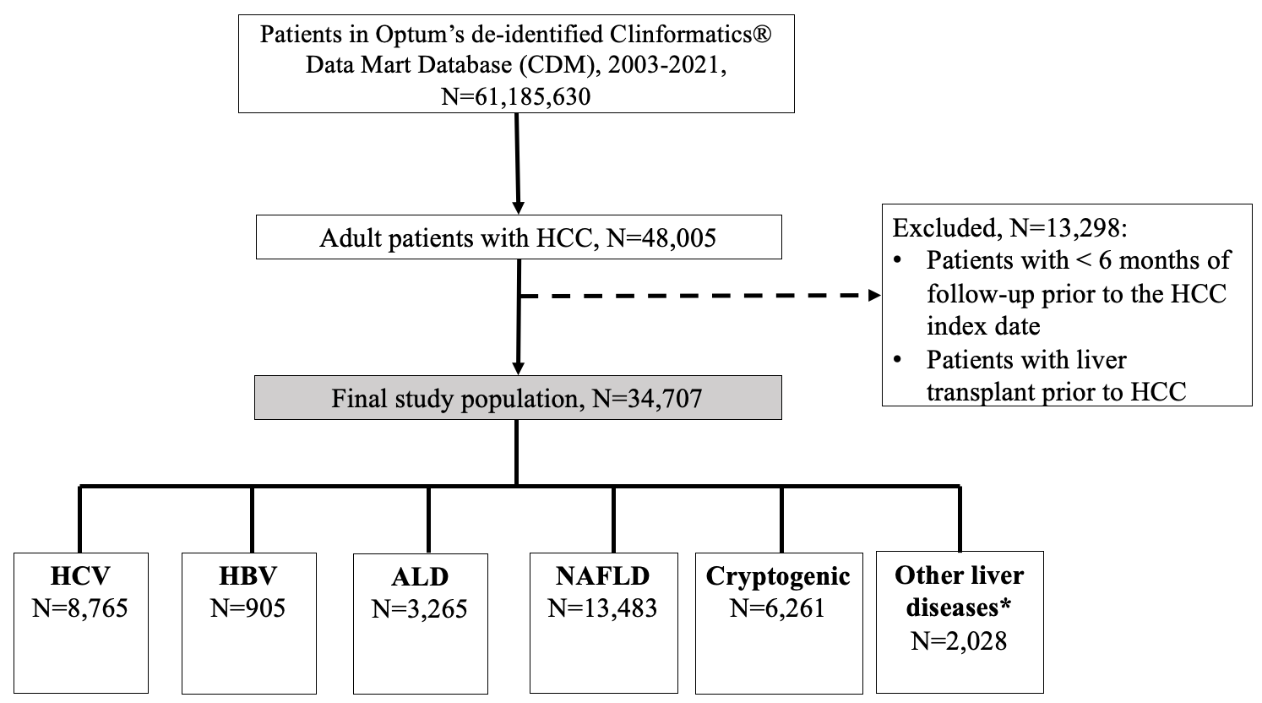

*Other liver diseases: autoimmune hepatitis, primary sclerosing cholangitis, primary biliary cholangitis, hemochromatosis, alpha-1 antitrypsin deficiency, and Wilson’s disease.

Abbreviation: HCC, hepatocellular carcinoma; HCV, hepatitis C virus; HBV, hepatitis B virus; ALD, alcohol-associated liver disease; NAFLD, non-alcoholic fatty liver disease

Supplemental Figure 2: Survival of HCC patients by sex
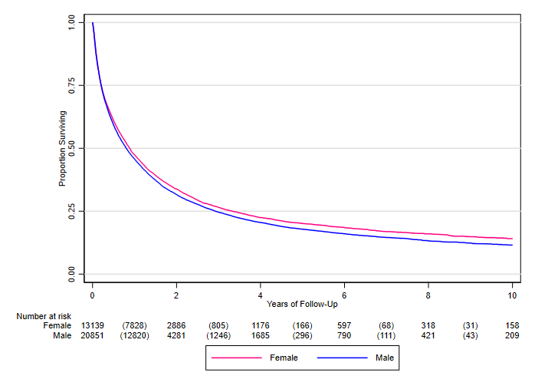
P<0.0001
Survival (95% CI) | Median (years) | 5-year (%)
Male | 0.80 (0.78-0.83) | 17.9 (17.2-18.6)
Female | 0.88 (0.85-0.92) | 20.2 (19.3-21.1)

Abbreviation: HCC, hepatocellular carcinoma

Supplemental Figure 3: Survival of HCC patients by viral vs. nonviral etiology

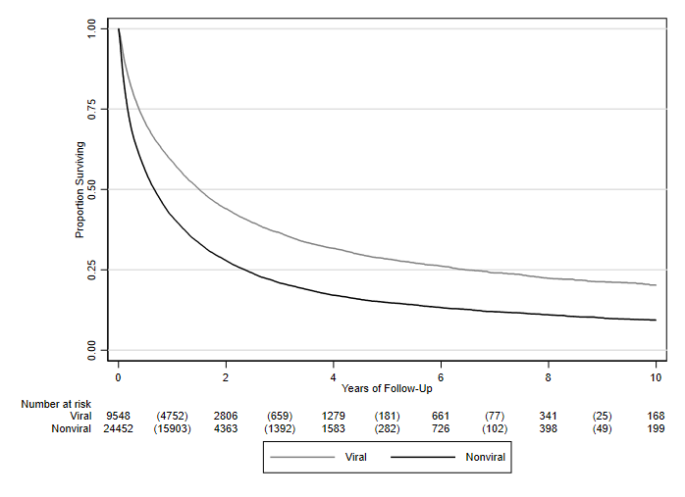
P<0.0001
Survival (95% CI) | Median (years) | 5-year (%)
Viral | 1.50 (1.44-1.58) | 28.4 (27.2-29.6)
Nonviral | 0.67 (0.65-0.69) | 14.9 (14.3-15.5)

Abbreviation: HCC, hepatocellular carcinoma

Supplemental Figure 4. Survival in HCC patients by cirrhosis status in the total cohort
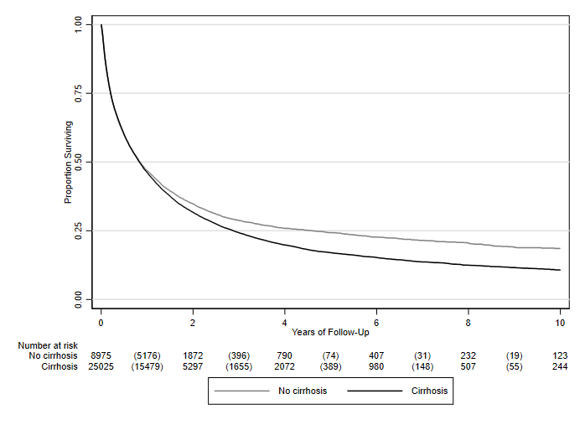
P<0.0001
Survival (95% CI) | Median (years) | 5-year (%)
No cirrhosis | 0.85 (0.80-0.89) | 24.3 (23.2-25.5)
Cirrhosis | 0.83 (0.81-0.86) | 17.0 (16.4-17.7)

Abbreviation: HCC, hepatocellular carcinoma

