Intranasal delivery of endothelial cell-derived extracellular vesicles with supramolecular gel attenuates myocardial ischemia-reperfusion injury
Junzhuo Wang ¹*, Ying Tan ¹*, Yang Dai ^{2,3}*, Ke Hu ¹, Xi Tan ¹, Shaoli Jiang ⁴, Guannan Li ¹, Xinlin Zhang ¹, Lina Kang ¹, Xiaojian Wang ⁴, Biao Xu ^{1,2}
¹Department of Cardiology, Nanjing Drum Tower Hospital, Affiliated Hospital of Nanjing University Medical School, Nanjing, China;
²Department of Cardiology, Nanjing Drum Tower Hospital, Clinical College of Nanjing Medical University, Nanjing, China;
³ Department of Geriatrics, Nanjing Drum Tower Hospital, Affiliated Hospital of Nanjing University Medical School, Nanjing, China;
⁴ Institute of Advanced Synthesis, School of Chemistry and Molecular Engineering, Nanjing Tech University, Nanjing, China;
Correspondence: Biao Xu, MD, PhD, Department of Cardiology, The Affiliated Hospital of Nanjing University Medical School, No. 321 Zhongshan Road, Nanjing, Jiangsu, China. E-mail: xubiao62@nju.edu.cn. Xiaojian Wang PhD, Institute of Advanced Synthesis, School of Chemistry and Molecular Engineering, Nanjing Tech University, Nanjing, China. Email: ias_xjwang@njtech.ed.cn.
*These authors contributed equally to this work

SUPPLEMENTAL FIGURES

Figure S1. A ¹H NMR of L-Boc-glutamine dodecylamide. ¹H NMR (400 MHz, CDCl₃): δ (ppm) 6.83 (br, 1H), 6.37 (br, 1H), 5.85 – 5.65 (m, 2H), 4.15 (br, 1H), 3.23 (q, J = 6.6 Hz, 2H), 2.47 – 2.25 (m, 2H), 2.14 – 2.02 (m, 1H), 2.02 – 1.85 (m, 2H), 1.55 – 1.46 (m, 2H), 1.44 (s, 9H), 1.33 – 1.19 (m, 18H), 0.88 (t, J = 6.9 Hz, 3H). B ¹H NMR of L-glutamine dodecylamide. H NMR (400 MHz, CDCl₃): δ (ppm) 7.47 (s, 1H), 6.46 (s, 1H), 5.69 (s, 1H), 3.52 (t, J = 6.5 Hz, 1H), 3.22 (d, J = 7.0 Hz, 2H), 2.39 (m, 2H), 2.34 (s, 2H), 1.97 (m, 2H), 1.49 (m, 2H), 1.27 (m, 18H), 0.88 (t, J = 6.8 Hz, 3H).

Figure S2. Representative cross-sections of heart, liver and kidney. DAPI (blue) and PKH67 (green).

Figure S3. The results of Immunofluorescence staining and HE staining of the effect of the hydrogel on main organs (heart, liver, spleen, lung and kidney). A Representative cross-sections of slpeen stained with DAPI (blue) and CD68 (red), and DiD fluorescence is green. B The flow cytometry plots illustrate the proportion of DiD-positive cells within the monocytes/macrophages (CD45+CD11b+Ly6C+) in peripheral blood.

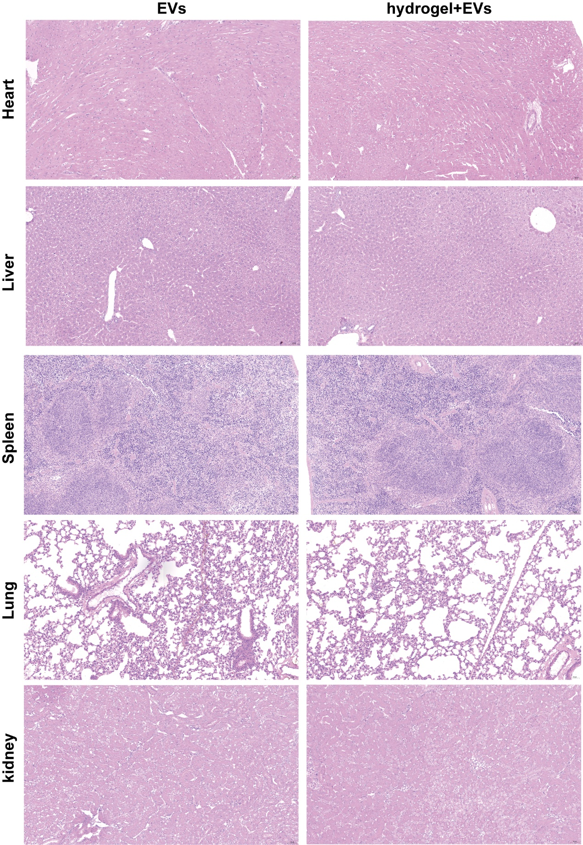
Figure S4. Representative cross-sections of main organs stained with HE.

