Supplemental Tables/Figures
Supplemental Figure 1. Conceptual framework
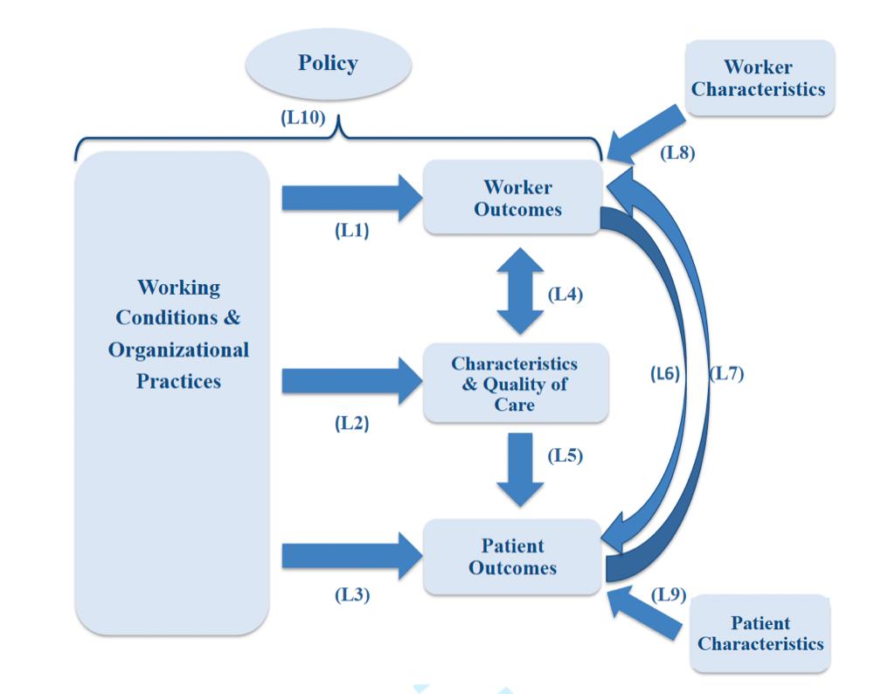
Note: Reprinted with permission from Zarska A, Avgar AC, Sterling MR. Relationship between working conditions, worker outcomes, and patient care: a theoretical model for frontline health care workers. Am J Med Qual off J Am Coll Med Qual. 2021;36(6):429–440. Available from: https://journals.lww.com/ajmqonline/abstract/2021/11000/relationship_between_working_conditions,_worker.8.aspx.¹⁵

Supplemental Table 1. The five questions that comprise the Voice Scale.
Voice Measure Questions
I have a good deal of say about the quality of patient care at my home care agency
My supervisors ask for my input about important patient care issues
My suggestions about patient care are listened to by higher-ups
Nobody ever asks for my opinion regarding patient care issues
Whenever I make a suggestion about patient care, it is usually ignored

Notes: Reprinted from Clark PF, Clark DA, Day DV, Shea DG. Healthcare reform and the workplace experience of nurses: implications for patient care and union organizing. Ind Labor Relat Rev. 2001;55(1):133–148. Reprinted by Permission of SAGE Publications.¹⁸ Responses were categorized with a 6-level Likert scale: strongly disagree, disagree, neutral, agree, strongly agree, and does not apply to me (which was scored as ‘zero’). Total scores ranged from 5-25 with a higher score indicating a higher degree of voice; individuals that responded ‘does not apply to me’ were excluded from analysis.

Supplemental Figure 2. The exclusion cascade survey participants.
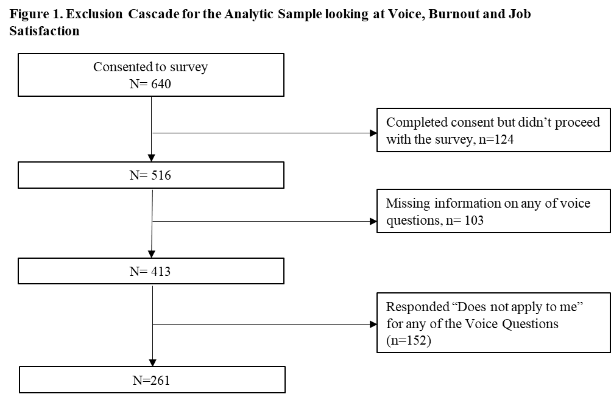

Supplemental Table 2. The demographics and characteristics among study participants who answered each question of the voice scale compared to those participants who answered ‘does not apply to me’ for any of the voice questions.
Factor | Participants with a voice score | Participants without a voice score | p-value
N (%) | 261 (63) | 152 (37)
Age (in years), mean (SD) | 48.42 (11.89) | 48.92 (10.53) | 0.67
Race |  |  | <0.001
Non-Hispanic White | 27 (10.4%) | 4 (2.6%)
Non-Hispanic Black | 77 (29.6%) | 10 (6.6%)
Hispanic | 115 (44.2%) | 133 (87.5%)
Asian/Pacific Islander | 7 (2.7%) | 0 (0.0%)
Other | 34 (13.1%) | 5 (3.3%)
Female Gender | 252 (96.6%) | 151 (99.3%) | 0.075
Foreign Born | 222 (85.1%) | 142 (93.4%) | 0.011
Years of experience as a HHA, median (IQR) | 10 (5, 17) | 10 (6, 16) | 0.81
Job Satisfaction Score, mean (SD) | 24.7 (4.9) | 29.2 (5.5) | <0.001

