Nonlinear relationship between maternal and cord blood vitamin B12 and folate from a Chinese population-based study
Supplementary files
The newborns and their mothers in a case-control study
n=2996

Excluded (n=1331)
- case with congenital heart disease and other birth defects (n=987)
- stillbirth (n=228)
- unknown born diagnosis or termination of pregnancy (n=56)
- multiple gestations (n=60)

The newborns and their mothers in the control group from a case-control study
n=1665

Excluded (n=807)
- maternal peripheral venous blood missing (n=219)
- neonatal umbilical cord blood missing (n=375)
- missing value of folate or vitamin B₁₂ (n=124)
- questionnaire key information missing (n=89)

Participants included finally in the study
n=858

Figure S1 Flow chart of study participant selection

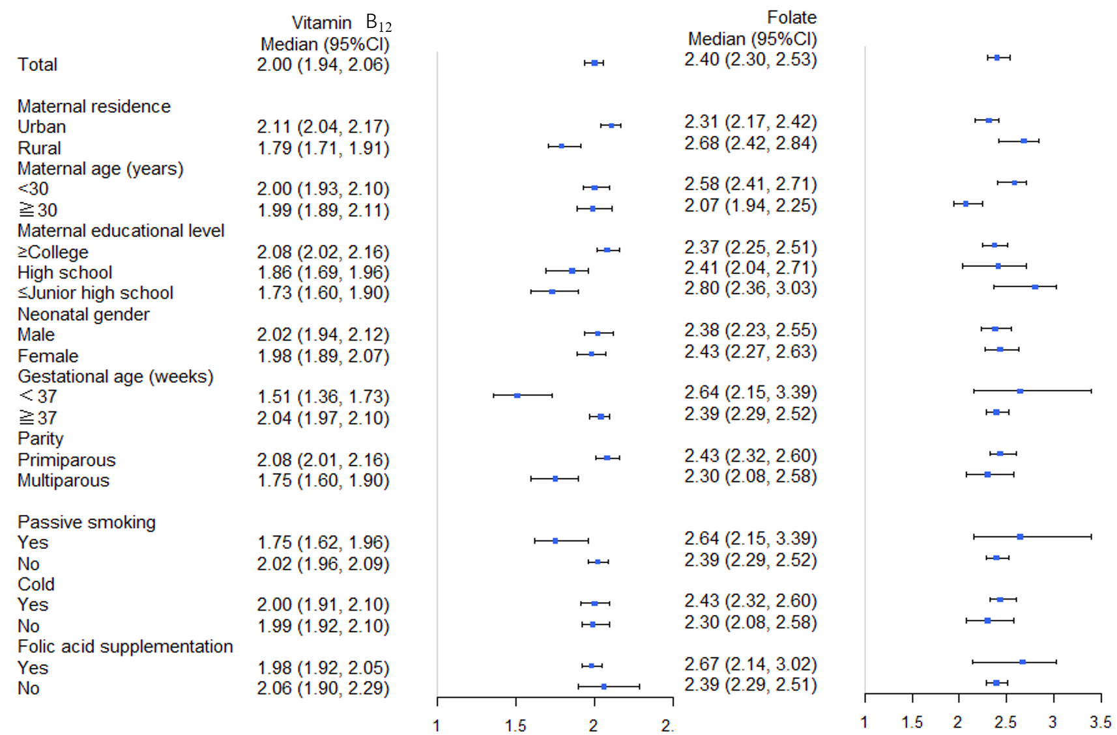
Figure S2 The UCS-MS ratios for folate and vitamin B₁₂ by socio-demographic characteristics and maternal health-related factors
Note: UCS-MS ratio was a relative level of UCS concentration to MS concentration and determined as the value of UCS concentration divided by MS concentration.

Table S1 Characteristics of the participants included and excluded in study
 |  | Inclusion group  N=858 | Exclusion group  N=718* | P #
 | Socio-demographic characteristics
 | Maternal residence |  |  | 0.770
 | Urban | 595(69.3) | 493(68.7)
 | Rural | 263(30.7) | 225(31.3)
 | Maternal age (years) |  |  | 0.705
 | <30 | 549(64.0) | 466(64.9)
 | ≧30 | 309(36.0) | 252(35.1)
 | Maternal educational level |  |  | 0.975
 | ≥College | 669(78.0) | 560(78.0)
 | High school | 109(12.7) | 93(13.0)
 | ≤Junior high school | 80(9.3) | 65(9.0)
 | Neonatal gender |  |  | 0.647
 | Male | 431(50.2) | 369(51.4)
 | Female | 427(49.8) | 349(48.6)
 | Gestational age (weeks) |  |  | 0.490
 | ﹤37 | 49(5.7) | 47(6.5)
 | ≧37 | 809(94.3) | 671(93.5)
 | Parity |  |  | 0.909
 | Primiparous | 651(75.9) | 543(75.6)
 | Multiparous | 207(24.1) | 175(24.4)
Maternal health-related factors from 3 months before pregnancy to delivery
 | Passive smoking |  |  | 0.733
 | Yes | 91(10.6) | 80(11.1)
 | No | 767(89.4) | 638(88.9)
 | Cold |  |  | 0.484
 | Yes | 384(44.8) | 334(46.5)
 | No | 474(55.2) | 384(53.5)
 | Folic acid supplementation |  |  | 0.642
 | Yes | 764(89.0) | 634(88.3)
 | No | 94(11.0) | 84(11.7)
* The participants with lack of multiple key information were not included (n =89).
# Categorical variables are compared between groups by χ² test.

