Supplementary Figure 1. The morphology of ARPE-19 cells used in this study. Scale bar: 200μm.
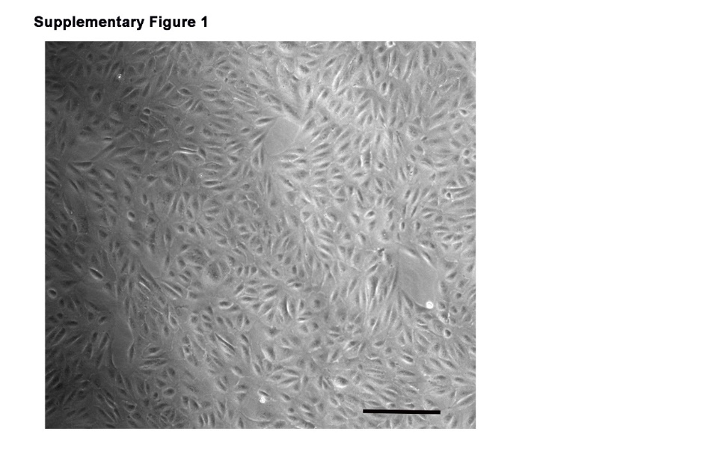

Supplementary Figure 2. Validation of the used ARPE-19 cells with RPE cell-specific markers. The following sequences used for quantitative real-time PCR: human Rlbp1 (NM_000326.4, CATTGAAGCTGGCTACCCTG [forward] and ATTCTCCAGCAGCTTCTCCA [reverse]), Human RPE65 (NM_000329.3, GCATCCTGCTGGTGGTTACA [forward] and AGTGCGGATGAACCTTCTGT [reverse]), human ACTB (NM_001101.3, AGAAAATCTGGCACCACACC [forward] and AGAGGCGTACAGGGATAGCA [reverse]). “-” represented human corneal epithelial (HCE) cells, and “+” represented ARPE-19 cells.
Supplementary Figure 3. Body weight and body size of mice. One-month-old mice were fed with HFD for 5 mouths and supplemented with 0.1% fenofibrate (Feno) in their diet in the last month. (A) Body weight of mice in the four groups at different months of age. (B) Body size of mice in the four groups at 6 months old. n=6. Two-way analysis of ANOVA followed by a post-hoc analysis Bonferroni test was applied to evaluate significant difference between groups. Bar graphs represent mean values ± SD. ***P < 0.001.
Supplementary Figure 4. Fluorescence intensity analysis of ARPE-19 cells. (A) Mean fluorescence intensity of 3-NT (Figure 2G) was analyzed. (B) Mean fluorescence intensity of VEGF (Figure 2L) was analyzed. (C) Mean fluorescence intensity of TNFα (Figure 2M) was analyzed. One-way analysis of variance (ANOVA) followed by a post-hoc analysis Tukey test was applied to evaluate significant difference between groups. Bar graphs represent mean values ± SD. ***P < 0.001.

Supplementary Figure 5. Fenofibrate ameliorated HFD-induced retinal dysfunction. Mice were fed with HFD for 5 mouths and supplemented with 0.1% fenofibrate (Feno) in their diet in the last month. (A) Representative electroretinogram (ERG) plots for four groups in response to a light stimulation intensity of 10.0 cd.s/m² under scotopic conditions. (B-G) Statistical analysis of amplitude changes of a-wave (B, D, F) and b-wave (C, E, G) under different stimulus intensities (0.01, 0.03, 0.1, 0.3, 1, 3, 10 cd.s/m2) under scotopic conditions. The a-wave amplitude was measured from baseline to the first trough, and b-wave amplitude was measured between a- and b-wave peaks. n=13 (SD), 12 (HFD), 10 (SD_ Fe), 10 (HFD_ Fe). Two-way analysis of ANOVA followed by a post-hoc analysis Bonferroni test was applied to evaluate significant difference between groups. Bar graphs represent mean values ± SEM. *P < 0.05, **P < 0.01, ***P < 0.001.

Supplementary Figure 6. Fluorescence intensity analysis of RPE tissue. (A) Mean fluorescence intensity of NOX4 (Figure 6F) was analyzed. (B) Mean fluorescence intensity of TNFα (Figure 6K) was analyzed. One-way analysis of variance (ANOVA) followed by a post-hoc analysis Tukey test was applied to evaluate significant difference between groups. Bar graphs represent mean values ± SD. ns: not significant, *P < 0.05, ***P < 0.001.
Supplementary Table 1: Composition of the research diets (Kcal%).

Ingredient |  | XTCON50J(D12492) | XTHF60(D12450J)
 |  | Kcal% | Kcal%
Protein | Casein | 19.8% | 19.8%
Protein | L-Cystine | 0.2% | 0.2%
Carbohydrate | Corn Starch | 50% | 0%
Carbohydrate | Maltodextrin 10 | 12.3% | 12.3%
Carbohydrate | Sucrose | 7.2% | 7.2%
Fat | Soybean Oil | 5.6% | 5.6%
Fat | Lard | 4.4% | 54.6%
Others | Mineral Mix S10026B | 0% | 0%
Others | Vitamin Mix V10001C | 0.09% | 0.09%
Others | Choline Bitartrate | 0% | 0%
Total |  | 100% | 100%

Supplementary Table 2: Antibodies applied in western blotting or immunofluorescent staining

Antibody | WB Dilutions | IF Dilutions | Catalog No. | Provider
anti-3-nitrotyrosine [3-NT] | 1:1000 | 1:300 | ab61392 | Abcam
anti-4-hydroxynonenal [4-HNE] | 1:500 | - | MAB3249 | R&D Systems
anti-nicotinamide adenine dinucleotide phosphate [NADPH]–oxidase 4 [NOX4] | 1:500 | - | ab133303 | Abcam
anti-TNFα | 1:500 | 1:300 | ab66579 | Abcam
anti-intracellular adhesion molecule-1 [ICAM1] | 1:1000 | - | sc8439 | Santa Cruz Biotechnology
anti-VEGF | 1:500 |  | sc7269 | Santa Cruz Biotechnology
anti-AKT | 1:500 | - | sc5298 | Santa Cruz Biotechnology
anti-p-AKT | 1:1000 | - | #4060 | Cell Signaling Technology
anti-ZO-1 | - | 1:100 | 40-2200 | Thermo Fisher Scientific
Alexa Fluor® 594 goat anti-rabbit IgG | - | 1:500 | ab150080 | Abcam
Alexa Fluor® 488 goat anti-rabbit IgG | - | 1:300 | ab150077 | Abcam
Alexa Fluor®488 goat anti-mouse IgG | - | 1:300 | ab150113 | Abcam
Horseradish peroxidase (HRP)-conjugated goat anti-rabbit IgG | 1:2000 | - | A0208 | Beyotime
HRP-conjugated goat anti-mouse IgG | 1:2000 | - | A0216 | Beyotime
anti-β-actin | 1:1000 | - | AF0003 | Beyotime

