Dupilumab Reduces Asthma Disease Burden and Recurrent SCS Use in Patients with CRSwNP and Coexisting Asthma

Supplementary Figure 1 Patient disposition
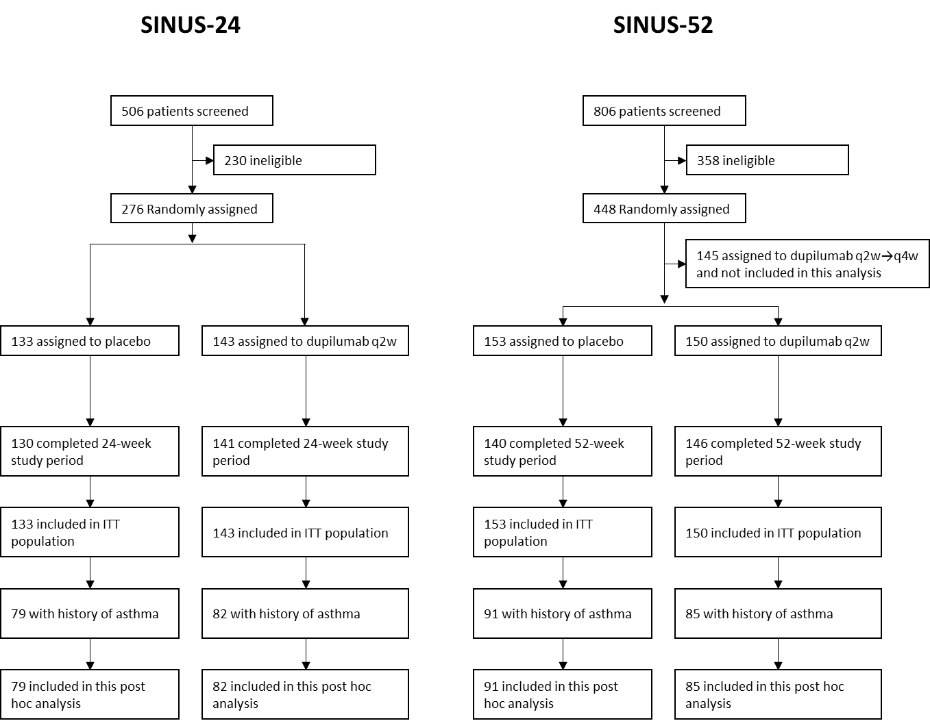
Additional details are provided in reference 8.
ITT, intention-to-treat; q2w→q4w, every 2 weeks changing to every 4 weeks

Supplementary Figure 2 Asthma control and airflow obstruction outcomes at Week 24 (pooled SINUS-24/52 ITT population with coexisting asthma) by history of asthma exacerbationª or prior SCS use.
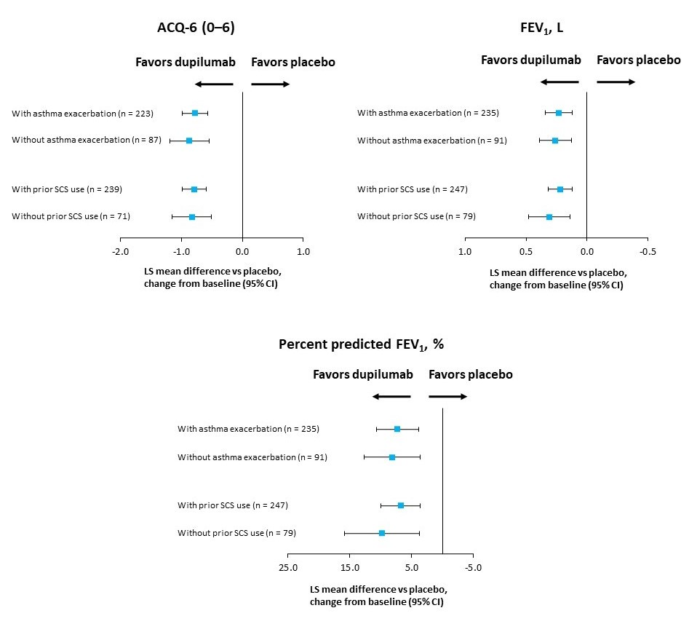
Notes: ªAsthma exacerbation was defined as an exacerbation requiring SCS or hospitalization (> 24 hours) for treatment of asthma and was determined using medical records.
Abbreviations: ACQ-6, 6-item Asthma Control Questionnaire; CI, confidence interval; FEV₁, forced expiratory volume in 1 second; ITT, intention-to-treat; LS, least squares; SCS, systemic corticosteroids.

Supplementary Table S1. List of institutional review boards and independent ethics committees for SINUS-24 (NCT02912468) and SINUS-52 (NCT02898454)
SINUS-24
Bulgaria | - Ethics Committee Multicenter Trials, 5 Sveta Nedelya Square, Sofia 1000
Czech Republic | - Eticka Komise Fakultni Nemocnice Hradec Kralove Sokolska 581, Hradec Kralove 500 05
France | - CPP Sud-Méditerranée 4 Centre Hôspitalier Universitaire de Montpellier Hôpital Saint Eloi 2, Avenue Bertin Sans Montpellier Cedex 05 34295
Germany | - Ethik-Kommission des Landes Berlin, Landesamt für Gesundheit und Soziales Berlin Geschäftsstelle der Ethik-Kommission des Landes Berlin, Fehrbelliner Platz 1, Berlin 10707
Hungary | - Egészségügyi Tudományos Tanács, Klinikai Farmakológiai Etikai Bizottsága, Arany János út 6-8 Budapest 1051
Italy | - Area Vasta Nord Ovest AOUP Comitato per la Sperimentazione Clinica dei Medicinali, Via Roma 67, Pisa 56126, Pisa  - AOU Policlinico-Vittorio, Emanuele, Via S. Sofia 78 Comitato Etico Catania 1, Catania 95123, Catania  - Ospedale di Circolo e Fondazione Macchi, Comitato Etico, Viale Luigi Borri 57, Varese, 21100, Varese  - Ospedale San Raffaele, Via Olgettina 60, Comitato Etico, Milano, 20132, Milano  - Istituto Clinico Humanitas, Comitato Etico dell'IRCCS, Istituto Clinico Humanitas di Rozzano (MI), Via Manzoni 56, Rozzano 20089, Milano  - Comitato Etico dell'A.O. San, Paolo, Via Di Rudinì 8, Milano 20142, Milano  - Comitato Etico Interaziendale, Bologna-Imola, Comitato Etico Interaziendale, Bologna-Imola, Via Castiglione 29, Bologna, 40124, Bologna
Netherlands | - Medisch Ethische Toetsingscommissie Academisch, Medisch Centrum Meibergdreef 9, Amsterdam 1105 AZ
Poland | - Komisja Bioetyczna przy Uniwersytecie Medycznym w Lodzi, Pl Hallera 1B Lodz 90-647, Lódzkie
Romania | - Nat Bioethics Committee of Medical Product – Medical Devices, 19-21 Stefan Cel Mare Street, District 2, Bucharest 020125
Russian Federation | - Ethics Board at Ministry of Health of the Russian Federation, 3, Rakhmanovskiy per., Moscow, 127994  - LEC of the “Alliance, Biomedical – Russian, Group”, LLC, 126, Griboedov canal emb., St Petersburg, 190068  - LEC of St Petersburg, Research Institute of ENT, and Speech, 9, Bronnitskaya str., St Petersburg, 190013  - LEC of the Federal State, Institution "Polyclinic #3", 31 Grokholsky per., Moscow, 129090  - LEC of the 1st Moscow State, Medical University n.a., Sechenov, 8/2 Trubetskaya str., Moscow, 119991  - LEC of the Clinical, Emergency Hospital, n.a.N.V.Solovyov, 11, Zagorodny Sad str., Yaroslavl' Russia, 150003, Yaroslavl', 150003, Russia  - LEC of St Petersburg State, Medical University n.a., Pavlov, 10 Rentgena str., St Petersburg, 197101
Ukraine | - LEC of Poltava Regional, Clinical Hospital n.a., Sklyfosofsky, 23 Shevchenko Str., Poltava, 36011  - LEC of the Central City, Clinical Hospital, 114, Hetmana Mazepy Str., Ivano-Frankivsk, 76000  - LEC of the Regional Clinical, Center of Radiation, Protection, 85 Novgorodska, Str., Kharkiv, 61166  - LEC of the Main Military, Medical Clinical Center, CMCH of MD, 18 Hospitalna Str., Kyiv, 01133  - LEC of the Institute of Otolaryngology n.a. Prof. O.S., Kolom, 3 Zoologichna Str., Kyiv, 03680  - LEC of Ternopil Municipal, City Hospital №2, 14 Kupchynskogo Str., Ternopil, 46000
United Kingdom | - Tayside Medical Science Centre, Residency Block, Level 3, Ninewells Hospital & Medical School, George Pirie Way, Dundee, DD1 9SY
United States | - Copernicus Group Institutional Review Board, 5000 CentreGreen Way, Suite 200, Cary, 27513, NCCopernicus Group Institutional Review Board, One Triangle Drive, Suite 100, Durham, 27713, NC  - Vanderbilt University Institutional Review Board, 1313 21st Ave. S., Rm. 504 Oxford House, Nashville, 37232, TN  - Mayo Clinic Institutional Review Board, 200 First Street SW, 201 Bldg. Room 4-60, Rochester, 55905, MN  - Western Institutional Review Board, 1019 39th Avenue SE, Suite 120, Puyallup, 98374-2115, WA  - Medical College of Wisconsin/Froedtert Hospital, 8701 Watertown Plank Road, PO Box 26509, Milwaukee, 53226, WI  - Chesapeake Research, Review Institutional Review Board, 6940 Columbia Gateway, Drive, Suite 110, Columbia, 21046, MD  - Office of Research Integrity, Medical University of SC, 19 Hagood Avenue, Room 601, P.O. Box 250857, Charleston, 29425, SC

SINUS-52
Argentina | - Comite de Etica en, Investigacion INAER, Arenales 3146 1A, Caba C1425BEN, Buenos Aires  - Investigaciones en Alergia y, Enfermedades Respiratorias, Arenales 3146 1B, Caba C1425BEN, Buenos Aires  - Comite de Etica en, Farmacologia Clinica, Paraguay 2041 9no H, Caba C1121ABE, Buenos Aires  - Centro Medico de Enfermedades Respiratorias Esmeralda 1550, Vicente López B1602DQD, Buenos Aires Province  - Comite Independiente de Etica para Ensayos en Farm. Clínica, Av. Cabildo 1536 5°B Caba C1426ABP, Buenos Aires  - Comite de Etica Dr. Claude Bernard, San Lorenzo 2555 Rosario S2000KPG, Santa Fe
Australia | - The Alfred Research & Ethics Unit, Commercial Road, Prahran 3181, Victoria  - Monash Health Human Research Ethics Committee 246 Clayton Road, Clayton 3168, Victoria  - Bellberry Limited, 129 Glen Osmond Road, Eastwood 5063, South Australia
Belgium | - UZ Gent, Corneel Heymanslaan 10 Dienst Neus-Keel en Oorheelkunde, Gent 9000
Canada | - The University of British Columbia Office of Research Ethics, Clinical Research Ethics Board, Room 210, 828 West 10th Avenue, Vancouver V5Z 1L8, BC  - Comite d'ethique de la recherche du CHUM, 900 rue St-Denis, Pavillon R, R03.456, Montreal H2X 0A9, QC  - Institutional Review Board Services (IRB Services) 372 Hollandview Trail, Suite 300, Aurora L4G 0A5, ON  - Queen's University Health Sciences REB, Office of Research Services Fleming Hall/Jemmett Wing Kingston, K7L 3N6, ON
Chile | - Comité de Ética de la Investigacion S.S.M. Sur Oriente, Av. Concha y Toro #3459 Puente Alto, Santiago 8207257, RM Region Metropolitan  - Comité de Ética Científico, S.S. M Oriente, Av. Salvador #364 Providencia Santiago, 7500922, RM Region Metropolitan
Israel | - Ethics Committee of Hillel Yaffe Medical Center, EC of Hillel Yaffe MC PO Box 169, Hadera 38100
Israel | - Ethics Committee of Rabin Medical Center, EC of Rabin Medical Center 39 Jabotinsky Street, Petach Tikva 49100  - Galilee Medical Center Helsinki Committee of Galilee Medical Center, Nahariya 22100  - Ethics Committee of Kaplan Medical Center, EC of Kaplan MC, PO Box 1 Rehovot 76100
Japan | - JCHO Shimonoseki Medical Center Institutional Review Board, 3-3-8 Kamishinchi-cho Shimonoseki-Shi 750-0061, Yamaguchi  - Shin Nihonbashi Ishii Clinic Insutitutional Review Board Kobunacho 8-6 Sinedobashi Bld.3kai, Nihombashi, Chuo-Ku 103-0024, Tokyo  - Japanese Red Cross Kyoto Daini Hospital Institutional Review Board, 355-5 Haruobi-cho Kamanzadori Kamigyo-ku, Kyoto-Shi 602-8026, Kyoto  - Institutional Review Board of Nippon Medical School Hospital, 1-1-5 Sendagi Bunkyo-Ku 113-8062, Tokyo  - Institutional Review Board of KKR Tohoku Kosai Hospital 2-3-11 Kokubuncho, Aoba-ku Sendai-Shi 980-0803, Miyagi  - Shinagawa East One Medical Clinic, 2-16-1 Konan Minato-Ku 108-0075, Tokyo  - Human Rights and Ethics for Clinical Studies Institutional Review Board, 13-2, Ichiban-cho Chiyoda-Ku 102-0082, Tokyo  - Institutional Review Board of the University of Tokyo Hospital 7-3-1 Hongo, Bunkyo-Ku 113-8655, Tokyo  - Institutional Review Board of Kansai Medical University Hospital 2-3-1, Shin-machi Hirakata-Shi 573-1191  - Institutional Review Board of Hiroshima University Hospital 1-2-3, Kasumi, Minami-ku Hiroshima-Shi 734-8551, Hiroshima  - Nihon University Hospitals' Joint Institutional Review Board, 30-1 Oyaguchi Kami-cho Itabashi-Ku 173-8610, Tokyo  - Institutional Review Board of Kansai Medical University Medical Center 10-15, Fumizonocho Moriguchi-Shi 570-8507, Osaka  - Rinku General Medical Center Institutional Review Board, 2-23 Rinkuouraikita Izumisano-Shi 598-8577, Osaka  - Institutional Review Board of Nippon Medical School Chiba Hokusoh Hospital, 1715 Kamagari Inzai-Shi 270-1694, Chiba  - Nippon Medical School Musashikosugi Hospital Institutional Review Board, 1-396 Kosugi-cho, Nakahara- ku, Kawasaki-Shi 211-8533, Kanagawa  - Institutional Review Board of Toho University Omori Medical Center, 6-11-1, Omorinishi Ota-Ku 143-8541, Tokyo  - Institutional Review Board of Otemae Hospital, 1-5-34 Otemae, Chuo-ku Osaka-Shi 540-0008, Osaka  - Institutional Review Board of University of Fukui Hospital, 23-3 Matsuokashimoaizuki, Eiheiji-cho Yoshida-Gun 910-1193, Fukui  - Kitakyusyu Municipal Medical Center Institutional Review Board, 2-1-1 Basyaku, Kokurakita-ku Kitakyushu-Shi 802-0077, Fukuoka  - Institutional Review Board of Tohoku Medical & Pharmaceutical University Hospital, 1-12-1 Fukumuro Miyagino-ku, Sendai-Shi 983-8512, Miyagi  - Institutional Review Board of Tokyo Kyosai Hospital, 2-3-8 Nakameguro Meguro-Ku 153-8934, Tokyo  - Institutional Review Board of Hoshikuma Dermatology Allergy Clinic, 2-1-1 Noke, Sawara-ku Fukuoka-Shi 814-0171, Fukuoka  - Institutional Review Board of Okayama University Hospital, 2-5-1 Shikata-cho, Kita-ku Okayama-Shi 700-8558, Okayama  - Institutional Review Board of Juntendo University Hospital, 3-1-3 Hongo, Bunkyo-Ku 113-8431, Tokyo  - Institutional Review Board of JCHO Kyushu Hospital, 1-8-1 Kishinoura, Yahatanishi-ku Kitakyushu-Shi 806-8501, Fukuoka  - Institutional Review Board of Osaka Medical College Hospital, 2-7, Daigakumachi Takatsuki-Shi 569-8686, Osaka  - Sugiura Clinic Institutional Review Board, 4-4-16-301 Honcho Kawaguchi-Shi 332-0012, Saitama  - Tokyo-Eki Center-building Clinic Institutional Review Board, 3-3-14 Nihombashi Chuo-Ku 103-0027, Tokyo
Mexico | - CEI Hospital Christus Muguerza del Parque S.A. de C.V. Chih. Dr. Pedro Leal Rodriguez No. 1802 Col. Centro, Chihuahua 31000, Chihuahua  - CEI Centro Hospitalario Vicor, Nebulosa No. 2956 Col. Jardines del Bosque, Guadalajara 44520, Jalisco  - CI Instituto Jalisciense de Investigacion Clinica S.A de C.V, Penitenciaria No. 20. Col. Centro, Guadalajara 44100, Jalisco  - CEI de la Facultad de Medicina y HU de la UANL Av. Francisco I. Madero y Gonzalitos V S/N Col. Mitras Centro, Monterrey 64460  - CI de la Facultad de Medicina y HU de la UANL Av. Francisco I. Madero y Gonzalitos S/N Col. Mitras Centro, CI del Hospital Universitario Dr. José Eleuterio Gonzalez, Monterrey 64460, Nuevo Leon  - CEI Hospital Angeles Chihuahua, Calle Haciendas del Valle No. 7120, Col. Plaza Las Haciendas, Chihuahua 31238, Chihuahua
Portugal | - CEIC – Comissão de Ética para a Investigação Clínica Parque da Saúde de Lisboa, Pav. 17-A, Avenida do Brasil nº 53, Lisboa 1749-004
Russian Federation | - LEC of the Yaroslavl Regional Hospital, 7 Yakovlevskaya str., Yaroslavl', Russia, 150062 Yaroslavl' 150062  - LEC of St Petersburg State Medical University n.a. Pavlov 10, Rentgena str. St Petersburg 197101  - LEC of the “Alliance Biomedical – Russian Group”, LLC 126, Griboedov canal emb., St Petersburg, 190068  - LEC of Stavropol Regional Clinical Hospital, 1, Semashko str. Stavropol 355030  - LEC of Clinical Research Centre for Otorhinolaryngology 30/2, Volokolamskoe Shosse, Moscow 123182
Spain | - Hospital Clinic i Provincial Villarroel, 170 Barcelona 08036, Barcelona
Sweden | - Regionala etikprövningsnämnden i Stockholm, Regionala etikprövningsnämnden FE 289, Stockholm 171 77
Turkey | - Istanbul Universitesi Tip Fakultesi Yerel Etik Kurulu Istanbul Universitesi Istanbul Tip Fakultesi, Tıbbi Arastirmalar Yerel Etik Kurulu, Capa Istanbul 34000  - Türkiye İlaç ve Tıbbi Cihaz Kurumu, Sogutozu mah. 2176 sok no: 5, Cankaya-Ankara 06520
United States | - Copernicus Group Institutional Review Board, 5000 CentreGreen Way, Suite 200 Cary 27513, NC  - Western Institutional Review Board, 1019 39th Avenue SE Suite 120, Puyallup 98374-2115, WA  - University of Utah Institutional Review Board, 75 S 2000 East, RAB 111, Salt Lake City 84112, UT  - Yale University Health Investigation Committee 25 Science Park, 3rd Floor, 150 Munson St. New Haven 06520, CT  - Brany Institutional Review Board, 1981 Marcus Ave., Suite 210, Lake Success 11042, NY

