Supplementary Material

Figure S1. Conditional Relative Attribute Importance for Respondents (N = 480)
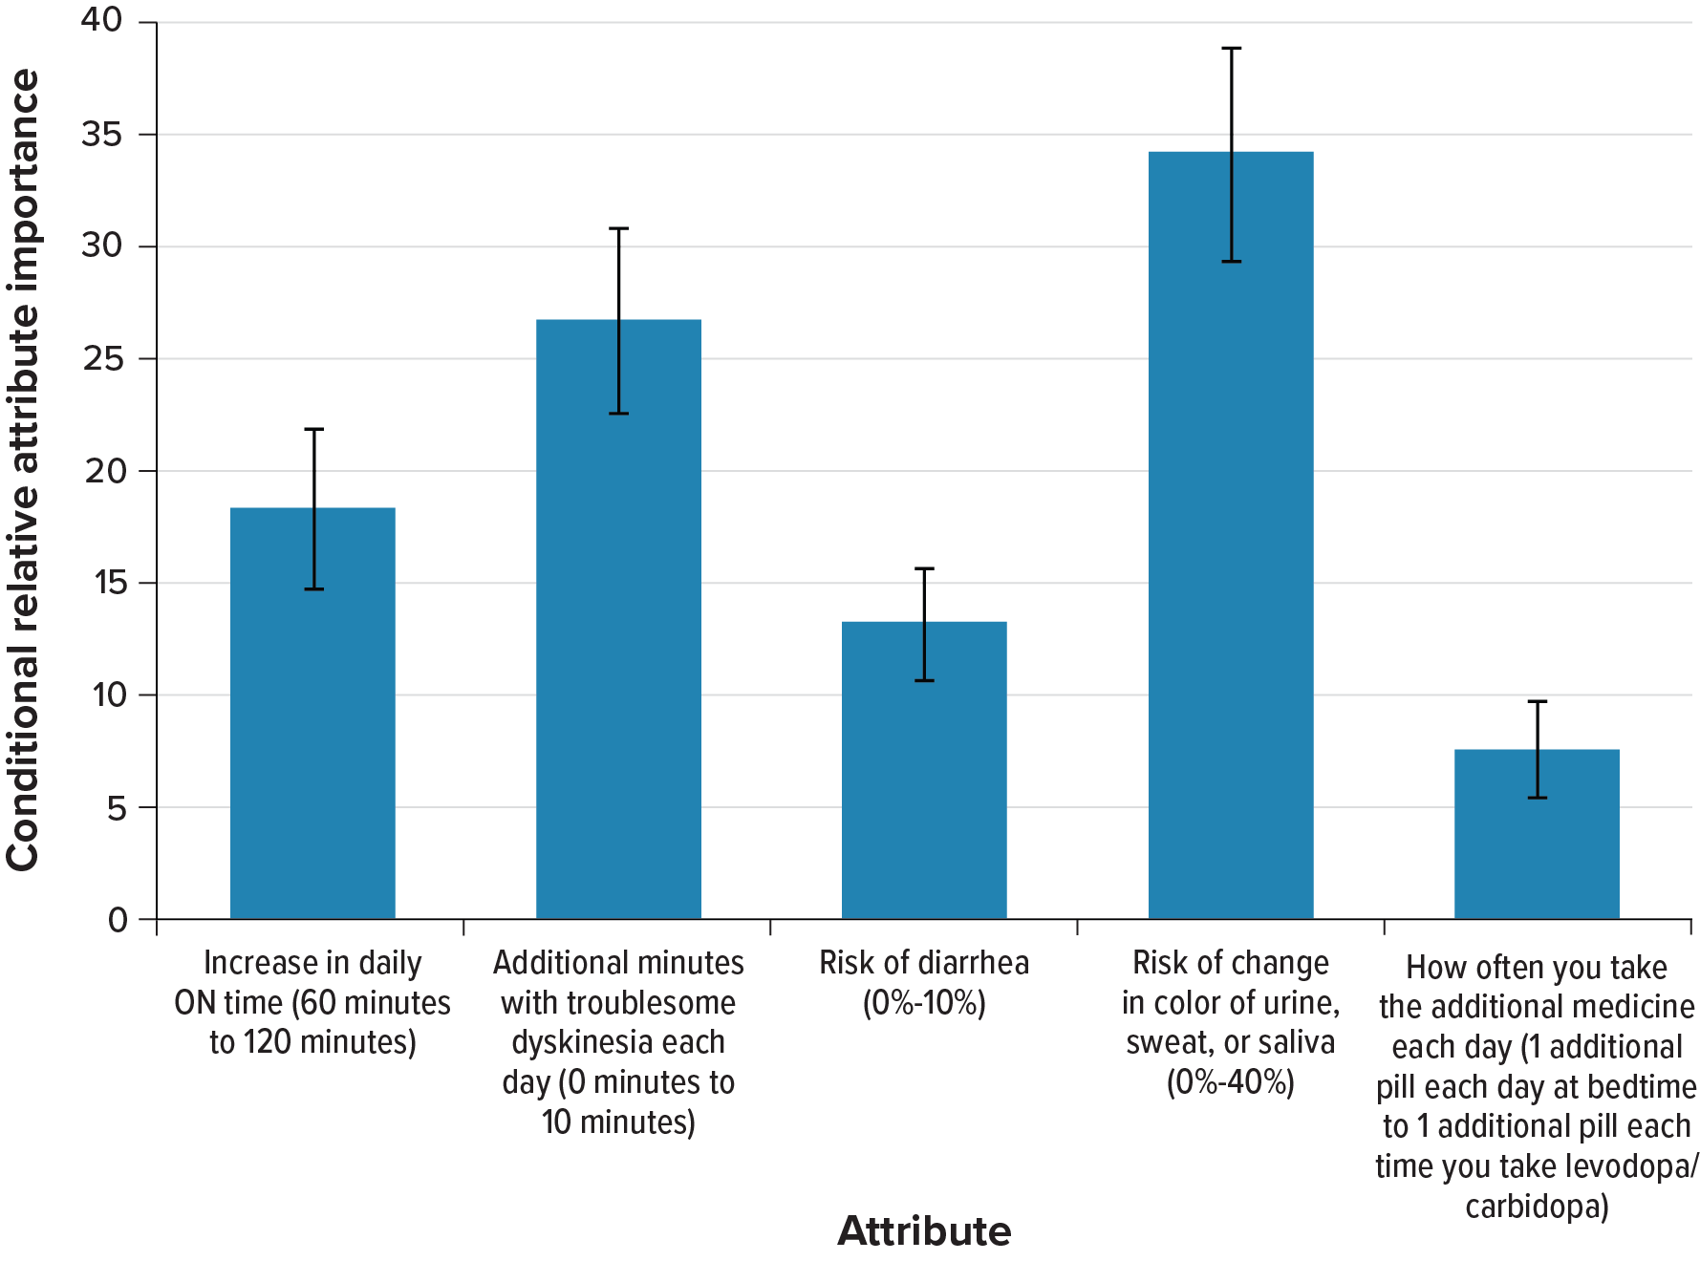
Note: The conditional relative importance is the difference between the preference weights on the most influential attribute level and the least influential attribute level. These differences are summed across attributes, and the sum is scaled to 100. The conditional importance of each attribute is a percentage of this total. The vertical bars surrounding each relative importance weight estimate denote the 95% confidence interval around the point estimate (computed by the delta method).

