Supplementary material

Methods
Those in the Birmingham AATD cohort had spirometric confirmation of COPD, in addition to emphysema. For AlphaNet, patients were referred by a respiratory physician for prescription of AAT augmentation therapy. A fixed criteria for AAT augmentation therapy is presence of AATD related lung disease which may not include spirometry confirmed COPD.

Results

Table S1: Logistic regression for prevalence of any cardiovascular disease at baseline assessment adjusted for sex, age, frequent exacerbator phenotype and previous/current smoke exposure.
Predictors | Prevalence Ratios | CI | p
(Intercept) | 0.04 | 0.02 – 0.09 | <0.001
Male | 1.1 | 0.89 – 1.37 | 0.364
Age (years) | 1.02 | 1.01 – 1.03 | <0.001
≥2 exacerbations* | 1.49 | 1.20 – 1.85 | <0.001
Ever smoker | 1.08 | 0.83 – 1.39 | 0.581
Observations; 2549, R² 0.011. *In year prior to review. CI; confidence interval.

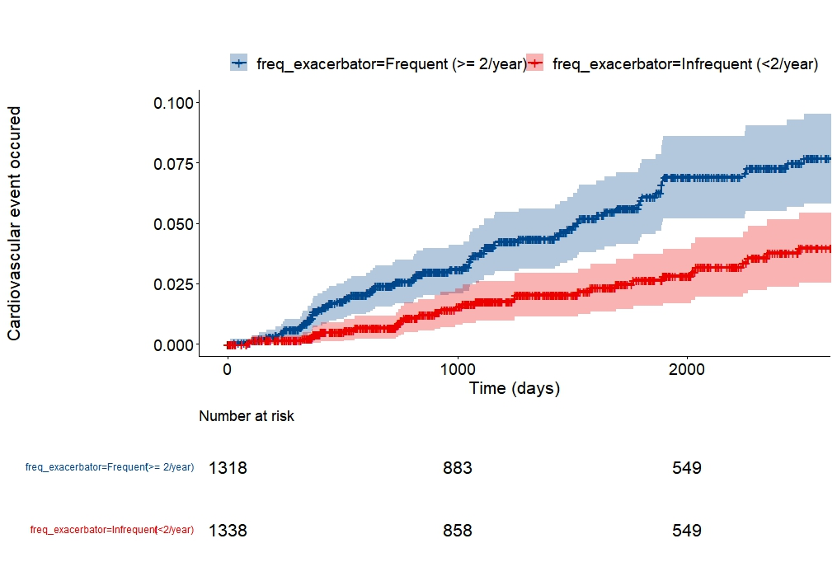
Figure S1: Kaplan Meier survival curve of time to first MACE event for frequent exacerbators (blue line, 2 or more exacerbations in year prior to baseline) vs infrequency exacerbators (blue line – one or no exacerbations in year prior to baseline). Y axis scale represents the probability of MACE occurring and has been adjusted to demonstrate separation of curves. Shaded areas represent 95% CI.

