Supplementary files
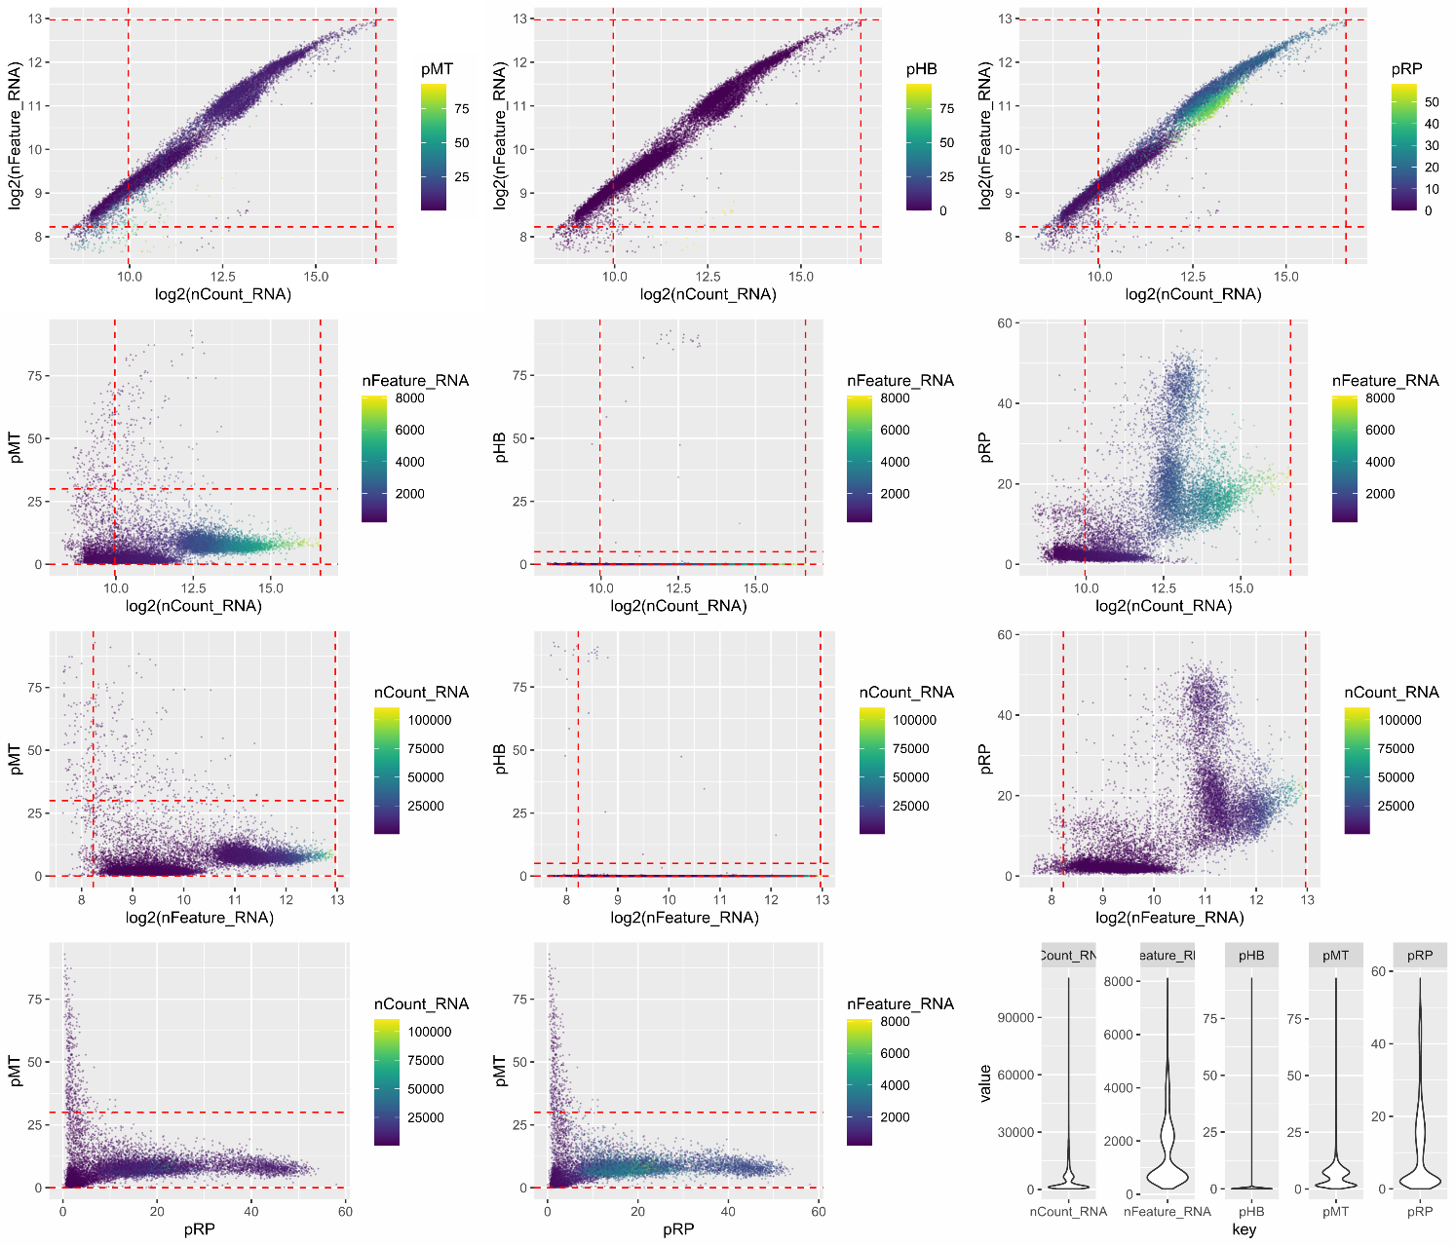
Supplementary Figure S1. Total cells obtained from samples of patients with acute respiratory distress syndrome (ARDS) and healthy controls before quality control. The range of detected gene numbers, sequencing counts, and percentage of mitochondrial sequencing counts per cell are included.

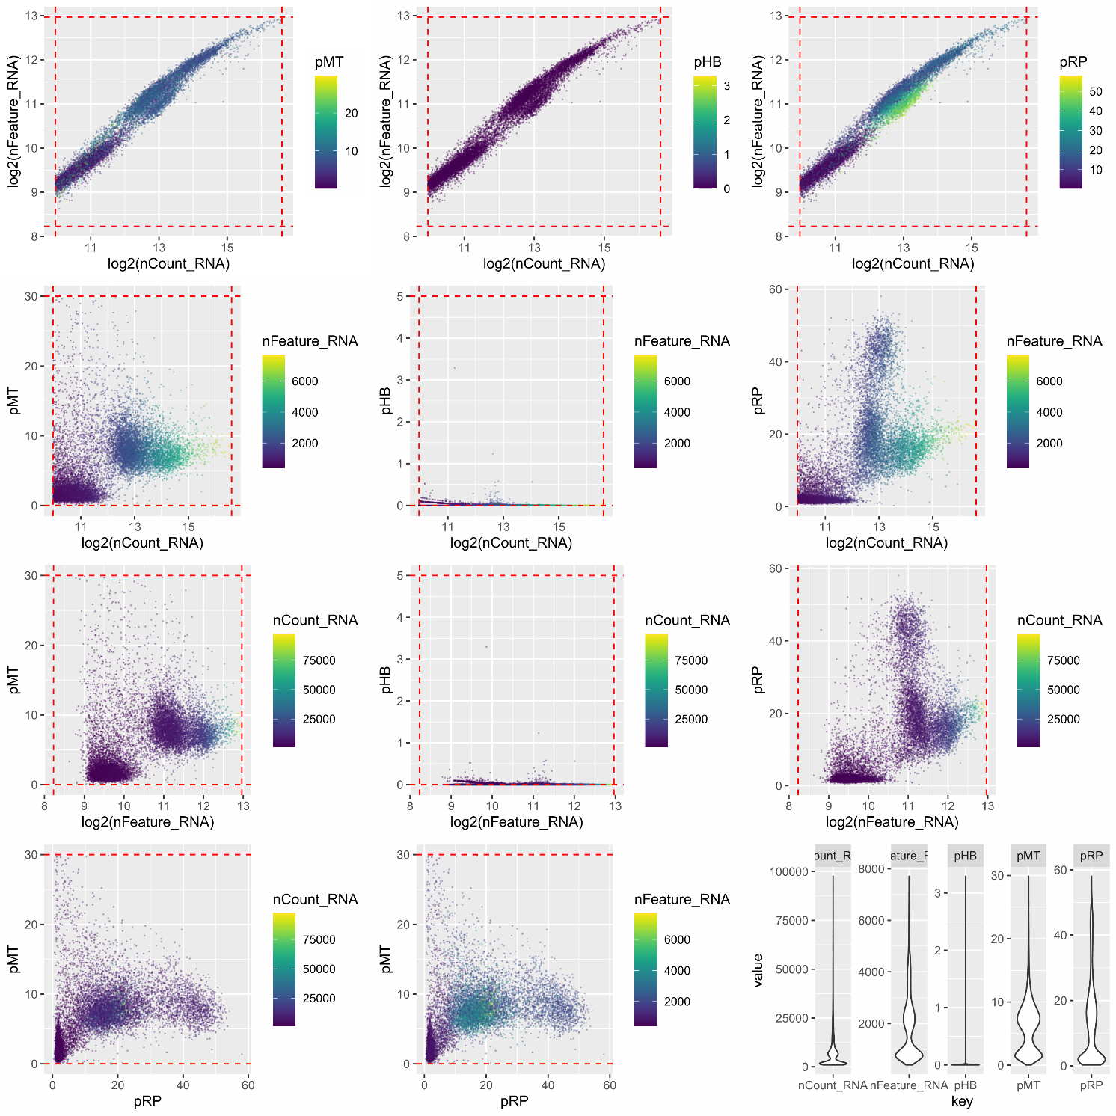
Supplementary Figure S2. Total cells obtained from samples of patients with acute respiratory distress syndrome (ARDS) and healthy controls after quality control. The range of detected gene numbers, sequencing counts, and percentage of mitochondrial sequencing counts per cell are included.

Supplementary Figure S3. Principal component analyses. A. Principal component analysis results before merging batches. B. Principal component analysis results after merging batches. PC, principal component.

Supplementary Table S1. Clinical information of all samples.
Group | Sex | Age | Disease Status | Time interval to diagnosis of ARDS | FIO2 (%) | pH(T)(mmHg) | pCO2(T)(mmHg) | pO2(T)(mmHg) | pO2(A), T (mmHg) | sO2 (%) | tO2 (ml/dL) | tCO2 (mmol/L) | Lac (mmol/L) | PO2(A-a,T)e (mmHg) | PO2(a/A，T) (%) | pO2(a)/FO2(I) (mmol/L) | mOsm (mmol/L)
PEN-ARDS | Male | 18 | No underlying disease | 36 hours after onset of disease | 100 | 7.39 | 46.1 | 51.30 | 655.3 | 86.9 | 9.6 | 60.3 | 0.7 | 603.9 | 7.8 | 51.3 | 316.3
SEP-ARDS1 | Male | 42 | No underlying disease | 26 hours after onset of disease | 100 | 7.4 | 35.6 | 74.6 | 664.1 | 94.8 | 17.2 | 43.4 | 3.7 | 589.5 | 11.2 | 68.5 | 251.4
SEP-ARDS2 | Female | 37 | No underlying disease | 42 hours after onset of disease | 70 | 7.43 | 30.1 | 69.2 | 461.1 | 95.1 | 11.7 | 42.4 | 3.7 | 391.9 | 15 | 95.7 | 276
Control | Male | 30 | No underlying disease | Control | 40 | 7.35 | 44.3 | 185 | 233.1 | 100 | 21.6 | 33.3 | 0.6 | 37.8 | 92.3 | 463 | 304.3

