Original article
Supporting Information

Long-Circulating Lipid Nanospheres Loaded with Flurbiprofen Axetil for Targeted Rheumatoid Arthritis Treatment
Supporting Figures
Fig. S1. Synthesis diagram of DSPE-PEG₂₀₀₀-cRGD from DSPE-PEG₂₀₀₀-Mal and cRGD at room temperature. cRGD, cyclic arginine-glycine-aspartic acid peptide; DSPE, distearoyl phosphatidyl ethanolamine; Mal, maleimide; PEG, polyethylene glycol
Fig. S2. ¹H NMR spectrum of DSPE-PEG₂₀₀₀-cRGD in DMSO-d₆ (400 MHz).
Fig. S3. Hemolytic potential of the prepared formulations.
Supporting tables
Table S1. Actual values of independent variables at different levels.
Table S2. Experimental values of independent and dependent variables used in the central composite design (n = 3).
Table S3. Observed and predicted values of particle size and encapsulation efficiency under optimum conditions (n = 3).
Table S4. Physical characterization of lipid nanospheres (LN).
Table S5. Stability of FA-SLN and cRGD-FA-SLN at 4 °C.
Table S6. Long-term stability of FA-SLN and cRGD-FA-SLN at 4 °C.
Table S7. Stability of FA-SLN and cRGD-FA-SLN at 30 °C.
Table S8. Pharmacokinetic parameters of FA in the plasma of healthy rats treated with different formulations.
Table S9. Pharmacokinetic parameters of FA in the plasma of collagen-induced arthritic rats treated with different formulations.
Table S10. Heat pain threshold of collagen-induced arthritic rats after various treatments.
Table S11. Effect of various treatments on the torsional response of collagen-induced arthritic rats intraperitoneally injected with acetic acid.

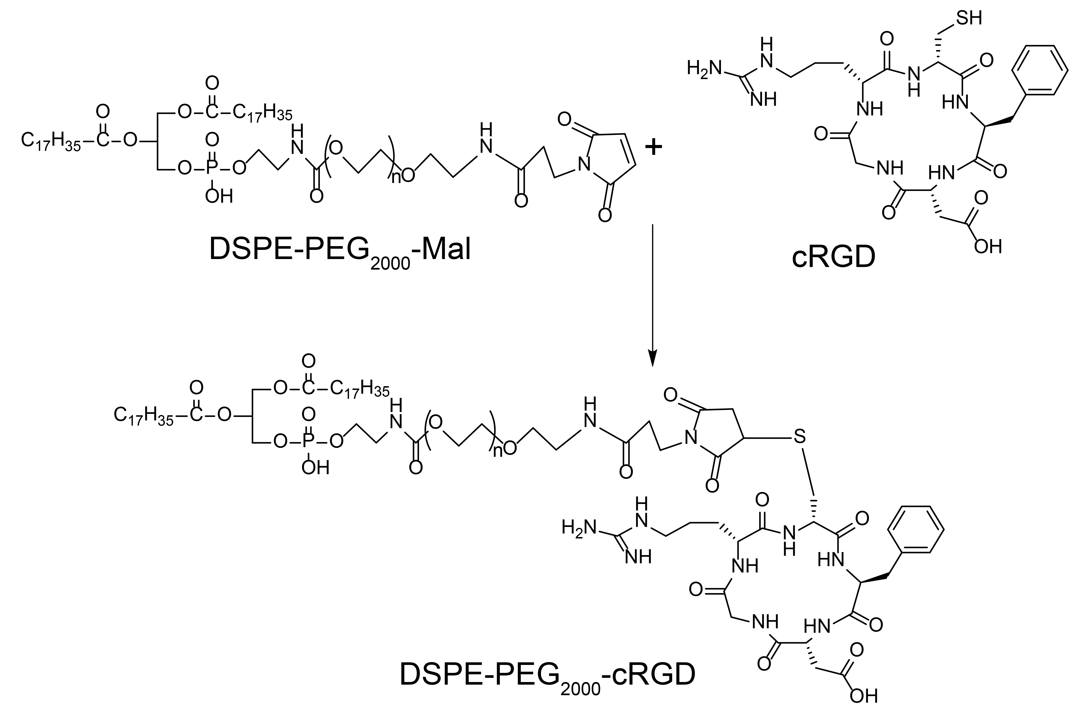
Fig. S1. Synthesis diagram of DSPE-PEG₂₀₀₀-cRGD from DSPE-PEG₂₀₀₀-Mal and cRGD at room temperature. cRGD, cyclic arginine-glycine-aspartic acid peptide; DSPE, distearoyl phosphatidyl ethanolamine; Mal, maleimide; PEG, polyethylene glycol

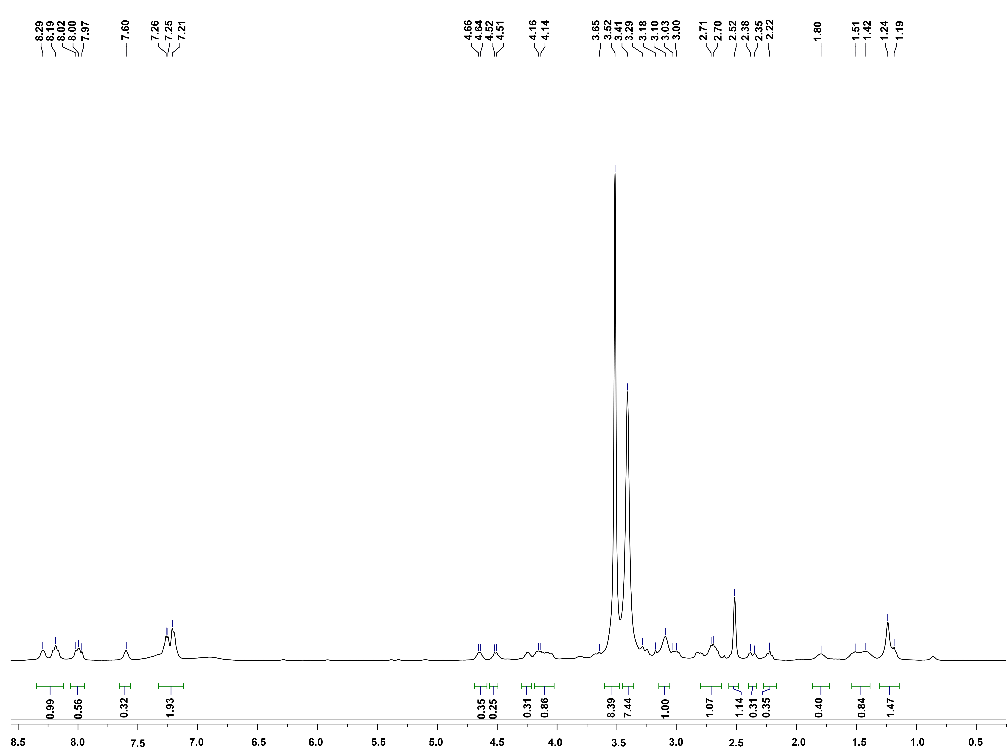
Fig. S2. ¹H NMR spectrum of DSPE-PEG₂₀₀₀-cRGD in DMSO-d₆ (400 MHz).

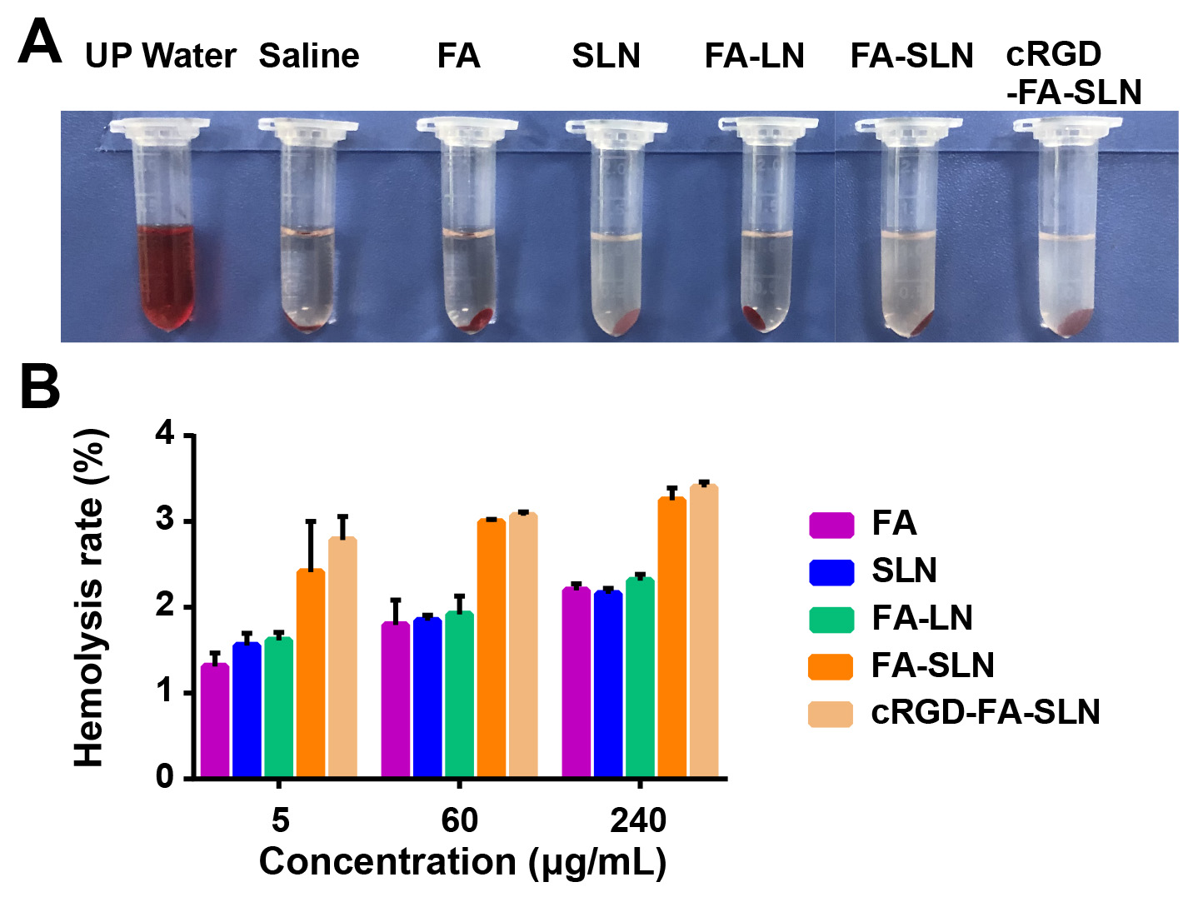
Fig. S3. Hemolytic potential of the prepared formulations. (A) Photographs of centrifuged whole-blood samples after treatment with various formulations. (B) Hemolysis rate induced by different formulations at various concentrations. Data are shown as mean ± SD (n = 3). cRGD, cyclic arginine-glycine-aspartic acid peptide; FA, flurbiprofen axetil; LN, lipid nanospheres; SLN, stealth lipid nanospheres.

Table S1. Actual values of independent variables at different levels.
Independent variable | Level
Independent variable | -1.682 | -1 | 0 | +1 | +1.682
X₁ | 5 | 7.03 | 10 | 12.97 | 15
X₂ | 0.5 | 0.8 | 1.25 | 1.7 | 2
X₃ | 80 | 88.11 | 100 | 111.89 | 120
X₁, soybean oil ratio (%); X₂, lecithin ratio (%); X₃, homogeneous pressure (MPa).
Table S2. Experimental values of independent and dependent variables used in the central composite design (n = 3).
Run | X₁ | X₂ | X₃ | Y₁ | Y₂
1 | 10.00 | 1.25 | 120.00 | 266.51 | 90.12
2 | 10.00 | 1.25 | 100.00 | 234.24 | 95.74
3 | 10.00 | 2.00 | 100.00 | 300.71 | 92.11
4 | 10.00 | 1.25 | 80.00 | 274.32 | 88.41
5 | 10.00 | 1.25 | 100.00 | 234.22 | 94.88
6 | 7.03 | 0.80 | 111.89 | 312.54 | 78.17
7 | 10.00 | 1.25 | 100.00 | 238.54 | 96.38
8 | 15.00 | 1.25 | 100.00 | 272.34 | 90.32
9 | 12.97 | 0.80 | 111.89 | 244.87 | 85.63
10 | 12.97 | 0.80 | 88.11 | 303.36 | 87.25
11 | 7.03 | 0.80 | 88.11 | 342.57 | 73.36
12 | 5.00 | 1.25 | 100.00 | 298.14 | 84.33
13 | 7.03 | 1.70 | 111.89 | 314.58 | 88.36
14 | 10.00 | 1.25 | 100.00 | 237.47 | 95.36
15 | 10.00 | 0.50 | 100.00 | 273.21 | 72.33
16 | 7.03 | 1.70 | 88.11 | 364.32 | 81.12
17 | 10.00 | 1.25 | 100.00 | 243.55 | 96.34
18 | 10.00 | 1.25 | 100.00 | 237.41 | 95.47
19 | 12.97 | 1.70 | 111.89 | 283.22 | 89.11
20 | 12.97 | 1.70 | 88.11 | 300.22 | 84.39
X₁, soybean oil ratio (%); X₂, lecithin ratio (%); X₃, homogeneous pressure (MPa); Y₁, mean particle size (nm); Y₂, encapsulation efficiency (%) of FA-SLN.
Table S3. Observed and predicted values of particle size and encapsulation efficiency under optimum conditions (n = 3).
Variable | Optimized value | Response | Expected  value | Observed value | Mean ± SD  (%)
X₁ | 11.24 | Y₁ | 233.201 | 242.66 | 245.05 ± 2.36
 |  |  |  | 247.38 | 245.05 ± 2.36
 |  |  |  | 245.12 | 245.05 ± 2.36
X₂ | 1.32 | ⸺ | ⸺ | ⸺ | ⸺
X₃ | 103.29 | Y₂ | 96.667 | 95.21 | 93.89 ± 1.58
 |  |  |  | 94.33 | 93.89 ± 1.58
 |  |  |  | 92.14 | 93.89 ± 1.58
X₁, soybean oil ratio (%); X₂, lecithin ratio (%); X₃, homogeneous pressure (MPa); Y₁, mean particle size (nm); Y₂, encapsulation efficiency (%) of FA-SLN.

Table S4. Physical characterization of lipid nanospheres (LN).
Formulation | Mean size (nm) | PDI | Zeta potential (mV) |  | Content (%) | Encapsulation  efficiency (%)
LN | 196 | 0.16 | -1.79 | ⸺ |  |  | ⸺
SLN | 223 | 0.17 | -1.67 | ⸺ |  |  | ⸺
FA-SLN | 245 | 0.19 | -1.15 | 97 |  |  | 93
cRGD-FA-SLN | 264 | 0.20 | -1.32 | 94 |  |  | 91
cRGD, cyclic arginine-glycine-aspartic acid peptide; FA, flurbiprofen axetil; SLN, stealth lipid nanospheres .

Table S5. Stability of FA-SLN and cRGD-FA-SLN at 4 °C.
Sample | Time (Day) | Appearance | Size (nm) |  | PDI | K_{e} (%)
FA-SLN | 0 | Uniform, milky white, free of oil droplets | 245.79 ±  2.83 | 0.188 ±  0.013 |  | 8.25 ±  0.36
 | 5 | No changes | 250.3 ±  1.73 | 0.192 ±  0.007 |  | 8.68 ±  0.32
 | 10 | No changes | 250.67 ±  2.80 | 0.213 ±  0.021 |  | 8.75 ±  0.30
cRGD-FA-SLN | 0 | Uniform, milky white, free of oil droplets | 262.01 ±  3.21 | 0.194 ±  0.013 |  | 8.38 ±  0.56
 | 5 | No changes | 263.89 ±  5.76 | 0.187 ±  0.006 |  | 8.40 ±  0.21
 | 10 | No changes | 266.45 ±  3.29 | 0.205 ±  0.008 |  | 8.99 ±  0.33
Data are shown as mean ± SD (n = 3). cRGD, cyclic arginine-glycine-aspartic acid peptide; FA, flurbiprofen axetil; K_{e}, centrifugal stability constant; SLN, stealth lipid nanospheres.
Table S6. Long-term stability of FA-SLN and cRGD-FA-SLN at 4 °C.
Sample | Time (Months) | Appearance | Size (nm) | PDI | K_{e} (%)
FA-SLN | 0 | Uniform, milky white, free of oil droplets | 242.75 ±  5.43 | 0.186 ±  0.010 | 8.15 ±  0.33
 | 1 | No changes | 252.08 ±  3.98 | 0.187 ±  0.005 | 8.02 ±  0.35
 | 2 | No changes | 256.60 ±  4.65 | 0.189 ±  0.009 | 8.22 ±  0.41
 | 3 | No changes | 260.78 ±  4.37 | 0.194 ±  0.009 | 8.99 ±  0.30
cRGD-FA-SLN | 0 | Uniform, milky white, free of oil droplets | 245.79 ±  2.83 | 0.183 ±  0.015 | 8.12 ±  0.57
 | 1 | No changes | 265.13 ±  4.91 | 0.250 ±  0.026 | 11.05 ±  0.97
 | 2 | Few oil drops | 307.69 ±  13.38 | 0.303 ±  0.031 | 14.41 ±  0.94
 | 3 | Many oil drops | 360.61 ±  8.77 | 0.400 ±  0.046 | 22.12 ±  1.76
Data are shown as mean ± SD (n = 3). cRGD, cyclic arginine-glycine-aspartic acid peptide; FA, flurbiprofen axetil; K_{e}, centrifugal stability constant; SLN, stealth lipid nanospheres.
Table S7. Stability of FA-SLN and cRGD-FA-SLN at 30 °C.
Sample | Time (Day) | Appearance | Size (nm) | PDI | K_{e} (%)
FA-SLN | 0 | Uniform, milky white, free of oil droplets | 245.79 ±  2.83 | 0.188 ±  0.013 | 8.12 ±  0.57
 | 5 | Few oil drops | 389.91 ±  1.47 | 0.411 ±  0.004 | 32.18 ±  2.04
 | 10 | Many oil drops | ⸺ | ⸺ | ⸺
cRGD-FA-SLN | 0 | Uniform, milky white, free of oil droplets | 262.33 ±  3.47 | 0.195 ±  0.011 | 8.18 ±  0.58
 | 5 | Few oil drops | 402.85 ±  8.38 | 0.425 ±  0.009 | 38.82 ±  2.42
 | 10 | Many oil drops | ⸺ | ⸺ | ⸺
Data are shown as mean ± SD (n = 3). cRGD, cyclic arginine-glycine-aspartic acid peptide; FA, flurbiprofen axetil; K_{e}, centrifugal stability constant; SLN, stealth lipid nanospheres.

Table S8. Pharmacokinetic parameters of FA in the plasma of healthy rats treated with different formulations.
Formulation | AUC_{0-t}  (mg/L*h) | MRT_{0-t}  (h) | C_{max}  (mg/L) | T_{1/2z}  (h) | CL_{z}  (L/h/kg) | T_{max}  (h)
FA | 36.110 ±  2.108 | 3.412 ±  0.176 | 9.109 ±  0.223 | 3.399 ±  0.236 | 0.025 ±  0.002 | 0.083
FA-LN | 47.951 ±  1.309 *** | 4.080 ±  0.077 **** | 9.074 ±  0.157 | 4.505 ±  0.405* | 0.018 ±  0.001*** | 0.167
FA-SLN | 59.671 ±  1.774### | 4.849 ±  0.101#### | 9.016 ±  0.247 | 8.434 ±  0.319#### | 0.010 ±  0.001### | 0.500
cRGD-FA-SLN | 60.672 ±  2.588 | 4.907 ±  0.025 | 9.021 ±  0.205 | 8.495 ±  0.610 | 0.010 ±  0.001 | 0.500
Data are shown as mean ± SD (n = 3). *P < 0.05, ***P < 0.001, ****P < 0.0001 vs FA. ###P < 0.001, ####P < 0.0001 vs FA-LN. AUC_{0-t}, area under the drug-time curve; CL_{z}, clearance rate; cRGD, cyclic arginine-glycine-aspartic acid peptide; FA, flurbiprofen axetil; MRT_{0-t}, mean residence time; SLN, stealth lipid nanospheres; T_{1/2z}, half-life; T_{max}, time to maximum plasma concentration.

Table S9. Pharmacokinetic parameters of FA in the plasma of collagen-induced arthritic rats treated with different formulations.
Formulation | AUC_{0-t}  (mg/L*h) | MRT_{0-t}  (h) | C_{max}  (mg/L) | T_{1/2z}  (h) | CL_{z}  (L/h/kg) | T_{max}  (h)
FA | 35.196 ±  1.766 | 3.391 ±  0.109 | 9.036 ±  0.168 | 3.447 ±  0.263 | 0.026 ±  0.002 | 0.083
FA-LN | 47.595 ±  0.819**** | 4.163 ±  0.099**** | 8.901 ±  0.154 | 4.618 ±  0.205*** | 0.018 ±  0.001**** | 0.167
FA-SLN | 59.279 ±  0.654#### | 4.908 ±  0.079#### | 8.929 ±  0.281 | 8.564 ±  0.314#### | 0.011 ±  0.001### | 0.500
cRGD-FA-SLN | 59.527 ±  1.947 | 4.908 ±  0.037 | 8.909 ±  0.186 | 8.588 ±  0.232 | 0.011 ±  0.001 | 0.500
Data are shown as mean ± SD (n = 3). *P < 0.05, ***P < 0.001, ****P < 0.0001 vs FA. ###P < 0.001, ####P < 0.0001 vs FA-LN. AUC_{0-t}, area under the drug-time curve; CL_{z}, clearance rate; cRGD, cyclic arginine-glycine-aspartic acid peptide; FA, flurbiprofen axetil; MRT_{0-t}, mean residence time; SLN, stealth lipid nanospheres; T_{1/2z}, half-life; T_{max}, time to maximum plasma concentration.

Table S10. Heat pain threshold of collagen-induced arthritic rats after various treatments.
Treatment | Foot licking time (s)
Treatment | 15 min | 30 min | 60 min
Saline | 10.68 ± 2.34**** | 10.81 ± 3.65**** | 10.15 ± 2.57****
FA-SLN | 27.31 ± 2.60 | 30.64 ± 2.36 | 26.48 ± 3.07
cRGD-FA-SLN | 36.40 ± 2.44*** | 41.50 ± 2.12**** | 35.23 ± 3.47**
Data are shown as mean ± SD (n = 5). **P < 0.01, ***P < 0.001, ****P < 0.0001 vs FA-SLN. cRGD, cyclic arginine-glycine-aspartic acid peptide; FA, flurbiprofen axetil; SLN, stealth lipid nanospheres.

Table S11. Effect of various treatments on the torsional response of collagen-induced arthritic rats intraperitoneally injected with acetic acid.
Treatment | Number of body torsions
Saline | 31.67 ± 4.04****
FA-SLN | 15.33 ± 3.51
cRGD-FA-SLN | 14.33 ± 2.52
Data are shown as mean ± SD (n = 5). ****P < 0.0001 vs FA-SLN. cRGD, cyclic arginine-glycine-aspartic acid peptide; FA, flurbiprofen axetil; SLN, stealth lipid nanospheres.

