Figure S1. After sectioning, the number of macrophages in lung tissue was detected by anti-CD68 antibody staining (n=6 per group). CD68 positive macrophages were normalized to dapi positive cells.

Figure S2. Intensity of immunofluorescence in lung tissues of M1 macrophages, (n =6 per group). iNOS (M1, green).
Figure S3. Intensity of immunofluorescence in lung tissues of M2 macrophages, (n =6 per group). Arg1 (M2, red).
Figure S4.The expression of iNOS was measured using quantitative qpcr. *p<0.05,**p<0.01,ns p>0.05.
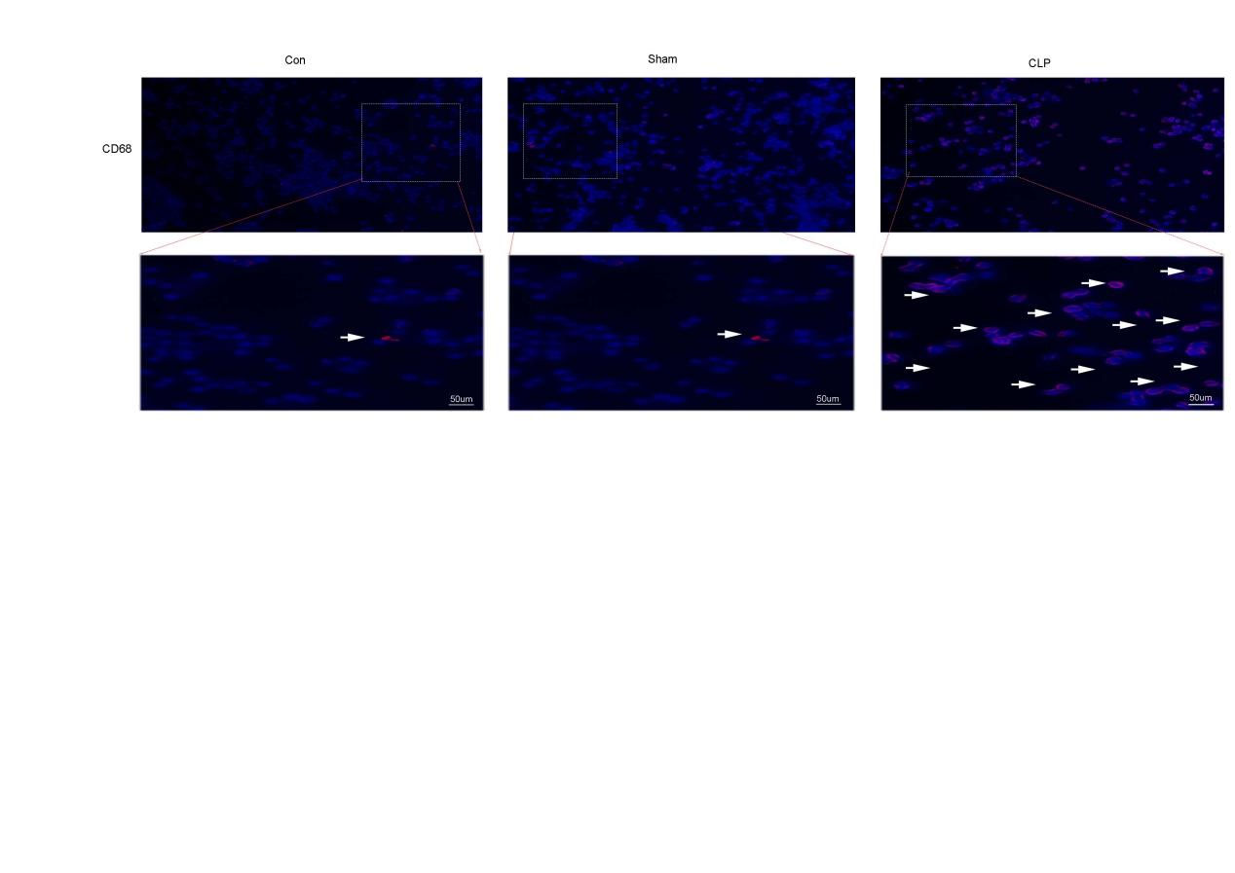
Figure S5 Co-incubation of extracellular vesicles with cells and lung tissue was performed. cells were stained with anti-cd68 antibody to identify the number of macrophages. cd68-positive macrophages were normalized to dapi-positive cells.
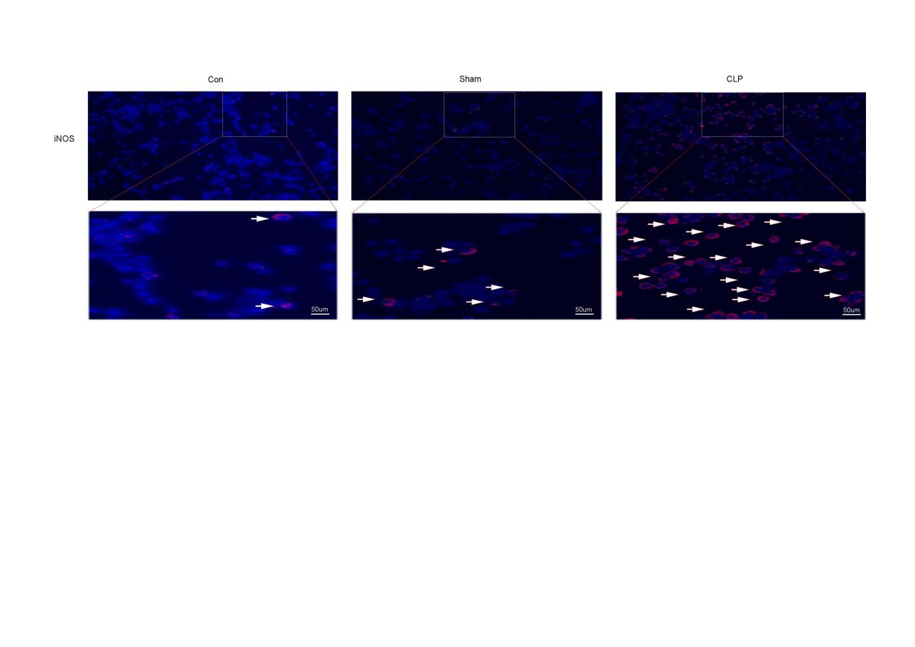

Figure S6 Immunofluorescence intensity of M1 macrophages.

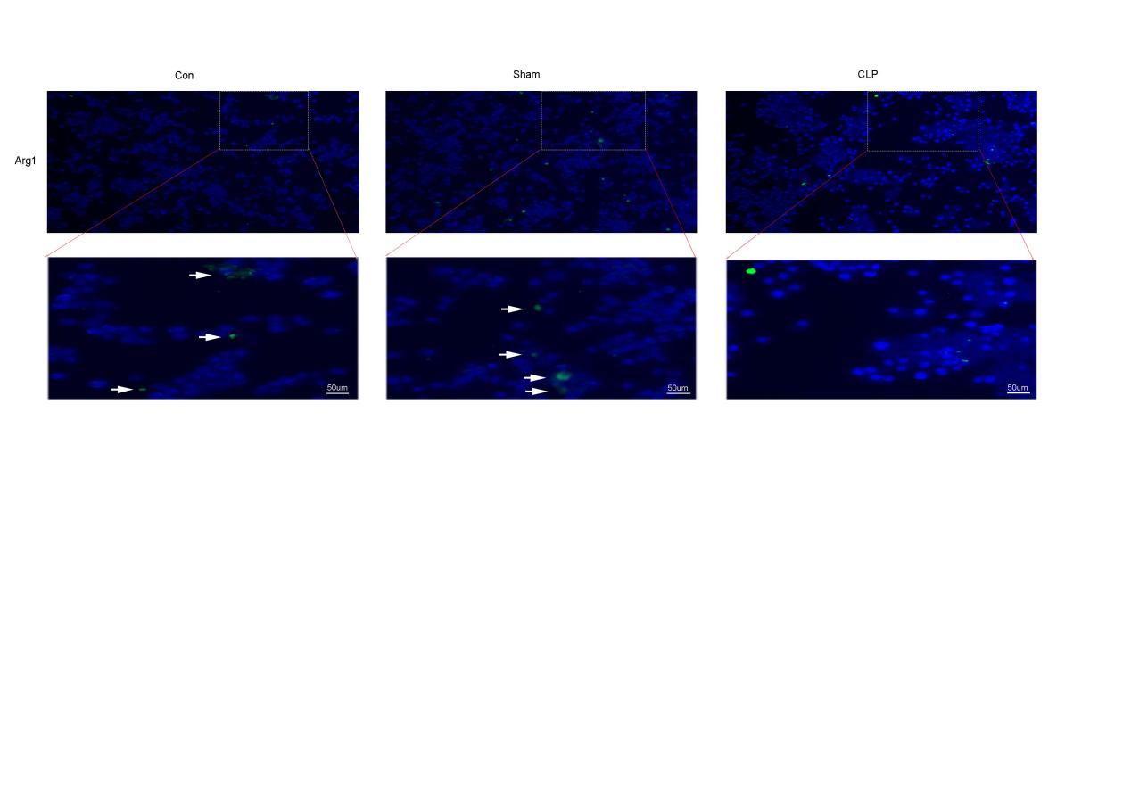
Figure S7 Immunofluorescence intensity of M2 macrophages.

Figure S8 Expression level of pri-miR-671-5p in macrophages.*p<0.05,**p<0.01,ns p>0.05.

Figure S9 Regulatory relationship between Gm4673 and mmu-miR-671-5p in ceRNA.（A）Upregulation of Gm4673 in ceRNA, qPCR analysis of expression levels of Gm4673, mmu-miR-671-5p, and Jak3.（B）Downregulation of Gm4673 in ceRNA, qPCR analysis of expression levels of Gm4673, mmu-miR-671-5p, and Jak3.（C）Upregulation of mmu-miR-671-5p in ceRNA, qPCR analysis of expression levels of Gm4673, mmu-miR-671-5p, and Jak3.（D）Downregulation of mmu-miR-671-5p in ceRNA, qPCR analysis of expression levels of Gm4673, mmu-miR-671-5p, and Jak3.*p<0.05,**p<0.01,***p<0.001, ns p>0.05.

Table S1. Primers used for qPCR
Primers | Sequence (5′-3′)
IL-6 | F:GCTCTGGTCTTCTGGAGTTCC  R:GAGTTGGATGGTCTTGGTCCT
TNF-α | F:GGCAGCCTTGTCCCTTGAAGAG  R:GTAGCCCACGTCGTAGCAAACC
CD80 | F:AAACCTAGCACTACCCTGGC  R:AGCAAATGTGCAAATCGTCCC
CD206 | F:CGGAATTTCTGGGATTCAGCTTC  R:CTCTGTTCAGCTATTGGACGC
GAPDH | F:CAATGTGTCCGTCGTGGATCT  R:GTCCTCAGTGTAGCCCAAGATG
Gm4673 | F:CTCCCATCCACTTCACGCA  R:GCCCAACTCTGCTCCAAATG
MSTRG.41696 | F:CACACGCTCCTGAGGTTCACTAAC  R:GGAGTGTATGTGGCAGAGGTGTTAG
miR-671-5p | F:AATTGTACAGGAAGCCCTGGAGG  R:ATCCAGTGCAGGGTCCGAGG
miR-122-5p | F:AATCGGCGTGGAGTGTGACAAT  R:AATCGGCGTGGAGTGTGACAAT
Jak3 | F:CCGCCTACTGCTGTTCGCTTG  R:CCTCGCTCTCCACCAAGATGTTG
Rab20 | F:AGCAGTGGCGTTCCTTCAACATC  R:GCAGTACAGGGAGCCCAGACC

