Supplementary materials

Supplementary Table 1. Broad definition for COVID-19 diagnoses
Concept ID | Concept Code | Concept Name | Vocabulary
3661405 | 138389411000119105 | Acute bronchitis caused by SARS-CoV-2 | SNOMED
3655976 | 870590002 | Acute hypoxemic respiratory failure due to disease caused by Severe acute respiratory syndrome coronavirus 2 | SNOMED
3661748 | 870589006 | Acute kidney injury due to disease caused by Severe acute respiratory syndrome coronavirus 2 | SNOMED
3661406 | 674814021000119106 | Acute respiratory distress syndrome due to disease caused by Severe acute respiratory syndrome coronavirus 2 | SNOMED
3662381 | 189486241000119100 | Asymptomatic SARS-CoV-2 | SNOMED
756031 | OMOP4873909 | Bronchitis caused by COVID-19 | OMOP Extension
3656667 | 119731000146105 | Cardiomyopathy due to disease caused by Severe acute respiratory syndrome coronavirus 2 | SNOMED
3656668 | 119741000146102 | Conjunctivitis due to disease caused by Severe acute respiratory syndrome coronavirus 2 | SNOMED
439676 | 186747009 | Coronavirus infection | SNOMED
37311061 | 840539006 | COVID-19 | SNOMED
4100065 | 27619001 | Disease due to Coronaviridae | SNOMED
3656669 | 119981000146107 | Dyspnea caused by Severe acute respiratory syndrome coronavirus 2 | SNOMED
37310284 | 1240561000000108 | Encephalopathy due to disease caused by Severe acute respiratory syndrome coronavirus 2 | SNOMED
3661885 | 119751000146104 | Fever caused by Severe acute respiratory syndrome coronavirus 2 | SNOMED
37310283 | 1240571000000101 | Gastroenteritis caused by SARS-CoV-2 (severe acute respiratory syndrome coronavirus 2) | SNOMED
37310286 | 1240541000000107 | Infection of upper respiratory tract caused by Severe acute respiratory syndrome coronavirus 2 | SNOMED
3663281 | 880529761000119102 | Lower respiratory infection caused by SARS-CoV-2 | SNOMED
3661631 | 866151004 | Lymphocytopenia due to Severe acute respiratory syndrome coronavirus 2 | SNOMED
37310287 | 1240531000000103 | Myocarditis due to disease caused by Severe acute respiratory syndrome coronavirus 2 | SNOMED
37310254 | 1240521000000100 | Otitis media due to disease caused by Severe acute respiratory syndrome coronavirus 2 | SNOMED
704995 | OMOP4912977 | Patient meets COVID-19 clinical diagnostic criteria | OMOP Extension
700297 | OMOP4912988 | Patient meets COVID-19 laboratory confirmation criterion (detection of specific RNA in a clinical specimen using a molecular amplification detection test) | OMOP Extension
704996 | OMOP4912978 | Patient meets COVID-19 laboratory diagnostic criteria | OMOP Extension
700296 | OMOP4912987 | Patient meets COVID-19 presumptive laboratory evidence criteria (detection of specific antigen in a clinical specimen, OR detection of specific antibody in serum, plasma, or whole blood indicative of a new or recent infection) | OMOP Extension
37016927 | 713084008 | Pneumonia caused by Human coronavirus | SNOMED
3661408 | 882784691000119100 | Pneumonia caused by SARS-CoV-2 | SNOMED
40479642 | 441590008 | Pneumonia due to Severe acute respiratory syndrome coronavirus | SNOMED
756039 | OMOP4873907 | Respiratory infection caused by COVID-19 | OMOP Extension
3655977 | 870591003 | Rhabdomyolysis due to disease caused by Severe acute respiratory syndrome coronavirus 2 | SNOMED
3655975 | 870588003 | Sepsis due to disease caused by Severe acute respiratory syndrome coronavirus 2 | SNOMED
320651 | 398447004 | Severe acute respiratory syndrome | SNOMED
37396171 | 715882005 | Severe acute respiratory syndrome of upper respiratory tract | SNOMED
37311060 | 840544004 | Suspected COVID-19 | SNOMED
3661632 | 866152006 | Thrombocytopenia due to Severe acute respiratory syndrome coronavirus 2 | SNOMED
45763724 | 700217006 | Suspected coronavirus infection | SNOMED

Supplementary Table 2. Narrow definition for COVID-19 diagnoses
Concept ID | Concept Code | Concept Name | Vocabulary
3661405 | 138389411000119105 | Acute bronchitis caused by SARS-CoV-2 | SNOMED
3655976 | 870590002 | Acute hypoxemic respiratory failure due to disease caused by Severe acute respiratory syndrome coronavirus 2 | SNOMED
3661748 | 870589006 | Acute kidney injury due to disease caused by Severe acute respiratory syndrome coronavirus 2 | SNOMED
3661406 | 674814021000119106 | Acute respiratory distress syndrome due to disease caused by Severe acute respiratory syndrome coronavirus 2 | SNOMED
3662381 | 189486241000119100 | Asymptomatic SARS-CoV-2 | SNOMED
756031 | OMOP4873909 | Bronchitis caused by COVID-19 | OMOP Extension
3656667 | 119731000146105 | Cardiomyopathy due to disease caused by Severe acute respiratory syndrome coronavirus 2 | SNOMED
3656668 | 119741000146102 | Conjunctivitis due to disease caused by Severe acute respiratory syndrome coronavirus 2 | SNOMED
37311061 | 840539006 | COVID-19 | SNOMED
3656669 | 119981000146107 | Dyspnea caused by Severe acute respiratory syndrome coronavirus 2 | SNOMED
37310284 | 1240561000000108 | Encephalopathy due to disease caused by Severe acute respiratory syndrome coronavirus 2 | SNOMED
3661885 | 119751000146104 | Fever caused by Severe acute respiratory syndrome coronavirus 2 | SNOMED
37310283 | 1240571000000101 | Gastroenteritis caused by SARS-CoV-2 (severe acute respiratory syndrome coronavirus 2) | SNOMED
37310286 | 1240541000000107 | Infection of upper respiratory tract caused by Severe acute respiratory syndrome coronavirus 2 | SNOMED
3663281 | 880529761000119102 | Lower respiratory infection caused by SARS-CoV-2 | SNOMED
3661631 | 866151004 | Lymphocytopenia due to Severe acute respiratory syndrome coronavirus 2 | SNOMED
37310287 | 1240531000000103 | Myocarditis due to disease caused by Severe acute respiratory syndrome coronavirus 2 | SNOMED
37310254 | 1240521000000100 | Otitis media due to disease caused by Severe acute respiratory syndrome coronavirus 2 | SNOMED
704995 | OMOP4912977 | Patient meets COVID-19 clinical diagnostic criteria | OMOP Extension
700297 | OMOP4912988 | Patient meets COVID-19 laboratory confirmation criterion (detection of specific RNA in a clinical specimen using a molecular amplification detection test) | OMOP Extension
704996 | OMOP4912978 | Patient meets COVID-19 laboratory diagnostic criteria | OMOP Extension
700296 | OMOP4912987 | Patient meets COVID-19 presumptive laboratory evidence criteria (detection of specific antigen in a clinical specimen, OR detection of specific antibody in serum, plasma, or whole blood indicative of a new or recent infection) | OMOP Extension
3661408 | 882784691000119100 | Pneumonia caused by SARS-CoV-2 | SNOMED
756039 | OMOP4873907 | Respiratory infection caused by COVID-19 | OMOP Extension
3655977 | 870591003 | Rhabdomyolysis due to disease caused by Severe acute respiratory syndrome coronavirus 2 | SNOMED
3655975 | 870588003 | Sepsis due to disease caused by Severe acute respiratory syndrome coronavirus 2 | SNOMED
3661632 | 866152006 | Thrombocytopenia due to Severe acute respiratory syndrome coronavirus 2 | SNOMED

Supplementary Table 3. Failed data quality checks
Check | Description | Interpretation
1 | The number and percent of records with a value of 0 in the source concept field DRUG_SOURCE_CONCEPT_ID in the DRUG_EXPOSURE table. (Threshold=10% - Records=100%). | Drugs are coming from a national drug vocabulary, so DRUG_SOURCE_CONCEPT_ID has to be 0.
2 | The number and percent of distinct source values in the DRUG_SOURCE_VALUE field of the DRUG_EXPOSURE table mapped to 0. (Threshold=10% - Records=100%). | DRUG_SOURCE_VALUE is set to 0, but stored by the development team to avoid identifying specific products.
3 | The number and percent of records with a value of 0 in the standard concept field UNIT_CONCEPT_ID in the OBSERVATION table. (Threshold=5% - Records=99.93%). | This 99.93% of records have unit_concept_id=0. It must be set to NULL instead of 0.
4 | For the combination of CONCEPT_ID 3017044 (THYROTROPIN RECEPTOR AB [UNITS/VOLUME] IN SERUM) and UNIT_CONCEPT_ID 8923 (INTERNATIONAL UNIT PER LITER), the number and percent of records that have a value less than 0.00E+00. (Threshold=5% - Records=51.40%). | This measurement has not been used in any OMOP-SIDIAP project before. Units and values need to be checked for future use.
5 | For the combination of CONCEPT_ID 3013466 (APTT IN BLOOD BY COAGULATION ASSAY) and UNIT_CONCEPT_ID 8555 (SECOND), the number and percent of records that have a value less than 1.80E+01. (Threshold=5% - Records=51.14%). | This measurement has not been used in any OMOP-SIDIAP project before. Units and values need to be checked for future use.
6 | For the combination of CONCEPT_ID 3034426 (PROTHROMBIN TIME (PT)) and UNIT_CONCEPT_ID 8554 (PERCENT), the number and percent of records that have a value higher than 1.000000E+02. (Threshold=5% - Records=20.08%). | This measurement has not been used in any OMOP-SIDIAP project before. Units and values need to be checked for future use.
7 | The number and percent of records with a value of 0 in the standard concept field OBSERVATION_CONCEPT_ID in the OBSERVATION table. (Threshold=5% - Records=19.80%). | Observation records with observation_concept_id=0 are local observations with no standard equivalent.
8 | For the combination of CONCEPT_ID 3020460 (C REACTIVE PROTEIN [MASS/VOLUME] IN SERUM OR PLASMA) and UNIT_CONCEPT_ID 8751 (MILLIGRAM PER LITER), the number and percent of records that have a value higher than 2.400000E+01. (Threshold=5% -Records=15.52%). | This measurement has not been used in any OMOP-SIDIAP project before. Units and values need to be checked for future use.
9 | For a CONCEPT_ID 193437 (NEOPLASM OF UNCERTAIN BEHAVIOR OF FEMALE GENITAL ORGAN), the number and percent of records associated with patients with an implausible gender (correct gender = FEMALE). (Threshold=5% - Records=14.95%). | The percentage of implausible gender is the same as in source data, so this was not an issue related to the mapping of this information and has to be revised at the source tables.
10 | For a CONCEPT_ID 434251 (INJURY OF MALE EXTERNAL GENITAL ORGANS), the number and percent of records associated with patients with an implausible gender (correct gender = MALE). (Threshold=5% - Records=13.95%). | The percentage of implausible gender is the same as in source data, so this was not an issue related to the mapping of this information and has to be revised at the source tables.
11 | For a CONCEPT_ID 201909 (FEMALE INFERTILITY), the number and percent of records associated with patients with an implausible gender (correct gender = FEMALE). (Threshold=5% - Records=13.45%). | The percentage of implausible gender is the same as in source data, so this was not an issue related to the mapping of this information and has to be revised at the source tables.
12 | For a CONCEPT_ID 4199600 (CANDIDAL BALANITIS), the number and percent of records associated with patients with an implausible gender (correct gender = MALE). (Threshold=5% - Records=13.37%). | The percentage of implausible gender is the same as in source data, so this was not an issue related to the mapping of this information and has to be revised at the source tables.
13 | For a CONCEPT_ID 4071874 (PAIN IN SCROTUM), the number and percent of records associated with patients with an implausible gender (correct gender = MALE). (Threshold=5% - Records=12.68%). | The percentage of implausible gender is the same as in source data, so this was not an issue related to the mapping of this information and has to be revised at the source tables.
14 | For the combination of CONCEPT_ID 3010084 (C PEPTIDE [MASS/VOLUME] IN SERUM OR PLASMA) and UNIT_CONCEPT_ID 8842 (NANOGRAM PER MILLILITER), the number and percent of records that have a value less than 0.00E+00. (Threshold=5% - Records=12.17%). | This measurement has not been used in any OMOP-SIDIAP project before. Units and values need to be checked for future use.
15 | The number and percent of distinct source values in the CONDITION_SOURCE_VALUE field of the CONDITION_OCCURRENCE table mapped to 0. (Threshold=10% - Records=11.61%). | The percentage of distinct source values not mapped is 11.61%, but the percentage of condition records mapped to a condition_concept_id=0 is less than 1%. To be improved, but the impact is minimum.
16 | For the combination of CONCEPT_ID 3038553 (BODY MASS INDEX (BMI) [RATIO]) and UNIT_CONCEPT_ID 9531 (KILOGRAM PER SQUARE METER), the number and percent of records that have a value less than 1.60E+01. (Threshold=5% - Records=11.24%). | This measurement has not been used in any OMOP-SIDIAP project before. Units and values need to be checked for future use.
17 | For the combination of CONCEPT_ID 3012516 (ALBUMIN [MASS/VOLUME] IN URINE) and UNIT_CONCEPT_ID 8751 (MILLIGRAM PER LITER), the number and percent of records that have a value less than 0.00E+00. (Threshold=5% - Records=10.81%). | This measurement has not been used in any OMOP-SIDIAP project before. Units and values need to be checked for future use.
18 | For a CONCEPT_ID 4270932 (PAIN IN TESTICLE), the number and percent of records associated with patients with an implausible gender (correct gender = MALE). (Threshold=5% - Records=10.80%). | The percentage of implausible gender is the same as in source data, so this was not an issue related to the mapping of this information and has to be revised at the source tables.
19 | For a CONCEPT_ID 193261 (VAGINOSPASM), the number and percent of records associated with patients with an implausible gender (correct gender = FEMALE). (Threshold=5% - Records=10.06%). | The percentage of implausible gender is the same as in source data, so this was not an issue related to the mapping of this information and has to be revised at the source tables.
20 | For a CONCEPT_ID 439871 (HEMOSPERMIA), the number and percent of records associated with patients with an implausible gender (correct gender = MALE). (Threshold=5% - Records=9.23%). | The percentage of implausible gender is the same as in source data, so this was not an issue related to the mapping of this information and has to be revised at the source tables.
21 | For a CONCEPT_ID 4171915 (ORCHITIS), the number and percent of records associated with patients with an implausible gender (correct gender = MALE). (Threshold=5% - Records=9.15%). | The percentage of implausible gender is the same as in source data, so this was not an issue related to the mapping of this information and has to be revised at the source tables.
22 | For a CONCEPT_ID 441068 (TORSION OF APPENDIX OF TESTIS), the number and percent of records associated with patients with an implausible gender (correct gender = MALE). (Threshold=5% - Records=8.72%). | The percentage of implausible gender is the same as in source data, so this was not an issue related to the mapping of this information and has to be revised at the source tables.
23 | For the combination of CONCEPT_ID 3026910 (GAMMA GLUTAMYL TRANSFERASE [ENZYMATIC ACTIVITY/VOLUME] IN SERUM OR PLASMA) and UNIT_CONCEPT_ID 8645 (UNIT PER LITER), the number and percent of records that have a value higher than 8.000000E+01. (Threshold=5% - Records=8.63%). | This measurement has not been used in any OMOP-SIDIAP project before. Units and values need to be checked for future use.
24 | For a CONCEPT_ID 4090039 (PENILE ARTERIAL INSUFFICIENCY), the number and percent of records associated with patients with an implausible gender (correct gender = MALE). (Threshold=5% - Records=8.06%). | The percentage of implausible gender is the same as in source data, so this was not an issue related to the mapping of this information and has to be revised at the source tables.
25 | For a CONCEPT_ID 198197 (MALE INFERTILITY), the number and percent of records associated with patients with an implausible gender (correct gender = MALE). (Threshold=5% - Records=7.72%). | The percentage of implausible gender is the same as in source data, so this was not an issue related to the mapping of this information and has to be revised at the source tables.
26 | For the combination of CONCEPT_ID 3003785 (CARCINOEMBRYONIC AG [MASS/VOLUME] IN SERUM OR PLASMA) and UNIT_CONCEPT_ID 8748 (MICROGRAM PER LITER), the number and percent of records that have a value less than 0.00E+00. (Threshold=5% - Records=7.69%). | This measurement has not been used in any OMOP-SIDIAP project before. Units and values need to be checked for future use.
27 | For a CONCEPT_ID 436466 (BALANOPOSTHITIS), the number and percent of records associated with patients with an implausible gender (correct gender = MALE). (Threshold=5% - Records=7.64%). | The percentage of implausible gender is the same as in source data, so this was not an issue related to the mapping of this information and has to be revised at the source tables.
28 | For a CONCEPT_ID 435648 (RETRACTILE TESTIS), the number and percent of records associated with patients with an implausible gender (correct gender = MALE). (Threshold=5% - Records=7.17%). | The percentage of implausible gender is the same as in source data, so this was not an issue related to the mapping of this information and has to be revised at the source tables.
29 | For a CONCEPT_ID 42709954 (PHIMOSIS), the number and percent of records associated with patients with an implausible gender (correct gender = MALE). (Threshold=5% - Records=6.14%). | The percentage of implausible gender is the same as in source data, so this was not an issue related to the mapping of this information and has to be revised at the source tables.
30 | The number and percent of records that do not have a standard, valid concept in the UNIT_CONCEPT_ID field in the MEASUREMENT table. (Threshold=0% - Records=6.10%). | These measurement units are mapped to 9117 concept id. This concept has been deprecated and remapped to 720870. This concept must be remapped in the next ETL. No effect in the current studies.
31 | For a CONCEPT_ID 4294393 (ULCER OF PENIS), the number and percent of records associated with patients with an implausible gender (correct gender = MALE). (Threshold=5% - Records=5.84%). | The percentage of implausible gender is the same as in source data, so this was not an issue related to the mapping of this information and has to be revised at the source tables.
32 | For the combination of CONCEPT_ID 3020630 (PROTEIN [MASS/VOLUME] IN SERUM OR PLASMA) and UNIT_CONCEPT_ID 8713 (GRAM PER DECILITER), the number and percent of records that have a value less than 6.00E+00. (Threshold=5% - Records=5.42%). | This measurement has not been used in any OMOP-SIDIAP project before. Units and values need to be checked for future use.
33 | The number and percent of records with a value of 0 in the standard concept field DRUG_CONCEPT_ID in the DRUG_EXPOSURE table. (Threshold=5% - Records=5.32%). | The value is slightly over the threshold. To be improved in future versions.
34 | For a CONCEPT_ID 26662 (TESTICULAR HYPOFUNCTION), the number and percent of records associated with patients with an implausible gender (correct gender = MALE). (Threshold=5% - Records=5.21%). | The percentage of implausible gender is the same as in source data, so this was not an issue related to the mapping of this information and has to be revised at the source tables.
35 | The number and percent of records with a value in the DAYS_SUPPLY field of the DRUG_EXPOSURE table greater than 365. (Threshold=1% - Records=2.78%). | The DRUG_EXPOSURE data comes from the prescriptions table. The source data includes prescriptions for a period longer than one year.
36 | The number and percent of records with a value of 0 in the standard concept field CONDITION_CONCEPT_ID in the CONDITION_ERA table. (Threshold=0% - Records=2.60%). | These records correspond to condition source values that do not match any code of the source vocabularies.
37 | The number and percent of records with a value in the DRUG_ERA_END_DATE field of the DRUG_ERA table greater than DATEADD(DD,1,GETDATE()). (Threshold=1% - Records=1.97%). | The DRUG_EXPOSURE data comes from the prescription table. In this case, it is possible that the planned end of treatment date occurs after the last date of data availability.
38 | The number and percent of records with a value in the QUANTITY field of the DRUG_EXPOSURE table greater than 1095. (Threshold=1% - Records=1.19%). | The DRUG_EXPOSURE data comes from the prescription table. The source data includes prescriptions for a period longer than one year.
39 | If yes, the number and percent of records with a date value in the DRUG_EXPOSURE_END_DATE field of the DRUG_EXPOSURE table that occurs after death. (Threshold=1% - Records=1.13%). | The DRUG_EXPOSURE data comes from the prescription table. In this case, it is possible that the planned end of treatment date occurs after the date of death. This data should not be used for research purposes.
40 | The number and percent of records that have a value in the CONDITION_CONCEPT_ID field in the CONDITION_ERA table that do not conform to the CONDITION domain. (Threshold=0% - Records=0.33%). | Some records mapped from ICD10 codes with the vocabularies end in the wrong domain. To be checked for future mappings
41 | The number and percent of records that have a value in the CONDITION_CONCEPT_ID field in the CONDITION_OCCURRENCE table that do not conform to the CONDITION domain. (Threshold=0% - Records=0.30%). | Some records mapped from ICD10 codes with the vocabularies end in the wrong domain. To be checked for future mappings
42 | A yes or no value indicating if OFFSET is present in the NOTE_NLP table as expected based on the specification. | No records in NOTE_NLP table since this information is not available in the source data.
43 | A yes or no value indicating if REVENUE_CODE_SOURCE_VALUE is present in the COST table as expected based on the specification. | No records in COST table since this information is not available in the source data.
44 | The number and percent of records with a NULL value in the REVENUE_CODE_SOURCE_VALUE of the COST. (Threshold=100%). | No records in COST table since this information is not available in the source data.

Supplementary Figure 1. Source tables to OMOP-CDM tables conversion diagram

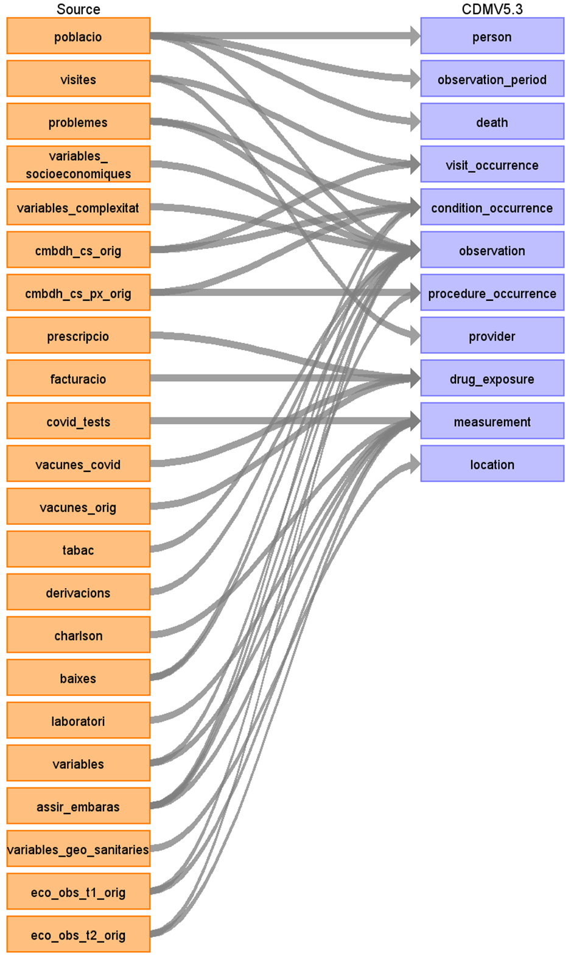

Supplementary Figure 2. Extract, transform, and load (ETL) framework
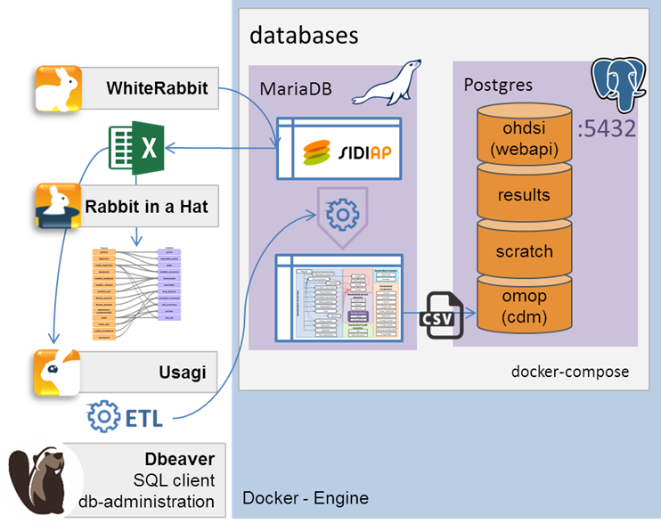

Supplementary Figure 3. Symptoms recorded at time of outpatient COVID-19 diagnosis or positive test, stratified by age group
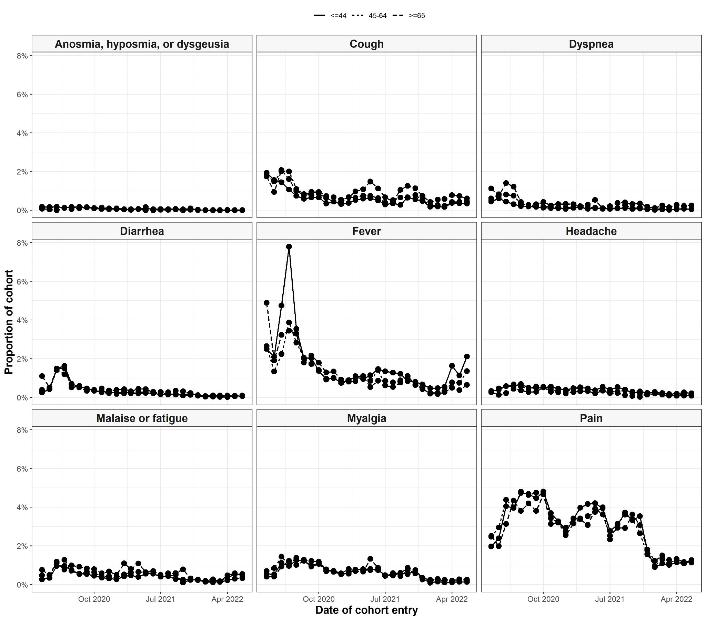

Supplementary Figure 4. Symptoms recorded at time of outpatient COVID-19 diagnosis or positive test, stratified by sex

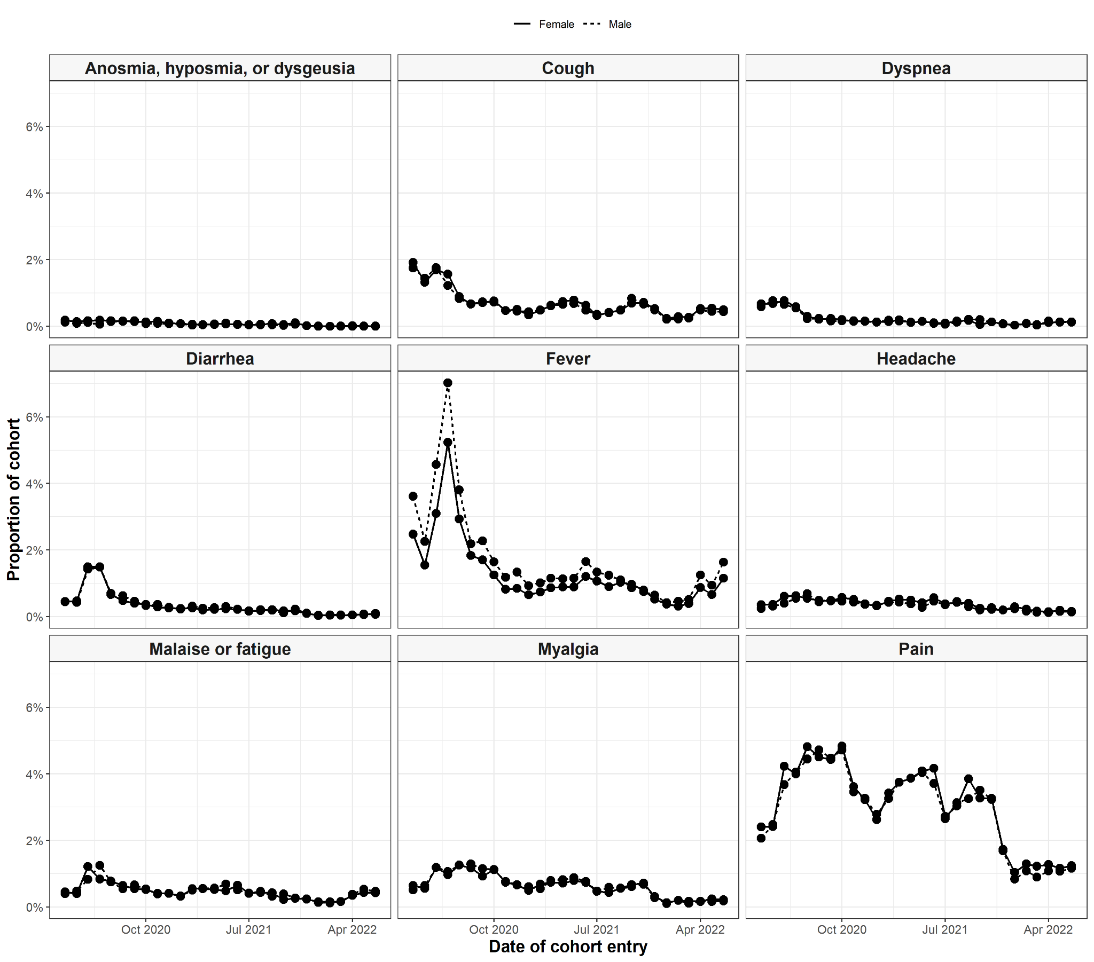

Supplementary Figure 5. COVID-19 vaccination cohort entry over calendar time, stratified by age group
