Supplementary appendix
Supplementary Table 1 Prednisone equivalent dosing conversion chart for OCS
Drug | Equivalent dosage (mg)
Betamethasone | 0.6
Budesonide | 0.375
Cortisone | 25
Dexamethasone | 0.75
Hydrocortisone | 20
Methylprednisone | 4
Prednisolone | 5
Prednisone | No conversion needed
Triamcinolone | 4
Fludrocortisone | N/A. Fludrocortisone is used for its mineralocorticoid activity (causing  increased reabsorption of sodium and loss of potassium/hydrogen).  Although fludrocortisone technically possesses a small degree of anti-inflammatory activity (1/10th that of hydrocortisone), this effect is  negligible at normal therapeutic doses of fludrocortisone (such as 0.05  to 0.2 mg per day). For this reason, fludrocortisone cannot realistically  be converted to another corticosteroid on the basis of anti-inflammatory potency.

Abbreviations: N/A, not applicable; OCS, oral corticosteroids.
Supplementary Table 2 Study sample selection
 | All patients
 | N | %
Patients in the IBM MarketScan® Commercial or Medicare Supplemental databases with ≥1 non-ruleout inpatient claim with a diagnosis of COPD in the primary position or ≥2 non-ruleout outpatient claims with a diagnosis of COPD with different service dates in any position between 1 November 2017 and 31 December 2018 | 249,908 | 100.0
Were ≥40 years of age on the COPD diagnosis date | 227,380 | 91.0
Had at least 12 months of continuous enrollment with medical and pharmacy benefits prior to the COPD diagnosis date | 173,350 | 69.4
Had at least 12 months of continuous enrollment with medical and pharmacy benefits after the COPD diagnosis date | 120,415 | 48.2
≥1 pharmacy claim for FF/UMEC/VI following the date of first COPD diagnosis | 3439 | 1.4
≥12 months of continuous enrollment prior to the index date  (pre-index period) | 3439 | 1.4
≥12 months of continuous enrollment following the index date  (post-index period) | 2925 | 1.2
≥1 OCS pharmacy claim in the 12 months prior to the index date | 2013 | 0.8
Final study population | 2013

Abbreviations: COPD, chronic obstructive pulmonary disease; FF/UMEC/VI, fluticasone furoate/umeclidinium/vilanterol; OCS, oral corticosteroids.
Supplementary Figure 1 Study design.
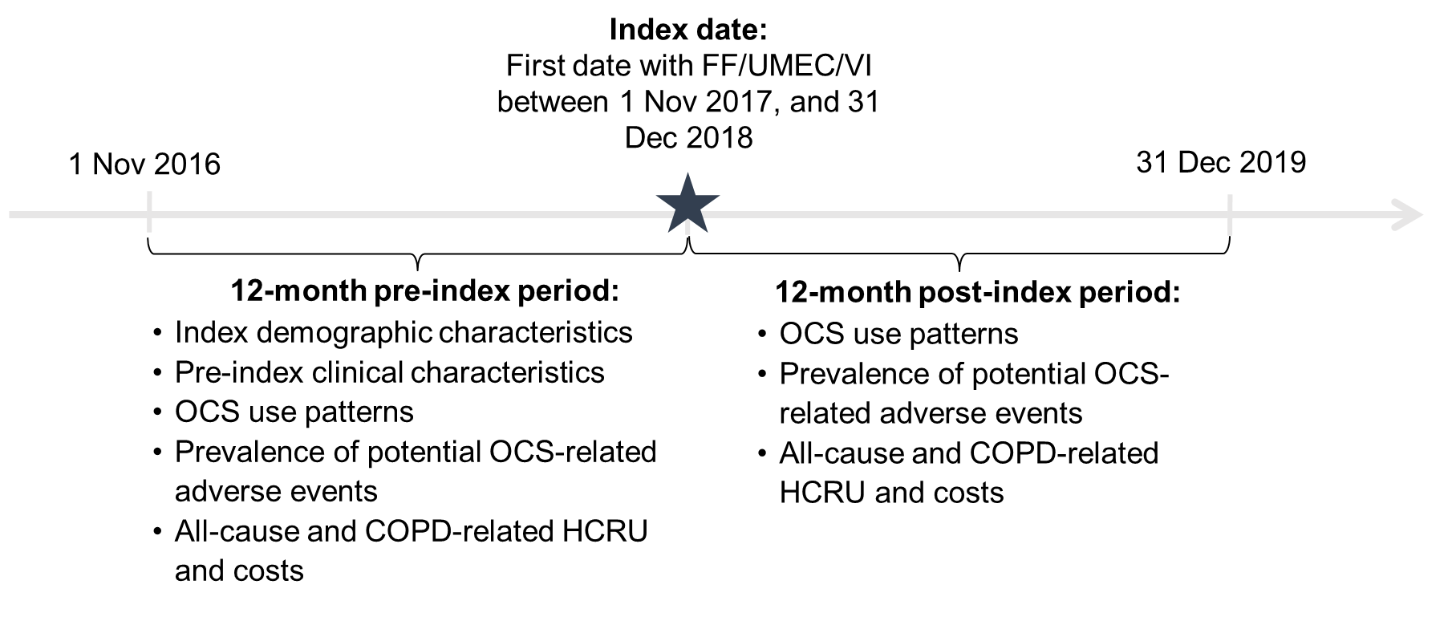
Abbreviations: COPD, chronic obstructive pulmonary disease; FF/UMEC/VI, fluticasone furoate/umeclidinium/vilanterol; HCRU, healthcare resource utilization; OCS, oral corticosteroids.
Supplementary Figure 2 Sensitivity analyses for potential OCS-related adverse events
A Patients with no OCS during follow-up.

B Patients with a reduction in OCS dose during follow-up.

Notes: *p < 0.05, comparing pre- and post-index periods.
C Patients with no reduction in OCS dose during follow-up.

Notes: *p < 0.001, comparing pre- and post-index periods.
Abbreviations: OCS, oral corticosteroids.

