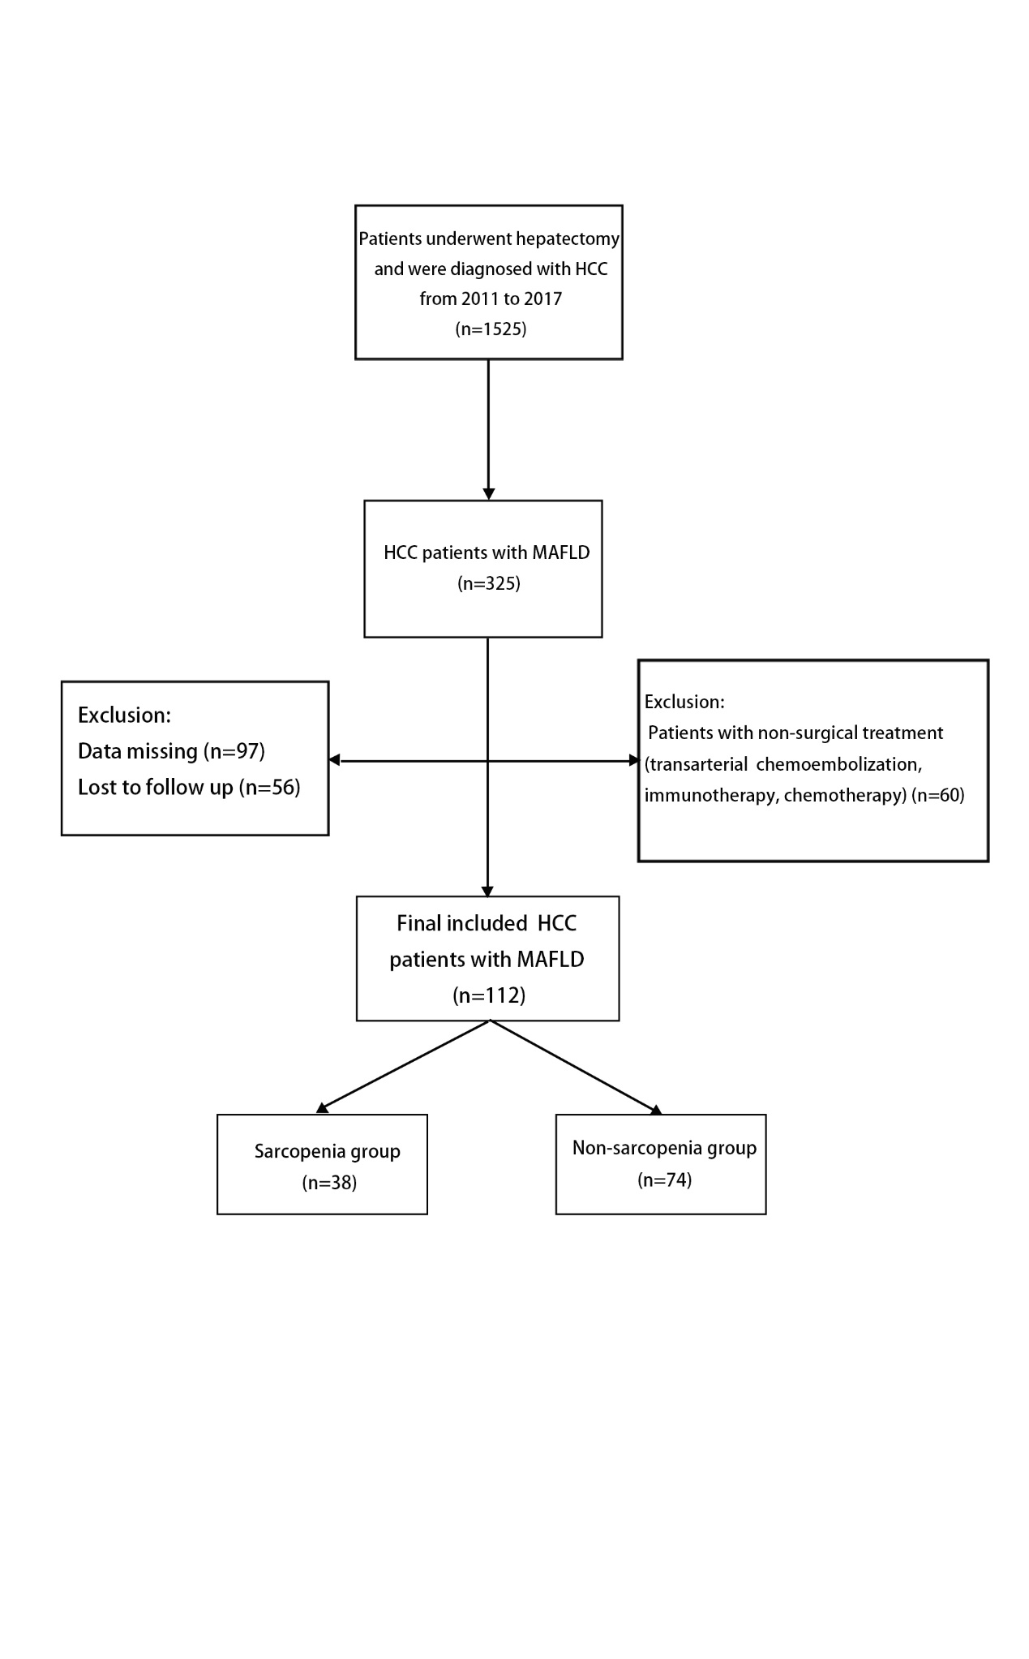
Figure S1 Patient selection flow diagram.
Figure S2 RFS (E) and OS (F) in MAFLD-HCC patients for subgroup analysis: the lean/normal weight group (BMI＜23 kg/m2) and the overweight group(BMI ≥23 kg/m²).
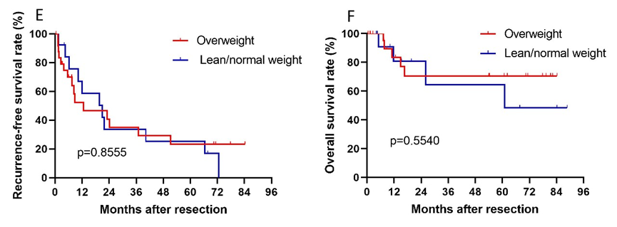

Figure S3 RFS (G) and OS (H) in MAFLD-HCC patients for subgroup analysis with or without T2D.
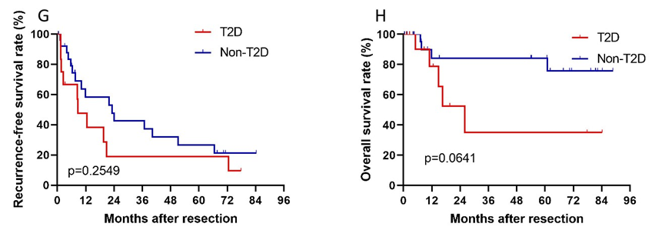

Figure S4 RFS (I) and OS (J) in MAFLD-HCC patients with HBV infection for subgroup analysis.
