Asthma symptom control
In the last 4 weeks, has the patient had: | Well controled | Partly controlled | Uncontrolled
Asthma symptoms in daytime, more than twice a week? | None of these | 1-2 of these | 3-4 of these
Any night waking due to asthma? | None of these | 1-2 of these | 3-4 of these
Reliever needed more than twice a week? | None of these | 1-2 of these | 3-4 of these
Any activity limitation due to asthma? | None of these | 1-2 of these | 3-4 of these
Supplementary table 1. GINA 2014 assessment of asthma control in adults, adolescents, and children 6-11 years old.

Supplementary Table 2. Inhaled corticosteroids daily doses in adults according to GINA guidelines 2014.

GINA 2014
Drug | Daily dose (mcg)
 | Low | Medium | High
Beclometasone dipropionate (CFC) | 200-500 | >500-1000 | >1000
Beclometasone dipropionate (HFA) | 100-200 | >200-400 | >400
Budesonide (DPI) | 200-400 | >400-800 | >800
Ciclesonide (HFA) | 80-160 | >160-320 | >320
Fluticasone propionate (DPI) | 100-250 | >250-500 | >500
Fluticasone propionate (HFA) | 100-250 | >250-500 | >500
Mometasone furoate | 110-220 | >220-440 | >440
Triamcinolone acetonide | 400-1000 | >1000-2000 | >2000
HFA – hydrofluoroalkane propellant; pMDI – pressurized metered-dose inhaler.

Supplementary table 3. Logistic regression in Asthma group
Variable* | Time | Sig. | Exp(B) | 95% C.I. EXP(B)
 |  |  |  | Low | Upper
High dose of ICS | t0 | 0.279 | 0.362 | 0.057 | 2.281
Short term of OCS | t0 | 0.284 | 0.423 | 0.088 | 2.039
LTRA use | t0 | 1.000 | 3521.000 | 0.000 | 0.000
High dose of ICS | t1 | 0.221 | 2.251 | 0.614 | 8.256
Short term of OCS | t1 | 0.483 | 0.446 | 0.047 | 4.270
LTRA use | t1 | 0.454 | 2.217 | 0.276 | 17.803
High dose of ICS | t2 | 0.831 | 0.883 | 0.283 | 2.760
Short term of OCS | t2 | 0.077 | 0.234 | 0.047 | 1.168
LTRA use | t2 | 0.999 | 0.000 | 0.000 | 0.000
High dose of ICS | t3 | 0.612 | 0.731 | 0.217 | 2.458
Short term of OCS | t3 | 0.180 | 0.200 | 0.019 | 2.101
LTRA use | t3 | 0.251 | 3.952 | 0.378 | 41.364
*Results adjusted by gender.
ICS- Inhaled corticosteroids; OCS- Oral Corticosteroid; LTRA- LTRA, leukotriene receptor antagonists

Name
File ID
Date of Birth Telephone number
Gender
File analysis date
 | Baseline | 12 months | 24 months | 36 months
Age
Variable
FVC L
FVC %
FEV₁ L
FEV₁ %
FVC/FEV₁ %
Reversibility test %
Obstruction
Eosinophils (#)
IgE (ku/L)
Oral corticosteroid for 6 months 1= Yes, 0= No
Steroid cycle 1= Yes, 0= No
How many cycles are used by year?
Use of Antileukotrienes? 1= Yes, 0= No
Use of SABA? (Rescue)
1= Yes, 0= No
Annotations

Supplementary Figure 1. Case report format
Abbreviations: ID, identification; FVC, forced vital capacity; FEV₁, forced expiratory volume in the first second; IgE, immunoglobulin E; SABA, short-acting beta₂-agonist.

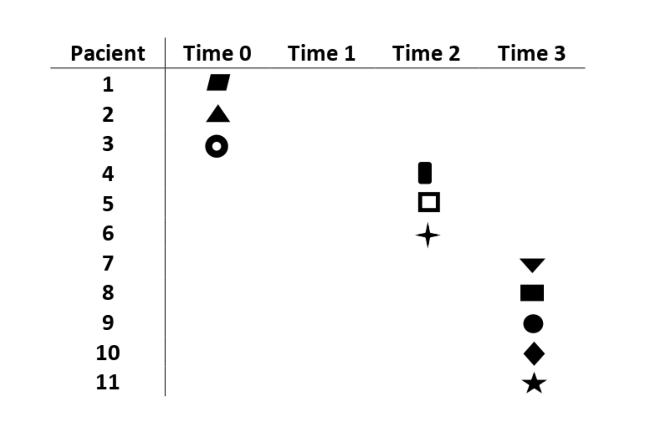 Supplementary Figure 2. Asthma patients with STEP-4.

