Appendix 1. Questionnaire on hand eczema used in the study
- Have you ever heard of hand eczema? Yes No
- Do you know what hand eczema is? Yes No
- Do you use hand creams regularly? Yes No
If yes, how frequently:
- once daily
- several times a day
- once a week
- several times a week
- What are the preventing procedures of the disease (hand eczema) shown on the photograph? (multiple answers allowed)
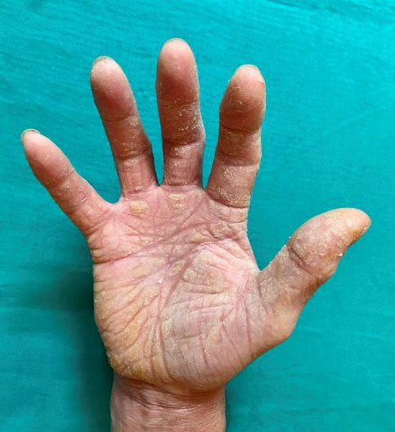
- frequent hand washing
- avoidance of allergic substances/allergens
- avoidance of irritating substances
- sun exposure
- avoidance of sun exposure
- usage of hand creams
- none of above

