Supplementary Tables and figures

Table S1 Key studies used to initiate pearl-growing
Title | Author(s) | Year published | Study type | DOI
Eosinophilic and Noneosinophilic Asthma  An Expert Consensus Framework to Characterize Phenotypes in a Global Real-Life Severe Asthma Cohort¹⁵ | Heaney et al. | 2021 | Real-world evidence | 10.1016/j.chest.2021.04.013
Prevalence and characterization of severe asthma in Hungary¹⁶ | Csoma et al. | 2020 | Real-world evidence | 10.1038/s41598-020-66445-4
Challenges faced in managing adult asthma: A perspective from Asian countries¹⁷ | Dhar et al. | 2020 | Review | 10.1111/resp.13935
Asthma inflammatory phenotypes on four continents: most asthma cases are non-eosinophilic¹⁸ | Pembrey et al. | 2020 | Real-world evidence | 10.1093/ije/dyac173
In-Depth Review of Allergic Rhinitis¹⁹ | Sullivan et al. | 2020 | Review | Not available
The characterization of asthma with blood eosinophilia in adults in Latin America²⁰ | Bedolla-Barajas et al. | 2019 | Real-world evidence | 10.1080/02770903.2018.1520863
National and regional asthma programmes in Europe²¹ | Selroos et al. | 2015 | Review | 10.1183/16000617.00008114
An estimate of asthma prevalence in Africa: a systematic analysis²² | Adeloye et al. | 2013 | Review | 10.3325/cmj.2013.54.519
Nasal polyposis in patients with asthma and allergic rhinitis²³ | Ahmadiafshar et al. | 2012 | Real-world evidence | 10.1017/S0022215112000771

Figure S1 Methodology for determining the prevalence of key clinical subgroups with asthma (those with EA, SA, NR, and NPs)
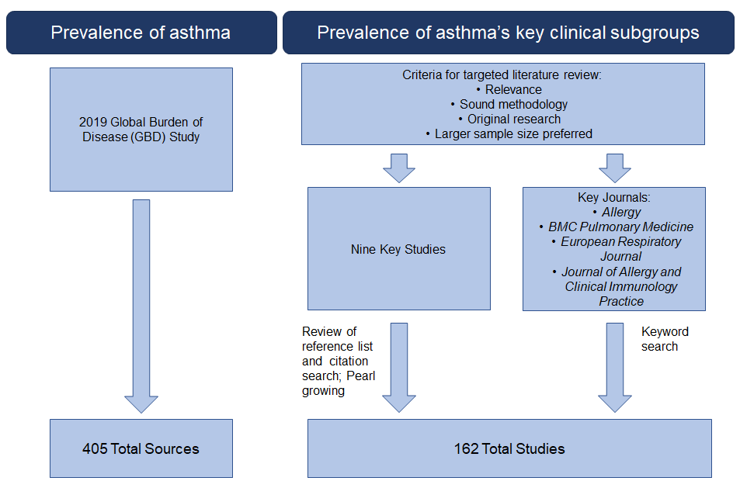
To determine the prevalence of asthma’s key clinical subgroups, a pearl-growing method was used alongside keyword searches of relevant journals. The pearl-growing process was initiated using 9 key studies (Table S1), while the key journals of Allergy, BMC Pulmonary Medicine, the European Respiratory Journal, and the Journal of Allergy and Clinical Immunology Practice were used for keyword searches. A total of 162 studies were included.

Figure S2 The global prevalence of AR within asthma.
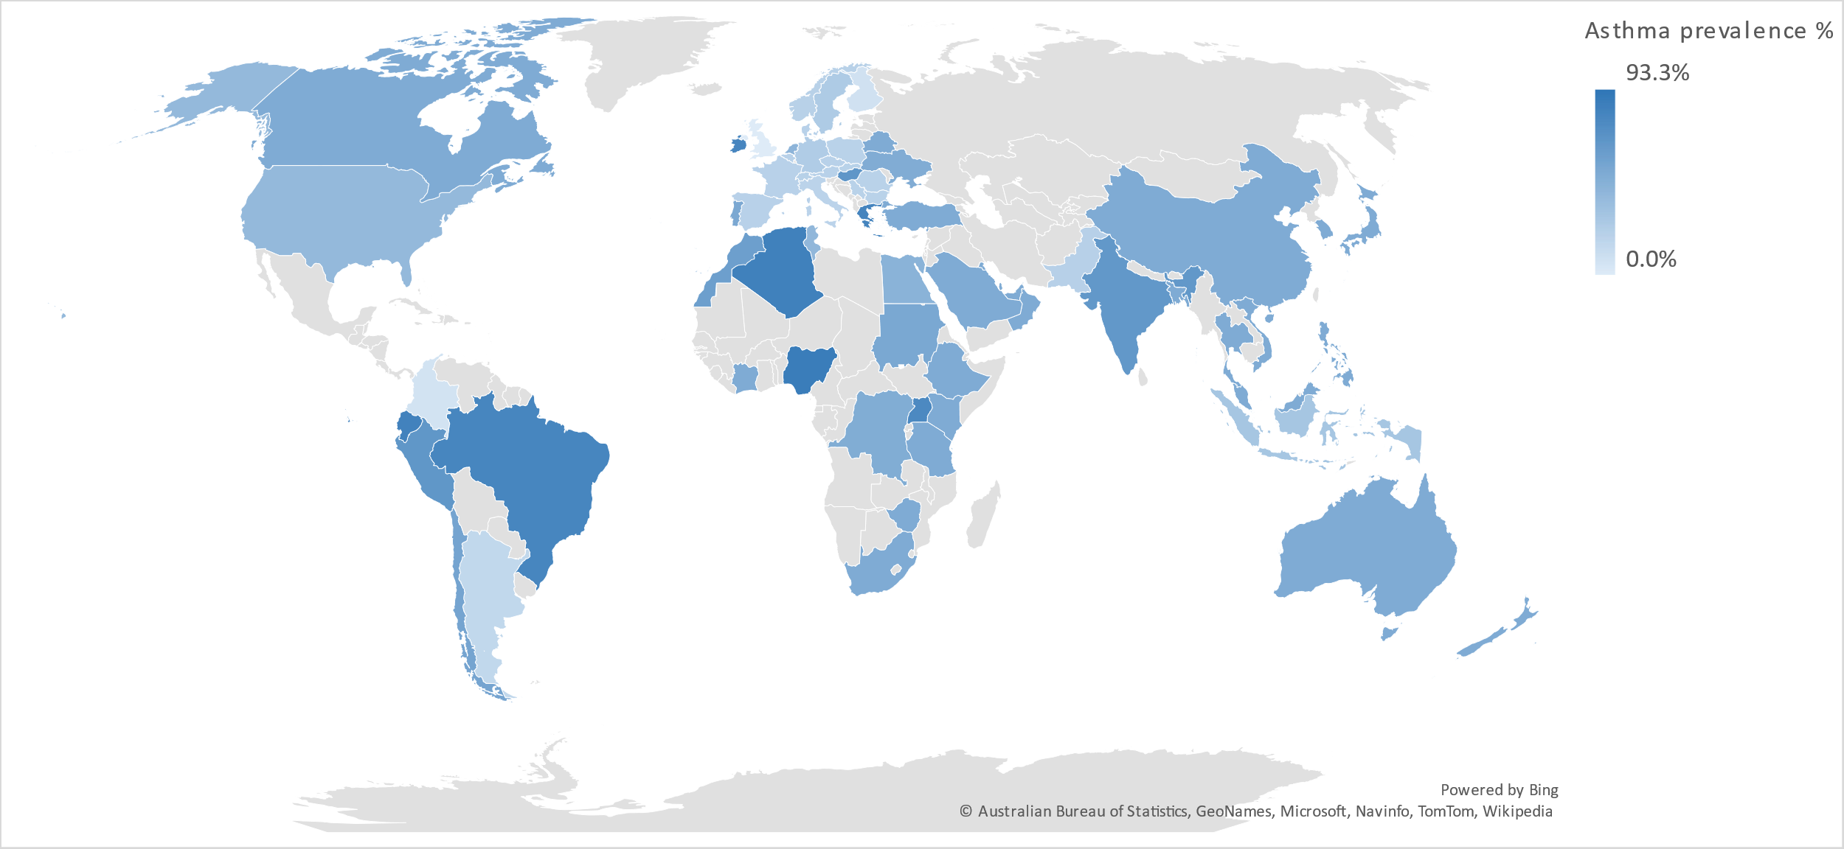
Figure S3 The global prevalence of EA within asthma.
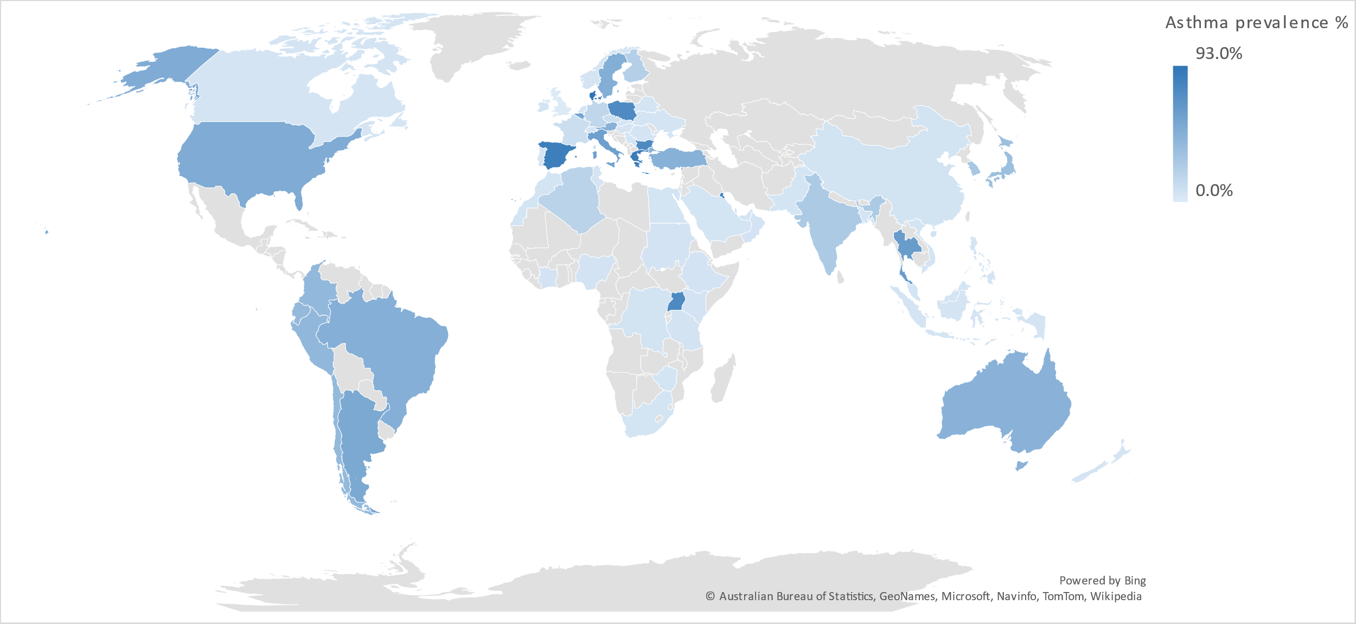
Figure S4 The global prevalence of SA within asthma.
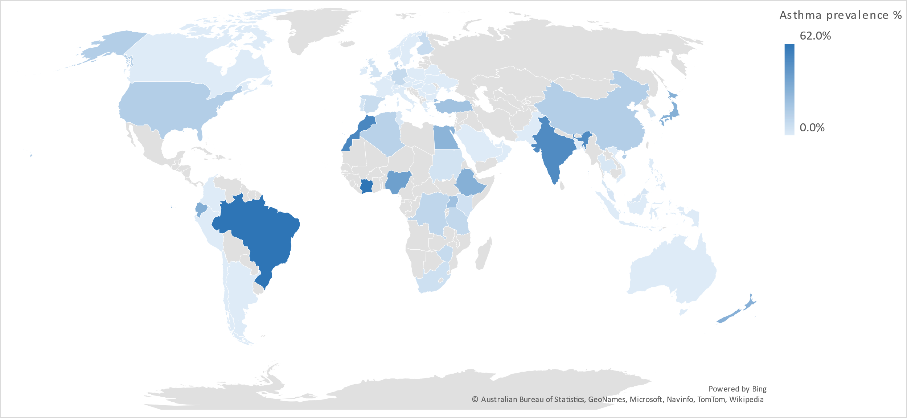
Figure S5 The global prevalence of NPs within asthma.
