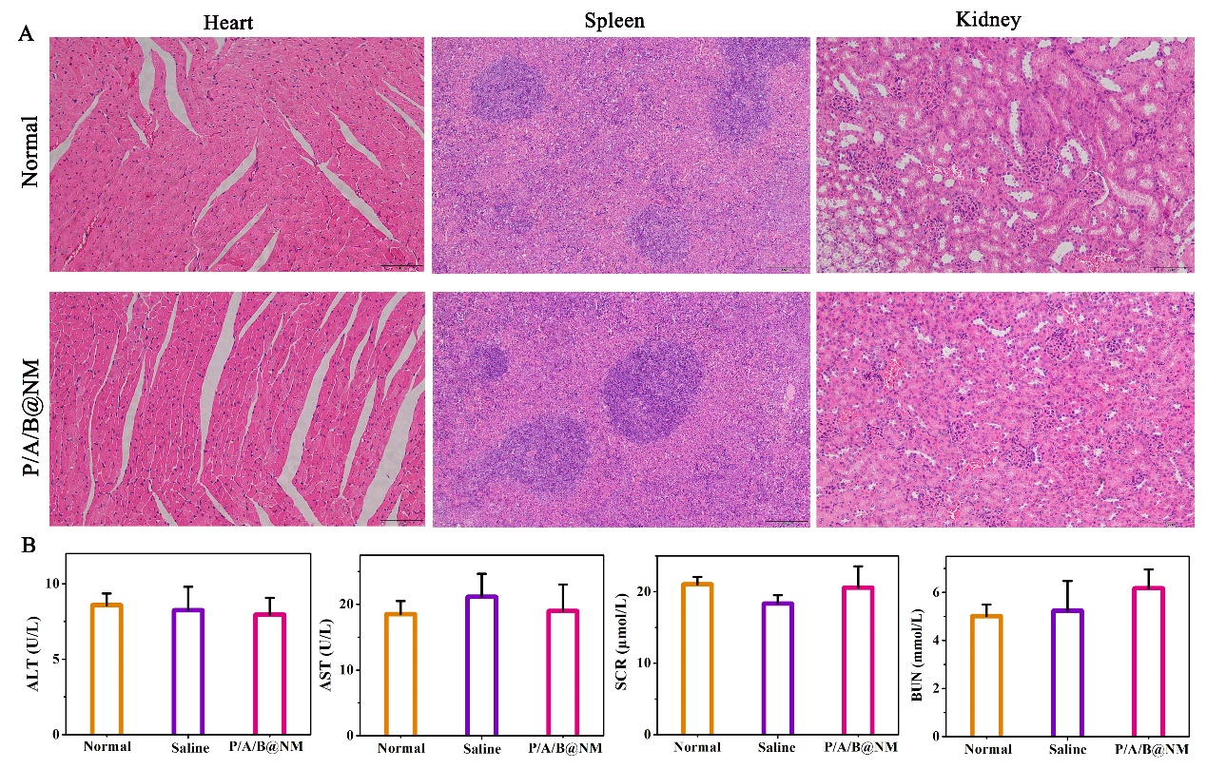
Figure S1 Therapeutic safety assessment of co-delivery nanomicelles based combination therapy. (A) Histological analysis of heart, spleen and kidney after P/A/B@NM treatment. (B) Serum biochemical assay result showing indicators of liver and kidney function (n=3). Error bars represent means ± SEM.

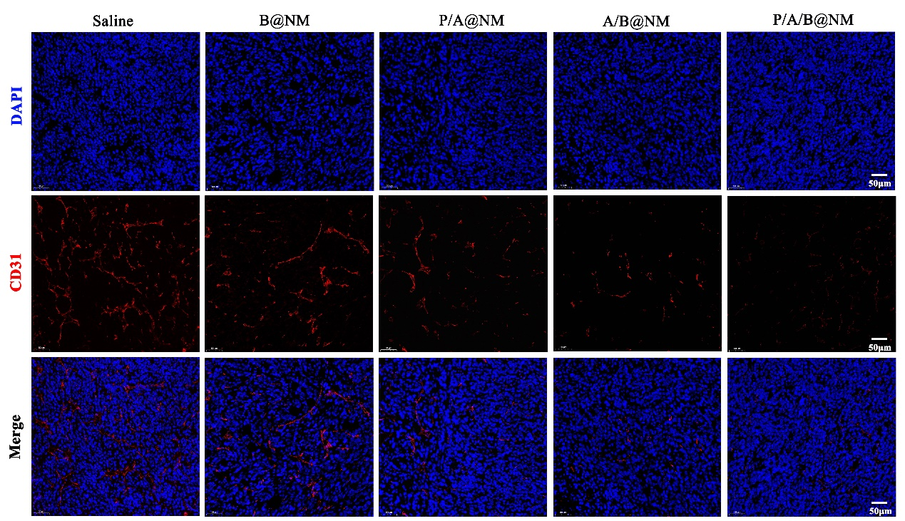
Figure S2 Co-delivery nanomicelles based combination therapy reduced angiogenesis.

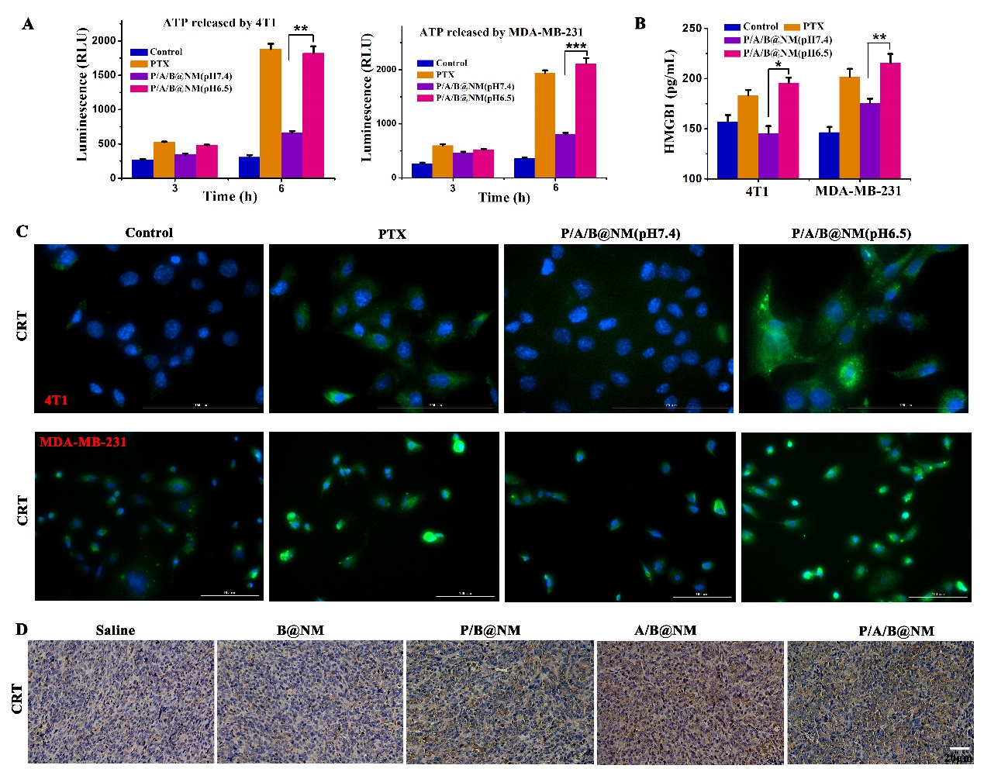
Figure S3 Co-delivery nanomicelles based combination therapy induced ICD. (A and B) P/A/B@NM promoted the release of ATP and HMGB1 in 4T1 and MDA-MB-231 cells (n=3). (C) Representative images of CRT expression in 4T1 and MDA-MB-231 cells using IF assay after P/A/B@NM treatment. (D) Representative images of CRT expression in tumor tissues using IHC assay after co-delivery nanomicelles based combination therapy. Error bars represent means ± SEM. **P < 0.01, ***P < 0.001.

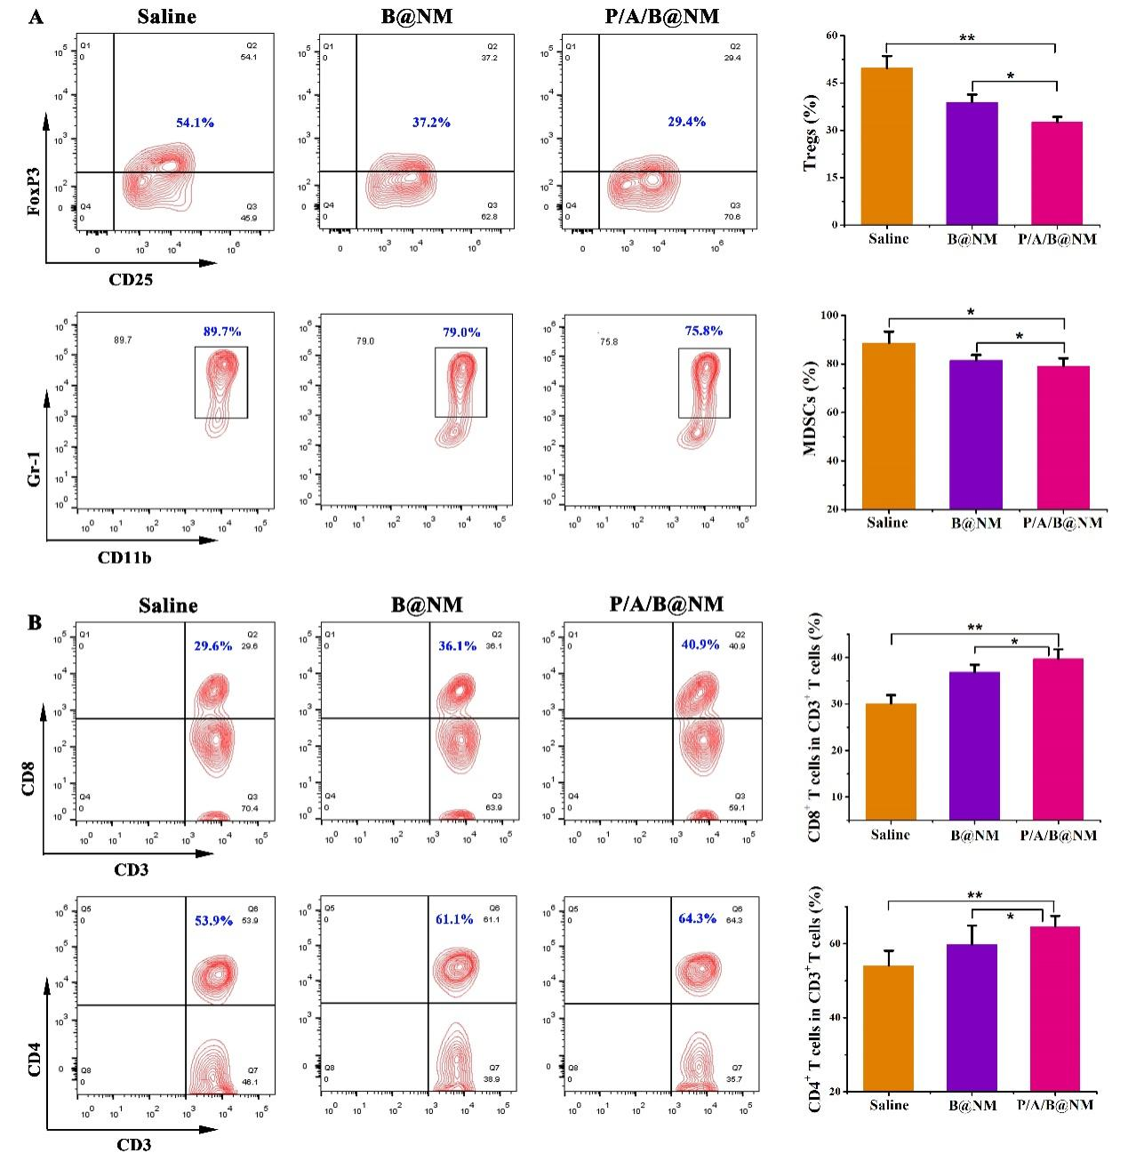
Figure S4 Co-delivery nanomicelles based combination therapy improved systemic immunity in spleen. (A) Representative cytometric dot plots of CD3⁺CD8⁺ T cells and CD3⁺CD4⁺ T cells in spleens (left) and the proportions of CD3⁺CD8⁺ T cells and CD3⁺CD4⁺ T cells in spleens in different treatment groups (right) (n=3). (B) Representative cytometric dot plots of Tregs cells and MDSCs in spleens (left) and percentage of Tregs cells and MDSCs of spleens in different treatment groups (right) (n=3). Error bars represent means ± SEM. *P < 0.05, **P < 0.01.

