Supplementary materials
Supplementary Table 1. Antibodies used in this study.
Antigens | Manufacturers | Application
GAPDH | KC-5G4, Kang Chen Bio-tech, Shanghai, China | 1:10000 for WB
anti-rabbit IgG HRP conjugated | Jackson Immuno Research Laboratories, Inc. West Grove, PA, USA | 1:5000 for WB
anti- mouse IgG HRP conjugated | Jackson Immuno Research Laboratories, Inc. West Grove, PA, USA | 1:5000 for WB
TRIM55 | HPA053691, ATLAS, Sweden  NBP2-33691, NOVUS, Colorado, USA | 1:1000 for WB; 1:300 for IHC;  1:50 for IF
TRIP6 | ab70747, abcam, Cambridge, MA, USA  Ab137478, abcam, Cambridge, MA, USA | 1:1000 for WB;  1:300 for IHC  1:100 for IP
HA | #3724, Cell Signaling Technology, Beverly, MA, USA | 1:2000 for WB; 1:800 for IF; 1:500 for IP
FLAG | F1804, Sigma-Aldrich, St. Louis, MO, USA | 1:2000 for WB; 1:500 for IP
MYC-Tag | #2276, Cell Signaling Technology, Beverly, MA, USA | 1:2000 for WB; 1:500 for IP
β-catenin | #8480, Cell Signaling Technology, Beverly, MA, USA | 1:1000 for WB
Cyclin D1 | #2978, Cell Signaling Technology, Beverly, MA, USA | 1:1000 for WB
Ki-67 | #9027, Cell Signaling Technology, Beverly, MA, USA | 1:300 for IHC
Abbreviations: IHC, immunohistochemistry; IF, immunofluorescence; WB, Western Blot; IP, immunoprecipitation; # indicates the item number.

Supplementary Table 2 Correlation of the clinicopathological characteristics with TRIM55 expression in HCC.
Features |  | expression
Features | N | Low | High | P Value
Gender
Male | 97 | 37 | 60 | 0.289
Female | 13 | 3 | 10 | 0.289
Age (years)
≤50 | 56 | 25 | 31 | 0.066
>50 | 54 | 15 | 39 | 0.066
AFP (ng/ml) |  |  |  | 0.043
≤20 | 32 | 7 | 25
>20 | 78 | 33 | 45
ALT (u/L) |  |  |  | 0.259
≤70 | 100 | 38 | 62
>70 | 10 | 2 | 8
AST (u/L) |  |  |  | 0.793
≤70 | 95 | 35 | 60
>70 | 15 | 5 | 10
Cirrhosis |  |  |  | 0.753
NO | 15 | 6 | 9
YES | 95 | 34 | 61
Tumor size (cm) |  |  |  | 0.039
≤5 | 50 | 13 | 37
>5 | 60 | 27 | 33
Tumor number |  |  |  | 0.322
Single | 88 | 34 | 54
Multiple | 22 | 6 | 16
TNM clinical stage |  |  |  | 0.302
I-II | 78 | 26 | 52
III-IV | 32 | 14 | 18
BCLC stage |  |  |  | 0.686
0+A | 66 | 23 | 43
B+C | 44 | 17 | 27
Abbreviations: N: number; AFP, Alpha-fetoprotein; ALT, alanine aminotransferase;
AST, aspartate aminotransferase; TNM, tumor node metastasis; BCLC, Barcelona
Clinic Liver Cancer; Bold text represents P-values with significant difference.

Supplementary Table 3 Proteins bind with TRIM55 identified by IP-MS in HEK293T cells.
Accession | Gene names | MW [kDa] | Protein score | Sequence coverage (%) | Unique Peptides | Peptides | PSMs
Q9BYV6 | TRIM55 | 60.43 | 13589.40 | 59.49 | 32 | 32 | 351
P17066 | HSPA6 | 70.98 | 788.42 | 26.91 | 5 | 14 | 19
P05023 | ATP1A1 | 112.82 | 743.30 | 19.65 | 17 | 17 | 19
P68032 | ACTC1 | 41.99 | 698.36 | 27.06 | 1 | 9 | 22
P61204 | ARF3 | 20.59 | 443.29 | 49.17 | 5 | 8 | 11
Q9Y277 | VDAC3 | 30.64 | 439.25 | 38.87 | 8 | 8 | 10
P18085 | ARF4 | 20.50 | 326.68 | 38.89 | 4 | 7 | 9
P25398 | RPS12 | 14.51 | 239.41 | 30.30 | 3 | 3 | 6
P16615 | ATP2A2 | 114.68 | 218.35 | 7.87 | 7 | 7 | 7
Q07065 | CKAP4 | 65.98 | 216.93 | 8.97 | 3 | 3 | 3
P62244 | RPS15A | 14.83 | 215.67 | 36.15 | 5 | 5 | 6
P12236 | SLC25A6 | 32.85 | 214.49 | 19.46 | 2 | 6 | 7
P02538 | KRT6A | 60.01 | 201.19 | 7.45 | 2 | 5 | 6
P25705 | ATP5F1A | 59.71 | 198.89 | 10.67 | 6 | 6 | 6
P14618 | PKM | 57.90 | 168.74 | 10.73 | 3 | 3 | 3
Q15758 | SLC1A5 | 56.56 | 165.80 | 6.65 | 3 | 3 | 3
P40616 | ARL1 | 20.40 | 119.53 | 20.99 | 3 | 3 | 3
Q06830 | PRDX1 | 22.10 | 118.71 | 13.57 | 2 | 3 | 3
O95573 | ACSL3 | 80.37 | 116.19 | 5.14 | 3 | 3 | 3
P46977 | STT3A | 80.48 | 113.05 | 3.83 | 3 | 3 | 3
P10809 | HSPD1 | 61.02 | 112.47 | 8.03 | 4 | 4 | 4
P54886 | ALDH18A1 | 87.25 | 110.04 | 3.40 | 3 | 3 | 3
O00148 | DDX39A | 49.10 | 106.11 | 7.96 | 3 | 3 | 3
Q14739 | LBR | 70.66 | 103.81 | 4.39 | 2 | 2 | 2
Q15654 | TRIP6 | 50.26 | 102.72 | 6.93 | 2 | 2 | 2
P49368 | CCT3 | 60.50 | 95.65 | 6.42 | 3 | 3 | 3
Q9NZ01 | TECR | 36.01 | 95.23 | 9.09 | 3 | 3 | 3
P35637 | FUS | 53.39 | 95.21 | 4.37 | 2 | 2 | 2
P28066 | PSMA5 | 26.39 | 94.78 | 7.88 | 1 | 1 | 1
P62829 | RPL23 | 14.86 | 93.32 | 16.43 | 2 | 2 | 4
Q9P035 | HACD3 | 43.13 | 92.04 | 9.67 | 2 | 2 | 2
Q9Y295 | DRG1 | 40.52 | 91.90 | 6.81 | 2 | 2 | 2
P41252 | IARS1 | 144.41 | 91.19 | 2.30 | 3 | 3 | 3
Q8TCT9 | HM13 | 41.46 | 90.35 | 5.84 | 2 | 2 | 2
P26639 | TARS1 | 83.38 | 87.78 | 3.04 | 2 | 2 | 2
P00338 | LDHA | 36.67 | 87.70 | 9.04 | 2 | 3 | 3
Q9Y5M8 | SRPRB | 29.68 | 87.02 | 10.70 | 2 | 2 | 2
P31689 | DNAJA1 | 44.84 | 86.60 | 4.79 | 2 | 2 | 2
P17987 | TCP1 | 60.31 | 85.12 | 5.94 | 3 | 3 | 3
Q07020 | RPL18 | 21.62 | 83.10 | 6.91 | 1 | 1 | 1
P42677 | RPS27 | 9.45 | 81.98 | 29.76 | 1 | 2 | 2
P53985 | SLC16A1 | 53.91 | 81.38 | 5.80 | 2 | 2 | 2
P07195 | LDHB | 36.62 | 81.12 | 6.29 | 1 | 2 | 2
Q16531 | DDB1 | 126.89 | 80.22 | 2.11 | 3 | 3 | 3
P06733 | ENO1 | 47.14 | 76.51 | 4.15 | 2 | 2 | 2
P48444 | ARCN1 | 57.17 | 75.46 | 3.72 | 2 | 2 | 2
Q16629 | SRSF7 | 27.35 | 74.24 | 10.92 | 2 | 2 | 2
O95831 | AIFM1 | 66.86 | 73.08 | 3.10 | 2 | 2 | 2
P62330 | ARF6 | 20.07 | 71.46 | 9.71 | 1 | 2 | 2
Q00325 | SLC25A3 | 40.07 | 69.48 | 4.42 | 2 | 2 | 2
P24390 | KDELR1 | 24.53 | 68.35 | 5.19 | 1 | 1 | 2
Q9H361 | PABPC3 | 69.99 | 68.10 | 3.33 | 2 | 2 | 2
P50750 | CDK9 | 42.75 | 68.06 | 3.76 | 2 | 2 | 2
Q8WWF6 | DNAJB3 | 16.55 | 66.93 | 8.97 | 1 | 1 | 1
P52292 | KPNA2 | 57.83 | 65.13 | 2.84 | 1 | 1 | 1
A0A075B6R9 | IGKV2D-24 | 13.07 | 64.86 | 13.33 | 1 | 2 | 2
Q71UM5 | RPS27L | 9.47 | 64.65 | 28.57 | 1 | 2 | 2
Q13263 | TRIM28 | 88.49 | 63.79 | 2.16 | 2 | 2 | 2
P04792 | HSPB1 | 22.77 | 63.63 | 4.88 | 1 | 1 | 1
Q96HC4 | PDLIM5 | 63.90 | 63.57 | 1.51 | 1 | 1 | 1
Q15942 | ZYX | 61.24 | 63.05 | 7.69 | 2 | 2 | 2
P62424 | RPL7A | 29.98 | 62.36 | 7.14 | 1 | 2 | 2
P63208 | SKP1 | 18.65 | 62.17 | 7.36 | 1 | 1 | 1
P09543 | CNP | 47.55 | 62.02 | 6.18 | 2 | 2 | 2
Q8N1F7 | NUP93 | 93.43 | 62.00 | 1.47 | 1 | 1 | 1
Q71RC2 | LARP4 | 80.55 | 61.62 | 1.80 | 1 | 1 | 1
P60900 | PSMA6 | 27.38 | 61.61 | 5.28 | 1 | 1 | 1
Q9BVG4 | PBDC1 | 26.04 | 60.24 | 4.29 | 1 | 1 | 1
P18621 | RPL17 | 21.38 | 58.57 | 13.04 | 2 | 2 | 2
Q13765 | NACA | 23.37 | 57.14 | 6.51 | 1 | 1 | 1
P27824 | CANX | 67.53 | 57.10 | 2.70 | 1 | 1 | 1
P36957 | DLST | 48.72 | 56.79 | 1.77 | 1 | 1 | 1
P05388 | RPLP0 | 34.25 | 56.42 | 3.15 | 1 | 1 | 1
Q15366 | PCBP2 | 38.56 | 55.80 | 3.56 | 1 | 1 | 1
P23528 | CFL1 | 18.49 | 55.53 | 12.05 | 1 | 1 | 1
P51571 | SSR4 | 18.99 | 54.68 | 5.78 | 1 | 1 | 1
Q96KK5 | H2AC12 | 13.90 | 54.04 | 14.84 | 1 | 1 | 2
Q9UKT4 | FBXO5 | 50.11 | 53.78 | 1.57 | 1 | 1 | 1
O00767 | SCD | 41.50 | 52.40 | 3.62 | 1 | 1 | 1
Q02978 | SLC25A11 | 34.04 | 52.27 | 5.10 | 1 | 1 | 1
Q8WU68 | U2AF1L4 | 25.73 | 51.77 | 5.45 | 1 | 1 | 1
P47985 | UQCRFS1 | 29.65 | 51.58 | 5.11 | 1 | 1 | 1
P11586 | MTHFD1 | 101.50 | 51.58 | 0.96 | 1 | 1 | 1
P22492 | H1-6 | 22.01 | 51.28 | 5.31 | 1 | 1 | 1
P63173 | RPL38 | 8.21 | 51.00 | 17.14 | 1 | 1 | 1
P61313 | RPL15 | 24.13 | 50.96 | 4.41 | 1 | 1 | 1
P31040 | SDHA | 72.65 | 50.72 | 1.66 | 1 | 1 | 1
Q86V85 | GPR180 | 49.36 | 50.56 | 2.27 | 1 | 1 | 1
P35268 | RPL22 | 14.78 | 48.55 | 8.59 | 1 | 1 | 1
P40227 | CCT6A | 57.99 | 48.39 | 3.01 | 1 | 1 | 1
P12277 | CKB | 42.62 | 47.00 | 4.20 | 1 | 1 | 1
Q9UK99 | FBXO3 | 54.53 | 46.45 | 1.70 | 1 | 1 | 1
P33993 | MCM7 | 81.26 | 46.15 | 1.81 | 1 | 1 | 1
Q9GZT9 | EGLN1 | 45.99 | 45.62 | 1.41 | 1 | 1 | 1
P60842 | EIF4A1 | 46.12 | 45.50 | 2.46 | 1 | 1 | 1
Q6NVV1 | RPL13AP3 | 12.13 | 44.52 | 10.78 | 1 | 1 | 1
Q6NXT2 | H3-5 | 15.20 | 44.21 | 5.19 | 1 | 1 | 1
P25788 | PSMA3 | 28.42 | 44.14 | 4.71 | 1 | 1 | 1
P78371 | CCT2 | 57.45 | 43.95 | 4.11 | 1 | 1 | 1
Q9H9B4 | SFXN1 | 35.60 | 43.21 | 3.11 | 1 | 1 | 1
Q9H3G5 | CPVL | 54.13 | 42.52 | 2.73 | 1 | 1 | 1
P62891 | RPL39 | 6.40 | 42.48 | 19.61 | 1 | 1 | 1
Q7Z418 | KCNK18 | 43.64 | 42.46 | 1.56 | 1 | 1 | 1
P62280 | RPS11 | 18.42 | 42.08 | 6.96 | 1 | 1 | 1
P62937 | PPIA | 18.00 | 41.87 | 5.45 | 1 | 1 | 1
P27708 | CAD | 242.83 | 41.60 | 0.54 | 1 | 1 | 1
P54709 | ATP1B3 | 31.49 | 41.53 | 3.58 | 1 | 1 | 1
P04075 | ALDOA | 39.40 | 41.47 | 1.92 | 1 | 1 | 1
P32969 | RPL9 | 21.85 | 41.13 | 9.90 | 1 | 1 | 1
Q9Y3L5 | RAP2C | 20.73 | 41.10 | 4.92 | 1 | 1 | 1
Q01130 | SRSF2 | 25.46 | 40.20 | 3.62 | 1 | 1 | 1
P00403 | MT-CO2 | 25.55 | 39.69 | 3.08 | 1 | 1 | 1
O15344 | MID1 | 75.20 | 39.69 | 1.95 | 1 | 1 | 1
P20618 | PSMB1 | 26.47 | 39.55 | 5.81 | 1 | 1 | 1
P36542 | ATP5F1C | 32.98 | 39.30 | 3.36 | 1 | 1 | 1
Q16877 | PFKFB4 | 54.01 | 38.90 | 2.13 | 1 | 1 | 1
Q92598 | HSPH1 | 96.80 | 38.43 | 1.17 | 1 | 1 | 1
P61956 | SUMO2 | 10.86 | 38.30 | 12.63 | 1 | 1 | 1
O95816 | BAG2 | 23.76 | 38.29 | 4.27 | 1 | 1 | 1
P57088 | TMEM33 | 27.96 | 38.29 | 4.05 | 1 | 1 | 1
P61247 | RPS3A | 29.93 | 38.05 | 3.03 | 1 | 1 | 1
P35998 | PSMC2 | 48.60 | 38.02 | 3.00 | 1 | 1 | 1
P62899 | RPL31 | 14.45 | 37.88 | 11.20 | 1 | 1 | 1
Q99884 | SLC6A7 | 70.86 | 37.50 | 0.94 | 1 | 1 | 1
P46779 | RPL28 | 15.74 | 37.44 | 8.03 | 1 | 1 | 1
P78527 | PRKDC | 468.79 | 36.60 | 0.17 | 1 | 1 | 1
Q86YZ3 | HRNR | 282.23 | 35.79 | 2.11 | 1 | 1 | 1
Q15555 | MAPRE2 | 37.01 | 35.26 | 2.14 | 1 | 1 | 1
P38935 | IGHMBP2 | 109.08 | 35.23 | 0.60 | 1 | 1 | 1
Q02543 | RPL18A | 20.75 | 34.14 | 5.68 | 1 | 1 | 1

Supplementary Figures
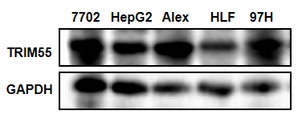
Supplementary Figure 1 TRIM55 expression level in hepatic and HCC cell lines was analyzed by Western blotting.
Abbreviations: TRIM55, Tripartite motif containing 55; HCC, Hepatocellular carcinoma.

HLF HepG2
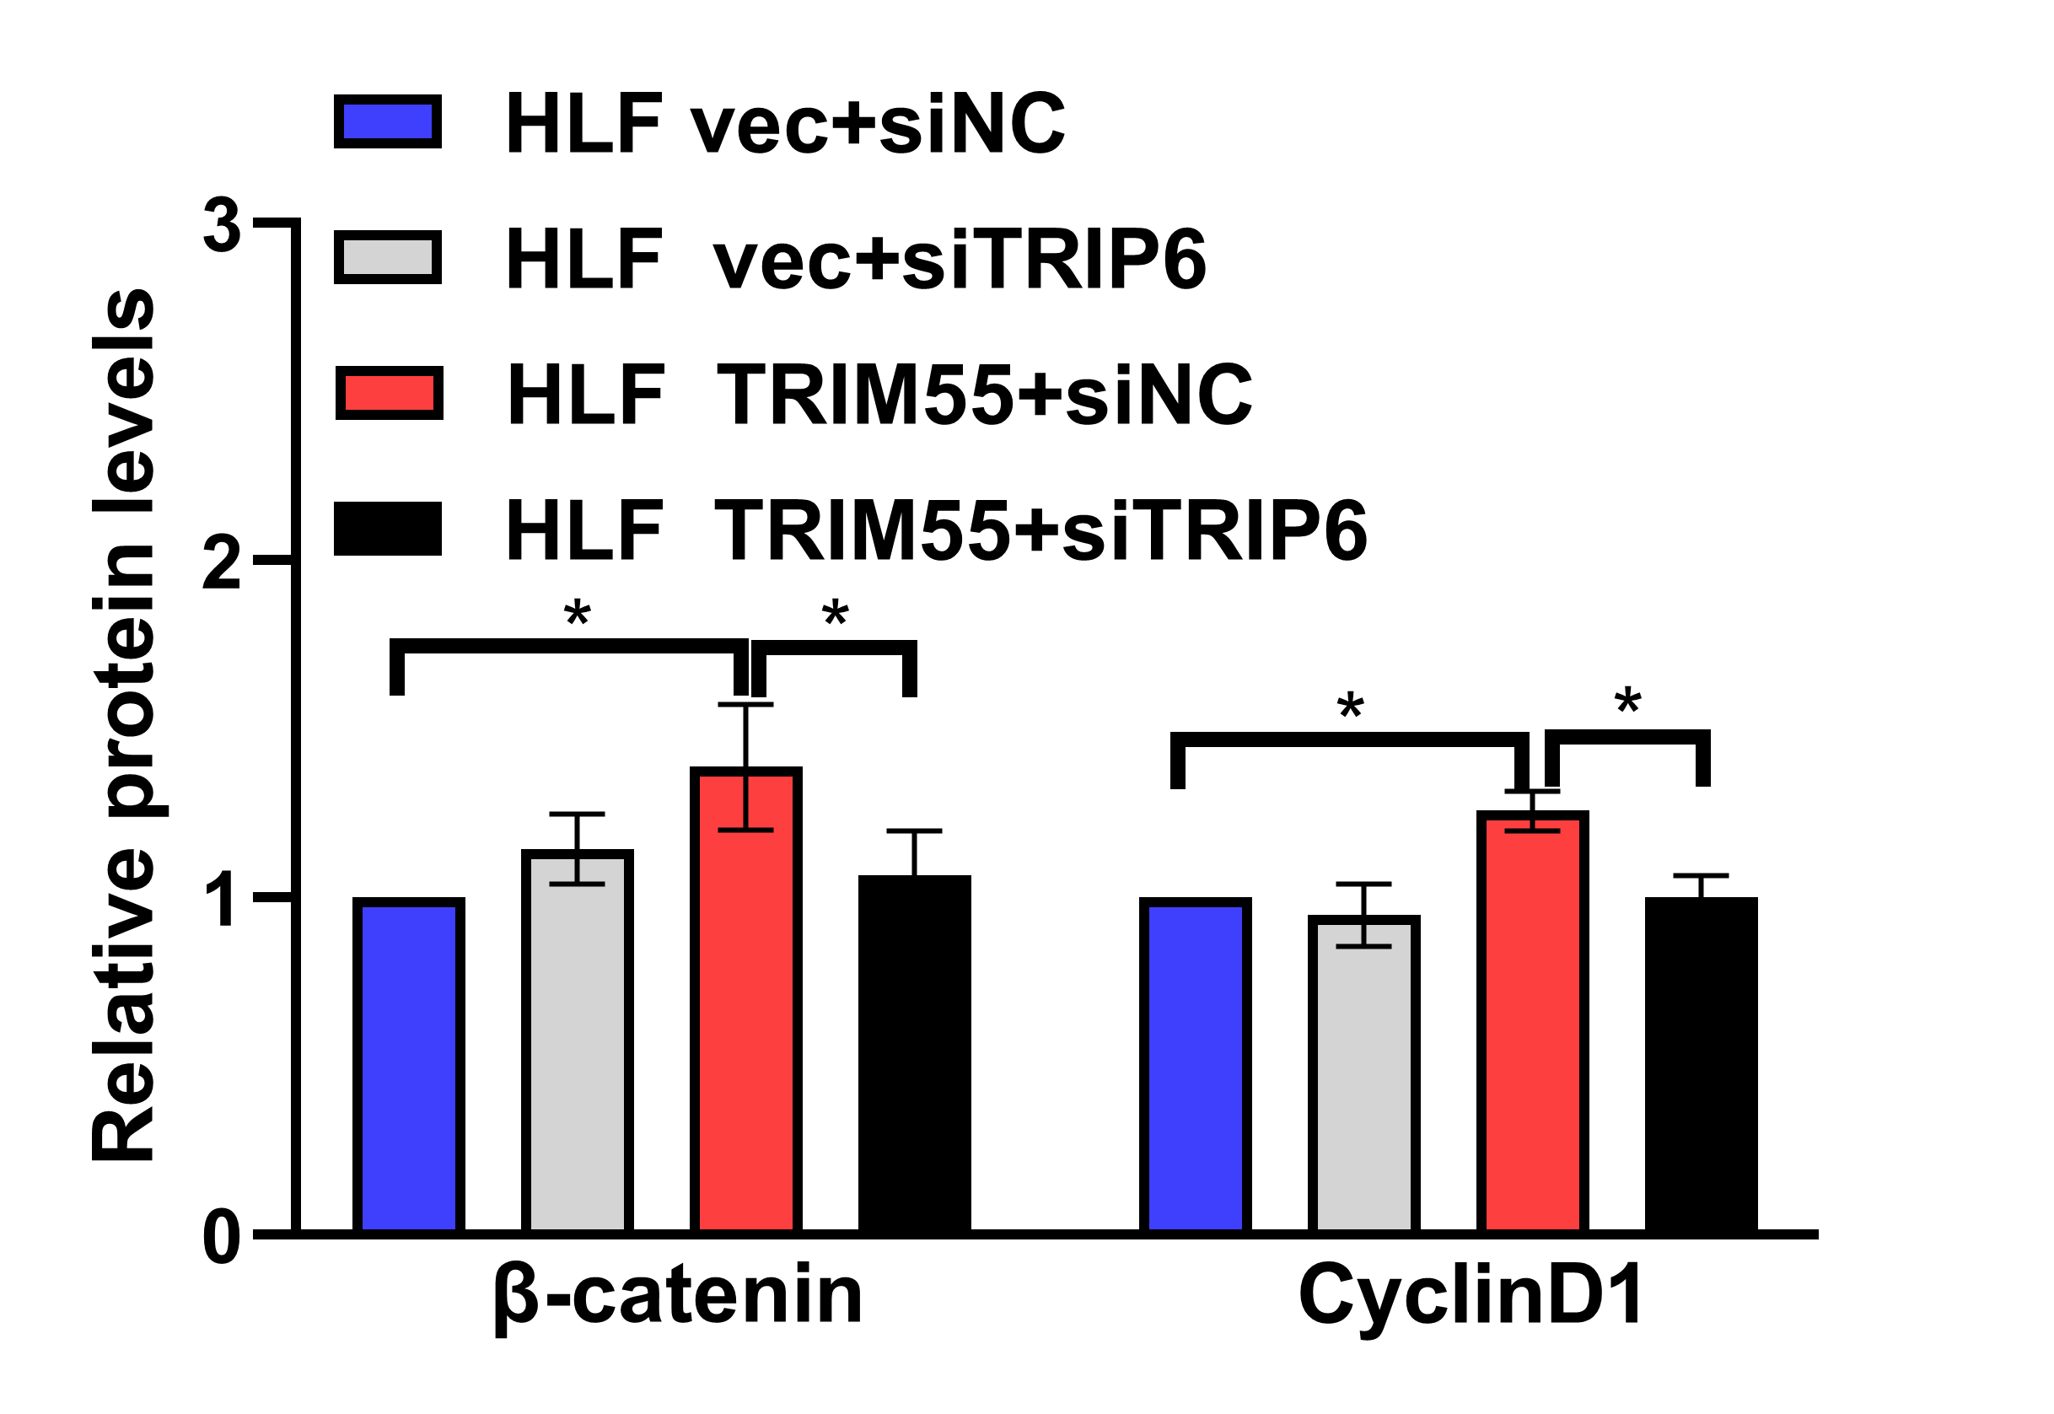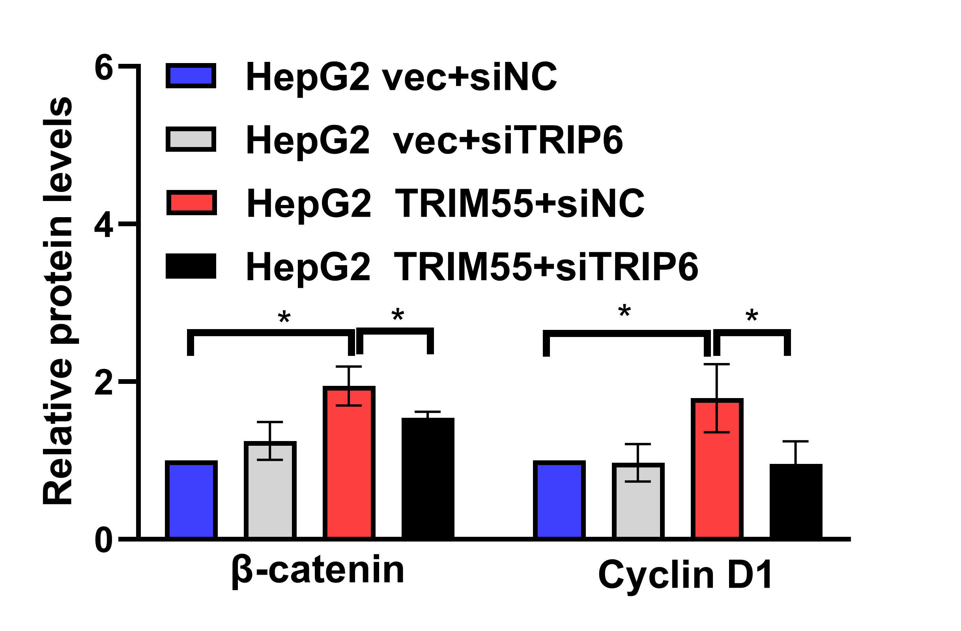
Supplementary Figure 2 Significance analysis of β-Catenin and Cyclin D1 protein levels in HLF and HepG2 cells with TRIM55-overexpression or control cells transiently transfected with siNC, siTRIP6. (*: P < 0.05)
Abbreviations: TRIM55, Tripartite motif containing 55; TRIP6, thyroid receptor interacting protein 6; NC, Negative control.

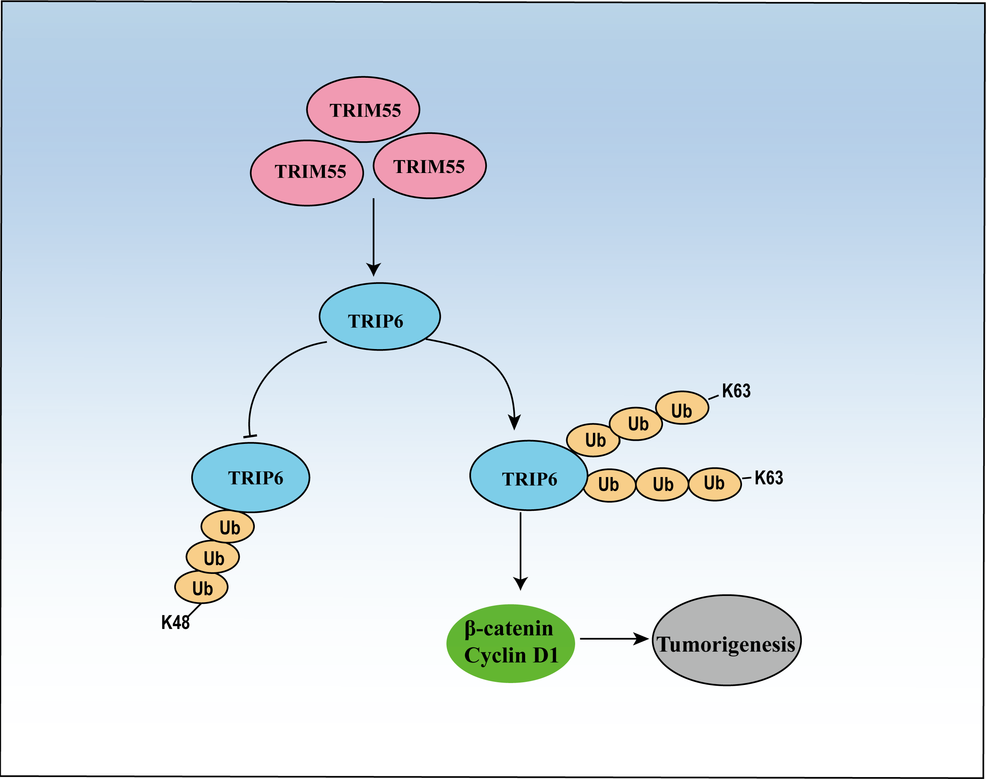
Supplementary Figure 3 A working model depicting how TRIM55 promotes HCC proliferation. TRIM55 interacted with TRIP6 and regulate its stability by inhibiting the K48-linked ubiquitination of TRIP6 and promoted the K63-linked ubiquitination of TRIP6, thereby affecting the Wnt signaling pathway.
Abbreviations: TRIM55, Tripartite motif containing 55; TRIP6, thyroid receptor interacting protein 6; HCC, Hepatocellular carcinoma; Ub, ubiquitination.

