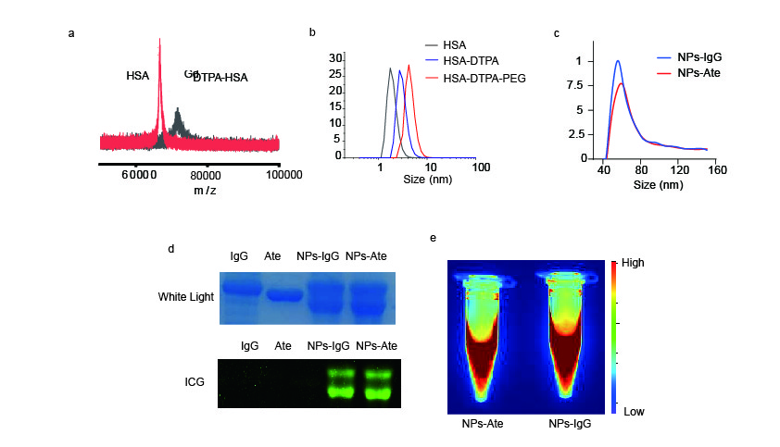

Supplementary Fig. 1. NPs-Ate and NPs-IgG characterization.
- Mass spectrometry revealed distinct peaks for free HSA and ^{Gd}DTPA-HSA. (b) DLS spectra displayed the size of HSA, HSA-DTPA, and HSA-DTPA-PEG. (c) The particle size of NPs-Ate and NPs-IgG detected by Nano-flow cytometry. (d) SDS-PAGE analysis was performed for NPs-Ate and NPs-IgG. The gel was stained with Coomassie brilliant blue, and an associated fluorescence image was taken. (e) Fluorescence gel signals (1000 nm–1700 nm region at an excitation wavelength of 808 nm).

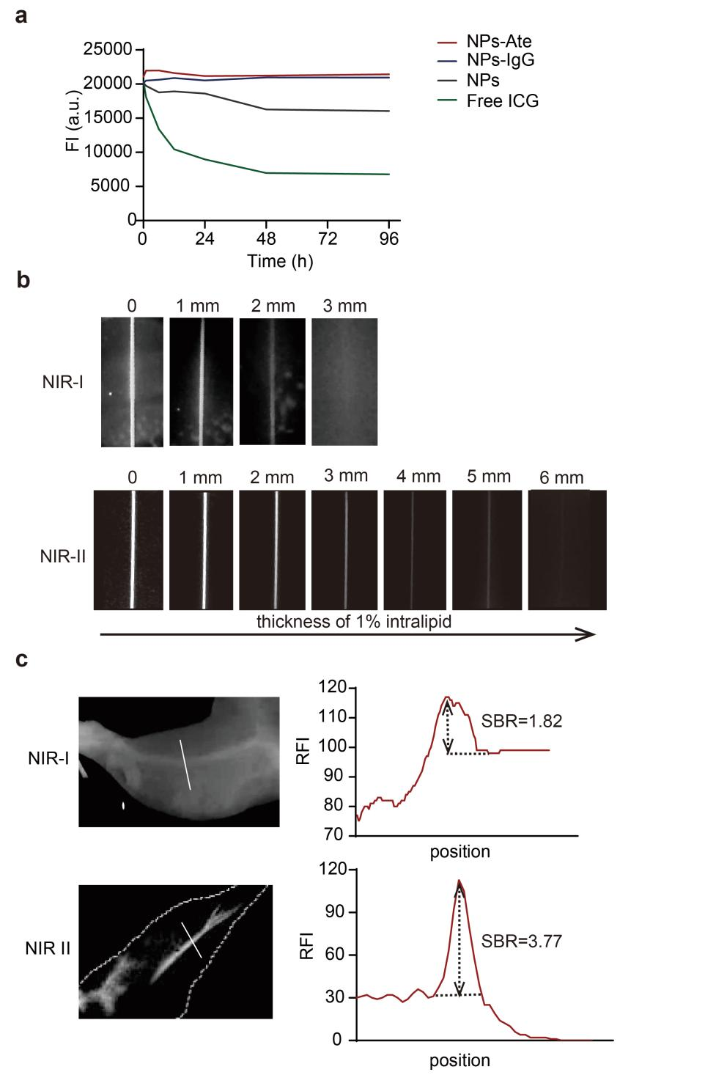
Supplementary Fig. 2. NPs-Ate and NPs-IgG characterization
- NPs-Ate (IgG), NPs, and ICG fluorescence stability in PBS. (b) NP penetration depth in NIR-I and NIR-II at the same concentration. (c) Vascular imaging of NIR-I/II and tumor-to-background ratios (SBR). FI = Fluorescence Intensity, RFI = Relative Fluorescence Intensity.

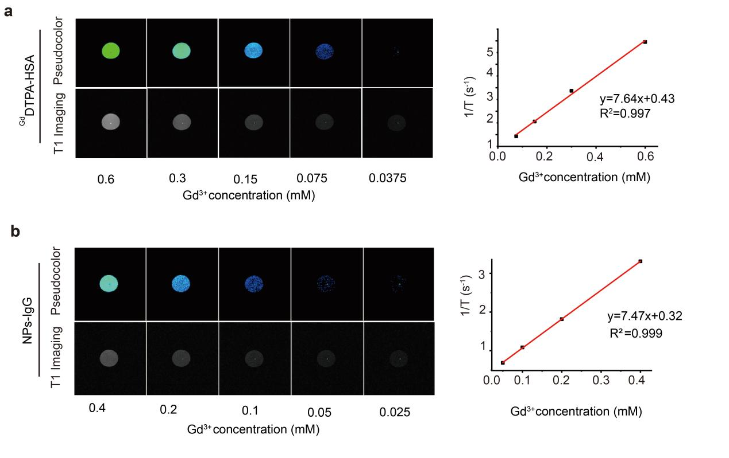
Supplementary Fig. 3. ^{Gd}DTPA-HAS and NPs-IgG MRI signals
T1-weighted MR phantom images (Upper panels: pseudocolor) and longitudinal relaxivity (γ1) of ^{Gd}DTPA-HAS (a) and NPs-IgG (b)

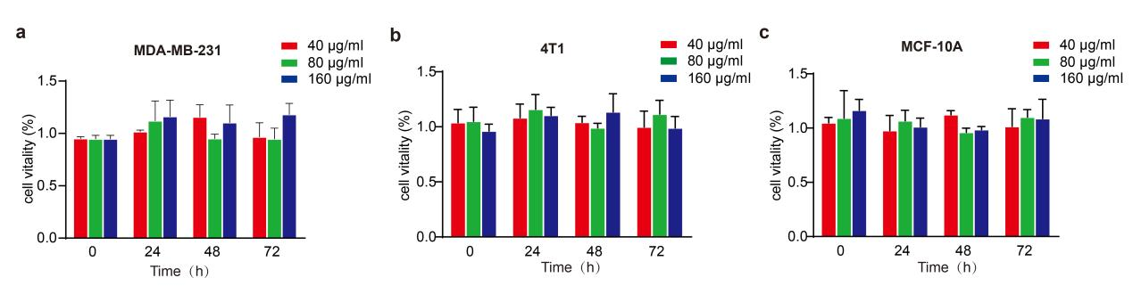

Supplementary Fig. 4. Cytotoxicity assays
MDA-MB-231 (a), 4T1 (b), and MCF-10A(c) cells incubated with NPs-Ate at different concentrations: 40, 80, and 160 µg/ml NPs-Ate for different times (0, 24, 48, and 72 h).

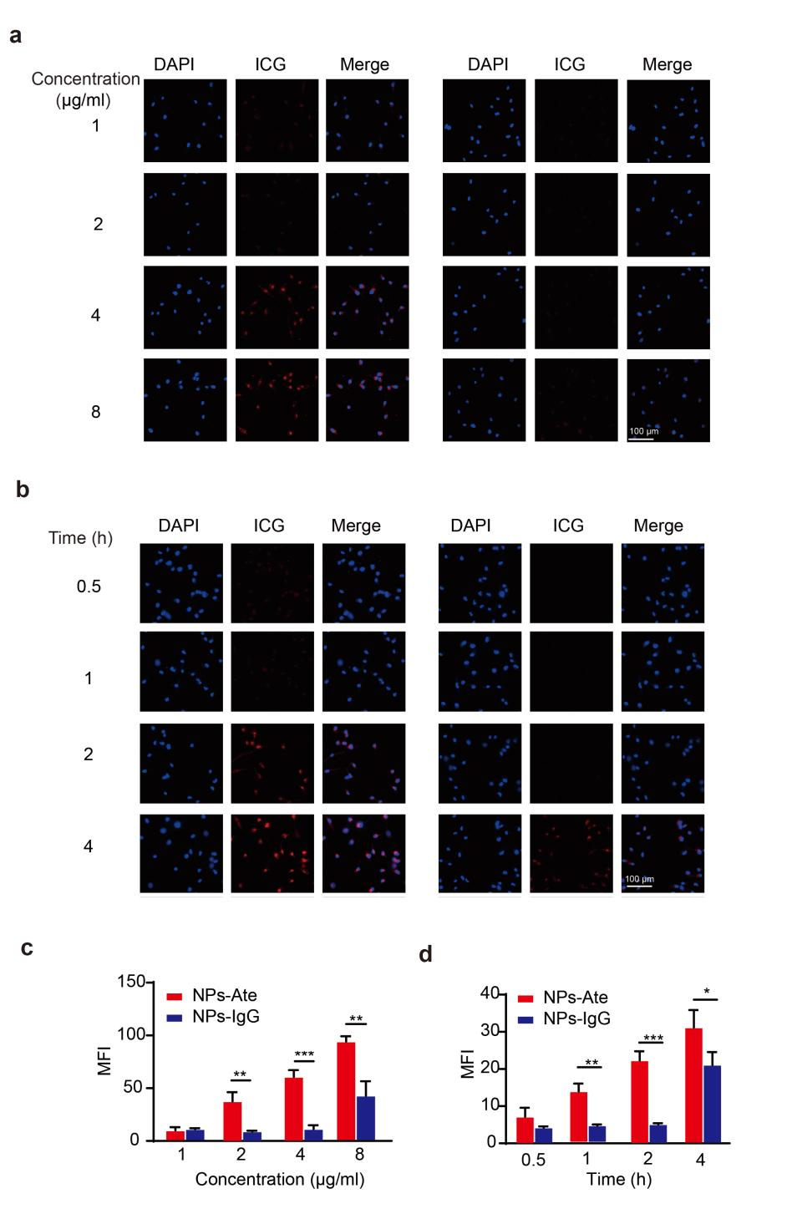
Supplementary Fig. 5. MDA-MB-231 cells incubated with different NPs-Ate concentration and times
(a, b) MDA-MB-231 cells incubated with different NPs-Ate concentrations (20, 40, 80, and 160 µg/ml = 1, 2, 4, 8 µg/ml ICG, respectively) in 2 h. (c, d) Fluorescent signal intensity of MDA-MB-231 cells at different time points (0.5, 1, 2, and 4 h) with 40 µg/ml NPs-Ate; (b, d) Quantitative analyses of cell fluorescent signals. Data are represented as the mean ± standard deviation (n=3), *** P < 0.001 and ** P < 0.01. MFI = Mean Fluorescence Intensity. Scale bar = 100 µm.

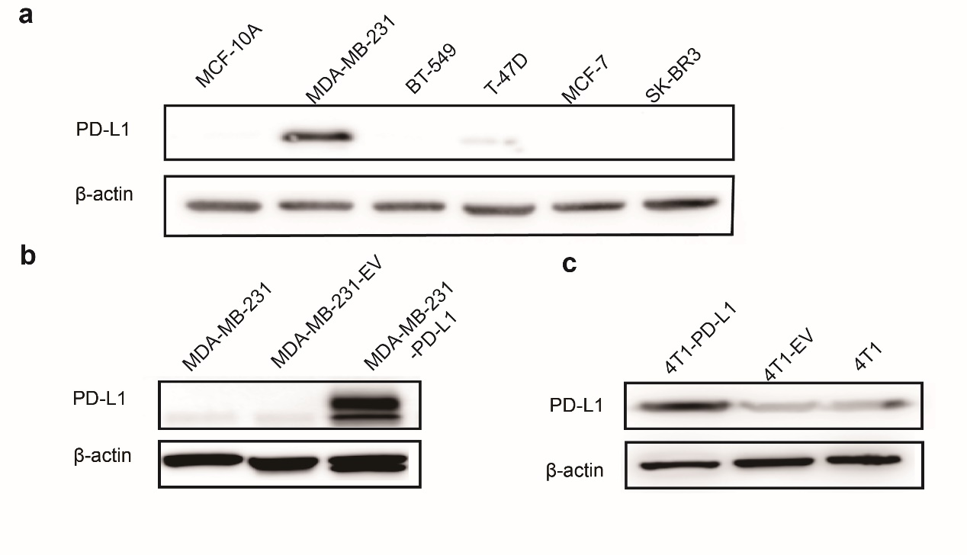
Supplementary Fig. 6. PD-L1 expression in different cell lines
(a). Western blot showing PD-L1 expression in different breast cancer and the normal breast cell line MCF-10A. (b) Western blot showing PD-L1 expression in MDA-MB-231 cells and over expressed PD-L1 cells MDA-MB-231-PD-L1 and control MDA-MB-231-EV. (c) Western blot of PD-L1 showing in 4T1 cells and high PD-L1 expression cells 4T1-PD-L1 and control 4T1-EV.

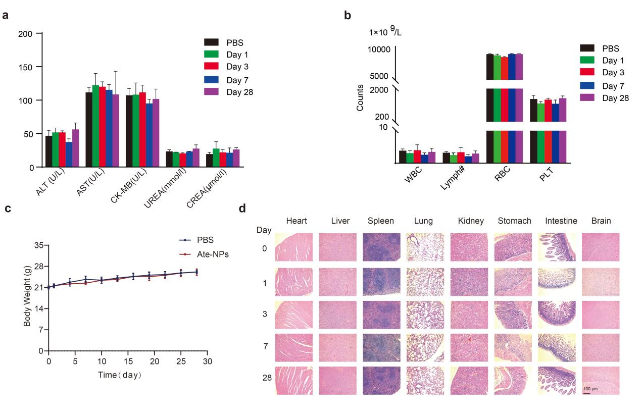

Supplementary Fig. 7. NPs-Ate biosafety
(a) Serum biochemistry results (ALT: Alanine transaminase; AST: Aspertate aminotransferase, CK-MB: creatine kinase-MB, UREA: , and CREA: creatinine) in BALB/c mice at different time points (1, 7, and 30 days) after NPs-Ate or saline (control) intravenous injection. (b) Routine blood results (WBC: white blood cells, Lymph: lymphocytes, RBC: White blood cells, and PLT: Platelets) in BALB/c mice at different time points (1, 7, and 30 days) after NPs-Ate or saline (control) intravenous injection. (c) Body weight curves of mice treated intravenously with saline (control) or NPs-Ate. (d) Hematoxylin & Eosin staining of vital organs (heart, liver, spleen, lung, kidney, stomach, intestines, and brain) in different days. Scale bar = 100 μm. Data are represented as the mean ± standard deviation (n=3).

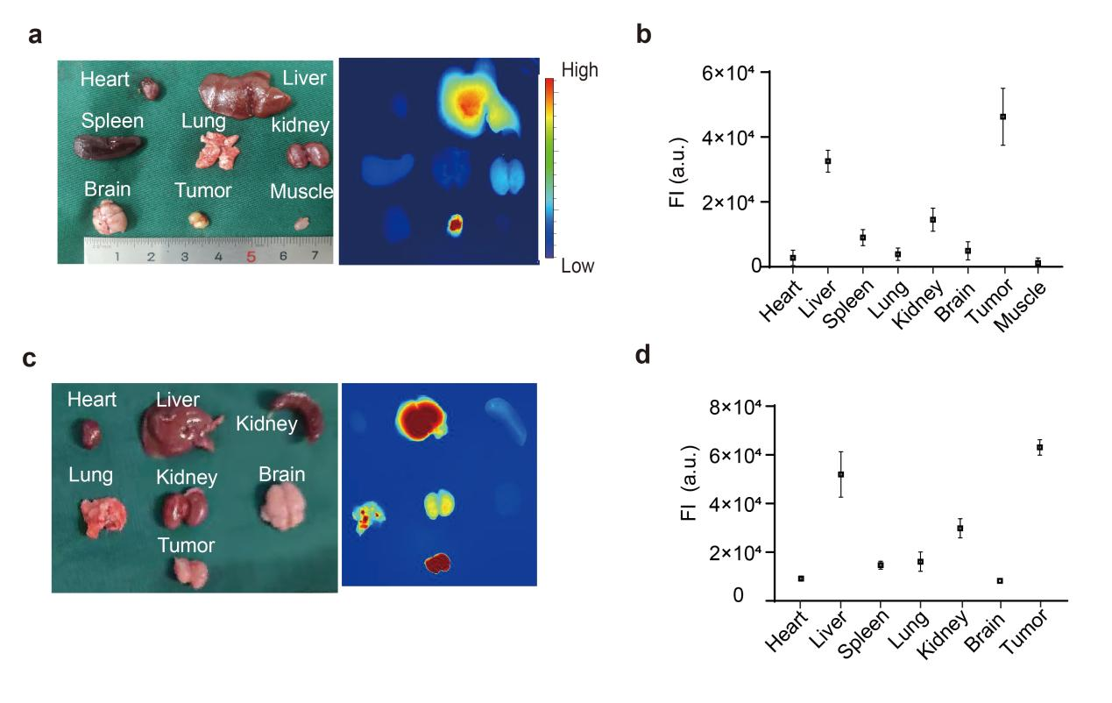
Supplementary Fig. 8. NPs-Ate bio-distribution
(a–d) MDA-MB-231 and 4T1-PD-L1 tumor mouse models were intravenously injected with NPs-Ate and mice were humanely sacrificed at 36 h post-injection. (a, c) Main organs (heart, liver, tumor, lung, spleen, kidney, brain, and tumor) were collected and (b, d) fluorescence intensity detected. FI = Fluorescence Intensity

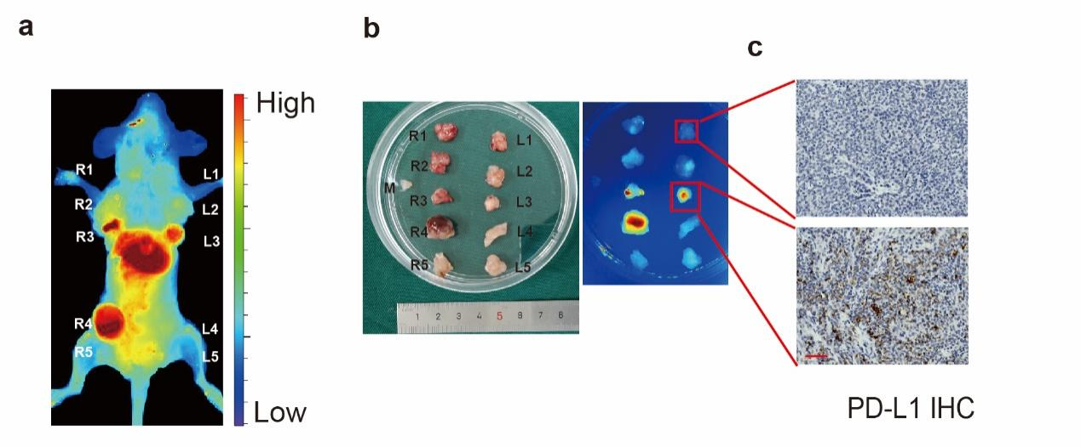

Supplementary Fig. 9. In vivo fluorescence images in the MMTV-PyVT mouse model.
- Fluorescence image showing a MMTV-PyVT mouse after NPs-Ate injection at 36. (R; right; L: left 1-5: five pairs of mammary glands (breast cancer) h. (b) In vitro fluorescence tumor imaging. (c) IHC of PD-L1 in tumor tissue. scale bar =50 µm

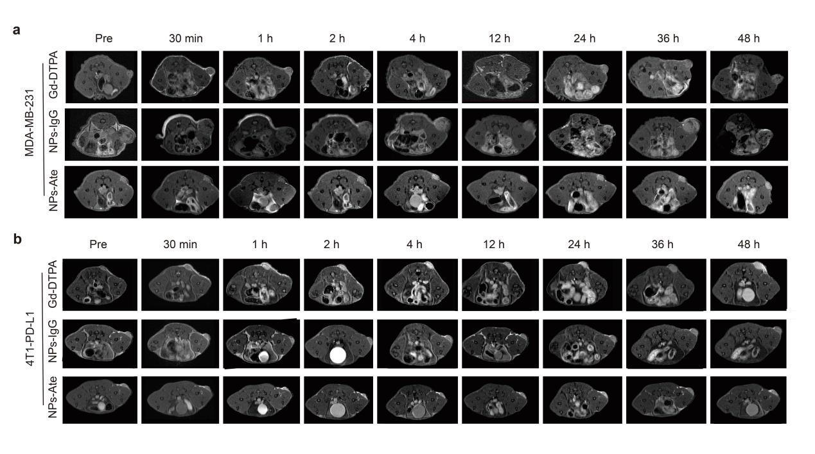
Supplementary Fig. 10. In vivo T1-weighted MRI
(a) MDA-MB-231 and (b) 4T1-hPD-L1 tumor-bearing mice before injection (Pre), and at 0.5, 1, 2, 4, 12, 24, 36, and 48 h after intravenous injection of NPs-Ate, NPs-IgG, and Gd-DTPA at 23.5 mg/kg Gd.

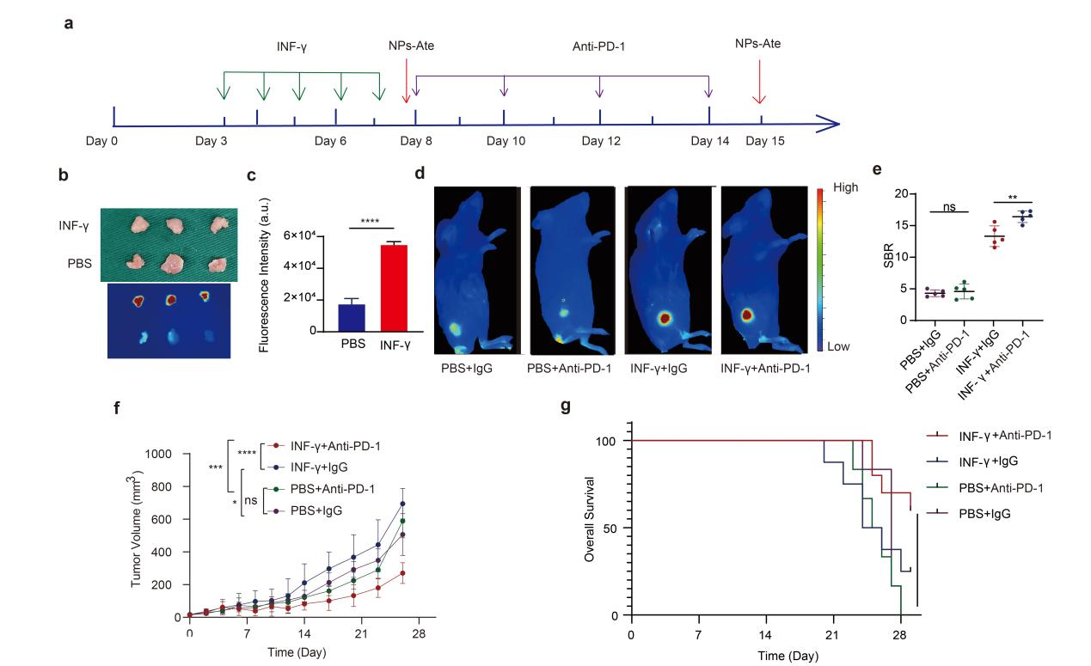

Supplementary Fig. 11. INF-γ combined with PD-1 therapy
(a) The treatment process. (b) The fluorescent picture of tumor tissue after INF-γ intervention on day 8 and (c) their quantitation. (d) the fluorescent pictures of INF-γ combine PD-1 treatment model on day 15 and (e) their quantitation. (f) Tumor volume during treatment. (g) Overall survival. Data are represented as the mean ± standard deviation (n=3), *** P < 0.001, ** P < 0.01, and *P < 0.05.

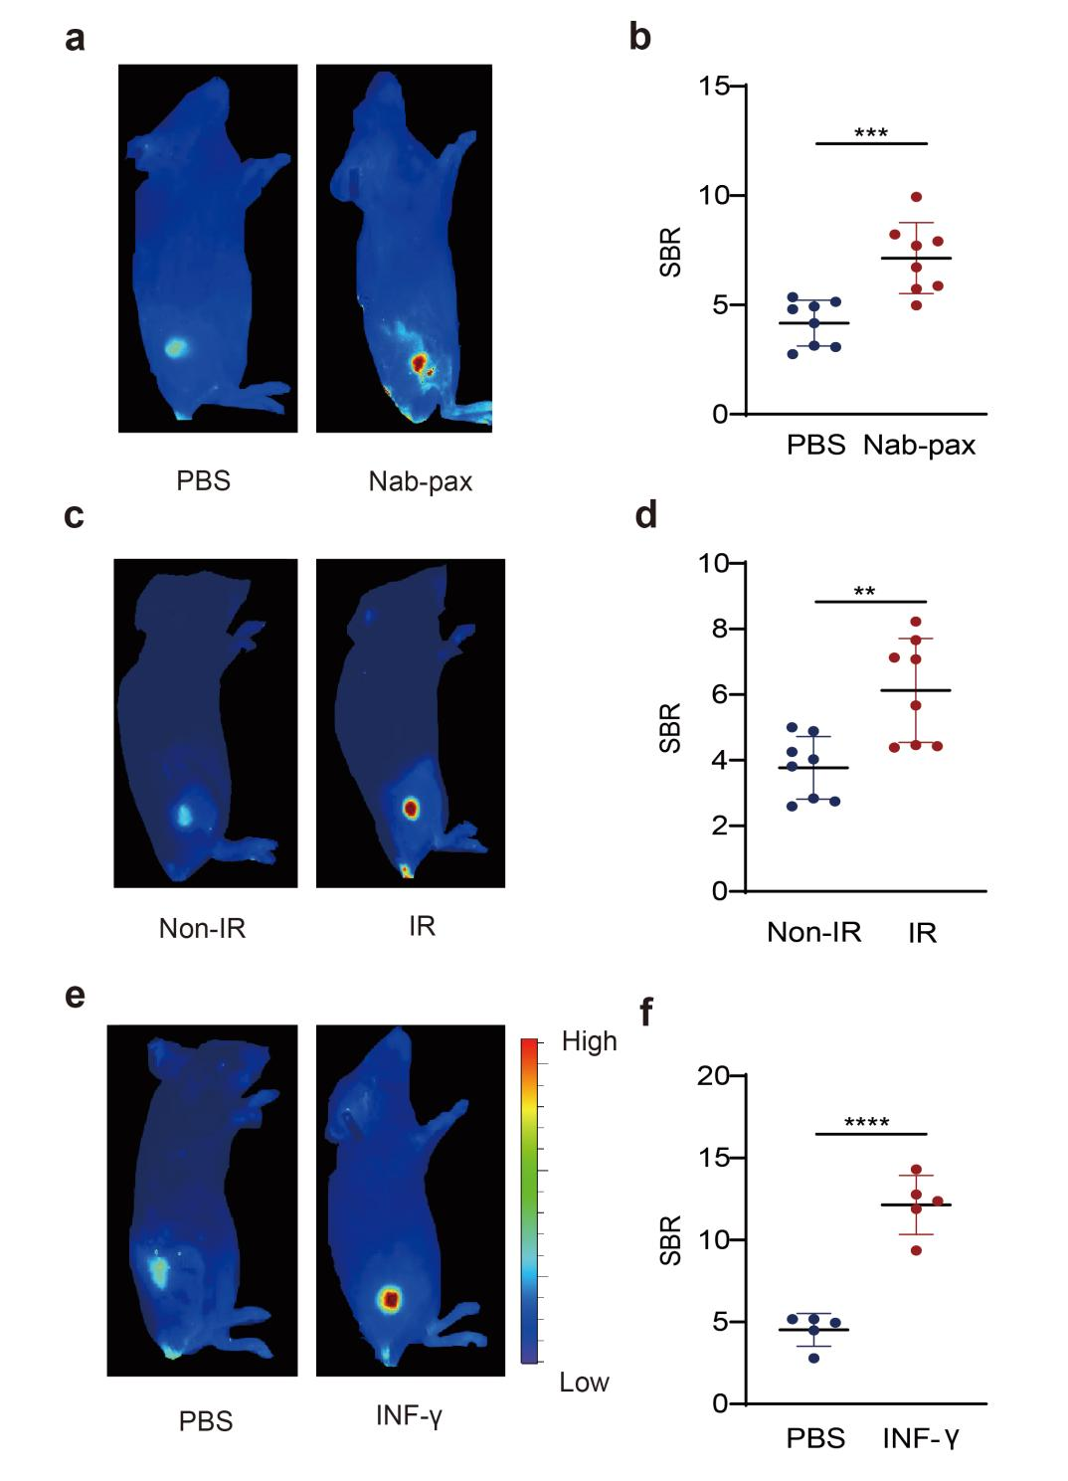

Supplementary Fig. 12. Dynamic changes in the PD-L1 mouse model.
(a, b) Nab-paclitaxel (Nab-pax) combined with PD-1 therapy. (c, d) IR combined with PD-1 therapy. (e, f) INF-γ combined with PD-1 therapy. (a, c, e) The fluorescent picture after Nab-pax (a), IR (c), INF-γ (e) intervention on day 8 and (b, d, f) their quantitation. Data are represented as the mean ± standard deviation (n=3), *** P < 0.001, ** P < 0.01, and *P < 0.05.
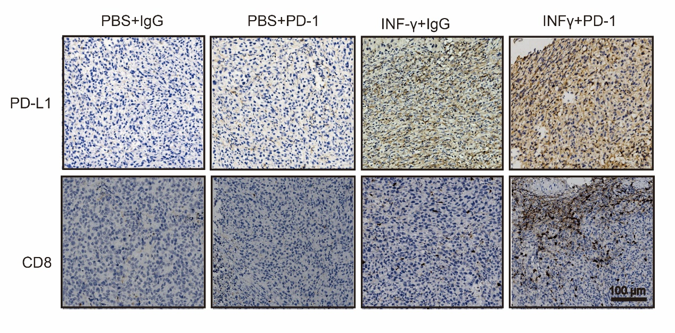
Supplementary Fig. 13. PD-L1 and CD8 expression after PD-1 combined with INF-γ therapy.
The expression (immunohistochemistry) of PD-L1 and CD8 in every treatment group after PD-1 concomitant with INF-γtherapy. Scale bar =100 µm.

