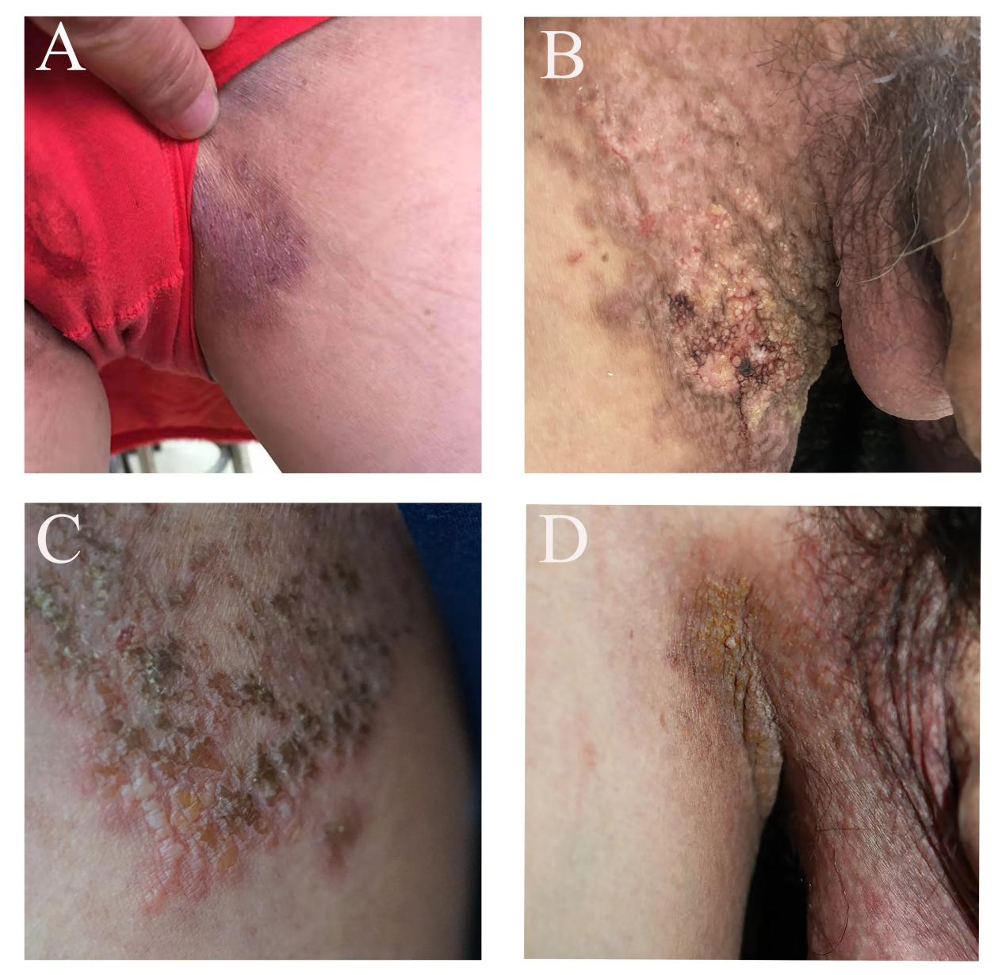

Supplementary Figure 1. Clinical manifestations of the proband of 2 pedigrees and 2 sporadic cases. (A) P1 erythema of the groin. (B) P2 erythema and papules of the groin. (C) P3 erythema, blisters and erosions of the groin. (D) P4 erythema and papules of the groin.

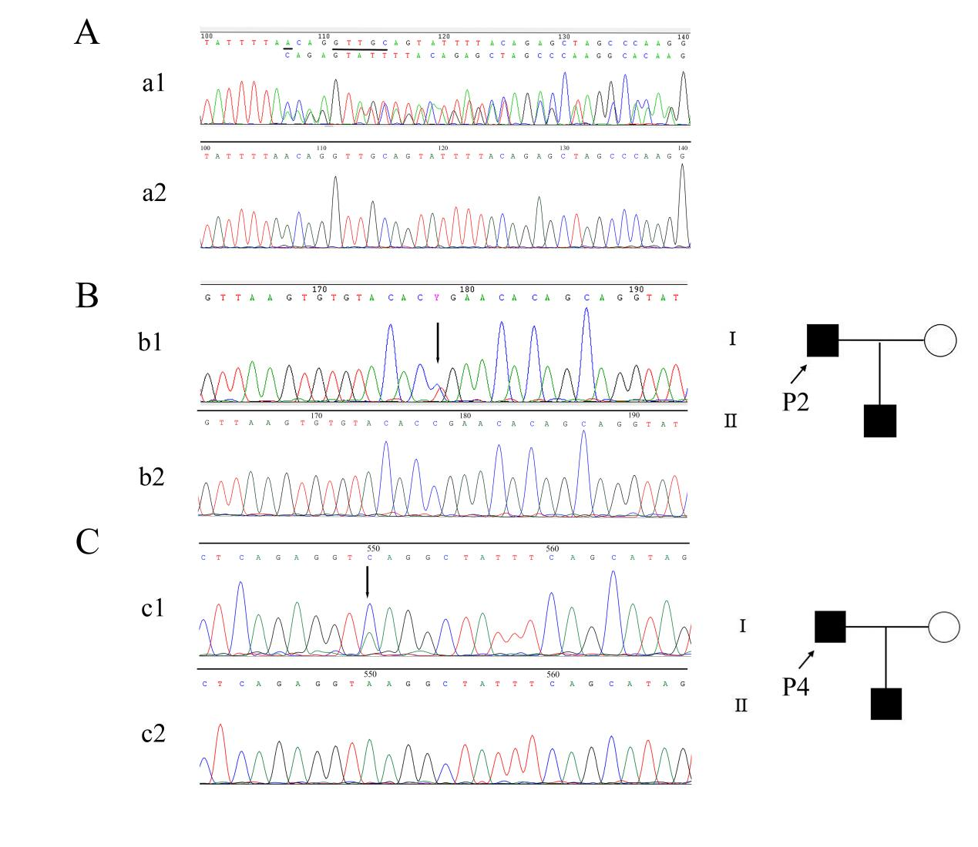
Supplementary Figure 2. Genetic findings and pedigree chart of HHD in this study. A (a1) Compound mutations of c.1840-4delA and c.1840_1844delGTTGC in exon 20 of ATP2C1 in P1. B (b1) Heterozygous nonsense mutation at nucleotide position 1402 C>T in exon 16 of ATP2C1 in P2. C (c1) Splice site mutation of c.1570+3A>C in intron 17 in P4. (a2, b2, c2) represented sequences of the normal persons respectively.

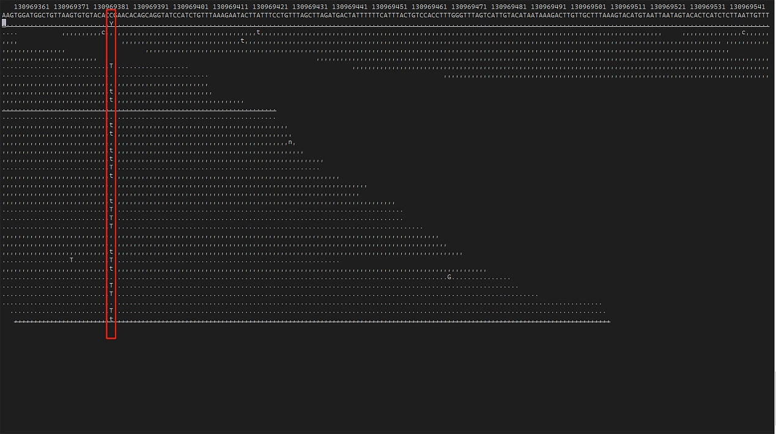

Supplementary Figure 3. Whole-exome sequencing of P3

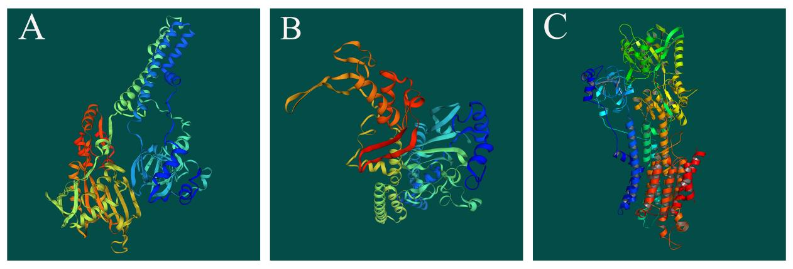
Supplementary Figure 4. Three-dimensional structure of ATP2C1. (A) the 3D structure of the protein products of c.1840_1844delGTTGC. (B) the 3D structure of the protein products of c.1402C>T. (C) the original 3D structure of ATP2C1.

