Supporting materials

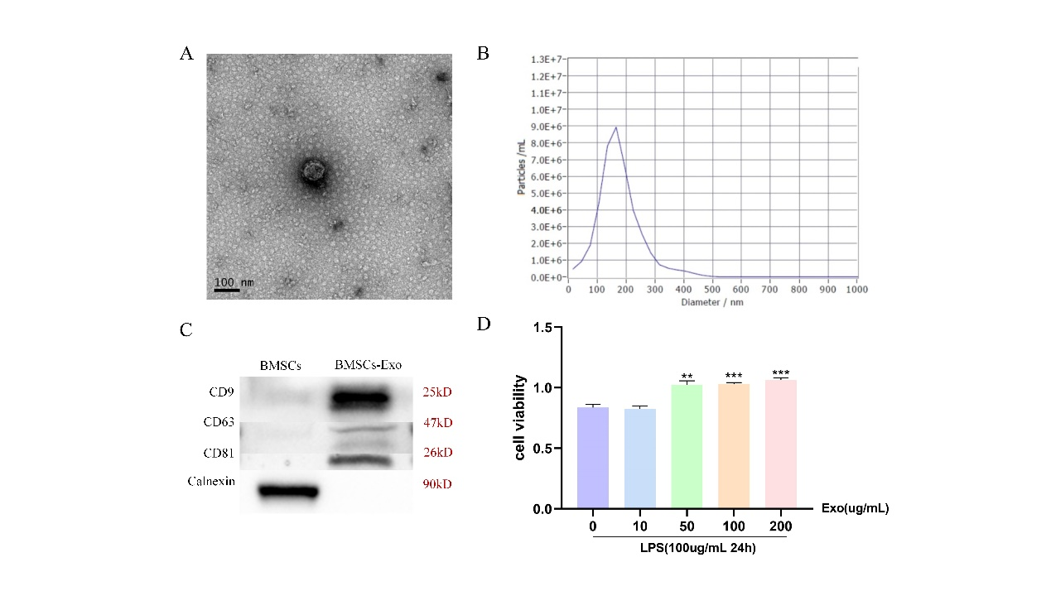

S1. (A) Representative picture of the ultrastructure of BMSCs-Exo. Scale bar: 100 nm. (B) Size distribution profile of BMSCs-Exo. (C) Western blot analyses of proteins (CD9, CD63, CD81and Calnexin) in BMSCs-Exo. (D) CCK-8 assay showed HK-2 cell viability after addition of different concentrations of BMSCs-Exo in LPS-treated HK-2 cells. **P<0.01, ***P<0.001 vs EXO 0 μg/mL.

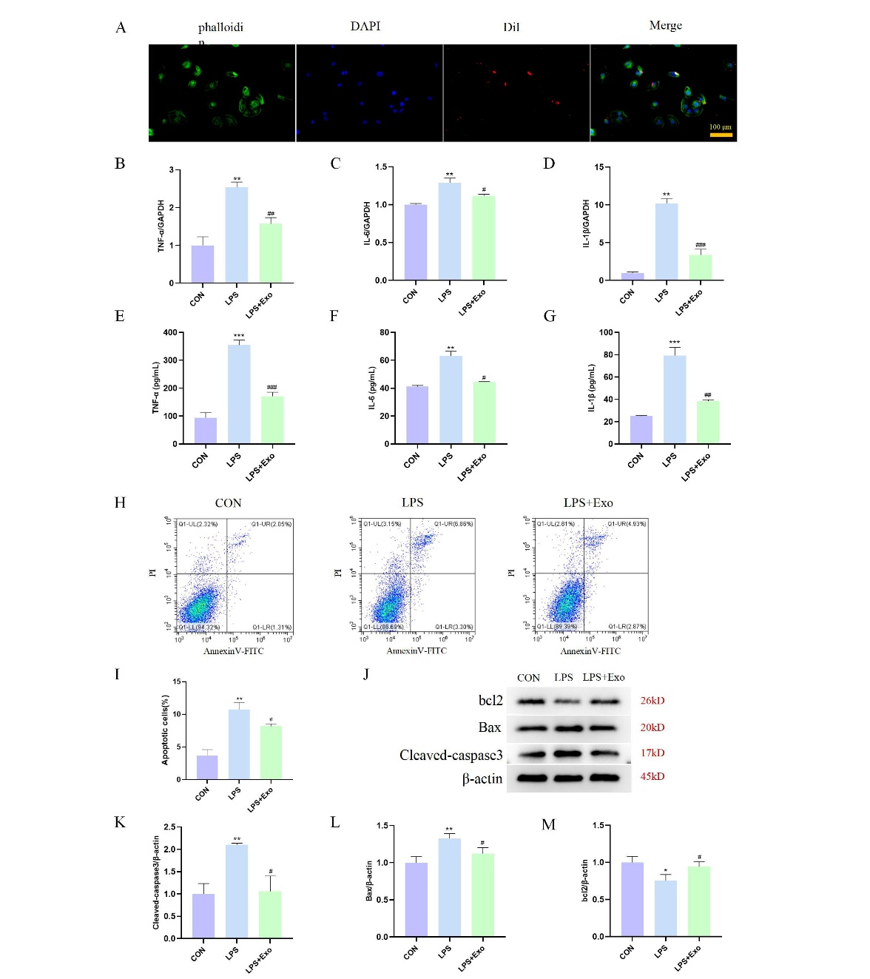
S2. (A) Uptake of the red fluorescence dye DiI-labeled BMSCs-Exo by HK-2 cells (ⅹ200). (B-D) qRT-PCR was applied to tested mRNAs of TNF-α, IL-6 and IL-1β in three groups. GAPDH was used as an internal control. (E-G) The concentration of TNF-α, IL-6 and IL-1β in the cell supernatants of each group was detected using the corresponding ELISA kit. (H) Flow cytometry showed that the apoptotic rate of LPS treatment group increased, and decreased in LPS+EXO group. (I) Statistical results of apoptotic rate of HK-2 cells. (J) Protein expression results of Cleaved-caspase 3, Bax and bcl2 in three groups were determined by Western blotting. β-actin was used as an internal control. (K-M) Statistical results of expression in panel J. *P<0.05, **P<0.01, and ***P<0.001 vs. CON, # P<0.05, ## P<0.01 and ### P<0.001 vs. LPS.

