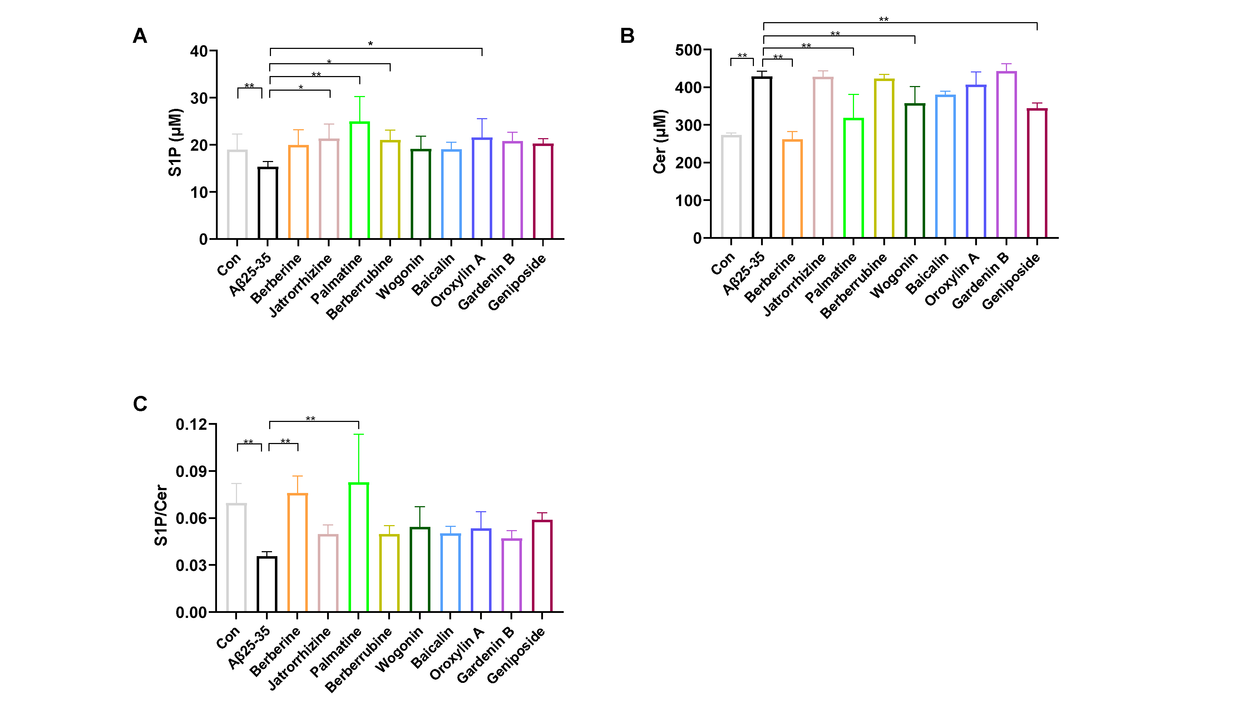
Figure S1. Regulation of different components of sphingolipid metabolism in microglia. Concentration of (A) S1P and (B) Cer. (C) The ratio of S1P/Cer. Aβ₂₅₋₃₅-stimulated microglia were separately incubated with Ber, Pal, Jat, Brb, Wog, Bai, OA, GB, and Gen for 24 h. The treatment concentration was 1 μM. S1P, sphingosine-1-phosphate; Cer, ceramide. n = 6. * p < 0.05, ** p < 0.01.

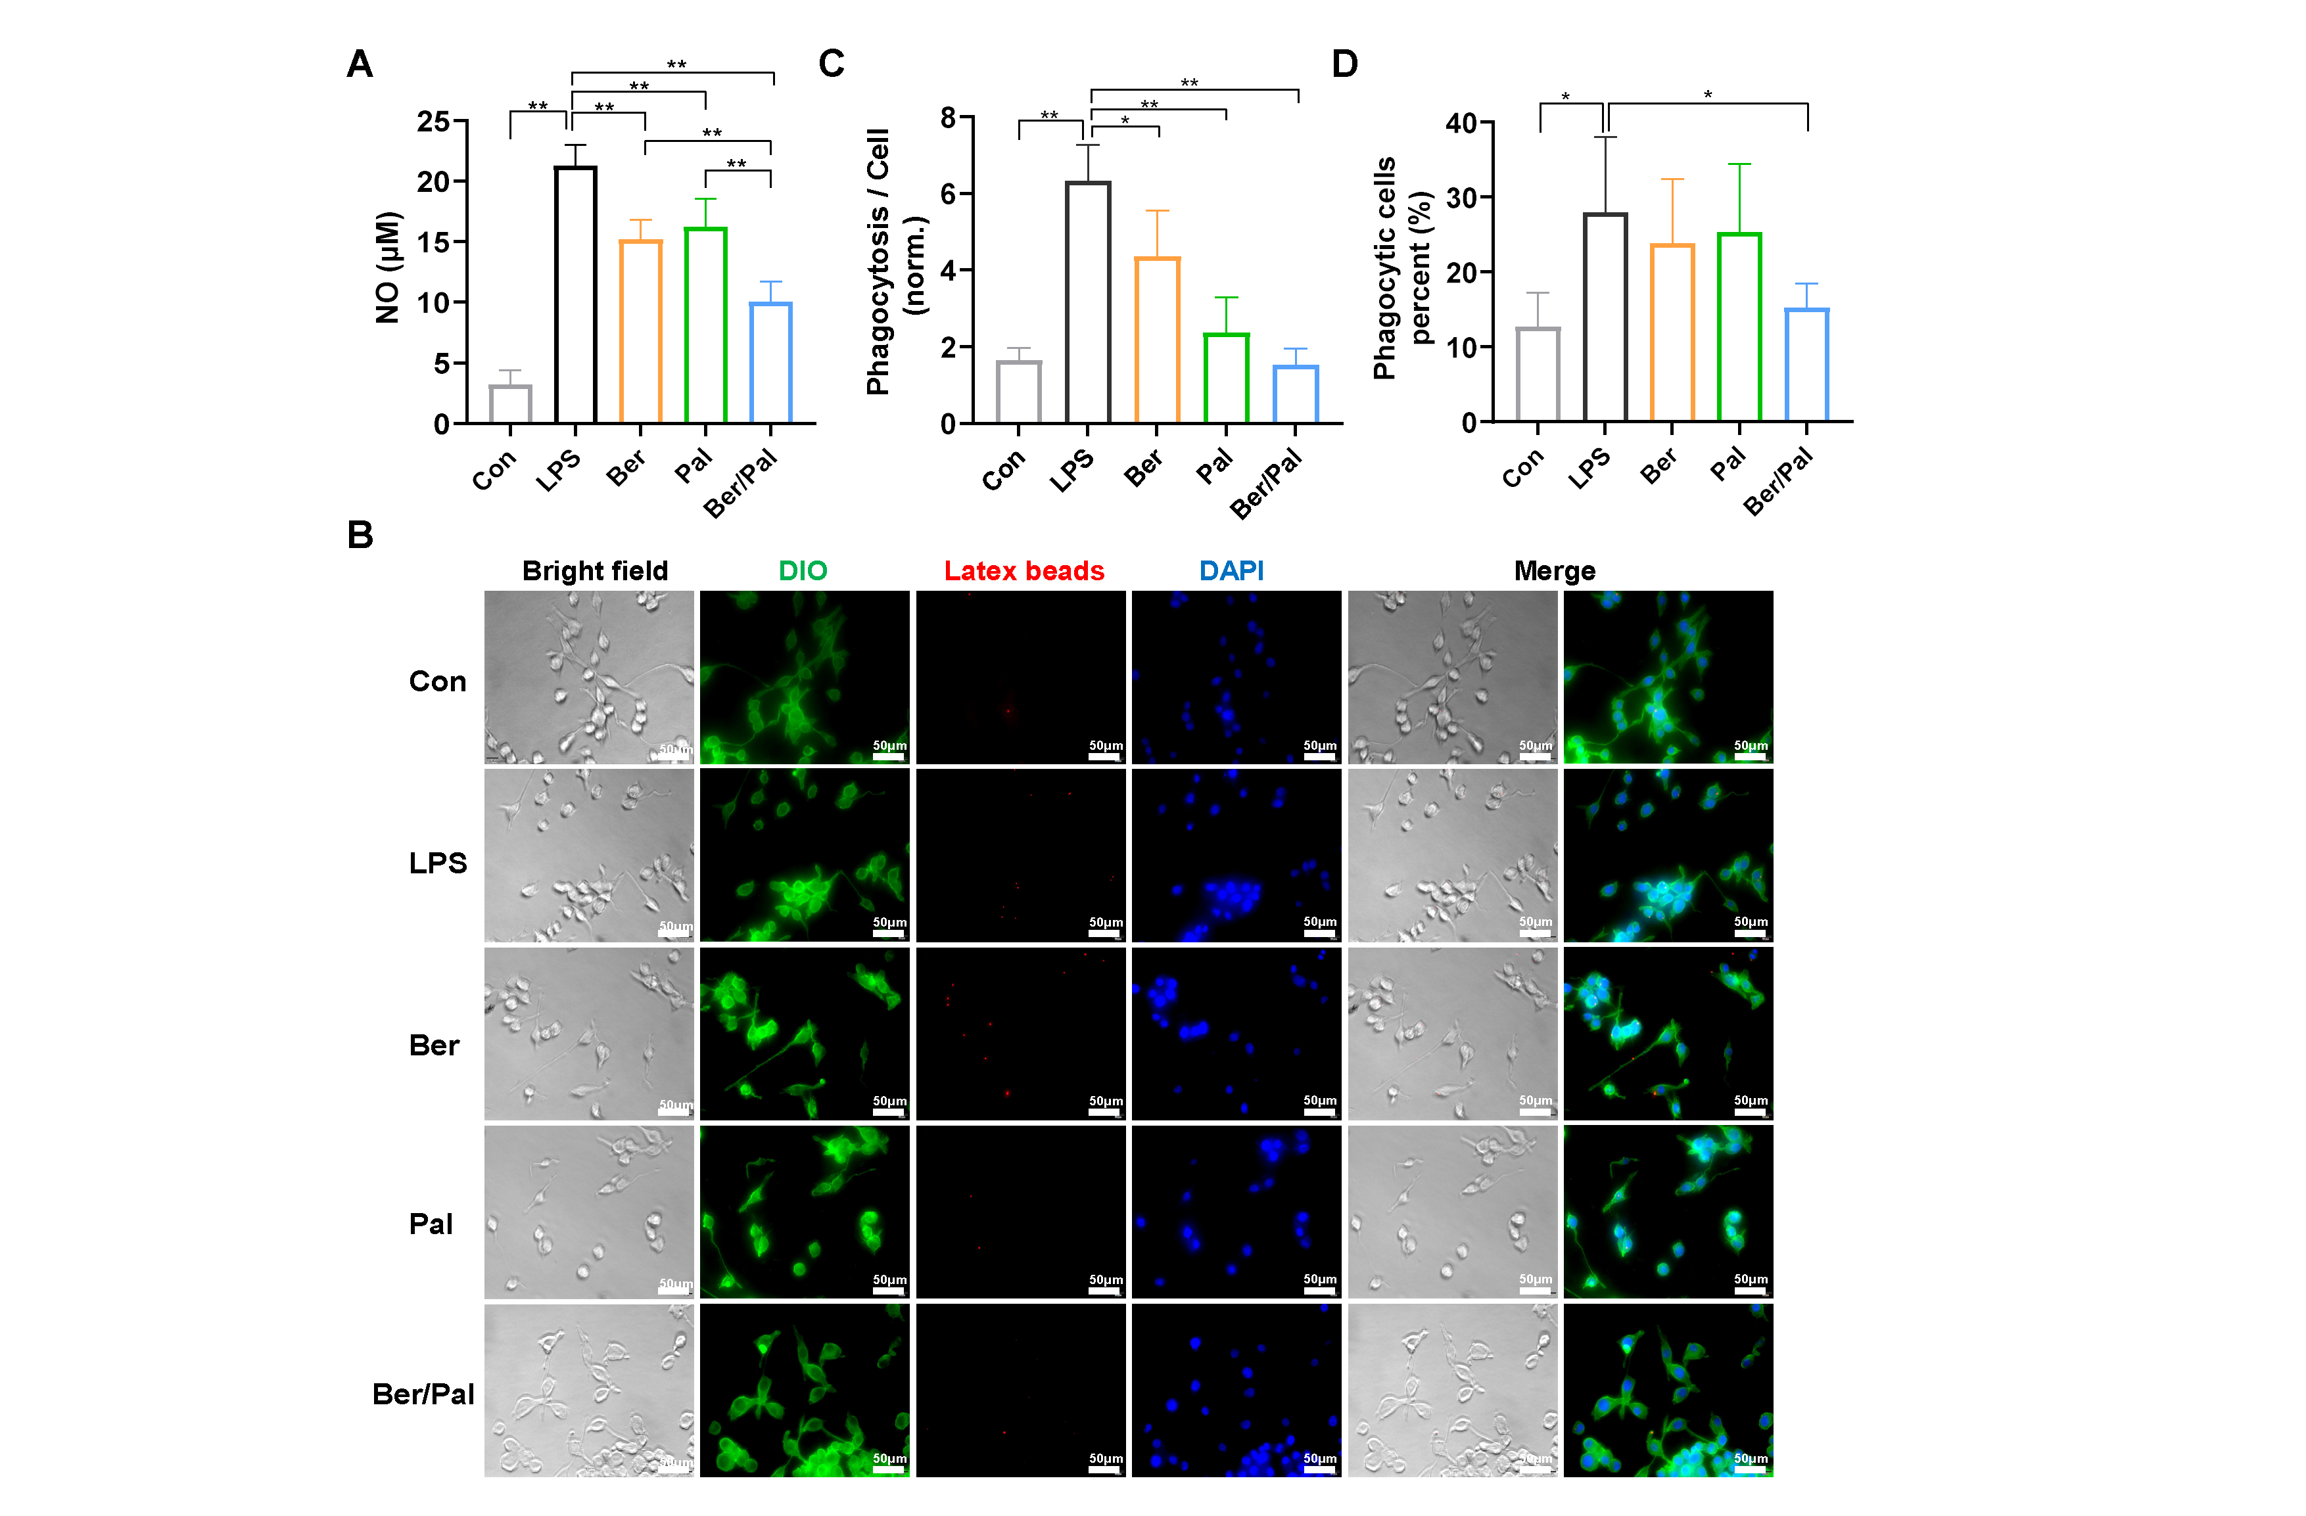
Figure S2. Anti-inflammatory effects of Ber and Pal. (A) NO content of microglia stimulated by LPS (250 ng/mL) after coincubation with free drug (Ber, Pal) and a combination of two drugs (Ber/Pal) for 24 h. (B-D) Phagocytosis capacity of LPS-stimulated microglia determined by the fluorescent latex bead method. (B) Fluorescence microscopy images of microglia stimulated by LPS treated with free drug (Ber, Pal) and the combination of the two drugs (Ber/Pal). (C) The quantitative phagocytosis capacity was expressed as the ratio of total areas of fluorescent signals to the total number of phagocytic cells. (D) The ratio of the number of phagocytes to the total number of cells. The concentration of Ber/Pal was 0.3 μM. n = 3, * p < 0.05, ** p < 0.01.

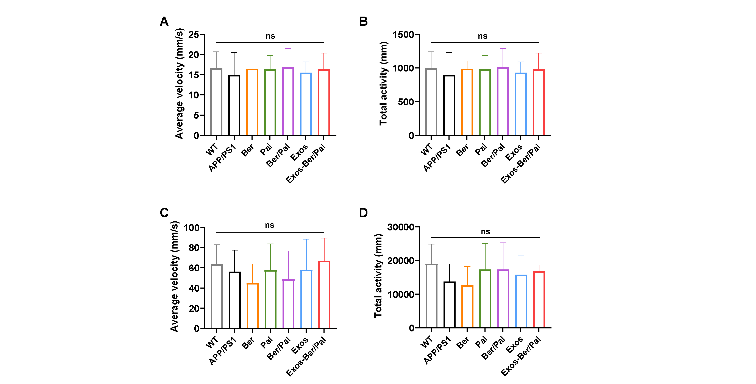
Figure S3. Motor ability of mice in the MWM and OLT. (A) Average velocity of mice in the MWM. (B) Total activity of mice in the MWM. (C) Average velocity of mice in the OLT. (D) Total activity of mice in the OLT. ns, no significance. n = 8.

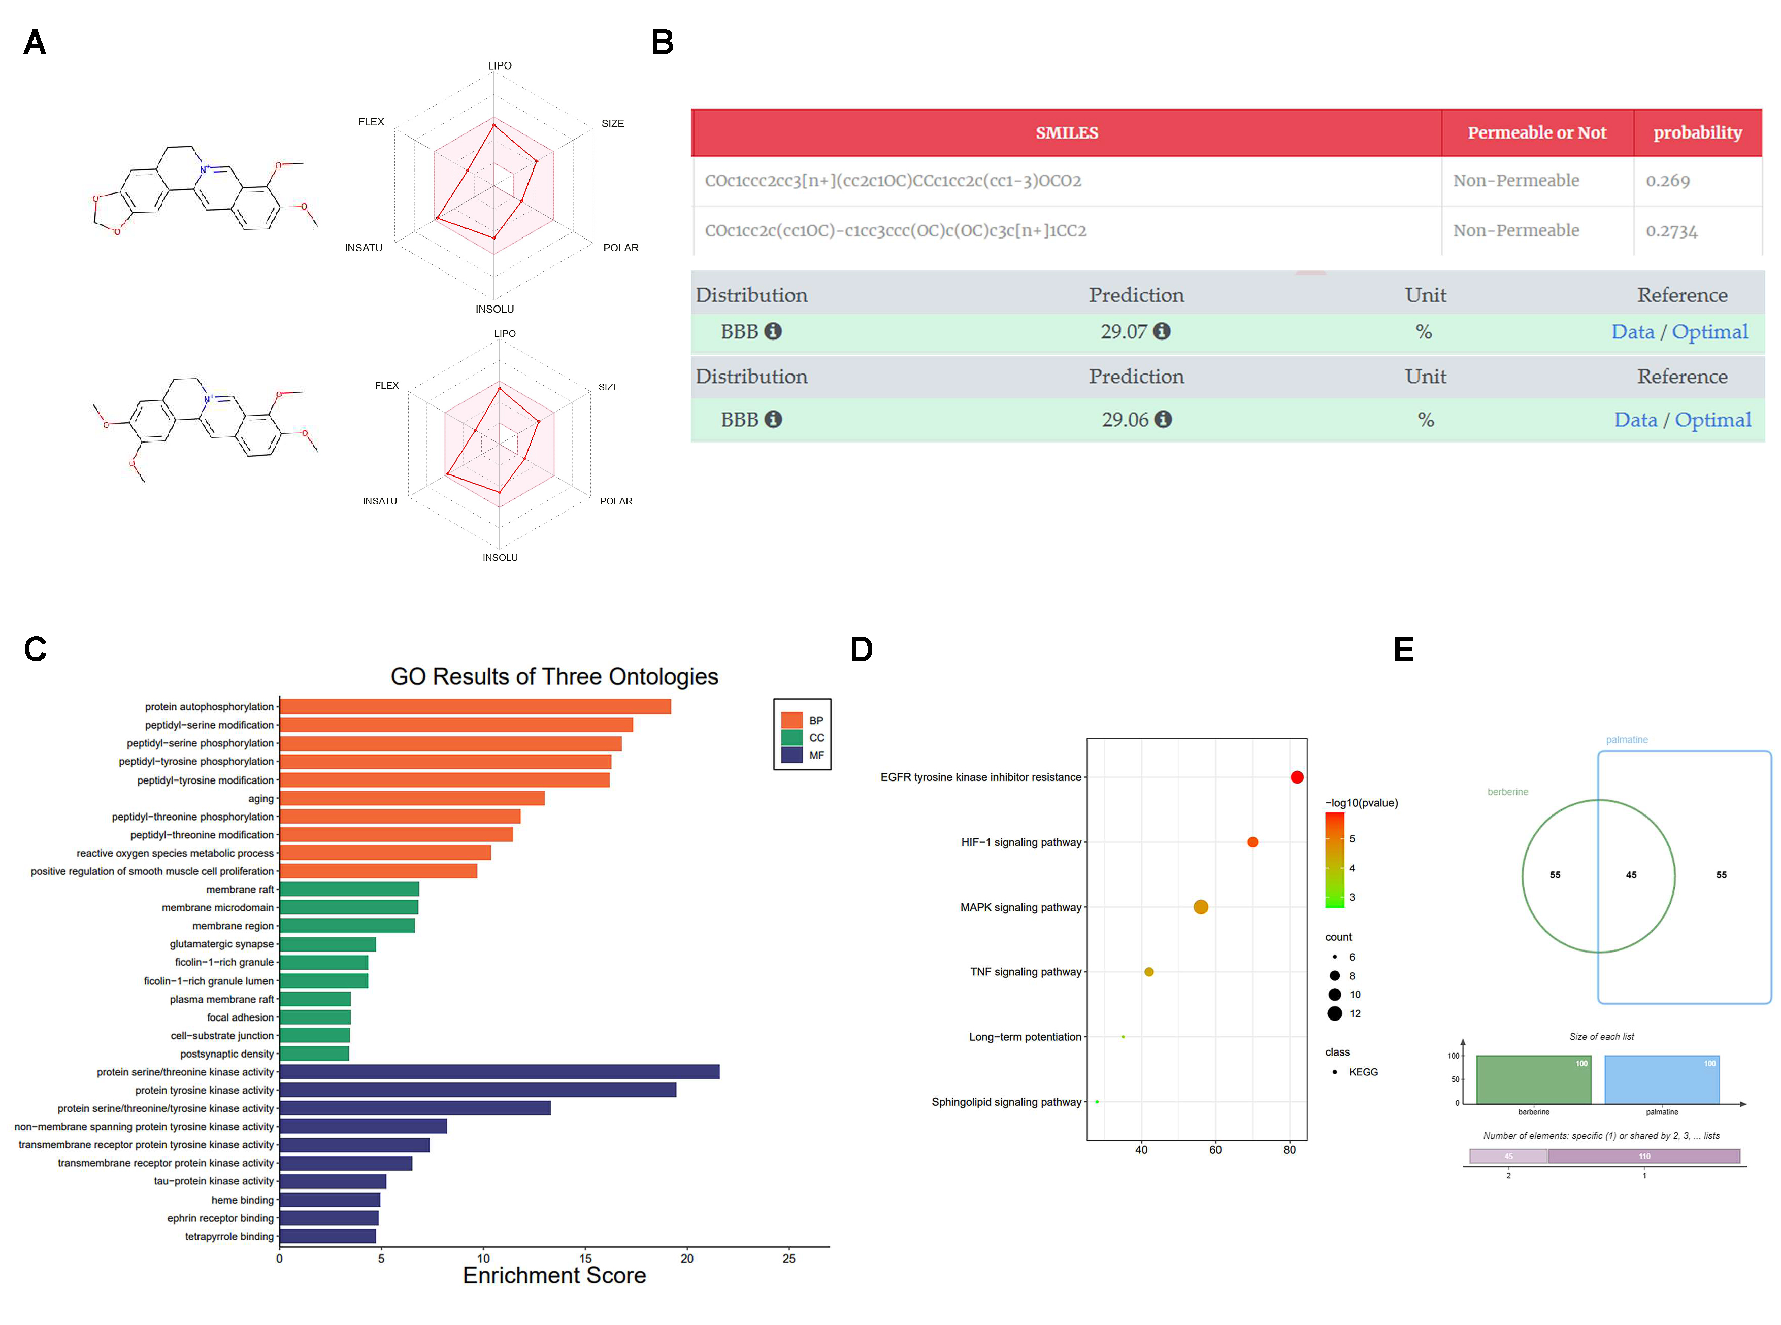

Figure S4. The target and BBB permeation prediction. (A-B) The ADMET and BBB permeation prediction of Ber and Pal. (C-D) The GO and KEGG enrichment analysis of non-intersected targets from Ber and Pal. (E) The venn plot of predicted target from Ber and Pal.

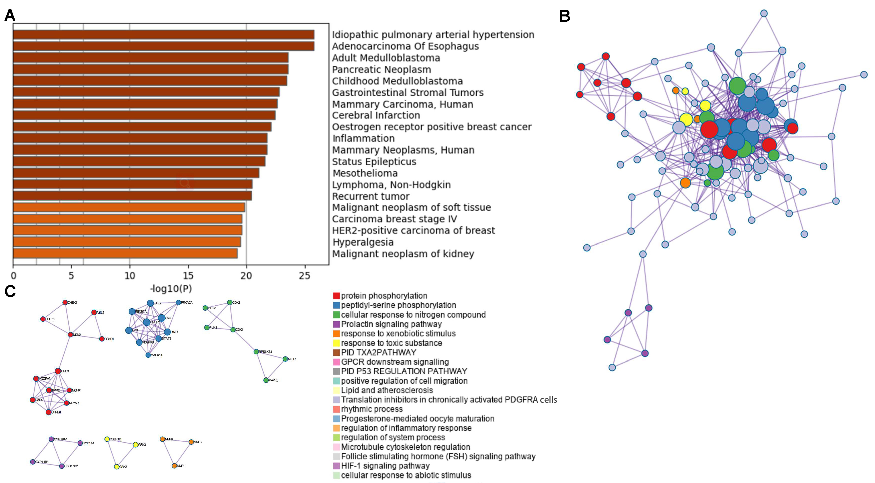
Figure S5. The bioinformatic analysis of non-intersected targets from Ber and Pal. (A) The enrichment analysis from Metascape. And the bar color depth Lightness is positively correlated with -log10(P). (B and C) The protein and protein interaction plot of non-intersected targets from Ber and Pal.

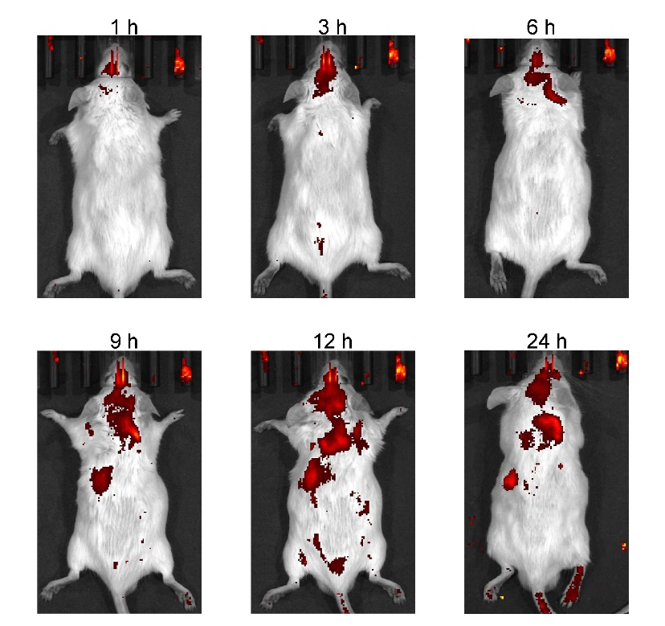
Figure S6. The accumulation of exosomes in the brain at different time points. After mice were injected with DIR-labelled exosomes by tail vein, they were observed at 1, 3, 6, 9, 12 and 24 h respectively. The concentration of exosomes was 200 μg/mL.

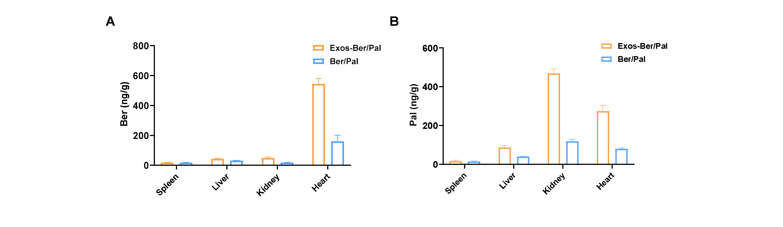
Figure S7. Ber and Pal concentrations in different tissues after treatment with the Ber/Pal physical mixture and Exos-Ber/Pal by i.v. for 24 h. (A-B) Contents of Ber and Pal in the heart, liver, spleen and kidney 24 h after Ber/Pal and Exos-Ber/Pal administration. The Ber/Pal dosage was 0.88/1.13 mg/kg. n = 6.
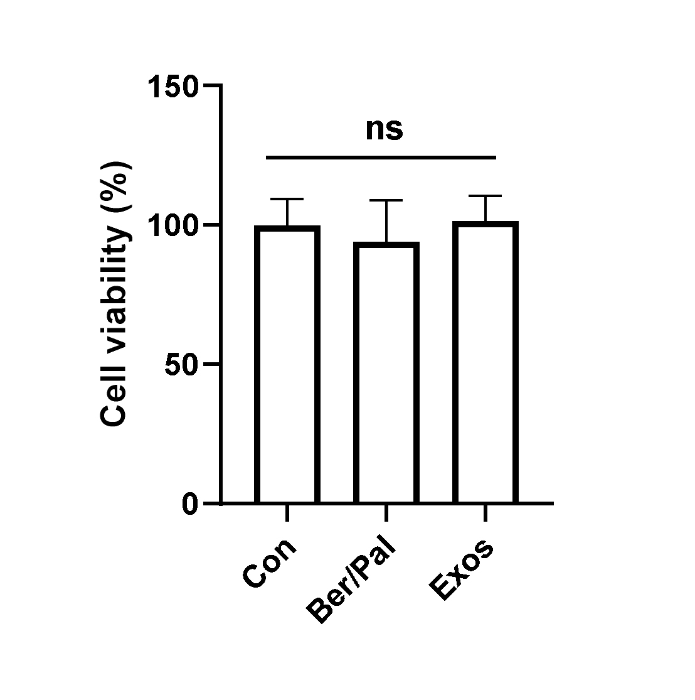
Figure S8. Effects of Ber/Pal and Exos on cell viability. The concentration of Ber/Pal was 0.3 μM.

