Supplementary Material

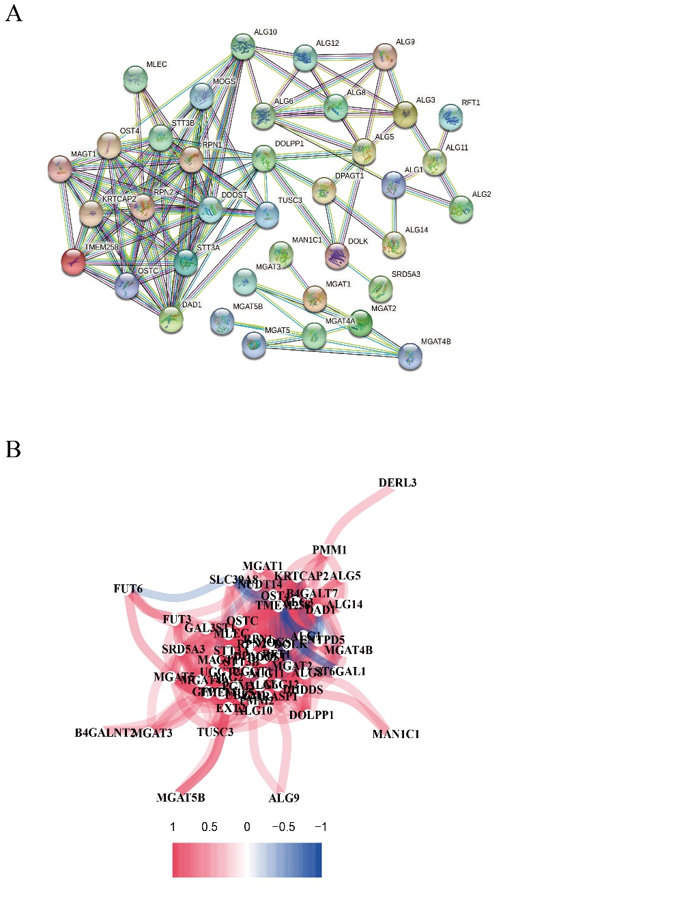
Fig.S1
- Protein-protein interaction networks represented protein interactions among DEGs (confidence=0.9).
- Co-expression network between DEGs (red line: positive correlation; blue line: negative correlation).

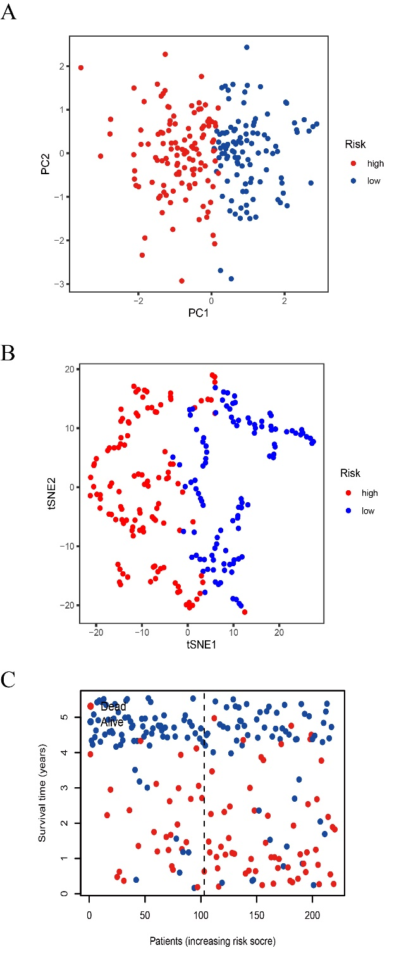
Fig.S2
- Principal component analysis plot was performed based on the risk score.
- t-Distributed Stochastic Neighbor Embedding for HCCs of GEO based on the risk score.
- Survival status and duration of HCC patients (low-risk population: the left of the dotted line; high-risk population: the right of the dotted line).

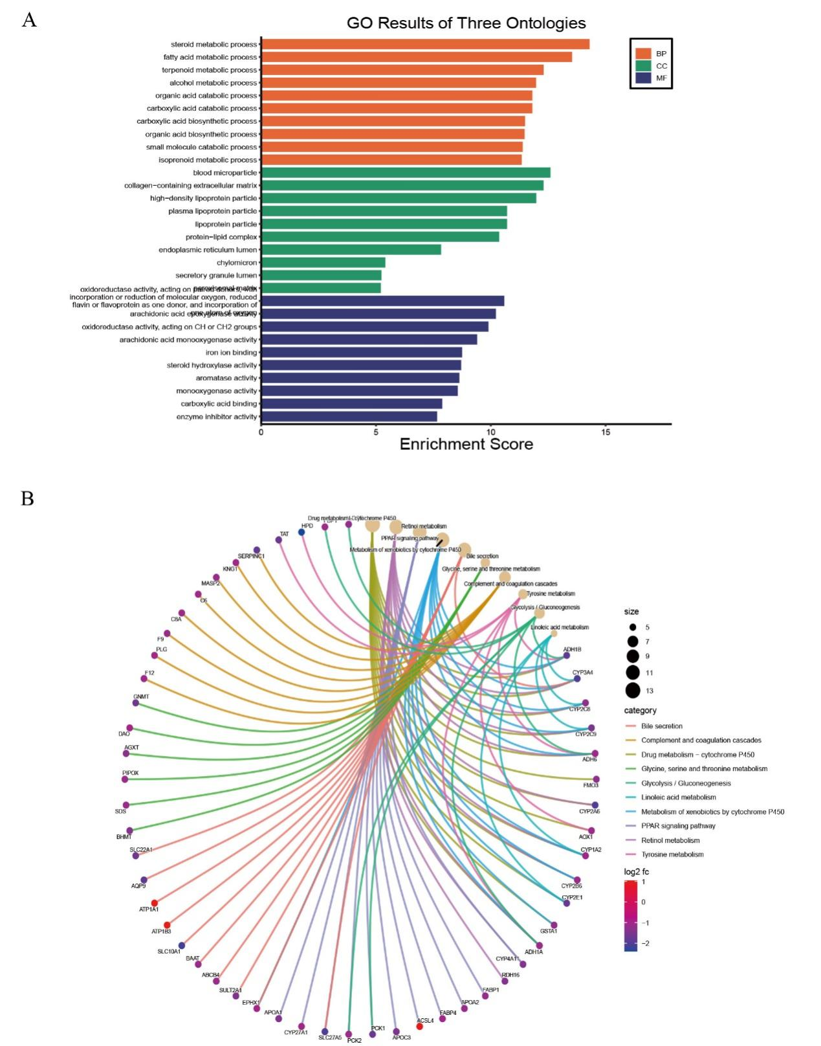
Fig.S3
- Barplot graph for GO enrichment
- Graph for KEGG pathways

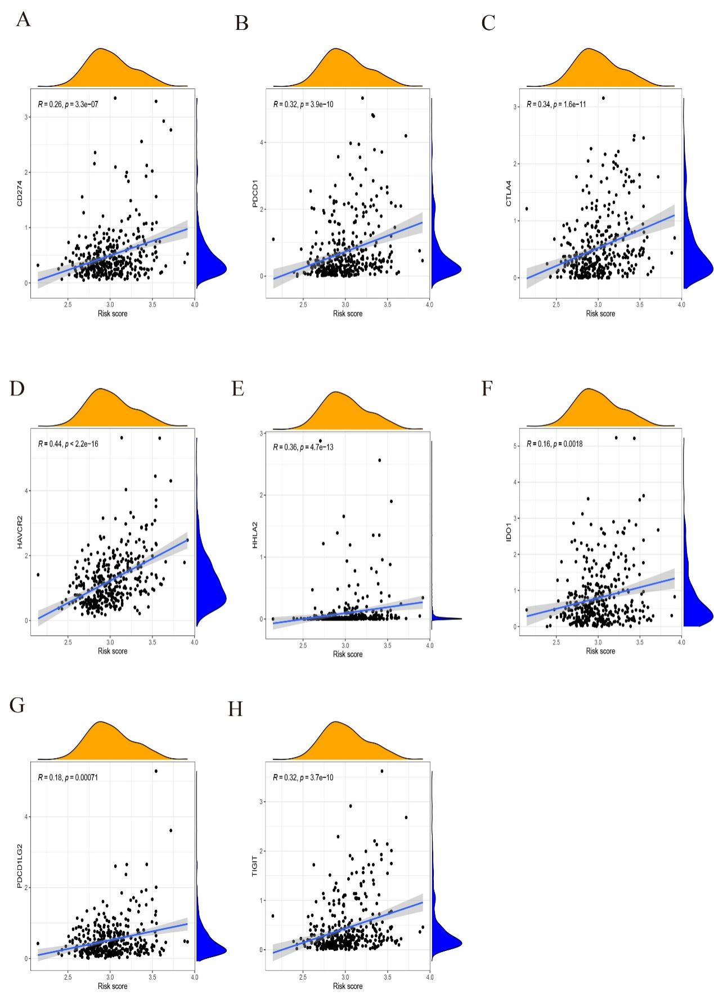
Fig.S4
A-H. Correlation analysis between the risk score and immune checkpoints.

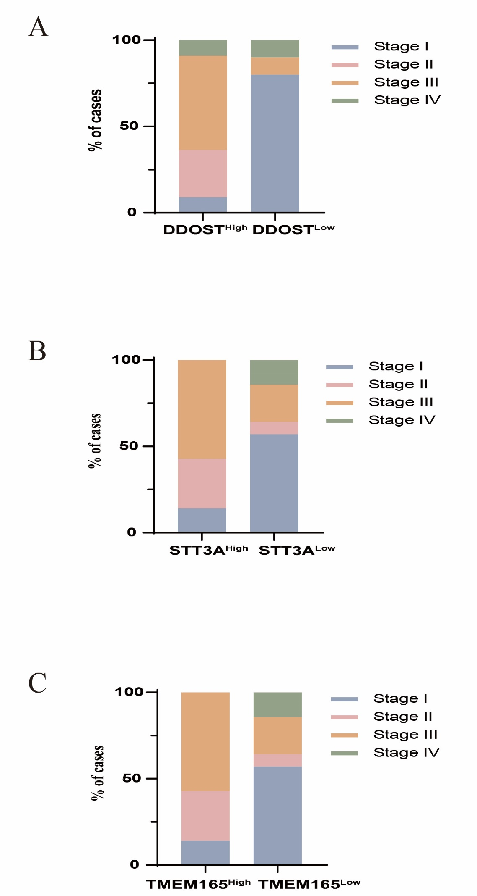
Fig.S5
A-C. Comparison of the different stage in HCC patients with the low and high expression of DDOST, STT3A and TMEM165 in our cohort.

Variables | All cases | Risk Score
Variables | All cases | Low | High
Gender
Male | 19 | 9 | 10
Female | 2 | 1 | 1
Age (years)
<60 | 16 | 6 | 10
≥60 | 5 | 4 | 1
HBV
Negative | 1 | 1 | 0
Positive | 20 | 9 | 11
Cirrhosis
No | 8 | 4 | 4
Yes | 13 | 6 | 7
AFP (ng/ml)
<400 | 10 | 8 | 2
≥400 | 11 | 2 | 9
TNM stage
I-II | 12 | 9 | 3
III-IV | 9 | 5 | 4
Response
CR | 0 | 0 | 0
PR | 2 | 1 | 1
SD | 5 | 4 | 1
PD | 14 | 5 | 9

Table S1. The clinicopathological details of HCC patients who received adjuvant PD-1/PD-L1 antibody treatment with high or low DDOST, STT3A and STMEM165 expression in our cohort.

Genes | Description
ALG1 | ALG1 Chitobiosyldiphosphodolichol Beta-Mannosyltransferase
ALG10 | ALG10 Alpha-1,2-Glucosyltransferase
ALG10B | ALG10 Alpha-1,2-Glucosyltransferase B
ALG11 | ALG11 Alpha-1,2-Mannosyltransferase
ALG12 | ALG12 Alpha-1,6-Mannosyltransferase
ALG14 | ALG14 UDP-N-Acetylglucosaminyltransferase Subunit
ALG2 | ALG2 Alpha-1,3/1,6-Mannosyltransferase
ALG3 | ALG3 Alpha-1,3- Mannosyltransferase
ALG5 | ALG5 Dolichyl-Phosphate Beta-Glucosyltransferase
ALG6 | ALG6 Alpha-1,3-Glucosyltransferase
ALG8 | ALG8 Alpha-1,3-Glucosyltransferase
ALG9 | ALG9 Alpha-1,2-Mannosyltransferase
B4GALNT2 | Beta-1,4-N-Acetyl-Galactosaminyltransferase 2
B4GALT1 | Beta-1,4-Galactosyltransferase 1
B4GALT7 | Beta-1,4-Galactosyltransferase 7
DAD1 | Defender Against Cell Death 1
DDOST | Dolichyl-Diphosphooligosaccharide--Protein Glycosyltransferase Non-Catalytic Subunit
DERL3 | Derlin 3
DHDDS | Dehydrodolichyl Diphosphate Synthase Subunit
DOLK | Dolichol Kinase
DOLPP1 | Dolichyldiphosphatase 1
DPAGT1 | Dolichyl-Phosphate N-Acetylglucosaminephosphotransferase 1
ENTPD5 | Ectonucleoside Triphosphate Diphosphohydrolase 5 (Inactive)
EXT2 | Exostosin Glycosyltransferase 2
FUT3 | Fucosyltransferase 3 (Lewis Blood Group)
FUT5 | Fucosyltransferase 5
FUT6 | Fucosyltransferase 6
FUT8 | Fucosyltransferase 8
FUT9 | Fucosyltransferase 9
GAL3ST1 | Galactose-3-O-Sulfotransferase 1
GFPT1 | Glutamine--Fructose-6-Phosphate Transaminase 1
GFPT2 | Glutamine-Fructose-6-Phosphate Transaminase 2
GORASP1 | Golgi Reassembly Stacking Protein 1
KRTCAP2 | Keratinocyte Associated Protein 2
MAGT1 | Magnesium Transporter 1
MAN1C1 | Mannosidase Alpha Class 1C Member 1
MGAT1 | Alpha-1,3-Mannosyl-Glycoprotein 2-Beta-N-Acetylglucosaminyltransferase
MGAT2 | Alpha-1,6-Mannosyl-Glycoprotein 2-Beta-N-Acetylglucosaminyltransferase
MGAT3 | Beta-1,4-Mannosyl-Glycoprotein 4-Beta-N-Acetylglucosaminyltransferase
MGAT4A | Alpha-1,3-Mannosyl-Glycoprotein 4-Beta-N-Acetylglucosaminyltransferase A
MGAT4B | Alpha-1,3-Mannosyl-Glycoprotein 4-Beta-N-Acetylglucosaminyltransferase B
MGAT4C | Alpha-1,3-Mannosyl-Glycoprotein 4-Beta-N-Acetylglucosaminyltransferase C
MGAT4D | Alpha-1,3-Mannosyl-Glycoprotein 4-Beta-N-Acetylglucosaminyltransferase D
MGAT5 | Alpha-1,6-Mannosylglycoprotein 6-Beta-N-Acetylglucosaminyltransferase
MGAT5B | Alpha-1,6-Mannosylglycoprotein 6-Beta-N-Acetylglucosaminyltransferase B
MLEC | Malectin
MOGS | Mannosyl-Oligosaccharide Glucosidase
MPDU1 | Mannose-P-Dolichol Utilization Defect 1
NUDT14 | Nudix Hydrolase 14
NUS1 | NUS1 Dehydrodolichyl Diphosphate Synthase Subunit
OST4 | Oligosaccharyltransferase Complex Subunit 4, Non-Catalytic
OSTC | Oligosaccharyltransferase Complex Non-Catalytic Subunit
PGM3 | Phosphoglucomutase 3
PMM1 | Phosphomannomutase 1
PMM2 | Phosphomannomutase 2
RFT1 | RFT1 Homolog
RPN1 | Ribophorin I
RPN2 | Ribophorin II
SLC39A8 | Solute Carrier Family 39 Member 8
SRD5A3 | Steroid 5 Alpha-Reductase 3
ST3GAL1 | ST3 Beta-Galactoside Alpha-2,3-Sialyltransferase 1
ST6GAL1 | ST6 Beta-Galactoside Alpha-2,6-Sialyltransferase 1
STT3A | STT3 Oligosaccharyltransferase Complex Catalytic Subunit A
STT3B | STT3 Oligosaccharyltransferase Complex Catalytic Subunit B
TMEM165 | Transmembrane Protein 165
TMEM258 | Transmembrane Protein 258
TUSC3 | Tumor Suppressor Candidate 3
UBE2J1 | Ubiquitin Conjugating Enzyme E2 J1
UGGT1 | UDP-Glucose Glycoprotein Glucosyltransferase 1
UGGT2 | UDP-Glucose Glycoprotein Glucosyltransferase 2

Table S2 70 N-linked glycosylation related genes and their description

gene | lowMean | highMean | logFC | pValue | fdr
ANXA5 | 6.003556 | 7.240652 | 1.237096 | 5.48E-29 | 1.26E-26
AZGP1 | 9.121133 | 7.855424 | -1.26571 | 6.25E-17 | 4.91E-16
F12 | 7.251963 | 6.183978 | -1.06799 | 7.30E-12 | 2.60E-11
SULT2A1 | 8.273201 | 6.850564 | -1.42264 | 9.55E-10 | 2.57E-09
MARCKSL1 | 5.614268 | 6.622252 | 1.007984 | 7.39E-16 | 4.89E-15
SLC38A1 | 2.913497 | 4.124678 | 1.211181 | 7.04E-18 | 6.54E-17
CDC20 | 3.175641 | 4.505128 | 1.329487 | 4.85E-21 | 8.52E-20
TAT | 6.625271 | 4.912683 | -1.71259 | 3.12E-12 | 1.17E-11
PYCR1 | 2.60857 | 3.611598 | 1.003028 | 1.56E-12 | 6.11E-12
PRC1 | 2.983524 | 4.059818 | 1.076294 | 1.93E-24 | 8.38E-23
HPD | 8.920589 | 6.523233 | -2.39736 | 2.68E-17 | 2.25E-16
APOC1 | 11.95662 | 10.84041 | -1.11621 | 3.73E-24 | 1.51E-22
CDO1 | 7.797453 | 6.330912 | -1.46654 | 2.15E-20 | 3.25E-19
MAGEA6 | 1.952812 | 2.986105 | 1.033293 | 2.22E-06 | 4.03E-06
BHMT | 7.205361 | 5.786991 | -1.41837 | 1.10E-09 | 2.93E-09
DCXR | 8.996762 | 7.566408 | -1.43035 | 2.03E-20 | 3.10E-19
S100A6 | 5.388371 | 6.410112 | 1.021741 | 2.14E-09 | 5.53E-09
ZWINT | 3.696844 | 4.835827 | 1.138983 | 4.20E-22 | 9.53E-21
AKR7A3 | 5.701069 | 4.569832 | -1.13124 | 1.85E-10 | 5.45E-10
SLC1A5 | 2.562559 | 3.687747 | 1.125188 | 3.13E-22 | 7.36E-21
ADH1B | 8.614319 | 6.752304 | -1.86202 | 3.14E-14 | 1.60E-13
DPYS | 7.299231 | 6.197692 | -1.10154 | 2.29E-11 | 7.62E-11
CYP3A4 | 6.793001 | 4.758451 | -2.03455 | 6.17E-11 | 1.95E-10
CTSC | 4.014964 | 5.097445 | 1.08248 | 2.78E-21 | 5.10E-20
HGFAC | 4.536267 | 3.342353 | -1.19391 | 2.91E-07 | 5.84E-07
CCL20 | 4.348152 | 5.538433 | 1.190282 | 4.35E-08 | 9.53E-08
PFKFB3 | 2.95171 | 4.067745 | 1.116034 | 2.03E-15 | 1.26E-14
DSG2 | 3.557049 | 4.822558 | 1.265509 | 2.04E-21 | 3.87E-20
RBP4 | 10.71491 | 9.592045 | -1.12287 | 7.14E-23 | 1.95E-21
CCNB2 | 2.717118 | 3.736401 | 1.019284 | 4.85E-22 | 1.08E-20
SPP1 | 5.51301 | 7.757279 | 2.244269 | 3.55E-13 | 1.54E-12
FETUB | 4.731935 | 3.697203 | -1.03473 | 2.81E-08 | 6.29E-08
PLG | 8.66496 | 7.60943 | -1.05553 | 2.66E-09 | 6.76E-09
ABCB4 | 5.579814 | 4.464604 | -1.11521 | 1.19E-10 | 3.60E-10
CYP2C8 | 6.290982 | 5.053717 | -1.23726 | 1.07E-10 | 3.27E-10
CYP2C9 | 7.099798 | 5.578574 | -1.52122 | 2.71E-15 | 1.66E-14
RGN | 6.94453 | 5.848414 | -1.09612 | 8.54E-20 | 1.15E-18
SPP2 | 6.709771 | 4.985928 | -1.72384 | 2.13E-12 | 8.18E-12
CXCL1 | 2.1837 | 3.374068 | 1.190369 | 1.95E-12 | 7.51E-12
MMD | 3.8737 | 4.95423 | 1.08053 | 1.94E-26 | 1.55E-24
TOP2A | 3.372189 | 4.814013 | 1.441825 | 5.65E-25 | 3.06E-23
CES2 | 7.776762 | 6.543222 | -1.23354 | 1.30E-13 | 6.05E-13
HPX | 9.995639 | 8.837653 | -1.15799 | 4.04E-13 | 1.74E-12
MELK | 2.503293 | 3.514057 | 1.010765 | 1.17E-24 | 5.40E-23
ADH6 | 6.400835 | 5.352164 | -1.04867 | 8.92E-13 | 3.64E-12
MUC13 | 3.231963 | 4.266987 | 1.035024 | 7.37E-06 | 1.27E-05
LAMB1 | 3.604595 | 4.756615 | 1.15202 | 1.01E-19 | 1.34E-18
SAA1 | 8.039173 | 7.0341 | -1.00507 | 0.003295 | 0.004274
FMO3 | 7.534589 | 6.248853 | -1.28574 | 4.72E-11 | 1.51E-10
FABP1 | 9.463716 | 8.311014 | -1.1527 | 1.98E-08 | 4.52E-08
SDS | 6.200846 | 5.111449 | -1.0894 | 0.000767 | 0.001061
TPX2 | 3.503676 | 4.736982 | 1.233306 | 4.12E-24 | 1.65E-22
LAPTM4B | 5.697398 | 6.831528 | 1.134131 | 4.36E-15 | 2.57E-14
APOA2 | 13.42286 | 12.27808 | -1.14478 | 1.37E-08 | 3.19E-08
MMP12 | 1.596669 | 2.654388 | 1.057718 | 1.29E-18 | 1.37E-17
CYP2A6 | 6.892888 | 4.886903 | -2.00599 | 1.15E-10 | 3.48E-10
SPINK1 | 6.042937 | 7.504744 | 1.461808 | 2.67E-05 | 4.32E-05
FBP1 | 7.281914 | 6.213178 | -1.06874 | 8.77E-12 | 3.08E-11
AOX1 | 7.566147 | 6.442622 | -1.12353 | 2.94E-08 | 6.56E-08
FABP4 | 3.764631 | 2.706533 | -1.0581 | 9.09E-14 | 4.34E-13
MMP7 | 2.0494 | 3.226823 | 1.177423 | 7.04E-13 | 2.92E-12
SPINT1 | 2.203461 | 3.354014 | 1.150553 | 4.19E-13 | 1.80E-12
CYP1A2 | 3.829156 | 2.794447 | -1.03471 | 3.79E-07 | 7.52E-07
HAO1 | 7.489318 | 6.236055 | -1.25326 | 4.09E-15 | 2.43E-14
AFP | 3.807872 | 5.144806 | 1.336934 | 0.000198 | 0.00029
APOF | 5.213093 | 3.898183 | -1.31491 | 1.20E-11 | 4.16E-11
ACSL4 | 4.936171 | 5.949252 | 1.013082 | 4.03E-06 | 7.13E-06
BAAT | 8.280765 | 7.140377 | -1.14039 | 4.40E-14 | 2.20E-13
ETNK2 | 5.493247 | 4.464655 | -1.02859 | 3.01E-13 | 1.31E-12
PFKFB1 | 4.062192 | 3.043203 | -1.01899 | 3.93E-13 | 1.69E-12
TTR | 10.44213 | 8.939695 | -1.50244 | 4.42E-15 | 2.60E-14
CPS1 | 8.100099 | 6.714144 | -1.38595 | 2.06E-07 | 4.19E-07
ITGAV | 4.469433 | 5.471644 | 1.002212 | 5.70E-20 | 7.93E-19
BUB1B | 2.270037 | 3.303831 | 1.033794 | 3.33E-28 | 5.70E-26
GINS1 | 2.791682 | 3.904587 | 1.112905 | 4.08E-25 | 2.24E-23
LGALS3 | 5.171889 | 6.174083 | 1.002194 | 4.78E-11 | 1.53E-10
SLC10A1 | 6.939579 | 4.79813 | -2.14145 | 3.57E-16 | 2.50E-15
F9 | 7.187793 | 6.025504 | -1.16229 | 6.62E-07 | 1.28E-06
CYP2B6 | 4.629665 | 3.499751 | -1.12991 | 5.17E-11 | 1.65E-10
AFM | 6.454044 | 5.085855 | -1.36819 | 2.54E-10 | 7.34E-10
ALDH1L1 | 5.464901 | 4.317757 | -1.14714 | 7.16E-11 | 2.24E-10
KRT19 | 1.908369 | 3.163578 | 1.255209 | 1.55E-09 | 4.04E-09
ASNS | 2.29752 | 3.322045 | 1.024524 | 1.82E-15 | 1.14E-14
NUSAP1 | 3.751399 | 4.876308 | 1.124909 | 2.28E-22 | 5.62E-21
CFHR4 | 5.628599 | 4.394628 | -1.23397 | 2.35E-10 | 6.83E-10
HSD17B6 | 8.381379 | 6.968212 | -1.41317 | 1.71E-13 | 7.78E-13
S100P | 3.459447 | 4.793417 | 1.333971 | 9.18E-07 | 1.74E-06
TESC | 2.964129 | 3.989827 | 1.025698 | 6.20E-08 | 1.33E-07
APOC3 | 12.2735 | 10.81984 | -1.45366 | 1.68E-15 | 1.06E-14
CD24 | 4.764573 | 6.480154 | 1.715581 | 4.39E-15 | 2.59E-14
PNMA1 | 3.171182 | 4.246977 | 1.075795 | 3.24E-27 | 3.33E-25
C8A | 7.185317 | 6.098597 | -1.08672 | 4.18E-10 | 1.18E-09
SLC2A2 | 7.896304 | 6.840772 | -1.05553 | 5.07E-10 | 1.41E-09
ATP1B3 | 4.575404 | 5.61292 | 1.037516 | 5.27E-21 | 9.16E-20
ECT2 | 2.420613 | 3.654419 | 1.233806 | 3.08E-33 | 5.81E-30
PCK1 | 7.61792 | 5.910739 | -1.70718 | 6.33E-12 | 2.27E-11
ALDOB | 10.20893 | 8.968506 | -1.24043 | 6.82E-08 | 1.46E-07
NR1I3 | 5.316171 | 3.859931 | -1.45624 | 4.72E-18 | 4.55E-17
MCM2 | 3.319991 | 4.401381 | 1.08139 | 6.83E-21 | 1.16E-19
CCNB1 | 3.47639 | 4.744144 | 1.267753 | 1.87E-24 | 8.21E-23
UPB1 | 6.27062 | 4.944048 | -1.32657 | 1.05E-13 | 4.93E-13
CYP4F2 | 6.19775 | 4.815332 | -1.38242 | 1.79E-16 | 1.32E-15
PON1 | 6.904406 | 5.625366 | -1.27904 | 1.64E-13 | 7.46E-13
HSD11B1 | 7.121447 | 5.732631 | -1.38882 | 1.62E-06 | 2.99E-06
CA9 | 1.658612 | 3.042859 | 1.384247 | 2.96E-20 | 4.30E-19
IER3 | 4.646018 | 5.842944 | 1.196927 | 1.85E-13 | 8.37E-13
GPC3 | 7.011035 | 8.152227 | 1.141191 | 1.21E-05 | 2.02E-05
NT5DC2 | 2.677442 | 3.702321 | 1.024879 | 1.10E-16 | 8.32E-16
MYBL2 | 2.776536 | 4.025072 | 1.248535 | 2.63E-21 | 4.85E-20
ATP1A1 | 6.237704 | 7.28255 | 1.044846 | 6.28E-28 | 8.71E-26
AQP9 | 7.594768 | 5.760866 | -1.8339 | 1.04E-13 | 4.90E-13
CYP2E1 | 7.487829 | 5.745428 | -1.7424 | 5.38E-09 | 1.32E-08
KIF4A | 2.336716 | 3.362783 | 1.026067 | 1.92E-25 | 1.18E-23
PIPOX | 7.579592 | 6.466514 | -1.11308 | 7.90E-14 | 3.81E-13
OTC | 6.722575 | 5.378849 | -1.34373 | 1.75E-11 | 5.94E-11
CRP | 6.953561 | 8.056059 | 1.102498 | 0.003104 | 0.00404
COL3A1 | 5.249534 | 6.449614 | 1.200079 | 7.90E-10 | 2.15E-09
GAL3ST1 | 2.322857 | 3.368393 | 1.045536 | 2.49E-11 | 8.27E-11
SPHK1 | 2.329972 | 3.3739 | 1.043928 | 3.19E-15 | 1.93E-14
COL1A1 | 4.132289 | 5.27309 | 1.140801 | 1.35E-11 | 4.64E-11
PCK2 | 7.70713 | 6.632633 | -1.0745 | 4.60E-17 | 3.71E-16
TNFRSF21 | 3.293118 | 4.325123 | 1.032005 | 1.53E-16 | 1.13E-15
LECT2 | 6.695587 | 5.124728 | -1.57086 | 1.06E-12 | 4.26E-12
SERPINA4 | 7.067249 | 6.050219 | -1.01703 | 2.74E-12 | 1.04E-11
RGS2 | 3.39663 | 4.602972 | 1.206342 | 6.87E-15 | 3.92E-14
PLP2 | 4.666466 | 5.719535 | 1.053069 | 3.44E-12 | 1.28E-11
CAPG | 3.240154 | 4.243245 | 1.003092 | 2.13E-13 | 9.51E-13
HRG | 9.273837 | 7.818997 | -1.45484 | 7.66E-10 | 2.09E-09
GSTA1 | 8.221203 | 6.996488 | -1.22471 | 1.34E-08 | 3.14E-08
AGXT | 8.193687 | 6.861132 | -1.33256 | 1.19E-13 | 5.58E-13
EPHX1 | 10.84262 | 9.841492 | -1.00113 | 4.81E-11 | 1.54E-10
ICAM1 | 3.843362 | 4.863688 | 1.020326 | 8.47E-17 | 6.52E-16
SLC27A5 | 6.722519 | 4.725064 | -1.99745 | 5.86E-27 | 5.58E-25
G6PD | 3.194235 | 4.544854 | 1.350618 | 1.19E-24 | 5.48E-23
HPR | 7.830219 | 5.997577 | -1.83264 | 4.72E-17 | 3.79E-16
MMP9 | 2.791178 | 3.887977 | 1.0968 | 4.22E-12 | 1.56E-11
DDR1 | 2.787402 | 3.795038 | 1.007636 | 1.26E-18 | 1.34E-17
RRM2 | 3.665019 | 4.782497 | 1.117478 | 1.49E-20 | 2.33E-19
FTCD | 7.02104 | 5.66246 | -1.35858 | 1.24E-21 | 2.49E-20
C6 | 6.917033 | 5.858932 | -1.0581 | 1.98E-08 | 4.52E-08
MAT1A | 8.525247 | 7.468528 | -1.05672 | 1.10E-16 | 8.32E-16
SOX9 | 3.545785 | 4.736838 | 1.191053 | 1.43E-13 | 6.60E-13
HP | 8.940492 | 7.598186 | -1.34231 | 1.88E-12 | 7.27E-12
IGFBP2 | 7.307103 | 6.083491 | -1.22361 | 4.04E-09 | 1.01E-08
ADH1A | 8.257616 | 7.157148 | -1.10047 | 1.64E-08 | 3.79E-08
CYP4A11 | 6.725331 | 5.295731 | -1.4296 | 1.06E-14 | 5.85E-14
DAO | 4.786994 | 3.786292 | -1.0007 | 4.01E-11 | 1.29E-10
GNMT | 6.142759 | 4.493829 | -1.64893 | 2.76E-13 | 1.21E-12
AHSG | 10.86252 | 9.669344 | -1.19318 | 2.07E-06 | 3.78E-06
CYP27A1 | 8.138557 | 7.092258 | -1.0463 | 2.56E-16 | 1.83E-15
ITIH1 | 9.129613 | 8.016446 | -1.11317 | 6.88E-16 | 4.56E-15
SOX4 | 2.908469 | 4.055654 | 1.147184 | 1.15E-17 | 1.04E-16
MASP2 | 5.691778 | 4.521742 | -1.17004 | 3.89E-12 | 1.45E-11
RDH16 | 6.024858 | 4.638821 | -1.38604 | 7.06E-13 | 2.92E-12
S100A11 | 5.891126 | 7.049702 | 1.158577 | 3.28E-14 | 1.67E-13
LMNB1 | 2.828866 | 3.865643 | 1.036776 | 6.48E-23 | 1.79E-21
HIF1A | 5.212642 | 6.21608 | 1.003439 | 2.53E-24 | 1.06E-22
KNG1 | 10.41555 | 9.362927 | -1.05262 | 3.06E-11 | 1.00E-10
AGR2 | 1.609635 | 2.76443 | 1.154795 | 4.31E-09 | 1.07E-08
KIF20A | 2.435225 | 3.483232 | 1.048007 | 9.09E-24 | 3.27E-22
COL1A2 | 4.695371 | 5.895602 | 1.200231 | 9.51E-12 | 3.33E-11
GYS2 | 4.782422 | 3.476739 | -1.30568 | 4.62E-12 | 1.69E-11
PEG10 | 3.781865 | 4.865845 | 1.083979 | 1.74E-06 | 3.20E-06
SERPINC1 | 11.04788 | 9.24289 | -1.80499 | 2.41E-20 | 3.59E-19
CCL16 | 6.35178 | 4.958199 | -1.39358 | 3.92E-12 | 1.45E-11
SLC22A1 | 5.983318 | 4.324335 | -1.65898 | 1.13E-09 | 3.00E-09
APOA1 | 12.11822 | 10.71445 | -1.40377 | 5.27E-11 | 1.68E-10
SEC14L2 | 5.054727 | 3.804101 | -1.25063 | 2.48E-16 | 1.78E-15
SAA4 | 7.42319 | 6.232799 | -1.19039 | 1.84E-09 | 4.76E-09
CLGN | 2.573868 | 3.773141 | 1.199273 | 4.32E-15 | 2.56E-14
IGHG1 | 3.520452 | 4.564451 | 1.043998 | 0.000145 | 0.000216
FOXM1 | 2.461459 | 3.512177 | 1.050718 | 8.37E-25 | 4.20E-23
GLYAT | 5.147303 | 3.337435 | -1.80987 | 5.03E-19 | 5.78E-18

Table S3 173 DEGs were identified between high and low risk group in TCGA cohort

