Supplementary materials
Supplementary Table 1 Quantitative analysis of three major bioactive components in the SNS by HPLC
Compound | paeoniflorin | liquiritin | hesperidin
Contents (mg/g) | 3.14 | 0.69 | 0.69

Supplementary Table 2 Qualitative analysis of three major bioactive components
in the SNS by HPLC-MS
Number | Name | Retention  (min) | Measured  (m/z) | chemical formula | chemical structure
1 | paeoniflorin | 8.31 | 525.1618 | C₂₃H₂₈O₁₁ | 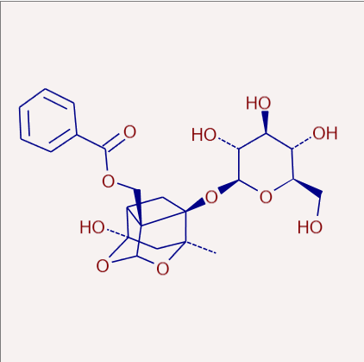
2 | liquiritin | 10.10 | 417.1196 | C₂₁H₂₂O₉ | 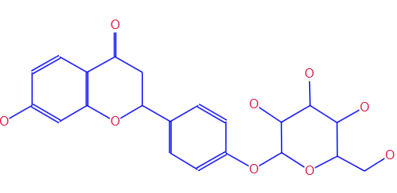
3 | hesperidin | 12.07 | 609.1830 | C₂₈H₃₄O₁₅ | 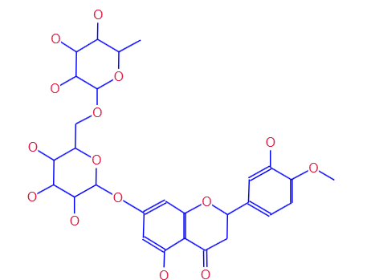

Supplementary Figure 1 (A) The body weight was weighed once per week during the experimental period. The data are stated as the means ± SD, n = 8, * vs. CON group (P < 0.05). (B) The average amount of food intake in each group was recorded daily during the experimental period.

Supplementary Figure 2 The cytotoxicity of SNS-containing serum. The data are stated as the means ± SD, n = 6, * vs. blank serum group (P < 0.05).

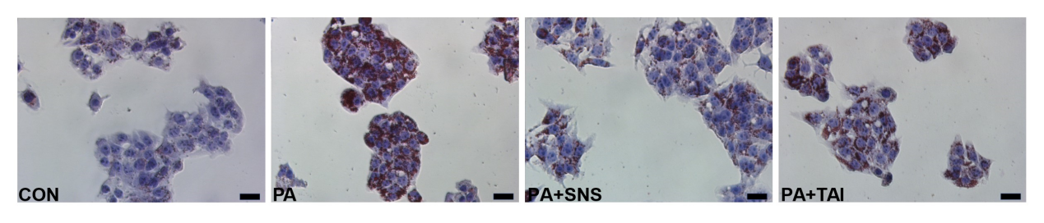
Supplementary Figure 3 Effects of the mix of the three bioactive components (paeoniflorin, liquiritin and hesperidin) on PA-induced lipid deposition in HepG2 cell. Photos of HepG2 cells stained with Oil red O. Scale bar = 50 µm (magnification 400×). Cells were obtained from control group (CON), PA group (PA), PA + SNS medicated serum group (PA + SNS), and PA + three active ingredients group (PA + TAI).

