Supplementary Figure 1. Example of calculation of PDC and MPR
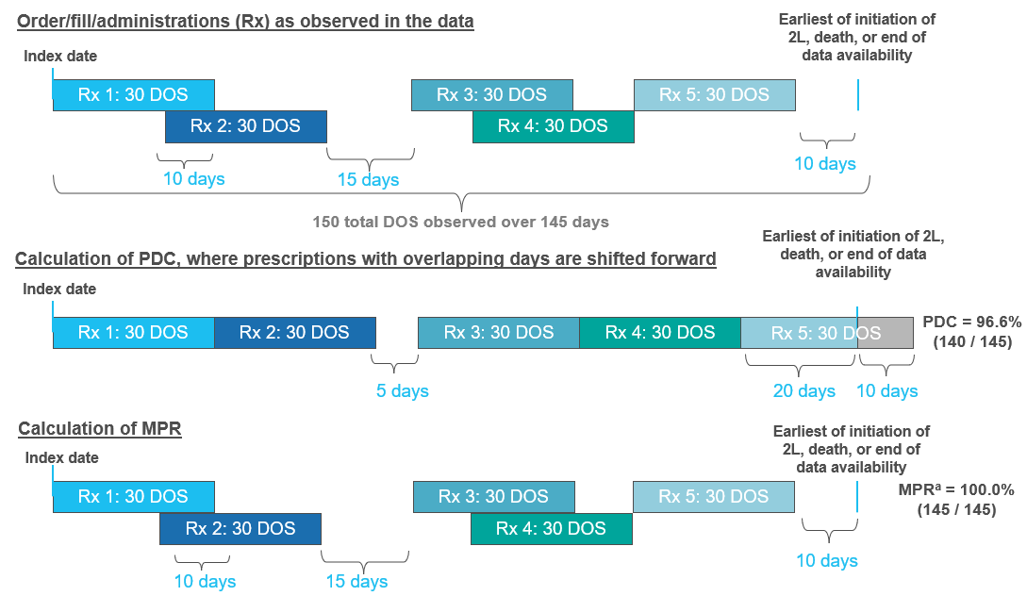
Abbreviations: 2L: second line; DOS: days of supply; MPR: medication possession ratio; PDC: proportion of days covered.
Note:
- MPR capped at 100%.

