Appendix for “Anxiety, depression and inflammatory skin disease: a comparison of associations in UK Biobank and linked primary care data”

Exposure & Outcomes in UK Biobank
We used the UK Biobank Data-Field 20002 to define anxiety/depression and eczema/psoriasis at recruitment. Participants had completed a touchscreen assessment before being asked “In the touch screen you selected that you have been told by a doctor that you have other serious illnesses or disabilities, could you now tell me what they are?”. Responses to this question were placed within a coding tree by the interview (a trained nurse). We were not able to use responses from the touch screen questionnaire because it does not distinguish between eczema/asthma/hay fever (Data-Field 6152) and anxiety/depression was not assessed.
We used PHQ-9/GAD-7 scores to define anxiety/depression outcomes at the mental health follow-up survey as detailed in Appendix Section “PHQ-9/GAD-7 scores”. Further information relating to depression and anxiety was available in Data-Field 20446 ("Have you ever had a time in your life when you felt sad, blue, or depressed for two weeks or more in a row?") and Data-Field 20421 ("Have you ever had a period lasting one month or longer when most of the time you felt worried, tense, or anxious?"), which we considered to have low specificity for depression/anxiety, and therefore did not use this information to define anxiety/depression outcomes. We report the number of people with and without eczema/psoriasis who responded yes to these question in Supplementary Table 2.

PHQ-9/GAD-7 scores
The PHQ-9/GAD-7 scores are calculated by assigning scores of 0 (“not at all”), 1 (“several days”), 2 (“more than half the days”), and 3 (“nearly every day”), and adding together the scores for the seven/nine questions. For each question the respondent is asked to judge “Over the last 2 weeks, how often have you been bothered by any of the following problems?”.
The questions for PHQ-9 are “Little interest or pleasure in doing things”, “Feeling down, depressed, or hopeless”, “Trouble falling or staying asleep, or sleeping too much”, “Feeling tired or having little energy”, “Poor appetite or overeating”, “Feeling bad about yourself or that you are a failure or have let yourself or your family down”, “Trouble concentrating on things, such as reading the newspaper or watching television”, “Moving or speaking so slowly that other people could have noticed? Or the opposite - being so fidgety or restless that you have been moving around a lot more than usual”, and “Thoughts that you would be better off dead or of hurting yourself in some way”.(20)
The questions for GAD-7 are “Becoming easily annoyed or irritable”, “Feeling afraid as if something awful might happen”, “Feeling nervous, anxious or on edge”, “Not being able to stop or control worrying”, “Being so restless that it is hard to sit still”, “Trouble relaxing”, “Worrying too much about different things”.(21)
A GAD-7 score of >= 10 has been found to have a sensitivity of 89% and a specificity of 82% for Generalised Anxiety Disorder.(30) A PHQ-9 score of ≥10 has been found to have a sensitivity of 88% and a specificity of 88% for major depression.(20)

Covariates
Age and sex were ascertained at recruitment. Ethnicity (Data-Field 21000) was ascertained at recruitment with categories White, Mixed, Asian or Asian British, Black or Black British, Chinese, Other ethnic group, Do not know, Prefer not to answer. Deprivation (Data-Field 189) was ascertained at recruitment using deciles of the Townsend deprivation index at recruitment based on the preceding national census output areas. (31)

Codelists
Lists of primary care clinical codes included Read Code Version 2 (Read V2) morbidity codes (for diagnoses and symptoms), and Dictionary of Medicines and Devices (DM+D) prescription codes. Linked data from UK Biobank comes from a range of primary care providers using different coding frameworks. To capture all recorded illnesses, we converted the Read V2 codes to Read Codes Clinical Terms Version 3 (CTV3) format using a mapping file available from UK Biobank.(32) We used a mapping file available from the NHS Business Service Authority to map prescription codes from DM+D to British National Formulary (BNF) codes.(33) We checked the 5 more prevalent clinical codes recorded in linked GP data for each disease (Supplementary Table 3).

Supplementary Tables
Characteristic | all UK Biobank Participants | without LINKED PRIMARY CARE DATA | with LINKED PRIMARY CARE DATA | WITH & DIDn’t RESPOND TO SURVEY | WITH & RESPONDED TO SURVEY
 | N = 502,409 | N = 272,362 | N = 230,047 | N = 159,166 | N = 70,881
SEX FEMALE | 273,325 (54%) | 147,570 (54%) | 125,755 (55%) | 85,487 (54%) | 40,268 (57%)
ETHNICITY “BRITISH” | 442,514 (88%) | 236,677 (87%) | 205,837 (90%) | 140,917 (89%) | 64,920 (92%)
age at recruitment¹ | 58 (50, 63) | 58 (50, 63) | 58 (50, 63) | 58 (50, 64) | 57 (50, 62)
Deprivation^{a,b} | -2.14 (-3.64, 0.55) | -2.1 (-3.6, 0.6) | -2.14 (-3.64, 0.48) | -1.98 (-3.55, 0.81) | -2.45 (-3.81, -0.23)
emplOyment
paid or self-employed | 287,080 (57%) | 156,460 (58%) | 130,620 (57%) | 85,895 (54%) | 44,725 (63%)
Retired | 166,968 (33%) | 89,433 (33%) | 77,535 (34%) | 56,183 (35%) | 21,352 (30%)
year of study entry
2006 | 3,796 (0.8%) | 3,640 (1.3%) | 156 (<0.1%) | 113 (<0.1%) | 43 (<0.1%)
2007 | 49,808 (9.9%) | 30,721 (11%) | 19,087 (8.3%) | 13,609 (8.6%) | 5,478 (7.7%)
2008 | 187,157 (37%) | 98,017 (36%) | 89,140 (39%) | 64,096 (40%) | 25,044 (35%)
2009 | 173,407 (35%) | 89,881 (33%) | 83,526 (36%) | 55,912 (35%) | 27,614 (39%)
2010 | 88,241 (18%) | 50,103 (18%) | 38,138 (17%) | 25,436 (16%) | 12,702 (18%)
RESPONDED TO SURVEY | 157,313‬ (31%) | 86,432‬ (32%) | 70,881 (31%) | 0 (0%) | 70,881 (100%)
ECZEMA AT RECRUITMENT | 12,545 (2.5%) | 6,940 (2.5%) | 5,605 (2.4%) | 3,704 (2.3%) | 1,901 (2.7%)
PSORIASIS AT RECRUITMENT | 5,574 (1.1%) | 3,010 (1.1%) | 2,564 (1.1%) | 1,804 (1.1%) | 760 (1.1%)
ANXIETY AT RECRUITMENT | 6,723 (1.3%) | 3,481 (1.3%) | 3,242 (1.4%) | 2,324 (1.5%) | 918 (1.3%)
DEPRESSION AT RECRUITMENT | 28,199 (5.6%) | 14,873 (5.5%) | 13,326 (5.8%) | 9,703 (6.1%) | 3,623 (5.1%)
ª median (interquartile range)
^{b} Townsend deprivation index at recruitment (positive values indicate higher material deprivation, negative values indicate higher affluence, 0 represents an area with mean values)
Supplementary Table 1: Baseline characteristics of UK Biobank participants with and without linked primary care data, and of those with linked primary care data, those who did and did not respond to the mental health follow-up survey.
UK Biobank mental health follow-up survey (in 2016) compared to primary care morbidity coding prior to survey
 | Ever felt worried, tense, or anxious for one month or longer? | Ever felt sad, blue, or depressed for two weeks or more in a row?
No Eczema  n=66,253 (100%) | 16,570  (25%) | 36,266  (55%)
Eczema  n=4,628 (100%) | 1,263  (27%) | 2,698  (58%)
No Psoriasis  n=68,584 (100%) | 17,209  (25%) | 37,603  (55%)
Psoriasis  n=2,294 (100%) | 624  (27%) | 1,361  (59%)
Supplementary Table 2: Number of people with and without eczema/psoriasis (based on recruitment interview and/or primary care data up to survey) who responded yes to the question "Have you ever had a time in your life when you felt sad, blue, or depressed for two weeks or more in a row?"/"Have you ever had a period lasting one month or longer when most of the time you felt worried, tense, or anxious?". Percentages are row percentages.

Recorded medical code in linked records | N | %
Eczema
Eczema nos | 12,859 | 41.2
Eczema | 4,926 | 15.8
Atopic dermatitis/eczema | 4,904 | 15.7
Atopic dermatitis | 4,272 | 13.7
Atopic eczema/dermatitis nos | 2,299 | 7.4
Psoriasis
Psoriasis nos | 4,120 | 42.2
Psoriasis and similar disorders | 1,176 | 12.0
Psoriasis | 1,088 | 11.1
Psoriasis unspecified | 867 | 8.9
Scalp psoriasis | 548 | 5.6
Anxiety
Anxiety state nos | 7,752 | 22.6
Mixed anxiety and depressive disorder | 6,692 | 19.5
Anxiousness | 4,338 | 12.6
Anxiety states | 3,371 | 9.8
Anxiety with depression | 2,630 | 7.7
Depression
Depressed mood | 8,095 | 15.4
Depressive disorder nec | 5,715 | 10.9
Mixed anxiety and depressive disorder | 5,710 | 10.9
Depression nos | 4,529 | 8.6
[X]depressive episode, unspecified | 3,393 | 6.5
Supplementary Table 3: The five more prevalent clinical codes recorded in linked GP data for each disease. N denotes the number of people with at least one record with the description, % is the percentage of total codes matching this description. This table shows records of diagnoses or symptoms only and does not include prescription data.

Supplementary Figures
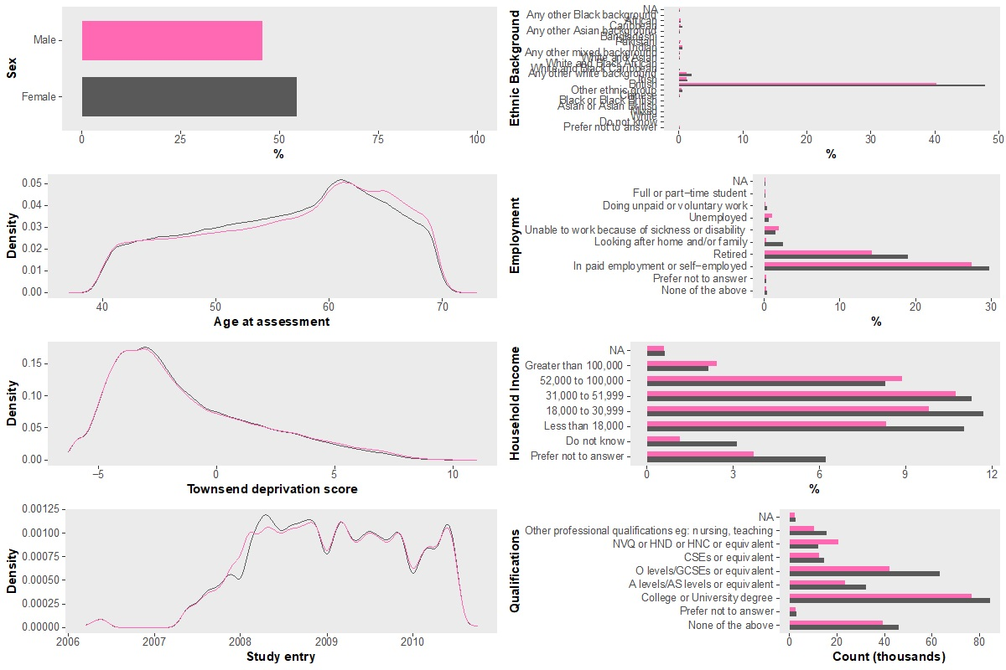
Supplementary Figure 1: Characteristics of the population at recruitment.

