1-year prospective study of the relationship of serial exhaled nitric oxide level and asthma control
Fanny Wai San Ko¹, Ka Pang Chan¹, Joyce Ka Ching Ng¹, Jenny CL Ngai¹, Wing Ho Yip¹, Rachel Lai Ping Lo¹, Tat On Chan², David Shu Cheong Hui¹
¹Department of Medicine and Therapeutics, The Chinese University of Hong Kong
²The Jockey Club School of Public Health and Primary Care, The Chinese University of Hong Kong
Supplementary information

Sample size calculations
Determination of sample size
Some previous studies that used FeNO to adjust FeNO treatment used these levels: maintained inhaled corticosteroid (ICS) dose if FeNO level <24ppb for women and <26ppb for men¹; if FeNO was >26ppb, ICS dose was increased² (i.e. FENO level of about 25 ppb was considered to be able to achieve a reasonable level of asthma control). Our previous study showed healthy adult subjects had a geometric mean FeNO of 32.6 (95% reference interval (RI) 31.4–33.7) ppb.³A sample size of 40 asthma subjects would be able to detect a difference of FeNO level of 7.6 ppb (32.6ppb -25ppb) for well-controlled asthma when compared to the study by Syk et al.¹ and Shaw et al.² in order to achieve 80% power in detecting the difference at a 5% significant level. As we had subjects with different levels of asthma control, we planned a total sample size of 3 times the estimated number for those with well-controlled asthma. Assuming a dropout rate of 10% during the study period, we needed at least 132 subjects.
References:
1 Syk J, Malinovschi A, Johansson G, Unden AL, Andreasson A, Lekander M, Alving K. Anti-inflammatory treatment of atopic asthma guided by exhaled nitric oxide: a randomized, controlled trial. J Allergy Clin Immunol Pract. 2013; 1: 639-48 e1-8.
2 Shaw DE, Berry MA, Thomas M, Green RH, Brightling CE, Wardlaw AJ, Pavord ID. The use of exhaled nitric oxide to guide asthma management: a randomized controlled trial. Am J Respir Crit Care Med. 2007; 176: 231-7.
3 Ko FW, Leung TF, Wong GW, Chu JH, Sy HY, Hui DS. Determinants of, and reference equation for, exhaled nitric oxide in the Chinese population. Eur Respir J. 2013; 42: 767-75.

Supplementary Table 1: Number of subjects with FeNO levels of ≤25, 26-50 and >50 with different levels of asthma control.
 | n | FeNO level  ≤25 ppb | FeNO level  26-50 ppb | FENO level  >50 ppb | p value*
GINA
--- controlled | 48 | 23 (47.9%) | 15 (31.3%) | 10 (20.8%) | 0.239
--- Partly controlled | 49 | 22 (44.9%) | 13 (26.5%) | 14 (28.6%)
--- uncontrolled | 39 | 11 (28.2%) | 12 (30.8%) | 16 (41.1%)
ACT
--- 20-25 | 85 | 38 (44.7%) | 25 (29.4%) | 22 (25.9%) | 0.679
--- 19-16 | 31 | 11(35.5%) | 8 (25.8%) | 12 (38.7%)
---<16 | 20 | 7 (35.0%) | 7 (35.0%) | 6 (30.0%)
ACQ
---≤0.75 | 79 | 33 (41.8%) | 23 (29.1%) | 23 (29.1%) | 0.520
--- 0.75–1.5 | 30 | 10 (33.3%) | 12 (40.0%) | 8 (26.7%)
--- ≥1.5 | 27 | 13 (48.1%) | 5 (18.5%) | 9 (33.3%)
Data are presented as number (%)
P* value by comparisons using Chi-square test
GINA: Global Initiative of Asthma level of asthma control; ACT: Asthma Control Test; ACQ: Asthma Control Questionnaire

Supplementary Table 2: Eosinophil levels and asthma control at baseline visit.

 | n | eosinophils <0.3X10⁹/L | eosinophils ≥0.3X10⁹/L | p value* | eosinophils <0.15 X10⁹/L | eosinophils  ≥0.15 X10⁹/L | p value*
GINA
--- controlled | 48 | 26 (54.2%) | 22 (45.8%) | 0.677 | 15 (31.3%) | 33 (68.8%) | 0.533
--- Partly controlled | 49 | 30 (61.2%) | 19 (38.8%) |  | 16 (32.7%) | 33 (67.3%)
--- uncontrolled | 38 | 20 (52.6%) | 18 (47.4%) |  | 16 (42.1%) | 22 (57.9%)
ACT
--- 20-25 | 85 | 50 (58.8%) | 35 (41.2%) | 0.598 | 29 (34.1%) | 56 (65.9%) | 0.759
--- 19-16 | 31 | 15 (48.4%) | 16 (51.6%) |  | 10 (32.3%) | 21 (67.7%)
---<16 | 19 | 11 (57.9%) | 8 (42.1%) |  | 8 (42.1%) | 11 (57.9%)
ACQ
---≤0.75 | 79 | 43 (54.4%) | 36 (45.6%) | 0.514 | 25 (31.6%) | 54 (68.4%) | 0.619
--- 0.75–1.5 | 29 | 19 (65.5%) | 10 (34.5%) |  | 12 (41.4%) | 17 (58.6%)
--- ≥1.5 | 27 | 14 (51.9%) | 13 (48.1%) |  | 10 (37.0%) | 17 (63.0%)
Data are presented as number (%)
P* value by comparisons using Chi-square test
GINA: Global Initiative of Asthma level of asthma control; ACT: Asthma Control Test; ACQ: Asthma Control Questionnaire

Supplementary Table 3: Inhaled corticosteroid doses and asthma control at baseline visit.

 | n | Low dose inhaled corticosteroid | Medium dose inhaled corticosteroid | High dose inhaled corticosteroid | p value*
GINA
--- controlled | 47 | 10 (21.3%) | 23 (48.9%) | 14 (29.8%) | 0.152
--- Partly controlled | 47 | 7 (14.9%) | 14 (29.8%) | 26 (55.3%)
--- uncontrolled | 31 | 4 (12.9%) | 13 (41.9%) | 14 (45.2%)
ACT
--- 20-25 | 82 | 15 (18.3%) | 36 (43.9%) | 31 (37.8%) | 0.425
--- 19-16 | 25 | 3 (12.0%) | 7 (28.0%) | 15 (60.0%)
---<16 | 18 | 3 (16.7%) | 7 (38.9%) | 8 (44.4%)
ACQ
---≤0.75 | 75 | 15 (20.0%) | 35 (46.7%) | 25 (33.3%) | 0.113
--- 0.75–1.5 | 26 | 3 (11.5%) | 8 (30.8%) | 15 (57.7%)
--- ≥1.5 | 24 | 3 (12.5%) | 7 (29.2%) | 14 (58.3%)

Data are presented as number (%)
P* value by comparisons of the median levels using Chi-square test
GINA: Global Initiative of Asthma level of asthma control; ACT: Asthma Control Test;
ACQ: Asthma Control Questionnaire

Supplementary Table 4: Inhaled corticosteroid doses and FeNO levels at baseline visit.

 |  | Low dose inhaled corticosteroid  (n= 21) | Medium dose inhaled corticosteroid  (n= 50) | High dose inhaled corticosteroid  (n= 54) | p value*
FeNO level (ppb) |  | 31 (17, 66) | 34 (21, 52) | 28.5 (17, 61) | 0.878

Data are presented as median (IQR)
P* value by comparisons of the median levels using Kruskal-Wallis test

Supplementary Table 5: Changes in asthma control and FeNO levels over time (For subjects with eosinophils ≥0.15 X10⁹/L, n=88)
Change of level of control | n | Mean (SD) |  | Median [IQR] | P# | n |  | Mean (SD) |  | Median [IQR]) | P# | n | Mean (SD) |  | Median [IQR]) | P#
Change of level of control | Changes from baseline to 4 months |  |  |  |  | Changes from baseline to 8 months |  |  |  |  |  | Changes from baseline to 12 months
GINA
Worsened | 13 | 4.5(23.7)ppb  29.5 (67.0)% | 5.0 [-4 .0– 12.0]ppb  26.3 [-8.9–60.0]% |  | 0.006*  0.003* | 6 | 5.8 (19.1)ppb  41.3 (90.7)% |  | 5.0 [-11.0 – 11.0]ppb  21.4[-28.0–73.3]% |  | 0.031*  0.058 | 9 | 9.6(10.4)ppb  58.6(77.8)% | 10 .0[5.0–16.0]ppb  52.6[5.9–80.0]% |  | 0.012*  0.028*
No change | 27 | 2.2(29.1)ppb  28.1 (122.7)% | -2.0 [-10.5 – 10.0]ppb  -8.0 [-31.2 –36.0]% |  |  | 24 | 1.4 (23.5)ppb  29.3 (94.4)% |  | 2.5 [-18.0 – 20.0]ppb  3.0[-40.7 – 47.0]% |  |  | 18 | 1.94(27.21)ppb  55.3(169.5)% | -4.5[-11.0 – 20.0]ppb  -11.8 [-31.4-27.0]%
Improved | 25 | -23.6(31.6)ppb  -28.9 (34.4)% | -20.0 [-45.0 – 2.0]ppb  -33.3 [-57.0 – 5.3]% |  |  | 24 | -24.9 (41.3)ppb  -19.1 (57.8)% |  | -17.5 [-43.0 – 2.5]ppb  -40.9 [-59.0 – 9.6]% |  |  | 24 | -24.5(41.4)ppb  -11.2 (67.0)% | -12.0 [-40.0 – 3.5]  -29.9[-61.2-15.5]%
ACT
Worsened | 9 | 1.0(25.0)ppb  17.2 (72.4)% | -1.0[-5.0 – 9.0]ppb  -3.6 [-19.5–26.3]% |  | 0.006*  0.001* | 8 | -5.5 (19.1)ppb  -14.4 (38.4)% |  | -9.0 [-14.5 – 8.0]ppb  -33.4[-43.9–24.7]% |  | 0.220  0.180 | 9 | 5.1 (23.7)ppb  90.8 (200.2)% | 5.0 [-6.0 – 22.0]ppb  5.9 [-28.6 – 80.0]% |  | 0.129  0.154
No change | 39 | 1.2 (26.4)ppb  23.7 (104.6)% | 0.0[-11.0 – 10.0]ppb  0.0 [-26.3–36.0]% |  |  | 31 | -3.1 (29.7)ppb  26.9 (93.3)% |  | -1.0 [-19.5 – 13.0]ppb  -4.4[-41.8–48.9]% |  |  | 28 | -3.829.6)ppb  23.5 (97.1)% | -3.5 [-1.02 – 10.0]ppb  -12.9 [-30.4–44.3]%
Improved | 17 | -31.1(34.6)ppb  -38.7 (34.8)% | -3.0 [-46.0 – -1.0]ppb  -43.8 [-65.3– -2.9]% |  |  | 15 | -25.9 (45.6)ppb  -15.0 (67.0)% |  | -25.0 [-50.5 – 3.0]ppb  -40.2[-63.4–22.4]% |  |  | 14 | -29.0(46.0)ppb  -15.8(68.4)% | -12.5 [-59 .0– -1.0]ppb  -35.0[-63.4– -1.2]%
ACQ
Worsened | 11 | 6.6(16.1)ppb  27.5(58.9)% | 5.0[-2.5 – 11.5]ppb  19.8 [-10.1–35.6]% |  | 0.002*  0.001* | 6 | -20.8 (45.5)ppb  -29.1 (45.3)% |  | -9.0 [-36.0 – 8.0]ppb  -42.4[-51.4-17.8]% |  | 0.017*  <0.001* | 13 | -0.5(39.7)ppb  78.4(186.2)% | -3.0[-7.0 – 22.0]ppb  -3.8[-28.6–80.0]% |  | 0.143  0.078
No change | 37 | -1.3(30.0)ppb  20.3(109.1)% | -1.0[-14.0 – 9.0]ppb  -7.7 [-33.3–34.6]% |  |  | 28 | 3.3 (22.7)ppb  41.6 (89.6)% |  | 4.0 [-11.5 – 16.0]ppb  19.1[-26.5–60.1]% |  |  | 23 | -1.2(18.0)ppb  23.5 (83.3)% | -3.0 [-1.02 – 10.0]ppb  -11.8[-28.0– 58.7]%
Improved | 17 | -29.3(32.4)ppb  -37.4 (32.1)% | -31.0[-46.0 – -6.0]ppb  -40.9[-58.3– -19.5]% |  |  | 20 | -24.7 (39.4)ppb  -24.8 (60.6)% |  | -20.5 [-43.0 – 2.5]ppb  -52.8[-61.8–9.6]% |  |  | 15 | -28.9(45.9)ppb  -20.4(66.5)% | -13 [-54.0 – 4.0]ppb  -39.4[-63.9 –12.5]%
Changes in FeNO levels were presented as observed FeNO at certain time points minus baseline level (ppb) and the results were illustrated as absolute change (SD) in ppb and percentage change (SD) in %
# = Kruskal-Wallis test
* = p<0.05
Changes in levels of control: Improved (improved in at least one level of asthma control, i.e. from partly controlled or uncontrolled to control, or from uncontrolled to partly controlled), no change (stayed at same level of control), worsened (worsened in at least one level of asthma control, i.e. from controlled to partly controlled or uncontrolled, from controlled to partly controlled)
GINA: Global Initiative of Asthma level of asthma control; ACT: Asthma Control Test; ACQ: Asthma Control Questionnaire

Supplementary Table 6: Changes in asthma control and FeNO levels over time (For subjects with eosinophils ≥0.3 X10⁹/L, n=59)
Level of  control | n | Mean (SD) |  | Median [IQR] | P# | n | Mean (SD) | Median [IQR]) | P# |  | n | Mean (SD) | Median [IQR]) | P#
 | Changes from baseline to 4 months |  |  |  |  | Changes from baseline to 8 months |  |  |  |  |  | Changes from baseline to 12 months
GINA
Worsened | 8 | 7.5(30.3)ppb  48.8 (77.9)% | 9.0[1.0 – 25.5]ppb  50.0 [3.9–70.2]% |  | 0.023*  0.012* | 5 | 9.2(19.2)ppb  58.7(89.5)% | 8.0[2.0 – 11.0]ppb  25.0[17.8 –73.3]% |  | 0.054  0.026* | 6 | 13.5 (7.3)ppb  78.8 (78.6)% | 11.0 [9.0 – 22.0]ppb  61.0 [34.9 – 80.0]% | 0.011*  0.009*
No change | 19 | 1.8(34.4)ppb  28.3 (141.0)% | -4.0[-14.5 – 10.0]ppb  -8.0[-34.9–33.6]% |  |  | 13 | 3.2(27.5)ppb  45.08(102.1)% | 6.0 [-17.0 – 25.0]ppb  31.65[-28.7–70.3]% |  |  | 14 | 1.9 (30.5)ppb  65.9 (190.3)% | -6.5[-17.0 – 27.0]ppb  -14.5[-34.2 –27.0]%
Improved | 20 | -21.9(25.7)ppb  -26.3(33.7)% | -25.0[-45.0 – 2.5]ppb  -31.6 [-55.4–5.7]% |  |  | 17 | -24.8(39.0)ppb  -21.2(63.4)% | -25.0 [-48.0 – 1.0]ppb  -41.6 [-62.4–2.0]% |  |  | 16 | -30.6 (42.8)ppb  -30.3(48.7)% | -12.5[-52.0 – -3.5]ppb  -35.0[-62.8 – -7.8]%
ACT
Worsened | 3 | 4.3(48.7)ppb  8.0(68.69)% | 19.0[-15.5–31.5]ppb  19.8 [-23.0 – 44.8]% |  | 0.043*  0.023* | 4 | -4.8(27.3)ppb  -4.6(34.7)% | -3.0[-26.0–16.5]ppb  -5.1[-34.0–24.7]% |  | 0.201  0.098 | 8 | 6.3 (25.0)ppb  105.7 (208.6)% | 8.5[-15.0 – 22.5]ppb  20.4 [-20.3– 55.0]% | 0.067  0.072
No change | 30 | 0.8(29.5)ppb  28.3(118.2)% | -0.5[-14.0 – 9.0]ppb  -3.9[-30.0–39.1]% |  |  | 20 | -2.2(33.9)ppb  37.7 (98.3)% | 1.5[-16.0 – 21.0]ppb  13.50[-42.08–71.80]% |  |  | 17 | -4.4 (36.2)ppb  24.6 (113.7)% | -4.0[-12.0 – 10.0]ppb  -14.0 [-29.3–36.0]%
Improved | 14 | -27.1 (27.8)ppb  -33.6(35.1)% | -33.5[-46.0–3.0]ppb  -40.7 [-58.3–5.3]% |  |  | 11 | -24.7(38.6)ppb  -19.5(72.7)% | -25.0[-50.5 – -5.0]ppb  -52.0[-63.4– -11.0]% |  |  | 11 | -32.5 (42.8)ppb  -32.1 (52.3)% | -13.0 [-52.0 – -7.0]ppb  -39.4[-62.8– -8.8]%
ACQ
Worsened | 5 | 12.8 (22.8)ppb  24.2 (33.4)% | 14.0[6.0–19.0]ppb  19.8[11.6–40.0]% |  | 0.009*  0.006* | 4 | -26.8(57.6)ppb  -22.5(56.9)% | -14.0[-70.0 – 16.5]ppb  -16.8 [-69.8–24.7]% |  | 0.045*  0.006* | 10 | 1.5 (45.4)ppb  107.9 (204.7)% | 4.5[-7.0 – 23.0]ppb  15.6[-14.0 – 230.0]% | 0.075  0.035*
No change | 29 | -1.9(33.3)ppb  26.0(121.3)% | -1.0[-14.0 – 7.0]ppb  -7.7 [-33.3–37.5]% |  |  | 18 | 5.2(23.7)ppb  51.7(94.0)% | 4.0 [-9.0 – 25.0]ppb  35.6[-25.0 – 73.3]% |  |  | 15 | -2.1 (17.7)ppb  14.7 (87.7)% | -4.0[-12.0 – 9.5]ppb  -13.8 [-27.1 – 31.5]%
Improved | 13 | -27.0(23.9)ppb  -36.5(34.3)% | -32.0[-46.0 – -1.0]ppb  -43.8[-58.3– -2.9]% |  |  | 13 | -24.7(35.50)ppb  -24.7(67.7)% | -25.0 [-48.0 – -13.0]ppb  -52.0 [-62.4 – -28.7]% |  |  | 11 | -33.1(45.7)ppb  -35.23(56.3)% | -28.0[-54.0 – -6.0]ppb  -60.1 [-71.2– -15.9]%
Changes in FeNO levels were presented as observed FeNO at certain time points minus baseline level (ppb) and the results were illustrated as absolute change (SD) in ppb and percentage change (SD) in %
# = Kruskal-Wallis test
* = p<0.05
Changes in levels of control: Improved (improved in at least one level of asthma control, i.e. from partly controlled or uncontrolled to control, or from uncontrolled to partly controlled), no change (stayed at same level of control), worsened (worsened in at least one level of asthma control, i.e. from controlled to partly controlled or uncontrolled, from controlled to partly controlled)
GINA: Global Initiative of Asthma level of asthma control; ACT: Asthma Control Test; ACQ: Asthma Control Questionnaire

Supplementary Table 7: Receiver Operator Curve analyses of the changes in FeNO level for improving asthma control at different time points for different asthma symptoms scores

Cutoff value of changes in FeNO levels | sensitivity | specificity | PPV | NPV | AUC | p-value
GINA
0-4 months
≤ -5 | 0.553 | 0.656 | 0.500 | 0.702 | 0.604 | 0.082
≤ -10 | 0.474 | 0.754 | 0.545 | 0.697 | 0.614 | 0.057
≤ -15 | 0.447 | 0.885 | 0.708 | 0.720 | 0.666 | 0.006*
≤ -20 | 0.395 | 0.918 | 0.750 | 0.709 | 0.656 | 0.009*
≤ -25 | 0.342 | 0.918 | 0.722 | 0.691 | 0.630 | 0.030*
0-8 months
≤ -5 | 0.528 | 0.627 | 0.500 | 0.653 | 0.578 | 0.219
≤ -10 | 0.472 | 0.745 | 0.567 | 0.667 | 0.609 | 0.086
≤ -15 | 0.417 | 0.824 | 0.625 | 0.667 | 0.620 | 0.057
≤ -20 | 0.389 | 0.882 | 0.700 | 0.672 | 0.636 | 0.032*
≤ -25 | 0.361 | 0.941 | 0.813 | 0.676 | 0.651 | 0.017*
0-12 months
≤ -5 | 0.513 | 0.674 | 0.571 | 0.620 | 0.593 | 0.140
≤ -10 | 0.487 | 0.826 | 0.704 | 0.655 | 0.657 | 0.013*
≤ -15 | 0.333 | 0.913 | 0.765 | 0.618 | 0.623 | 0.051
≤ -20 | 0.282 | 0.935 | 0.786 | 0.606 | 0.608 | 0.086
≤ -25 | 0.256 | 0.957 | 0.833 | 0.603 | 0.606 | 0.092
ACT
0-4 months
≤ -5 | 0.640 | 0.649 | 0.381 | 0.842 | 0.644 | 0.032*
≤ -10 | 0.560 | 0.743 | 0.424 | 0.833 | 0.652 | 0.024*
≤ -15 | 0.520 | 0.851 | 0.542 | 0.840 | 0.686 | 0.006*
≤ -20 | 0.440 | 0.878 | 0.550 | 0.823 | 0.659 | 0.018*
≤ -25 | 0.440 | 0.905 | 0.611 | 0.827 | 0.673 | 0.010*
0-8 months
≤ -5 | 0.545 | 0.600 | 0.316 | 0.796 | 0.573 | 0.310
≤ -10 | 0.500 | 0.708 | 0.367 | 0.807 | 0.604 | 0.147
≤ -15 | 0.409 | 0.769 | 0.375 | 0.794 | 0.589 | 0.213
≤ -20 | 0.409 | 0.831 | 0.450 | 0.806 | 0.620 | 0.094
≤ -25 | 0.409 | 0.892 | 0.563 | 0.817 | 0.651 | 0.035*
0-12 months
≤ -5 | 0.579 | 0.636 | 0.314 | 0.840 | 0.608 | 0.154
≤ -10 | 0.579 | 0.758 | 0.407 | 0.862 | 0.668 | 0.026*
≤ -15 | 0.368 | 0.848 | 0.412 | 0.824 | 0.608 | 0.151
≤ -20 | 0.316 | 0.879 | 0.429 | 0.817 | 0.597 | 0.198
≤ -25 | 0.316 | 0.909 | 0.500 | 0.822 | 0.612 | 0.137
ACQ5
0-4 months
≤ -5 | 0.524 | 0.625 | 0.314 | 0.800 | 0.574 | 0.308
≤ -10 | 0.476 | 0.734 | 0.370 | 0.810 | 0.605 | 0.149
≤ -15 | 0.381 | 0.859 | 0.471 | 0.809 | 0.620 | 0.100
≤ -20 | 0.381 | 0.806 | 0.571 | 0.817 | 0.644 | 0.049*
≤ -25 | 0.381 | 0.938 | 0.667 | 0.822 | 0.659 | 0.029*
0-8 months
≤ -5 | 0.708 | 0.667 | 0.405 | 0.877 | 0.688 | 0.006*
≤ -10 | 0.541 | 0.733 | 0.394 | 0.833 | 0.638 | 0.043*
≤ -15 | 0.500 | 0.840 | 0.500 | 0.840 | 0.670 | 0.012*
≤ -20 | 0.458 | 0.880 | 0.550 | 0.835 | 0.669 | 0.013*
≤ -25 | 0.458 | 0.907 | 0.611 | 0.84 | 0.682 | 0.007*
0-12 months
≤ -5 | 0.524 | 0.625 | 0.314 | 0.800 | 0.574 | 0.308
≤ -10 | 0.476 | 0.734 | 0.370 | 0.810 | 0.605 | 0.149
≤ -15 | 0.381 | 0.859 | 0.471 | 0.809 | 0.620 | 0.100
≤ -20 | 0.381 | 0.806 | 0.571 | 0.817 | 0.644 | 0.049*
≤ -25 | 0.381 | 0.938 | 0.667 | 0.822 | 0.659 | 0.029*

GINA: Global Initiative of Asthma level of asthma control; ACT: Asthma Control Test; ACQ: Asthma Control Questionnaire
* = p<0.05

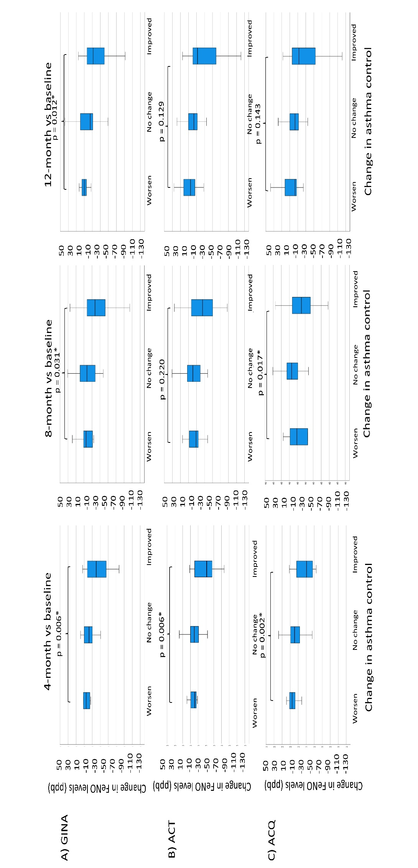
Supplementary Figure 1: Boxplot of change in FeNO levels at 4, 8 and 12 months compared with baseline (Subjects with eosinophil count ≥150 cells/µL). (n=88)
A) Global Initiative of Asthma level of asthma control (GINA), B) Asthma Control Test (ACT), C) Asthma Control Questionnaire (ACQ).
Changes in FeNO levels were presented as observed FeNO at certain time point minus baseline level (ppb)
p value was calculated by Kruskal-Wallis test
* = p<0.05
The solid line represents the median level, the box represents the IQR and the upper / lower whiskers are from the upper / lower quartile to the highest/lowest actual value within the 75th percentile / 25th percentile ± 1.5 × IQR.
Changes in levels of control: Improved (improved in at least one level of asthma control, i.e. from partly controlled or uncontrolled to control, or from uncontrolled to partly controlled), no change (stayed at same level of control), worsened (worsened in at least one level of asthma control, i.e. from controlled to partly controlled or uncontrolled, from controlled to partly controlled)
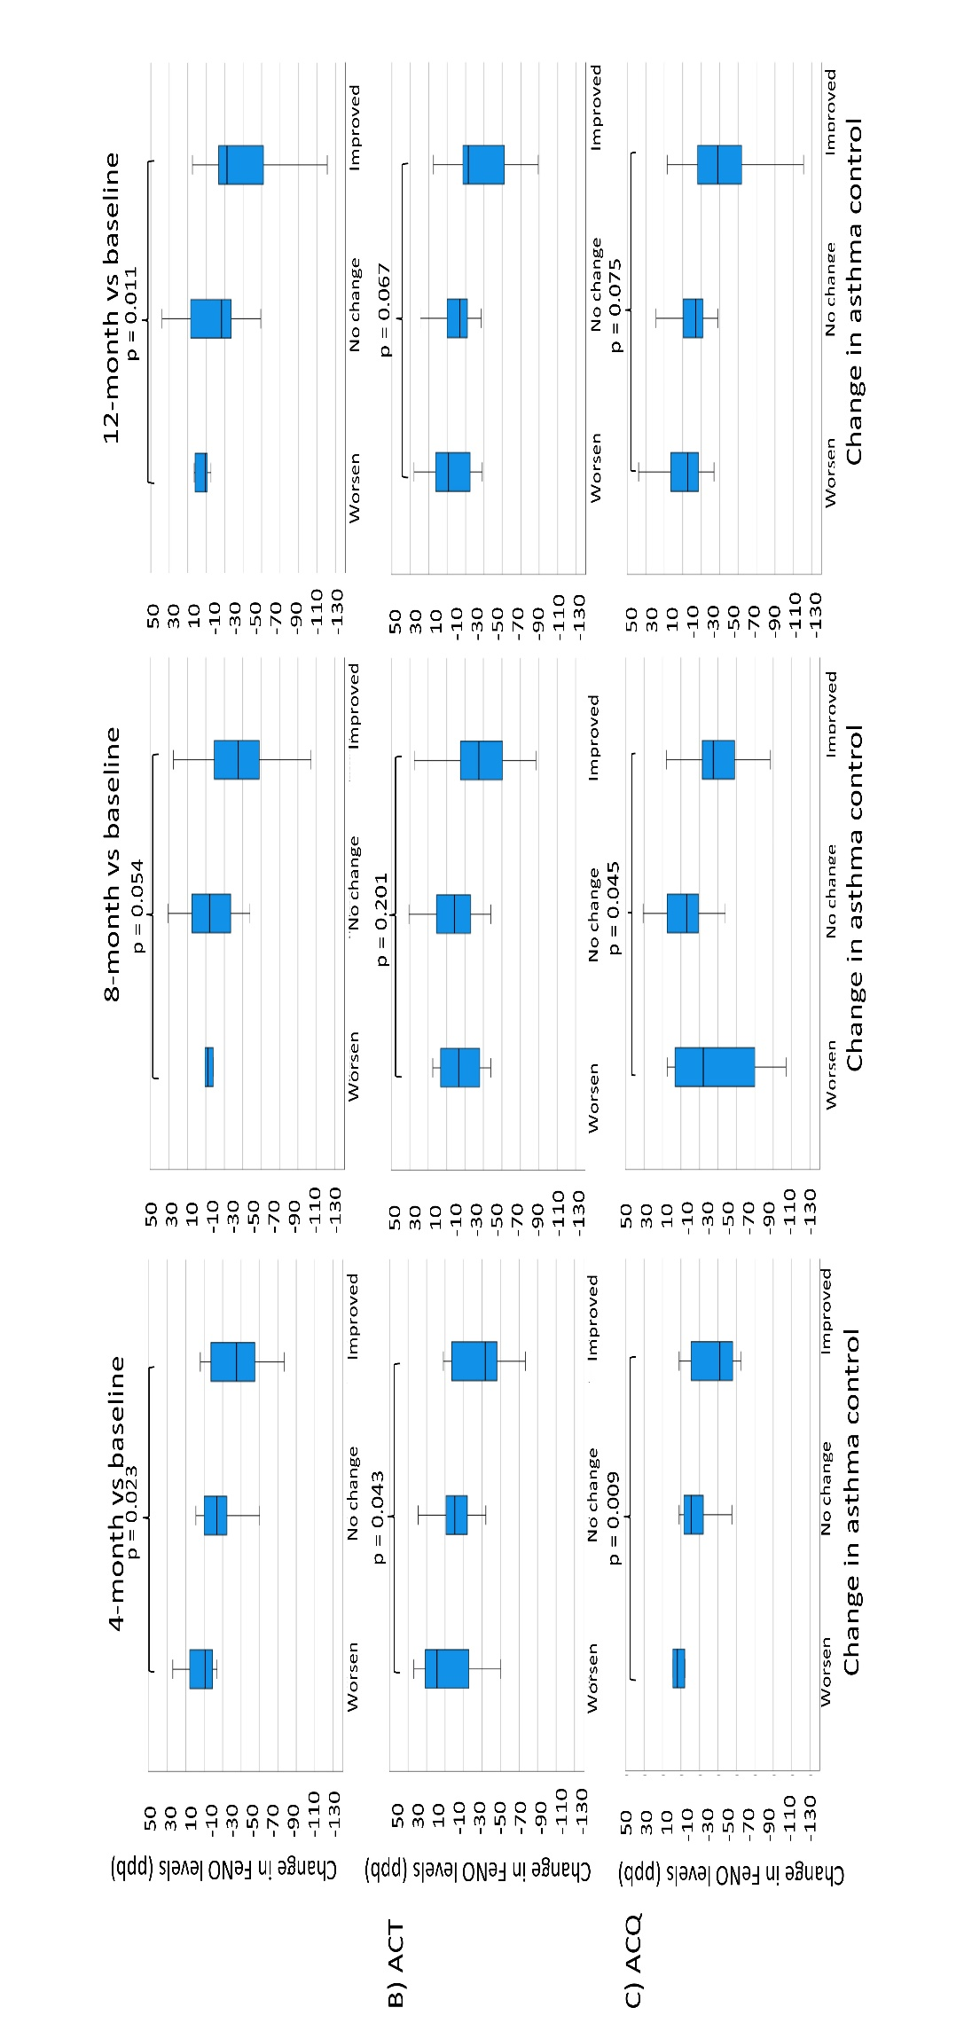
*
*
*
*
A) GINA
Supplementary Figure 2: Boxplot of change in FeNO levels at 4, 8 and 12 months compared with baseline (Subjects with eosinophil count ≥300 cells/µL). (n=59)
A) Global Initiative of Asthma level of asthma control (GINA), B) Asthma Control Test (ACT), C) Asthma Control Questionnaire (ACQ).
Changes in FeNO levels were presented as observed FeNO at certain time point minus baseline level (ppb)
p value was calculated by Kruskal-Wallis test
* = p<0.05
The solid line represents the median level, the box represents the IQR and the upper / lower whiskers are from the upper / lower quartile to the highest/lowest actual value within the 75th percentile / 25th percentile ± 1.5 × IQR.
Changes in levels of control: Improved (improved in at least one level of asthma control, i.e. from partly controlled or uncontrolled to control, or from uncontrolled to partly controlled), no change (stayed at same level of control), worsened (worsened in at least one level of asthma control, i.e. from controlled to partly controlled or uncontrolled, from controlled to partly controlled)

