Reference | Intervention | Age (years) | Screening rating scale criteria | Previous failed trials criteria  (retrospective) | Lead in/ prospective phase design | Lead in phase duration (weeks) | Lead in phase AD | Lead in phase non-response criteria | DB phase duration (weeks) | DB phase AD | Endpoint rating scale | Endpoint remission criteria
Berman et al. 2007 | Aripiprazole  2-20 mg | 18-65 | HAMD-17≥18 | 1-3 | OL with SB placebo | 8 | SSRI: ESC, FLU,  PAR, SER;  SNRI: VEN | HAMD-17≥14  (and <50%)  and CGI-I≥3 | 6 | Continuing AD | MADRS | MADRS≤10
Marcus et al. 2008 | Aripiprazole  2-20 mg | 18-65 | HAMD-17≥18 | 1-3 | OL with SB placebo | 8 | SSRI: ESC, FLU,  PAR, SER;  SNRI: VEN | HAMD-17≥14  (and <50%)  and CGI-I≥3 | 6 | Continuing AD | MADRS | MADRS≤10
Thase et al. 2015a | Brexpiprazole 2mg | 18-65 | HAMD-17≥18 | 1-3 | OL with SB placebo | 8 | SSRI: ESC, FLU,  PAR, SER; SNRI: DUL, VEN | HAMD-17≥14  (and <50%)  and MADRS <50%  and CGI-I≥3 | 6 | Continuing AD | MADRS | MADRS≤10  (and ≥50%)
Thase et al. 2015b | Brexpiprazole 1mg and 3 mg | 18-65 | HAMD-17≥18 | 1-3 | OL with SB placebo | 8 | SSRI: ESC, FLU,  PAR, SER; SNRI: DUL, VEN | HAMD-17≥14  (and <50%)  and MADRS <50% and CGI-I≥3 | 6 | Continuing AD | MADRS | MADRS≤10  (and ≥50%)
Shelton et al. 2005 | Olanzapine  6-12 mg | 18-65 | MADRS≥20 | 1- | OL | 7 | TCA: NOR | MADRS<30% | 8 | FLU | MADRS | MADRS≤8
Corya et al. 2006 | Olanzapine  6-12 mg | 18- | CGI-S ≥4 | 1- | OL | 7 | SNRI: VEN | MADRS<30% | 12 | FLU | MADRS | MADRS≤8
Thase et al. 2007.1 | Olanzapine  6 mg | 18-65 | HAMD-17≥22 | 1- (other than fluoxetine) | OL | 8 | SSRI: FLU | HAMD-17≥18 or <25% or ≤15% in last 2 weeks | 8 | FLU | MADRS | MADRS≤10
Thase et al. 2007.2 | Olanzapine  6 mg | 18-65 | HAMD-17≥22 | 1- (other than fluoxetine) | OL | 8 | SSRI: FLU | HAMD-17≥18 or <25% or ≤15% in last 2 weeks | 8 | FLU | MADRS | MADRS≤10
Bauer et al. 2009 | Quetiapine  150 and 300 mg | 18-65 | HAMD-17≥20 and item 1≥2 | 1 (current episode) | N/A | N/A | N/A | N/A | 6 | Ongoing AD | MADRS | MADRS≤8
El-Khalili et al. 2010 | Quetiapine  150 and 300 mg | 18-65 | HAMD-17≥20 and item 1≥2 | 1(current episode) | N/A | N/A | N/A | N/A | 6 | Ongoing AD | MADRS | MADRS≤8
Fedgchin et al. 2019 | Esketamine  56 and 84 mg | 18-64 | MADRS≥28  and IDS-C30≥34 | 1- | OL | ≥6 | SSRI: ESC, SER;  SNRI: DUL, VEN | MADRS≥28  (and < 25%) | 4 | Newly initiated AD | MADRS | MADRS≤12
Popova et al. 2019 | Esketamine  56 or 84 mg | 18-64 | MADRS≥28  and IDS-C30≥34 | 1- | OL | ≥6 | SSRI: ESC, SER;  SNRI: DUL, VEN | MADRS≥28  (and < 25%) | 4 | Newly initiated AD | MADRS | MADRS≤12
Supplementary Table S1. Study Characteristics of Pivotal Trials on AAPs and ESK-NS Resulted in FDA Approvals.
AD, antidepressant; CGI-I, Clinical Global Impression Improvement; CGI-S, Clinical Global Impression Severity; DB, double-blind; DUL, duloxetine; ESC, escitalopram; FLU, fluoxetine; HAMD, Hamilton Depression Rating Scale; IDS-C, Inventory of Depressive Symptomatology Clinician Rated; MADRS, Montgomery-Åsberg Depression Rating Scale; N/A, not applicable; NOR, nortriptyline; OL, open label; PAR, paroxetine; SNRI, selective noradrenalin reuptake inhibitor; SSRI, selective serotonin reuptake inhibitors; SER, sertraline; SB, single blind; VEN, venlafaxine.

Reference | Intervention | Patients (n) | Age (years) | Female (%) | Weight (kg) | BMI (kg/m²) | Race (White/Black/Other) (%) | No. of previous failed trials (1/2/3/>3) (%) | Duration of current episode (weeks) | Lead in phase non responder rate (%) | DB phase AD assignment (SSRI/SNRI/other) (%) | Baseline MADRS
Berman et al. 2007 | Aripiprazole  2-20 mg | 358 | 45.4 [44.3-46.5] | 63 | 85.3 [83.2-87.4] | - | 90/7/3 | 66/25/8/0 | 41.3 [35.5-47.1] | 46 | 73/27/0 | 26.0 [25.3-26.6]
Marcus et al. 2008 | Aripiprazole  2-20 mg | 381 | 44.5 [43.4-45.6] | 67 | 87 [84.8-89.2] | 30.7 [30-31.5] | 89/7/4 | 69/26/4/1 | 45.5 [37.8-53.1] | 46 | 72/28/0 | 26.2 [25.6-26.8]
Thase et al. 2015a | Brexpiprazole 2mg | 379 | 44.7 [43.5-45.8] | 70 | 83.2 [81.1-85.2] | 29.8 [29.1-30.5] | 87/11/2 | - | 54.3 [48.1-60.6] | 46 | 61/39/0 | 26.9 [26.3-27.4]
Thase et al. 2015b | Brexpiprazole 1mg and 3 mg | 677 | 45.6 [44.7-46.4] | 68 | 83.3 [81.7-84.9] | 29.6 [29.1-30.1] | 84/13/3 | 78/18/3/0 | 70.2 [59.3-81.1] | 44 | 55/45/0 | 26.5 [26.1-26.9]
Shelton et al. 2005 | Olanzapine  6-12 mg | 288 | 42.1 [40.9-43.4] | 70 | - | 31 [30-32] | 91/5/4 | - | - | 53 | 100/0/0 | 28.5 [27.6-29.3]
Corya et al. 2006 | Olanzapine  6-12 mg | 303 | 45.7 [44.5-46.9] | 71 | 79.9 [77.4-82.4] | 28.5 [27.7-29.3] | 89/3/8 | - | - | 60 | 100/0/0 | 30.2 [29.5-31.0]
Thase et al. 2007.1 | Olanzapine  6 mg | 206 | 45.7 [44.2-47.2] | 60 | 88.3 [84.9-91.7] | 30.5 [29.6-31.5] | 84/5/11 | - | 54.2 [46-62.4] | 52 | 100/0/0 | 29.6 [28.6-30.6]
Thase et al. 2007.2 | Olanzapine  6 mg | 200 | 44.9 [43.6-46.3] | 68 | 82.7 [81.3-84.1] | 29.3 [28.3-30.4] | 90/4/6 | - | 70.4 [55.1-85.7] | 52 | 100/0/0 | 30.3 [29.5-31.2]
Bauer et al. 2009 | Quetiapine  150 and 300 mg | 487 | 45.4 [44.5-46.3] | 68 | - | - | 98/1/1 | - | - | N/A | 69/27/4 | 28.4 [27.9-28.9]
El-Khalili et al. 2010 | Quetiapine  150 and 300 mg | 432 | 45.5 [44.4-46.5] | 72 | - | - | 90/8/2 | - | - | N/A | 54/27/19 | 27.5 [27.0-28.0]
Fedgchin et al. 2019 | Esketamine  56 and 84 mg | 342 | 46.3 [45.1-47.5] | 70 | 81.5 [79.3-83.8] | 28.8 [28.1-29.4] | 77/6/9ª | 9/51/27/13 | 201.6 [171.2-231.9] | 49 | 43/57/0 | 37.6 [37.0-38.1]
Popova et al. 2019 | Esketamine  56 or 84 mg | 223 | 45.7 [44.2-47.3] | 62 | 81 [78.4-83.6] | 28.4 [27.2-28.8] | 93/5/2 | 12/55/21/12 | 113.4 [94.2-132.5] | 52 | 50/50/0 | 37.1 [36.4-37.9]
Supplementary Table S2. Baseline Characteristics of Pivotal Trials on AAPs and ESK-NS Resulted in FDA Approvals.
Data are presented as mean [95% confidence interval] or mean (for percentage).
ªRemaining 8% with no race information reported.
AD, antidepressants; BMI, body mass index; SNRI, selective noradrenalin reuptake inhibitor; SSRI, selective serotonin reuptake inhibitors; MADRS, Montgomery-Åsberg Depression Rating Scale; N/A, not applicable.

Supplementary Table S3. Contribution of Baseline Characteristics to the Heterogeneity of the Mean Difference in MADRS Total Score Reduction at Endpoint.
Baseline Characteristic | R-squared % | P-value
Age | 10.0 | 0.155
BMIª | 61.1 | 0.054
Weight^{b} | 0 | 0.470
Percentage of female | 0 | 0.785
Percentage of race (white) | 0 | 0.797
Duration of current episode^{c} | 0.7 | 0.306
Lead-in phase non-responder rate^{d} | 0 | 0.855
Baseline MADRS total score | 8.4 | 0.198

Each baseline characteristic was tested by incorporating it as a covariate in the meta-regression model. Contribution to the total heterogeneity and corresponding p-value was obtained to assess its significance of contribution.
ªExcluding Shelton et al., 2005, Bauer et al., 2009 and El-Khalili et al., 2010 for which data were not available.
^{b}Excluding Berman et al., 2007, Bauer et al., 2009 and El-Khalili et al., 2010 for which data were not available.
^{c}Excluding Shelton et al., 2005, Corya et al., 2006, Bauer et al., 2009 and El-Khalili et al., 2010 for which data were not available.
^{d}Excluding Bauer et al., 2009 and El-Khalili et al., 2010 for which data were not applicable, as both trials only required an inadequate response history during the current episode to one of the pre-specified ADs.
BMI, body mass index; MADRS, Montgomery-Åsberg Depression Rating Scale.

Supplementary Table S4. Contribution of Baseline Characteristics to the Heterogeneity of the Mean Difference in Response Rate.
Baseline Characteristic | R-squared % | P-value
Age | 0 | 0.517
BMIª | 0 | 0.896
Weight^{b} | 0 | 0.463
Percentage of female | 0 | 0.612
Percentage of race (white) | 0 | 0.833
Duration of current episode^{c} | 0 | 0.872
Lead-in phase non-responder rate^{d} | 0 | 0.914
Baseline MADRS total score | 0 | 0.542

Each baseline characteristic was tested by incorporating it as a covariate in the meta-regression model. Contribution to the total heterogeneity and corresponding p-value was obtained to assess its significance of contribution.
ªExcluding Shelton et al., 2005, Bauer et al., 2009 and El-Khalili et al., 2010 for which data were not available.
^{b}Excluding Berman et al., 2007, Bauer et al., 2009 and El-Khalili et al., 2010 for which data were not available.
^{c}Excluding Shelton et al., 2005, Corya et al., 2006, Bauer et al., 2009 and El-Khalili et al., 2010 for which data were not available.
^{d}Excluding Bauer et al., 2009 and El-Khalili et al., 2010 for which data were not applicable, as both trials only required an inadequate response history during the current episode to one of the pre-specified ADs.
BMI, body mass index; MADRS, Montgomery-Åsberg Depression Rating Scale.

Supplementary Table S5 Sensitivity Analysis for the Difference Between ESK-NS and AAPs in Responses and Remission Rates by Logit Transformation.

Response rate:
 | log(OR) | 95% CI.lower | 95% CI.upper | P value
Control | 0.84 | -0.08 | 1.76 | 0.073
Active | 1.39 | 0.57 | 2.21 | 0.0009
MD | 0.6 | 0.2 | 1 | 0.0034

Remission rate:
 | log(OR) | 95% CI.lower | 95% CI.upper | P value
Control | 0.14 | 0.05 | 0.24 | 0.0041
Active | 0.18 | 0.04 | 0.32 | 0.01
MD | 0.05 | -0.05 | 0.14 | 0.31

AD, antidepressant; MD, mean difference; OR, odds ratio.

Supplementary Table S6. Contribution of Baseline Characteristics to the Heterogeneity of the Mean Difference in MADRS Total Score Reduction at Week One Timepoint
Baseline Characteristic | R-squared % | P-value
Age | 0 | 0.530
BMIª | 0 | 0.314
Weight^{b} | 0 | 0.381
Percentage of female | 0 | 0.828
Percentage of race (white) | 0 | 0.589
Duration of current episode^{c} | 44.6 | 0.061
Lead-in phase non-responder rate^{d} | 100 | 0.017
Baseline MADRS total score | 100 | 0.019

Each baseline characteristic was tested by incorporating it as a covariate in the meta-regression model. Contribution to the total heterogeneity and corresponding p-value was obtained to assess its significance of contribution.
ªExcluding Shelton et al., 2005, Bauer et al., 2009 and El-Khalili et al., 2010 for which data were not available.
^{b}Excluding Berman et al., 2007, Bauer et al., 2009 and El-Khalili et al., 2010 for which data were not available.
^{c}Excluding Shelton et al., 2005, Corya et al., 2006, Bauer et al., 2009 and El-Khalili et al., 2010 for which data were not available.
^{d}Excluding Bauer et al., 2009 and El-Khalili et al., 2010 for which data were not applicable, as both trials only required an inadequate response history during the current episode to one of the pre-specified ADs.
BMI, body mass index; MADRS, Montgomery-Åsberg Depression Rating Scale.

Supplementary Figure S1. Risk of Bias Assessment of the Methodological Quality of the Pivotal Trials on AAPs and ESK-NS Resulted in FDA Approvals
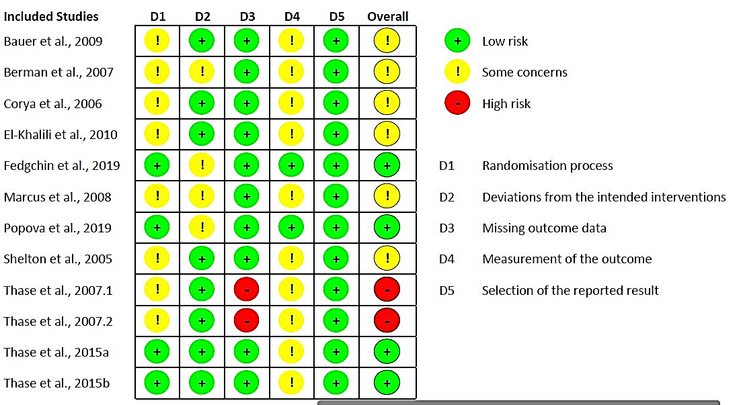
A.

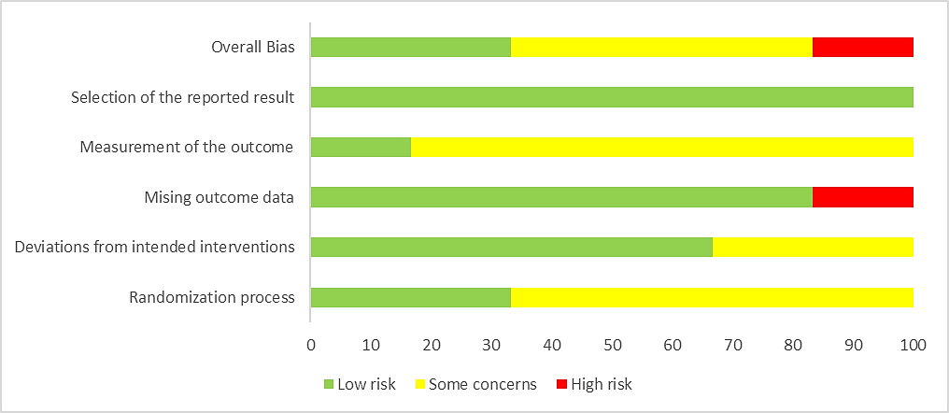
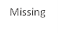
B.

Cochrane Risk of Bias 2 (RoB 2.0) tools was implemented to assess five domains: randomization process, deviation from the intended interventions, missing outcome data, measurement of the outcome and selection of the reported result. “Traffic light” plots which display individual domain and overall judgements study-by-study (A), as well as an overview plot of the percentage of risk of bias assessments at each level of risk of bias per domain across all the included studies (B) are shown.

Supplementary Fig S2. Funnel Plot Analysis for Publication Bias.

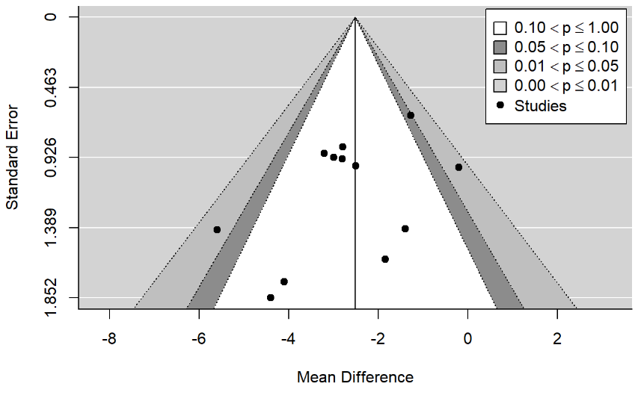

The mean difference for the primary outcome of all included studies were plotted against the standard errors. There is no strong evidence for the presence of a publication bias.

Supplementary Figure S3. Estimated Net Treatment Effect in AAPs and ESK-NS Studies With Expanded Study Selection: Study Endpoint.

Additional studies were included additional 8 studies used in the analysis by Dold et al.. The corresponding net treatment effect, represented by the mean difference between the active treatment and control arms on least squares mean MADRS total score reduction, was shown in the forest plot, with 95% CI. The pooled effect sizes for individual drugs, AAPs and ESK-NS were estimated by random effects regression model, including the subgroup information as a factor variable. The difference between active treatment and control arms is significant for all the drugs, as well as pooled AAPs and ESK-NS, as indicated by p-values. Pair-wise comparison of the estimated net treatment effect between ESK-NS and the individual AAP or pooled AAPs was conducted with no statistical significance observed: ESK-NS vs aripiprazole, p = 0.2244; ESK-NS vs brexpiprazole, p = 0.0704; ESK-NS vs olanzapine, p = 0.1505; ESK-NS vs quetiapine, p = 0.0998; ESK-NS vs pooled AAPs, p = 0.0933. All the p-values are two sided. AAPs = atypical antipsychotics; ESK-NS = esketamine nasal spray; MADRS = Montgomery-Åsberg Depression Rating Scale; MD = mean difference; RCTs = randomized clinical trials.

