Supplemental Online Content

Supplementary Figure 1. Study Design

Abbreviations: BCLC, Barcelona Clinic Liver Cancer.
ECOG, Eastern Cooperative Oncology Group.
TACE, transarterial chemoembolization; TAE, Transarterial embolization.

Supplementary Figure 2. Overall Survival Since Randomization
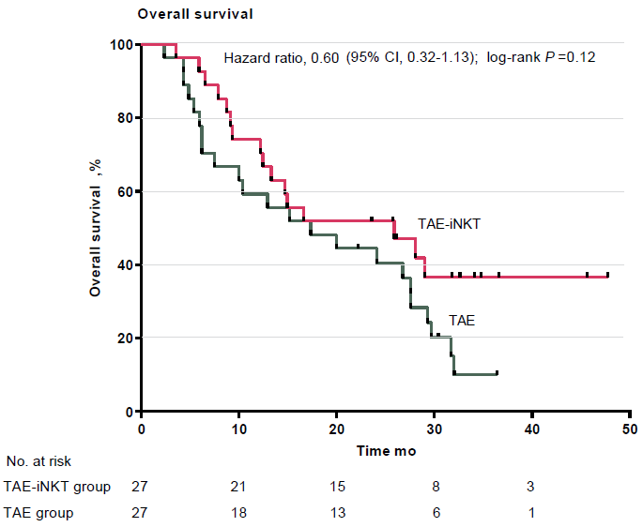
Supplementary Figure 3. Time to Deterioration of Physical Functioning

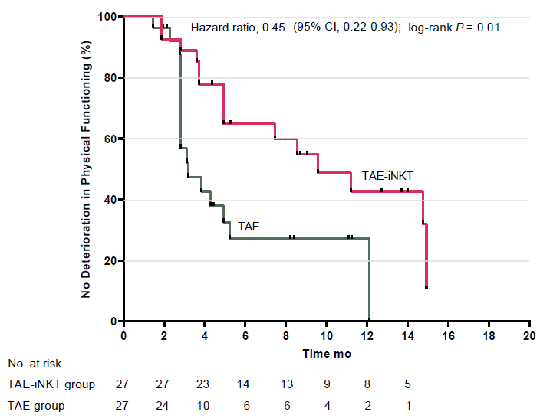

Supplementary Figure 4. Time to Deterioration of Role Functioning

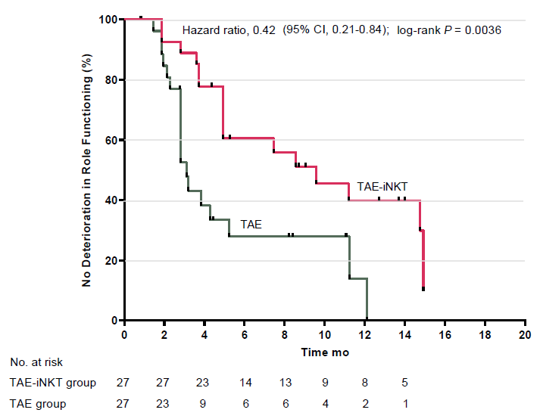
Supplementary Figure 5. Quantification of White Blood Cells (ns, p>0.05)

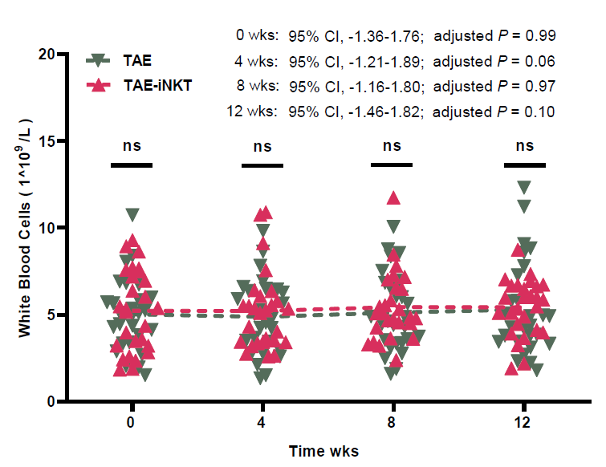
Supplementary Figure 6. Quantification of Platelets (ns, p>0.05)

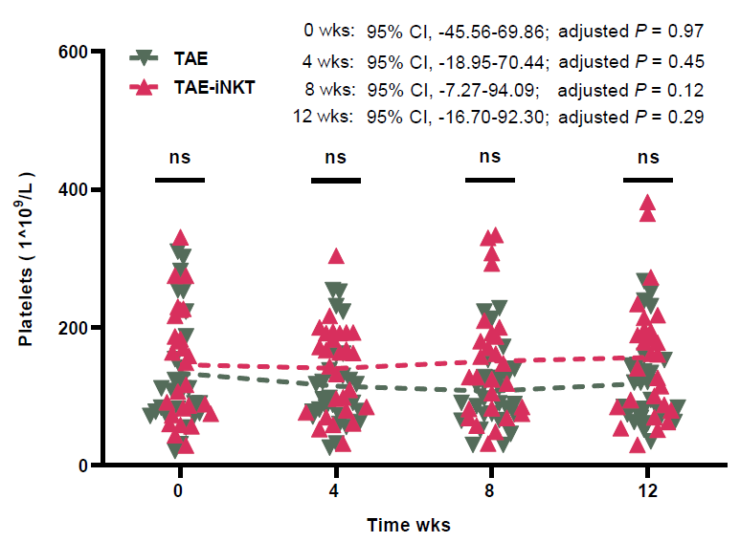
Supplementary Method 1. Preparation of iNKT Cells
1) Isolate PBMCs by leukapheresis using a COM.TEC apheresis system (Fresenius Medical Care, Bad Homburg, Germany) and Lymphoprep density gradient medium (Stemcell Technologies, Cambridge, UK).
2) Resuspend PBMCs in Corning serum-free cell medium KBM581 (Corning Inc., Corning, NY) and stimulate with 100 ng/mL α-GalCer (BioVision, Milpitas, CA) and 100 U/mL animal-free recombinant human interleukin-2 (rhIL-2; BioLegend, San Diego, CA) for 48 hours; the rhIL-2 was replenished every other day.
3) Stimulate PBMCs with 1,000 IU/mL granulocyte-macrophage colony-stimulating factor (BioLegend, San Diego, CA) and IL-4 (BioLegend, San Diego, CA) for 1 week, and obtain mature, monocyte-derived DCs.
4) Sort iNKT cells by using anti-iNKT microbeads (Miltenyi Biotec, Bergisch Gladbach, Germany) according to the manufacturer’s protocol on day 7.
5) Co-culture the sorted iNKT cells with mature DCs for 14 days, and collect cells for infusion on day 21. An aliquot of cells was used for immunophenotyping and functional testing.
6) Determine the frequency of iNKT cells in T cells by using a FACSCanto II cytometer (BD Biosciences, San Jose, CA).
7) The criteria for iNKT cell administration includes a negative bacterial culture, a negative mycoplasma test result, and an endotoxin level < 0.05 units/mL.

Supplementary Method 2. Criteria and End Point Defintions
Inclusion Criteria:
1) 18-80 years of age, 2) TACE failure/refractory BCLC B HCC confirmed by CT, MRI, and/or histopathology, 3) life expectancy of at least 12 weeks, 4) Child-Pugh A/B，5) adequate hematological and renal functions, including white blood cell (WBC) count >3.0×10⁹/L, lymphocyte count >0.8×10⁹/L, platelet count >50×10⁹/L, hemoglobin concentration >85 g/L, and serum creatinine concentration of <1.5-times the upper limit of normal value (ULN), and 6) previous treatment terminated at least 4 weeks before entry to this study.
Exclusion Criteria:
1) Known history of the human immunodeficiency virus (HIV) or syphilis infection, 2) clinically serious infections, 3) history of stem cell transplant or organ allograft, 4) history of severe hypertension or cardiac disease, 5) known central nervous system (CNS) tumor, 6) autoimmune disease requiring systemic therapy with immunosuppressive agents, 7) history of allergy to immunotherapy or related drugs, 8) pregnancy or lactation, or 9) deemed not suitable for cellular immunotherapy by the investigators.
TACE failure:
(1) Intrahepatic lesion [i, two or more consecutive ineffective responses seen within the treated tumors (viable lesion >50%), even after changing the chemotherapeutic agents and/or reanalysis of the feeding artery, on response evaluation CT/MRI after 1–3 months following adequately performed selective TACE. ii, Two or more consecutive progressions in the liver (including an increase in the number of tumors compared to that before the previous TACE procedure), even after changing the chemotherapeutic agents and/or reanalysis of the feeding artery, on response evaluation CT/MRI after 1–3 months following adequately performed selective TACE]. (2) Continuous elevation of tumor markers right after TACE, even though transient minor reduction is observed. (3) Appearance of vascular invasion. (4) Appearance of extrahepatic spread.
Endpoint Definitions
Progression-Free Survival: Time from the date of enrollment to the date of first documentation of tumor progression.
Progression was defined using Modified RECIST (mRECIST): an increase of at least 20% in the sum of the diameters of viable (enhancing) target lesions, taking as reference the smallest sum of the diameters of viable (enhancing) target lesions recorded since treatment started.
Overall survival: time from the date of enrollment to the date of death from any cause.
Objective response rate: including complete response (CR) and partial response (PR) evaluated by imaging according to mRECIST for target lesions and assessed by MRI/CT. Complete Response (CR), disappearance of any intratumoral arterial enhancement in all target lesions. Partial Response (PR), at least a 30% decrease in the sum of diameters of viable (enhancement in the arterial phase) target lesions, taking as reference the baseline sum of the diameters of target lesions. Objective Response Rate = CR + PR.
Disease Control Rate: including complete response (CR), partial response (PR), and disease stabilization (SD), evaluated by imaging according to mRECIST for target lesions and assessed by MRI/CT. Complete Response (CR), disappearance of any intratumoral arterial enhancement in all target lesions. Partial Response (PR), at least a 30% decrease in the sum of diameters of viable (enhancement in the arterial phase) target lesions, taking as reference the baseline sum of the diameters of target lesions. Stable disease (SD), any cases that do not qualify for either partial response or progressive disease. Disease Control Rate = CR + PR + SD.

Supplementary Method 3. The Implementation of TAE
1) Select catheterization of the feeding artery by using a microcatheter (STD125-26S, Asahi Intecc Co., Ltd., Tokyo, Japan).
2) Perform abdominal and hepatic arteriography.
3) Embolization with Gelfoam (ALICON Pharmaceutical Science & Technology Co., Ltd., Hangzhou, China, Gelfoam350, 350-560 µm) until near stasis of the arterial flow.
4) Determine the dose of iodized oil (Liebel-Flasheim Canada Inc. Pointe-Claire, Canada, 100 ml, 35 g) by the tumor size or based on whether the portal vein had a tumor thrombosis.
5) Inject the emulsion of iodized oil until the accumulation of the emulsion in the tumor and the visualization of the portal vein branches near the tumor. (If there was a significant arterioportal shunt, embolization with Gelfoam was first performed to occlude the shunt, after which the iodized oil emulsion was infused, and embolization with Gelfoam was performed.)

Supplementary Table 1. Patient Treatments Prior to the Trial
Patient No. | Prior resection therapy | Prior local therapy  for hepatocellular carcinoma |  |  | Prior radiotherapy  (times) | Argon-helium knife(times)
Patient No. | Prior resection therapy | Systemic treatment | TAE/  TACE  (times) | Radiofrequency ablation(times) | Prior radiotherapy  (times) | Argon-helium knife(times)
TAE-iNKT-1 | 1 |  | 6
TAE-iNKT-2 | 1 |  | 2 |  | 1
TAE-iNKT-3 |  |  | 2 | 1
TAE-iNKT-4 |  | Lenvatinib | 2
TAE-iNKT-5 |  |  | 2
TAE-iNKT-6 |  |  | 5 | 3 |  | 1
TAE-iNKT-7 |  |  | 12
TAE-iNKT-8 |  |  | 2 |  |  | 1
TAE-iNKT-9 | 1 |  | 2
TAE-iNKT-10 |  |  | 7 | 6
TAE-iNKT-11 |  |  | 2 | 2
TAE-iNKT-12 |  |  | 2 | 3
TAE-iNKT-13 | 1 |  | 2
TAE-iNKT-14 |  |  | 4 | 3
TAE-iNKT-15 |  |  | 2
TAE-iNKT-16 |  |  | 2
TAE-iNKT-17 | 1 |  | 2
TAE-iNKT-18 |  |  | 9
TAE-iNKT-19 |  |  | 4 | 4
TAE-iNKT-20 |  |  | 2
TAE-iNKT-21 | 1 |  | 5 | 1 | 1
TAE-iNKT-22 |  | Sorafenib | 2
TAE-iNKT-23 |  |  | 2
TAE-iNKT-24 |  |  | 2
TAE-iNKT-25 |  |  | 2
TAE-iNKT-26 | 1 |  | 2
TAE-iNKT-27 |  |  | 2 | 1
TAE-1 |  |  | 2
TAE-2 |  |  | 2 | 1
TAE-3 |  |  | 2
TAE-4 |  |  | 2
TAE-5 |  |  | 5
TAE-6 |  | Sorafenib | 2
TAE-7 | 1 |  | 2 | 7
TAE-8 |  |  | 2
TAE-9 |  |  | 2
TAE-10 |  |  | 3 | 3
TAE-11 |  |  | 2
TAE-12 |  |  | 4 | 4 |  | 1
TAE-13 |  |  | 2
TAE-14 |  |  | 3 | 2
TAE-15 |  |  | 2 | 1
TAE-16 |  |  | 2 | 2
TAE-17 |  |  | 2
TAE-18 |  |  | 4 | 4
TAE-19 |  |  | 2
TAE-20 |  |  | 2
TAE-21 |  |  | 3 | 3
TAE-22 |  |  | 4 | 4
TAE-23 |  |  | 6
TAE-24 |  |  | 3 | 3
TAE-25 |  |  | 2
TAE-26 |  |  | 2
TAE-27 |  |  | 2 | 2

Supplementary Table 2. Response to autologous iNKT cell infusion
Variable | TAE–iNKT  (N = 27) | TAE (N = 27) | Difference  (P Value)
Confirmed objective response,  N (% [95% CI]) | 14 (52  [33.98–69.26]) | 3 (11  [3.03–28.88]) | 41 (P= .003）
Complete response, N (%) | 5 (19) | 1 (4)
Partial response, N (%) | 9 (33) | 2 (7)
Stable disease, N (%) | 9 (33) | 6 (22)
Disease control rate, N  (% [95% CI]) | 23 (85  [66.90-94.70]) | 9 (33  [18.53-52.29]) | 52 (P< .001）
Progressive disease, N (%) | 4 (15) | 18 (67)
P values calculated using a 2-sided Fisher’s exact test.
Abbreviations: TACE, transarterial chemoembolization; TAE, Transarterial embolization; CI, confidence interval.

