Supplementary Material 1: The detailed search strategy.

Search Strategy
Searching on PubMed: 185records
#1. "normal saline" [Title/Abstract] OR "isotonic saline" [Title/Abstract] OR "sodium chloride" [Title/Abstract] OR "0.9% saline" [Title/Abstract] OR "0.9% NaCl" [Title/Abstract] OR "saline" [Title/Abstract]
#2. "balanced crystalloids" [Title/Abstract] OR "buffered crystalloid" [Title/Abstract] OR "Plasma-Lyte"[Title/Abstract] OR "lactated Ringer's solution"[Title/Abstract] OR "Lactated Ringer's "[Title/Abstract] OR "Normosol" [Title/Abstract] OR "Plasmalyte" [Title/Abstract] OR "Hartmann's" [Title/Abstract] OR "Ringerfundin" [Title/Abstract] OR "Ringer's" [Title/Abstract] OR "Sterofundin" [Title/Abstract] OR "Kabilyte" [Title/Abstract]
#3."sepsis" [Title/Abstract] OR "infection" [Title/Abstract] OR "septic shock" [Title/Abstract] "hypovolemic shock" [Title/Abstract] OR "shock" [Title/Abstract] OR "systemic inflammatory response syndrome" [Title/Abstract] OR "SIRS" [Title/Abstract] OR "critical ill" [Title/Abstract] OR "critical illness" [Title/Abstract] OR "intensive care unit" [Title/Abstract] OR "intensive care" [Title/Abstract] OR "ICU" [Title/Abstract] OR "toxic shock syndrome" [Title/Abstract] "acute pancreatitis" [Title/Abstract] OR "trauma" [Title/Abstract] OR "injury" [Title/Abstract] OR "burns" [Title/Abstract] OR " diabetic ketoacidosis" [Title/Abstract] " OR "multiple organ failure" [Title/Abstract]
#4."RCT" [Title/Abstract] OR "randomized controlled trial" [Title/Abstract] OR "randomized clinical trial" [Title/Abstract] OR "randomized" [Title/Abstract] OR "blinded" [Title/Abstract] OR "random" [Title/Abstract] OR "controlled clinical trial " [Title/Abstract]
#5. #1 AND #2 AND #3 AND #4

Searching on Web of Science: 282 records
#1. "normal saline" [Topic] OR "isotonic saline" [Topic] OR "sodium chloride" [Topic] OR "0.9% saline" [Topic] OR "0.9% NaCl" [Topic] OR "saline" [Topic]
#2. "balanced crystalloids" [Topic] OR "buffered crystalloid" [Topic] OR "Plasma-Lyte"[Topic] OR "lactated Ringer's solution"[Topic] OR "Lactated Ringer's "[Topic] OR "Normosol" [Topic] OR "Plasmalyte" [Topic] OR "Hartmann's" [Topic] OR "Ringerfundin" [Topic] OR "Ringer's" [Topic] OR "Sterofundin" [Topic] OR "Kabilyte" [Topic]
#3."sepsis" [Topic] OR "infection" [Topic] OR "septic shock" [Topic] "hypovolemic shock" [Topic] OR "shock" [Topic] OR "systemic inflammatory response syndrome" [Topic] OR "SIRS" [Topic] OR "critical ill" [Topic] OR "critical illness" [Topic] OR "intensive care unit" [Topic] OR "intensive care" [Topic] OR "ICU" [Topic] OR "toxic shock syndrome" [Topic] "acute pancreatitis" [Topic] OR "trauma" [Topic] OR "injury" [Topic] OR "burns" [Topic] OR " diabetic ketoacidosis" [Topic] " OR "multiple organ failure" [Topic]
#4."RCT" [Topic] OR "randomized controlled trial" [Topic] OR "randomized clinical trial" [Topic] OR "randomized" [Topic] OR "blinded" [Topic] OR "random" [Topic] OR "controlled clinical trial " [Topic]
#5. #1 AND #2 AND #3 AND #4

Searching on EMBASE: 300 records
#1. "normal saline" [Topic] OR "isotonic saline" [Topic] OR "sodium chloride" [Topic] OR "0.9% saline" [Topic] OR "0.9% NaCl" [Topic] OR "saline" [Topic]
#2. "balanced crystalloids" [Topic] OR "buffered crystalloid" [Topic] OR "Plasma-Lyte"[Topic] OR "lactated Ringer's solution"[Topic] OR "Lactated Ringer's "[Topic] OR "Normosol" [Topic] OR "Plasmalyte" [Topic] OR "Hartmann's" [Topic] OR "Ringerfundin" [Topic] OR "Ringer's" [Topic] OR "Sterofundin" [Topic] OR "Kabilyte" [Topic]
#3."sepsis" [Topic] OR "infection" [Topic] OR "septic shock" [Topic] "hypovolemic shock" [Topic] OR "shock" [Topic] OR "systemic inflammatory response syndrome" [Topic] OR "SIRS" [Topic] OR "critical ill" [Topic] OR "critical illness" [Topic] OR "intensive care unit" [Topic] OR "intensive care" [Topic] OR "ICU" [Topic] OR "toxic shock syndrome" [Topic] "acute pancreatitis" [Topic] OR "trauma" [Topic] OR "injury" [Topic] OR "burns" [Topic] OR " diabetic ketoacidosis" [Topic] " OR "multiple organ failure" [Topic]
#4."RCT" [Topic] OR "randomized controlled trial" [Topic] OR "randomized clinical trial" [Topic] OR "randomized" [Topic] OR "blinded" [Topic] OR "random" [Topic] OR "controlled clinical trial " [Topic]
#5. #1 AND #2 AND #3 AND #4

Searching on MEDLINE: 188 records
#1. "normal saline" [Topic] OR "isotonic saline" [Topic] OR "sodium chloride" [Topic] OR "0.9% saline" [Topic] OR "0.9% NaCl" [Topic] OR "saline" [Topic]
#2. "balanced crystalloids" [Topic] OR "buffered crystalloid" [Topic] OR "Plasma-Lyte"[Topic] OR "lactated Ringer's solution"[Topic] OR "Lactated Ringer's "[Topic] OR "Normosol" [Topic] OR "Plasmalyte" [Topic] OR "Hartmann's" [Topic] OR "Ringerfundin" [Topic] OR "Ringer's" [Topic] OR "Sterofundin" [Topic] OR "Kabilyte" [Topic]
#3."sepsis" [Topic] OR "infection" [Topic] OR "septic shock" [Topic] "hypovolemic shock" [Topic] OR "shock" [Topic] OR "systemic inflammatory response syndrome" [Topic] OR "SIRS" [Topic] OR "critical ill" [Topic] OR "critical illness" [Topic] OR "intensive care unit" [Topic] OR "intensive care" [Topic] OR "ICU" [Topic] OR "toxic shock syndrome" [Topic] "acute pancreatitis" [Topic] OR "trauma" [Topic] OR "injury" [Topic] OR "burns" [Topic] OR " diabetic ketoacidosis" [Topic] " OR "multiple organ failure" [Topic]
#4."RCT" [Topic] OR "randomized controlled trial" [Topic] OR "randomized clinical trial" [Topic] OR "randomized" [Topic] OR "blinded" [Topic] OR "random" [Topic] OR "controlled clinical trial " [Topic]
#5. #1 AND #2 AND #3 AND #4

Searching on the Cochrane Library: 172 records
#1. "normal saline" [Topic] OR "isotonic saline" [Topic] OR "sodium chloride" [Topic] OR "0.9% saline" [Topic] OR "0.9% NaCl" [Topic] OR "saline" [Topic]
#2. "balanced crystalloids" [Topic] OR "buffered crystalloid" [Topic] OR "Plasma-Lyte"[Topic] OR "lactated Ringer's solution"[Topic] OR "Lactated Ringer's "[Topic] OR "Normosol" [Topic] OR "Plasmalyte" [Topic] OR "Hartmann's" [Topic] OR "Ringerfundin" [Topic] OR "Ringer's" [Topic] OR "Sterofundin" [Topic] OR "Kabilyte" [Topic]
#3."sepsis" [Topic] OR "infection" [Topic] OR "septic shock" [Topic] "hypovolemic shock" [Topic] OR "shock" [Topic] OR "systemic inflammatory response syndrome" [Topic] OR "SIRS" [Topic] OR "critical ill" [Topic] OR "critical illness" [Topic] OR "intensive care unit" [Topic] OR "intensive care" [Topic] OR "ICU" [Topic] OR "toxic shock syndrome" [Topic] "acute pancreatitis" [Topic] OR "trauma" [Topic] OR "injury" [Topic] OR "burns" [Topic] OR " diabetic ketoacidosis" [Topic] " OR "multiple organ failure" [Topic]
#4."RCT" [Topic] OR "randomized controlled trial" [Topic] OR "randomized clinical trial" [Topic] OR "randomized" [Topic] OR "blinded" [Topic] OR "random" [Topic] OR "controlled clinical trial " [Topic]
#5. #1 AND #2 AND #3 AND #4

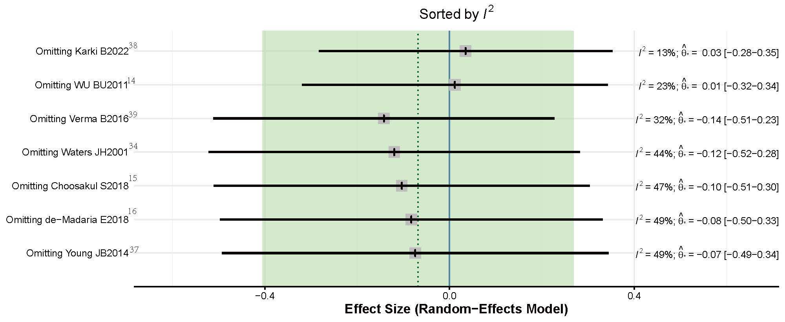
Supplementary Figure 1. The Leave-one-out plot of analysis of heterogeneity.

