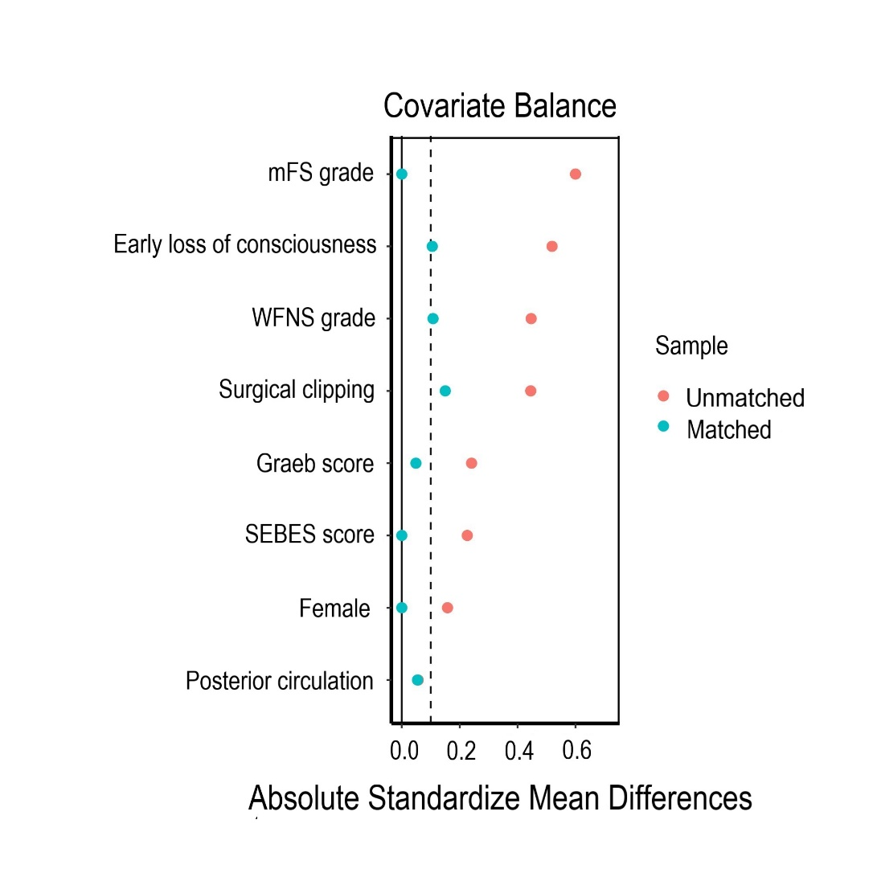

Supplementary Figure 1 Comparison of confounding factors before and after propensity score matching.
Notes: Propensity score matching (caliper 0.02, ratio 1:1, nearest neighbor approach) was performed according to the following parameters: Female, Early loss of consciousness, WFNS grade, mFS grade, Graeb score, SEBES score, Acute hydrocephalus and surgical clipping. After PS matching, 2 evenly balanced cohorts consisting of 57 patients each and without significant differences in outcome-relevant parameters were available for further analyses.
Abbreviations: WFNS, world federation of neurological societies; mFS, modified Fisher; SEBES, subarachnoid hemorrhage early brain edema score; IBI, inflammatory burden index

Supplementary Table 1. In-hospital Complications and Definitions
In-hospital complications | Definitions
Delayed cerebral ischemia | New focal neurological deficit or global neurological deterioration (a drop of ≥ 2 points on the Glasgow Coma Scale [GCS]) lasting > 2 hours, after exclusion of intracranial hemorrhage, hydrocephalus, seizures, metabolic derangements, and infection, with or without radiological signs of cerebral vasospasm.
Intracranial infection | (1) The patient had clinical manifestations of various intracranial infections such as postoperative fever, headache, or neck stiffness. (2) The patient’s cerebrospinal fluid test showed inflammatory index changes, which met one of the following: white blood cell count > 0.01 × 10⁹ /L; cerebrospinal fluid protein > 4.50 g/L; cerebrospinal fluid glucose < 2.50 mmol/L. (3) The peripheral blood white blood cell count was > 10 × 10⁹ /L.
Hypoproteinemia | Total protein < 60g/L or albumin < 30g/L.
Pneumonia | Description of clinical indications or positive chest radiograph.
Deep vein thrombosis | Clinical diagnosis of deep vein thrombosis supported by ultrasound or venography.

Supplementary Table 2. Comparison of Unadjusted and Risk-Adjusted Outcomes by ln IBI
Outcome parameters | Unadjusted(n=408) |  | Multivariable regression adjustment (n=408)
Outcome parameters | OR (95% CI) | p Value | OR (95% CI) | p Value
mRS 3-6 at 3-month | 1.432 (1.223-1.677) | ＜0.001 | 1.362 (1.148-1.615) | ＜0.001
Delayed cerebral ischemia | 1.158 (1.010-1.326) | 0.034 | 1.101 (0.958-1.265) | 0.177
Intracranial infection | 1.108 (0.913-1.346) | 0.300 | 1.068 (0.883-1.291) | 0.500
Hypoproteinemia | 1.071 (0.945-1.215) | 0.283 | 0.984 (0.861-1.124) | 0.811
Pneumonia | 1.455 (1.267-1.671) | ＜0.001 | 1.427 (1.227-1.659) | ＜0.001
Deep Vein Thrombosis | 1.326 (1.124-1.564) | 0.001 | 1.326 (1.124-1.564) | 0.001
Notes: Multivariable regression: adjusted for Female, WFNS grade, mFS grade, GRAEB score, SEBES score, Acute hydrocephalus and surgical clipping. As indicated by the bold font, the p Value reached statistical significance.

Abbreviations: ln IBI, the natural logarithm of “inflammatory burden index”; OR, odds ratio; CI, con confidence intervals

Supplementary Table 3. Comparison of Unadjusted and Risk-Adjusted Outcomes by ln MLR
Outcome parameters | Unadjusted(n=408) |  | Multivariable regression adjustment (n=408)
Outcome parameters | OR (95% CI) | p Value | OR (95% CI) | p Value
mRS 3-6 at 3-month | 4.147 (2.543-6.762) | ＜0.001 | 2.935 (1.684-5.117) | ＜0.001
Delayed cerebral ischemia | 1.640 (1.102-2.440) | 0.015 | 1.210 (0.776-1.887) | 0.399
Intracranial infection | 1.079 (0.613-1.899) | 0.792 | 0.863 (0.484-1.537) | 0.616
Hypoproteinemia | 1.521 (1.049-2.206) | 0.027 | 0.985 (0.645-1.505) | 0.946
Pneumonia | 2.400 (1.633-3.528) | ＜0.001 | 1.394 (0.894-2.173) | 0.143
Deep Vein Thrombosis | 1.300 (0.817-2.068) | 0.268 | 1.074 (0.636-1.812) | 0.789
Notes: Multivariable regression: adjusted for Female, WFNS grade, mFS grade, GRAEB score, SEBES score, Acute hydrocephalus and surgical clipping. As indicated by the bold font, the p Value reached statistical significance.

Abbreviations: ln MLR, the natural logarithm of “monocytes to lymphocytes ratio”; OR, odds ratio; CI, con confidence intervals

Supplementary Table 4 Comparison of Unadjusted and Risk-Adjusted Outcomes by ln SIRI
Outcome parameters | Unadjusted(n=408) |  | Multivariable regression adjustment (n=408)
Outcome parameters | OR (95% CI) | p Value | OR (95% CI) | p Value
mRS 3-6 at 3-month | 2.735 (1.955-3.826) | ＜0.001 | 2.450 (1.651-3.635) | ＜0.001
Delayed cerebral ischemia | 1.431 (1.091-1.877) | 0.010 | 1.130 (0.825-1.549) | 0.447
Intracranial infection | 1.074 (0.731-1.579) | 0.716 | 0.945 (0.639-1.399) | 0.778
Hypoproteinemia | 1.387 (1.075-1.789) | 0.012 | 0.994 (0.735-1.345) | 0.970
Pneumonia | 2.096 (1.596-2.751) | ＜0.001 | 1.348 (0.979-1.855) | 0.067
Deep Vein Thrombosis | 1.209 (0.881-1.658) | 0.241 | 1.052 (0.718-1.542) | 0.794
Notes: Multivariable regression: adjusted for Female, WFNS grade, mFS grade, GRAEB score, SEBES score, Acute hydrocephalus and surgical clipping. As indicated by the bold font, the p Value reached statistical significance.

Abbreviations: ln SIRI, the natural logarithm of “Systemic Inflammation Response Index”; OR, odds ratio; CI, con confidence intervals

Supplementary Table 5. Patient Characteristics Before and After Multiple Imputation Method
 | Multiple Imputation |  | p Value
Patient Characteristics | Pre (n=408) | Post (n=528) | p Value
Age, yrs, mean±SD | 55.28±12.26 | 55.71±11.35 | 0.577
Female n (%) | 235 (57.6) | 312 (59.1) | 0.646
Prior medical history
Hypertension, n (%) | 222 (54.4) | 276 (52.3) | 0.515
Hyperlipidemia, n(%) | 28 (6.9) | 26 (4.9) | 0.207
Diabetes mellitus, n (%) | 25 (6.1) | 30 (5.7) | 0.774
Heart Disease, n (%) | 31 (7.6) | 68 (12.9) | 0.009
Aneurysm characteristics
Posterior circulation, n(%) | 42 (10.3) | 57 (10.8) | 0.805
Neurological data/score
Early seizures, n (%) | 22 (5.4) | 17 (3.2) | 0.099
Early loss of consciousness, n (%) | 110 (27.0) | 153 (29.0) | 0.496
WFNS grade 4-5, n (%) | 83 (20.3) | 114 (21.6) | 0.642
mFS grade 3-4, n (%) | 281 (68.9) | 333 (63.1) | 0.642
Graeb score 5-12, n (%) | 32 (7.8) | 42 (8.0) | 0.950
SEBES score 3-4, n (%) | 168 (41.2) | 240 (45.5) | 0.191
Acute hydrocephalus, n (%) | 168 (41.2) | 202 (38.3) | 0.365
Laboratory values on admission
IBI ª, median (IQR) | 24.51 (9.45-70.83) | 25.24 (10.65-76.14) | 0.350
N/L, median (IQR) | 11.46 (7.29-16.95) | 11.98 (7.56-17.94) | 0.356
C-reactive protein ^{b}, median (IQR) | 2.24 (1.00-5.87) | 2.44 (1.04-5.82) | 0.675
Neutrophils ^{c}, median (IQR)^{c} | 11.00 (8.40-13.72) | 10.72 (8.63-13.83) | 0.794
Lymphocytes ^{d}, median (IQR) | 0.98 (0.71-1.35) | 0.98 (0.71-1.30) | 0.235
Glucose ^{e}, median (IQR) | 7.69 (6.62-9.26) | 6.61 (6.61-9.02) | 0.929
Hemoglobin ^{f}, median (IQR) | 141 (129-151) | 130 (130-151) | 0.984
Leukocytes ^{g}, median (IQR) | 12.56 (9.96-15.29) | 10.09 (9.71-15.26) | 0.960
Platelet ^{h}, median (IQR) | 225 (189-273) | 225 (189-267) | 0.516
Monocytes ^{i}, median (IQR) | 0.40 (0.28-0.57) | 0.42 (0.27-0.57) | 0.377
Treatment modality
Surgical clipping, n (%) | 204 (50.0) | 300 (56.8) | ＜0.001
Endovascular coiling, n (%) | 204 (50.0) | 228 (43.2) | ＜0.001
Outcome parameters
mRS 3-6 at 3-month, n (%) | 88 (21.6) | 107 (20.3) | 0.626
Delayed cerebral ischemia, n (%) | 116 (28.4) | 136 (25.8) | 0.360
Intracranial infection, n (%) | 44 (10.8) | 75 (14.2) | 0.119
Hypoproteinemia, n (%) | 147 (36.0) | 189 (35.8) | 0.941
Pneumonia, n (%) | 167 (40.9) | 207 (39.2) | 0.593
Deep Vein Thrombosis, n (%) | 71 (17.1) | 156 (29.5) | ＜0.001
Notes: ªunit of measurement: mg/L ^{b}unit of measurement: mg/L ^{c}unit of measurement: 10⁹/L ^{d}unit of measurement: 10⁹/L ^{e}unit of measurement: mg/L ^{f}unit of measurement: g/L ^{g}unit of measurement: 10⁹/L ^{h}unit of measuremen ^{i}unit of measurement: 10⁹/L As indicated by the bold font, the p Value reached statistical significance.

Abbreviations: ASMD, Absolute Standardized Mean Difference; WFNS, world federation of neurological societies; mFS, modified Fisher; SEBES, subarachnoid hemorrhage early brain edema score; IBI, inflammatory burden index; N/L, neutrophils to lymphocytes ratio; mRS, modified Rankin Scale

