Supplementary Information

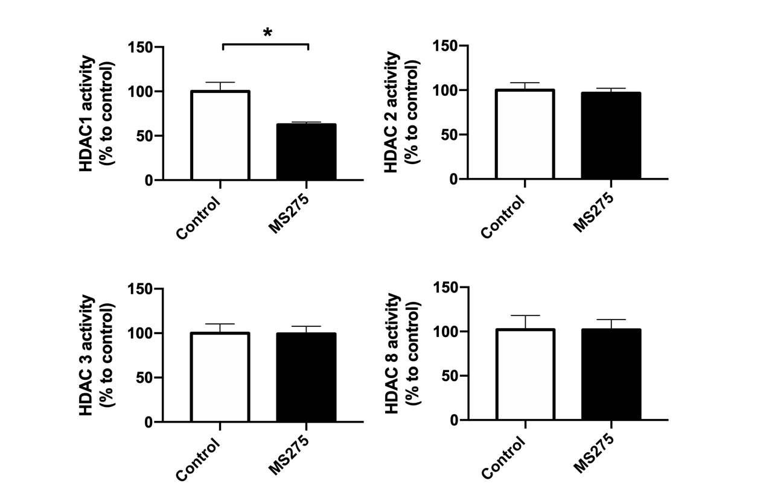
Fig. S1. MS-275 exhibited selectivity towards the enzymatic activity of HDAC1 within the brain. To assess the enzymatic specificity of MS-275 with respect to class 1 HDACs, we evaluated the enzymatic activity of HDAC 1, 2, 3, and 8 in brain lysates obtained from rats subjected to either HBSS (control) or intracerebral microinjection of 100μM MS-275. The collected data exclusively revealed a reduction in the enzymatic activity of HDAC1 due to the presence of MS-275. This outcome strongly implies that the application of MS-275 at this concentration selectively targets HDAC1 within the brain.
N=5 per group. * denotes p < 0.05 analyzed by unpaired-t test.

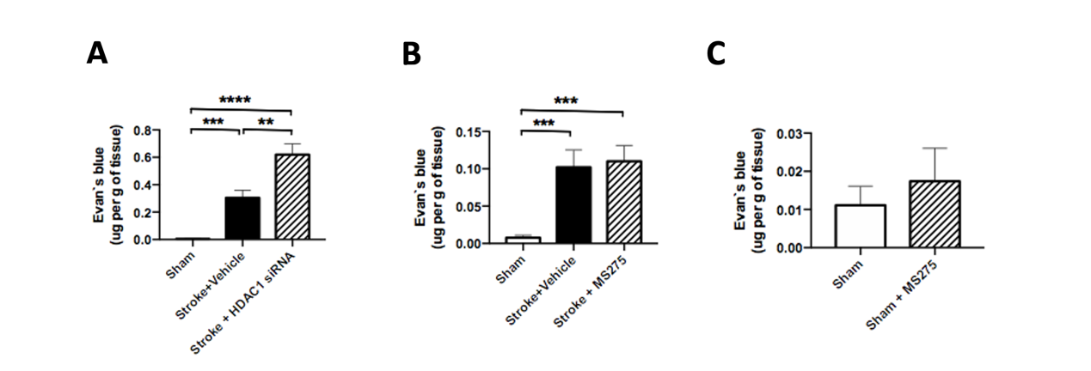
Fig. S2. The Evan's blue assay was employed on brain lysates from rats that underwent cerebral ischemia or sham operation. Brain lysates were extracted using TCA buffer to assess BBB damage in rats with cerebral ischemia, utilizing Evan's blue dye. Spectrophotometry was subsequently performed to quantify the concentration of Evan's blue. (A) To investigate the impact of HDAC1 on BBB damage induced by stroke, we performed a stereotaxic injection of HDAC1 antisense oligomer to reduce HDAC1 levels in the brain, concurrently with endothelin-1 injection, 24 hours after the onset of cerebral ischemia. The results demonstrated noteworthy BBB damage in rats affected by stroke. Notably, the injection of HDAC1 siRNA worsened Evan's blue leakage levels following the stroke. As a comparison, a scramble antisense oligomer was utilized as a control for vehicle injection. (B) To clarify the impact of MS-275 during the inflammation stage linked with BBB damage, we introduced the administration of MS-275 two weeks after the occurrence of stroke. The findings indicated that BBB disruption persisted two weeks after the ischemic event, albeit at a reduced magnitude compared to the initial day. Remarkably, no discernible distinction was observed between the stroke group and the stroke group with delayed MS-275 administration. This suggests that the inflammation level during the acute stage contributed to this phenomenon. (C) In order to examine the isolated impact of MS-275 on BBB damage, we employed stereotaxic injection to introduce MS-275 directly into the brain. Subsequently, we conducted an Evan's blue assay to assess BBB damage. The obtained data demonstrated comparable results between the sham group and the group that underwent sham operation along with MS275 injection. This observation suggests that MS-275, when administered alone, does not exert any discernible influence on BBB damage. N=5 per group. ** denotes p < 0.01, *** denotes p < 0.001, **** denotes p < 0.0001 analyzed by unpaired-t test,

