Supporting Information
Polydopamine modified ceria nanorods alleviate inflammation in colitis by scavenging ROS and regulating macrophage M2 polarization
Bingqing Zhang^{1†}, Qiang Li^{1†}, Qinglin Xu¹, Baochao Li¹, Heng Dong^{1*} and Yongbin Mou^{1, *}
1. Nanjing Stomatological Hospital, Medical School of Nanjing University, Nanjing, China.
†These authors contributed equally to this study.
*Corresponding author:
Yongbin Mou, yongbinmou@nju.edu.cn; Heng Dong, dongheng90@smail.nju.edu.cn. Nanjing Stomatological Hospital, Medical School of Nanjing University, #30 Zhongyang Road, Nanjing 210008, China.

Table S1. Primer sequences for RT-qPCR
Genes | Forward (5' to 3'） | Reverse (3' to 5'）
iNOS | ACATCGACCCGTCCACAGTAT | CAGAGGGGTAGGCTTGTCTC
IL-6 | TAGTCCTTCCTACCCCAATTTCC | TTGGTCCTTAGCCACTCCTTC
TNF-α | CTGAACTTCGGGGTGATCGG | GGCTTGTCACTCGAATTTTGAGA
IL-1β | CTGTGACTCATGGGATGATGATG | CGGAGCCTGTAGTGCAGTTG
Arg-1 | TGTCCCTAATGACAGCTCCTT | GCATCCACCCAAATGACACAT
IL-10 | CTTACTGACTGGCATGAGGATCA | GCAGCTCTAGGAGCATGTGG
GAPDH | AGGTCGGTGTGAACGGATTTG | GGGGTCGTTGATGGCAACA

Table S2. Scoring of disease activity index (DAI)
 | 0 | 1 | 2 | 3 | 4
Weight loss | None | 1%-5% | 5%-10% | 10%-20% | >20%
Stool trait | Normal | Loose stool | Watery diarrhea | Slimy diarrhea, little blood | Severe watery diarrhea with blood
Bloody stool | No blood | / | Presence of blood | / | Gross bleeding
Note: Adapted with permission from Liu YJ, Tang B, Wang FC, et al. Parthenolide ameliorates colon inflammation through regulating Treg/Th17 balance in a gut microbiota-dependent manner. Theranostics. 2020; 10(12): 5225-5241. Copyright©2020. Creative Common.¹

Table S3. Pathological scoring of colon tissue.
 | 0 | 1 | 2 | 3 | 4
Inflammation severity | None | Mild | Moderate | Severe | /
Depth of mucosal damage | None | Mucosal | Mucosal and submucosal | Transmural | /
Crypt loss | None | Basal 1/3 damage | Basal 2/3 damage | Crypt lost, only surface epithelium intact | Entire crypt and epithelium lost
Percent involvement | None | 1%-25% | 26%-50% | 51%-75% | 76%-100%
Note: Adapted with Binabaj MM, Asgharzadeh F, Avan A, et al. EW-7197 prevents ulcerative colitis-associated fibrosis and inflammation. J Cell Physiol. 2019; 234(7): 11654-11661. Copyright©2018, Wiley Periodicals, Inc.²

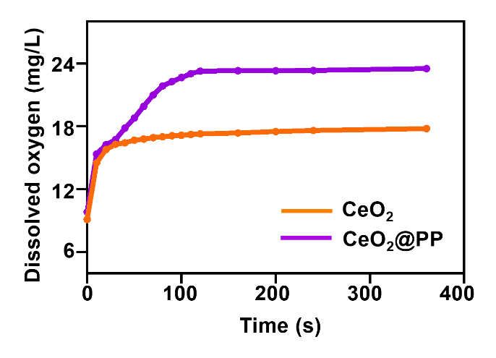
Figure S1. Typical kinetic curves of oxygen production of CeO₂ NRs and CeO₂@PP in H₂O₂ aqueous solution.

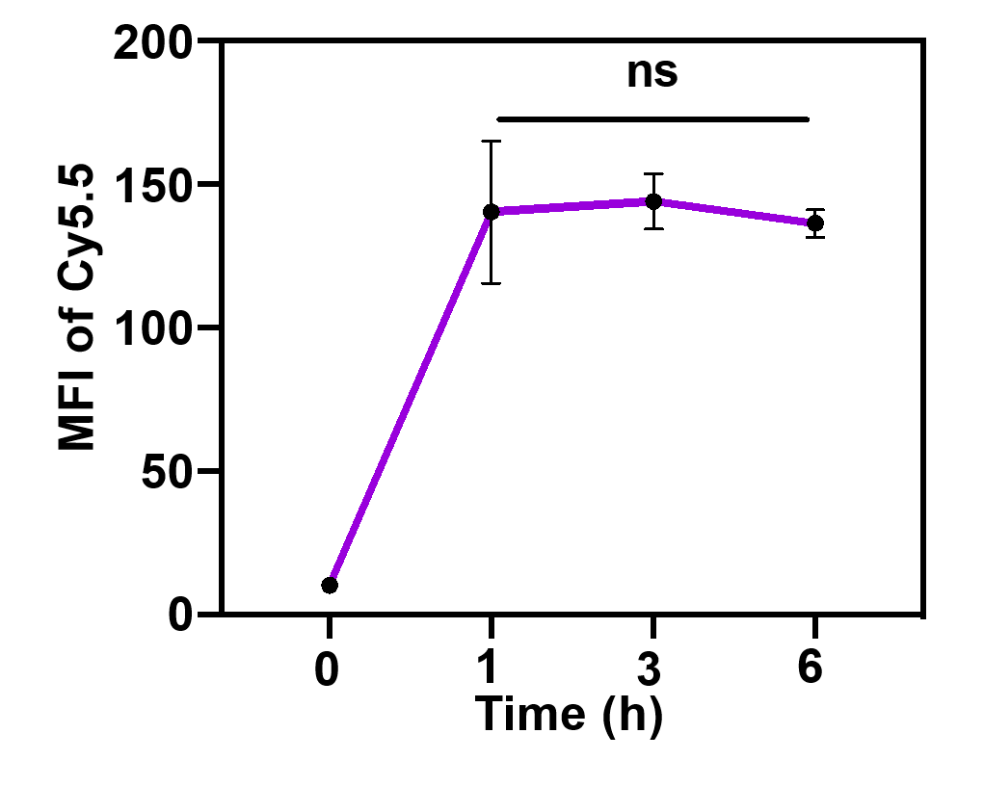

Figure S2. Cell uptake ability of CeO₂@PP. (ns, not significant)

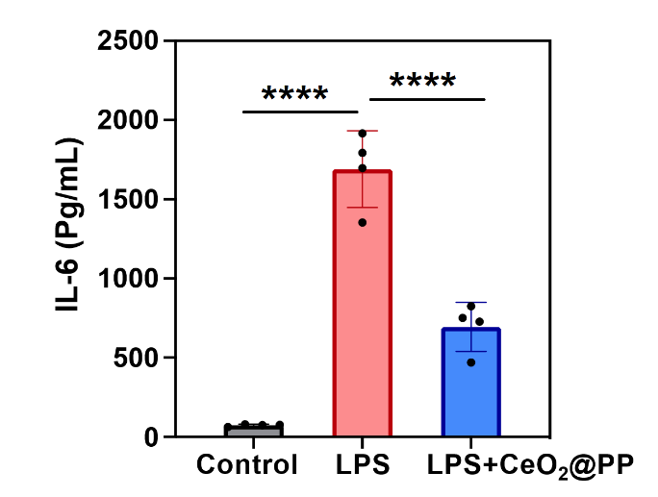
Figure S3. The level of IL-6 proinflammatory cytokine by Elisa assay. (****P< 0.0001)

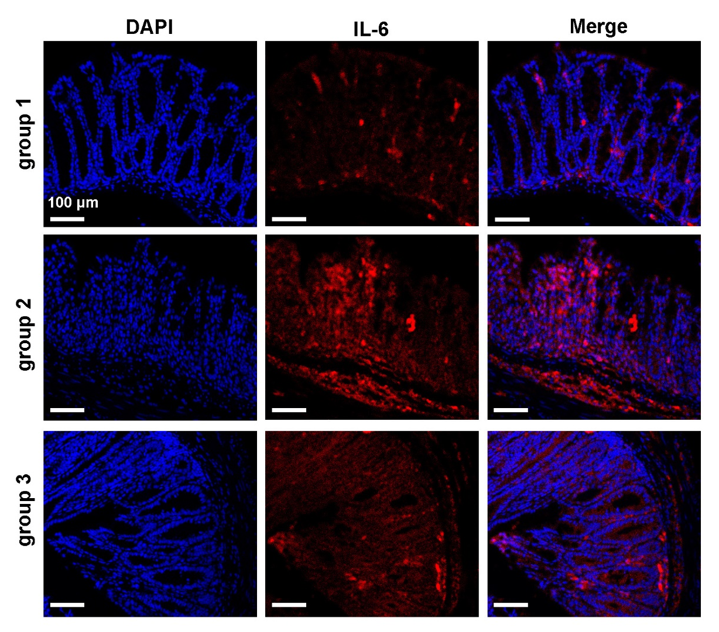
Figure S4. Immunofluorescence staining of IL-6 in colitis.

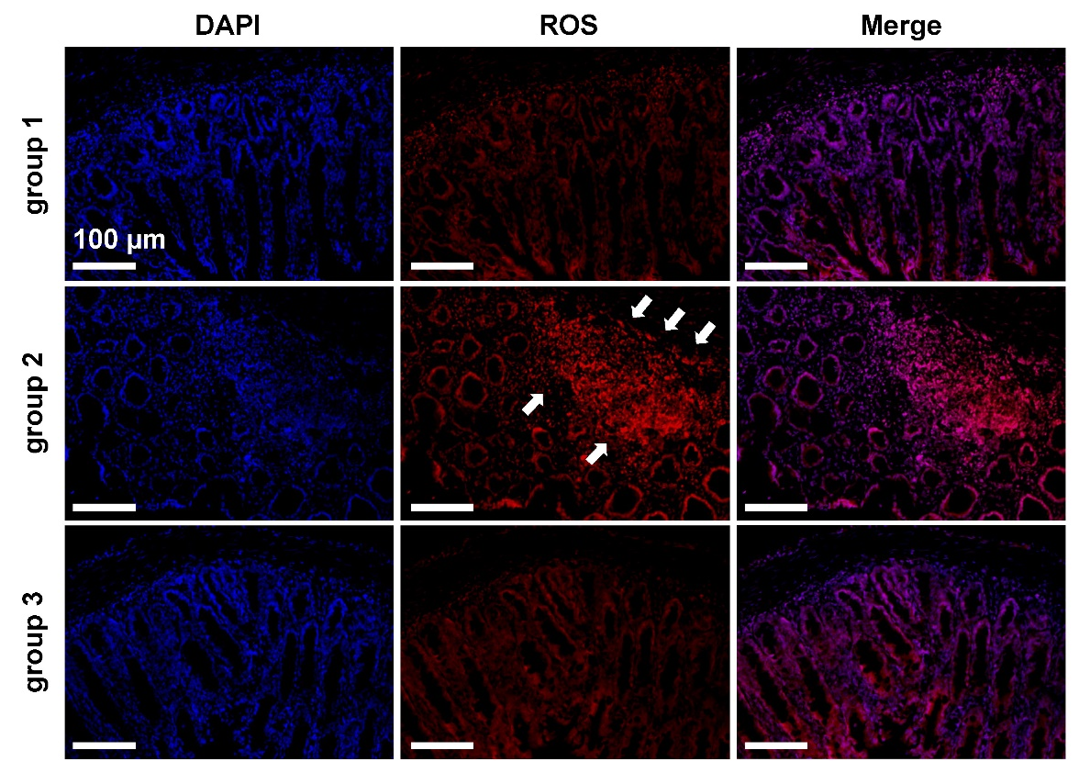
Figure S5. Immunofluorescence staining of ROS in colitis. White arrows indicate ROS enrichment areas

References
1. Liu YJ, Tang B, Wang FC, et al. Parthenolide ameliorates colon inflammation through regulating Treg/Th17 balance in a gut microbiota-dependent manner. Theranostics. 2020; 10(12): 5225-5241.
2. Binabaj MM, Asgharzadeh F, Avan A, et al. EW-7197 prevents ulcerative colitis-associated fibrosis and inflammation. J Cell Physiol. 2019; 234(7): 11654-11661.

