Supplementary materials
Table S1 International Staging System (ISS) staging and immunoelectrophoretic types of paraproteinemia in patients with multiple myeloma
International Staging System (ISS) staging | Total (n=586)
International Staging System (ISS) staging | n | (%)
Stage I | 49 | (8.36)
Stage II | 87 | (14.85)
Stage III | 280 | (47.78)
Unknown | 170 | (29.01)
Immunoelectrophoretic types of paraproteinemia
IgG | 274 | (46.76)
IgA | 91 | (15.53)
Light chain | 65 | (11.09)
Alpha heavy chain | 36 | (6.14)
Other Paratype | 5 | (0.85)
Unknown | 115 | (19.62)

Table S2 Types of primary cancer in patients diagnosed with bone metastasis
Primary cancer | ICD-10 | Total (n=2,432)
Primary cancer | ICD-10 | n | (%)
Lung | C34 | 687 | (28.25)
Breast | C50 | 401 | (16.49)
Prostate | C61 | 384 | (15.79)
Liver | C22 | 231 | (9.50)
Cervix | C53 | 87 | (3.58)
Rectosigmoid | C19 | 62 | (2.55)
Nasopharynx | C11 | 60 | (2.47)
Thyroid | C73 | 54 | (2.22)
Colon | C18 | 51 | (2.10)
Urinary bladder | C67 | 47 | (1.93)
Stomach | C16 | 38 | (1.56)
Kidney | C64 | 37 | (1.52)
Lymphoma | C81-C96 | 25 | (1.03)
Skin | C44 | 14 | (0.58)
Spinal cord | C72 | 14 | (0.58)
Connective tissue | C48 | 11 | (0.45)
Pancreas | C25 | 9 | (0.37)
Brain | C71 | 3 | (0.12)
Others |  | 92 | (3.78)
Unknown |  | 125 | (5.14)

Table S3 Association between the model’s predicted log likelihood ratio (logLR) of MM and the International Stating System (ISS) for patients with MM (n=394) and between the logLR of MM and serum ALP tertiles for patients with BM (n=1870) in the validation dataset.
 | Number | Median LR | 25th percentile LR | 75th percentile LR | logLR (SD) | P-value*
ISS stage | (n=394)
I | 48 | 0.96 | 0.33 | 2.87 | 0.30 (2.05) | <0.001
II | 83 | 4.74 | 0.80 | 19.04 | 1.64 (2.49)
III | 263 | 9.61 | 2.28 | 60.99 | 2.79 (3.76)
ALP tertiles | (n=1870)
Tertile 1 | 634 | 0.43 | 0.30 | 0.72 | -0.60 (1.31) | <0.001
Tertile 2 | 610 | 0.26 | 0.16 | 0.47 | -1.01 (2.34)
Tertile 3 | 626 | 0.10 | 0.06 | 0.21 | -2.20 (1.16)
Note: Analysis set limited to patients with complete data on MM-BM DDx predictors and available information of ISS stage (n=394 for MM and n=1870 for BM). Abbreviations: ALP, alkaline phosphatase; BM, bone metastases; ISS, International Staging System; LR, likelihood ratio; MM, multiple myeloma; SD, standard deviation. *P-value from Oneway analysis of variance (ANOVA)

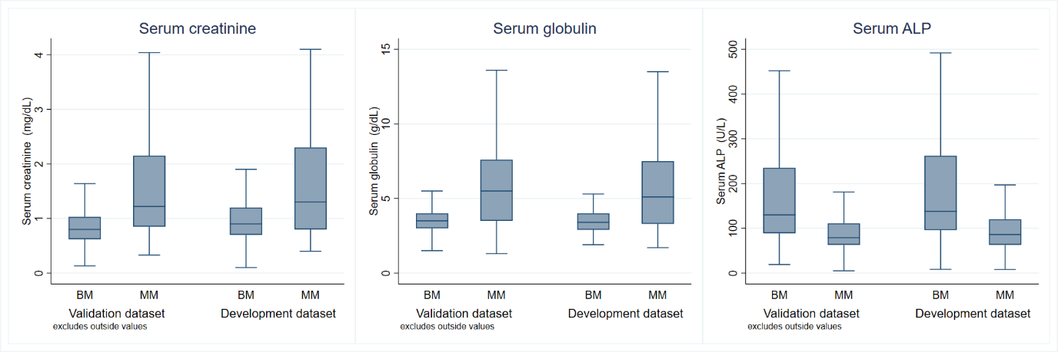
Figure S1 The distributions of the three parameters, categorized by diagnosis and datasets.

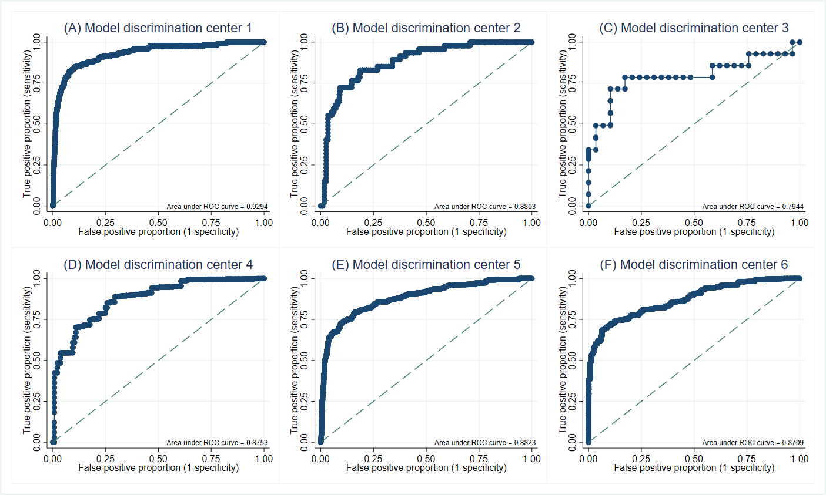
Figure S2 The model discriminative ability in the external validation dataset illustrated with area under the receiver operating characteristics curve (ROC) stratified by center. (A) Chiang Mai University (B) Khon Kaen University (C) Siriraj Hospital (D) Queen Savang Vadhana Memorial Hospital (E) Khon Kaen Hospital (F) Chulabhorn Hospital.

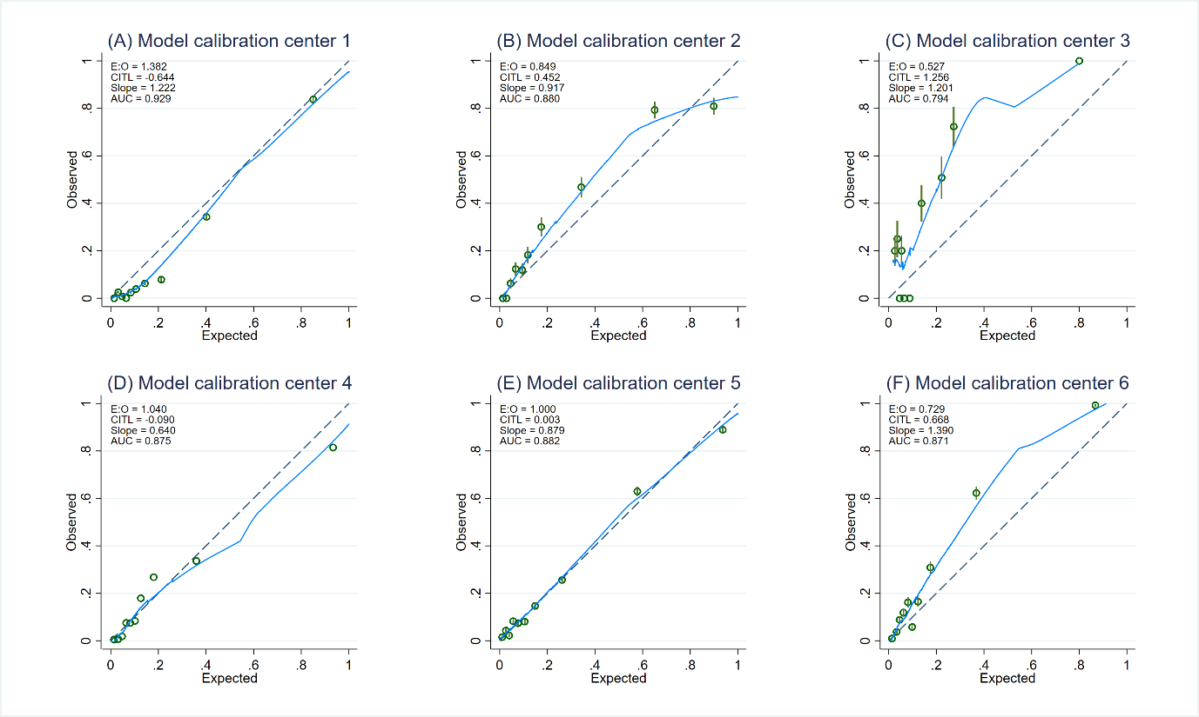
Figure S3 The model calibration plots illustrating the agreement between the expected probability from the MM-BM DDx model and the observed probability of multiple myeloma in the external validation dataset stratified by center. (A) Chiang Mai University (B) Khon Kaen University (C) Siriraj Hospital (D) Queen Savang Vadhana Memorial Hospital (E) Khon Kaen Hospital (F) Chulabhorn Hospital.

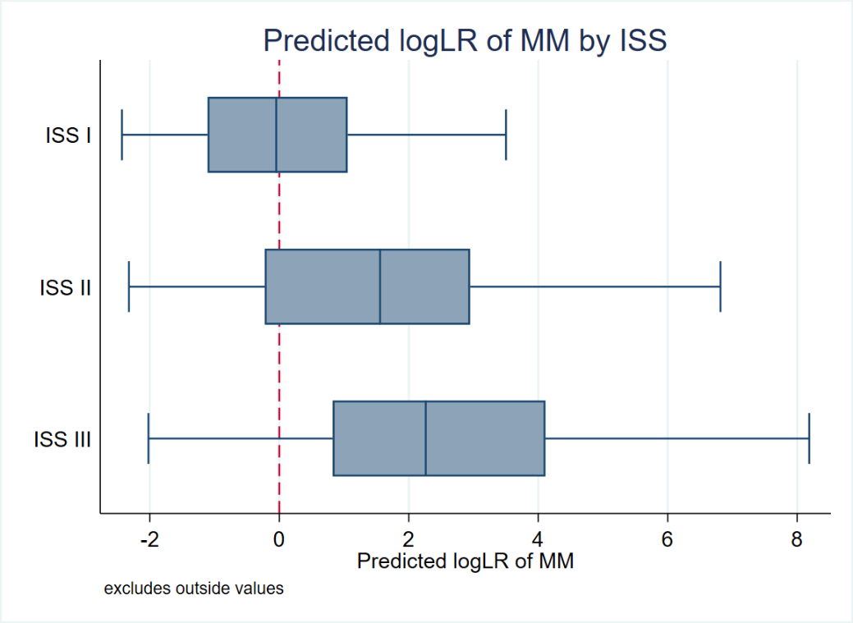
Figure S4 The distribution of model’s predicted log likelihood ratio (logLR) of multiple myeloma (MM) for each stage of International Staging System

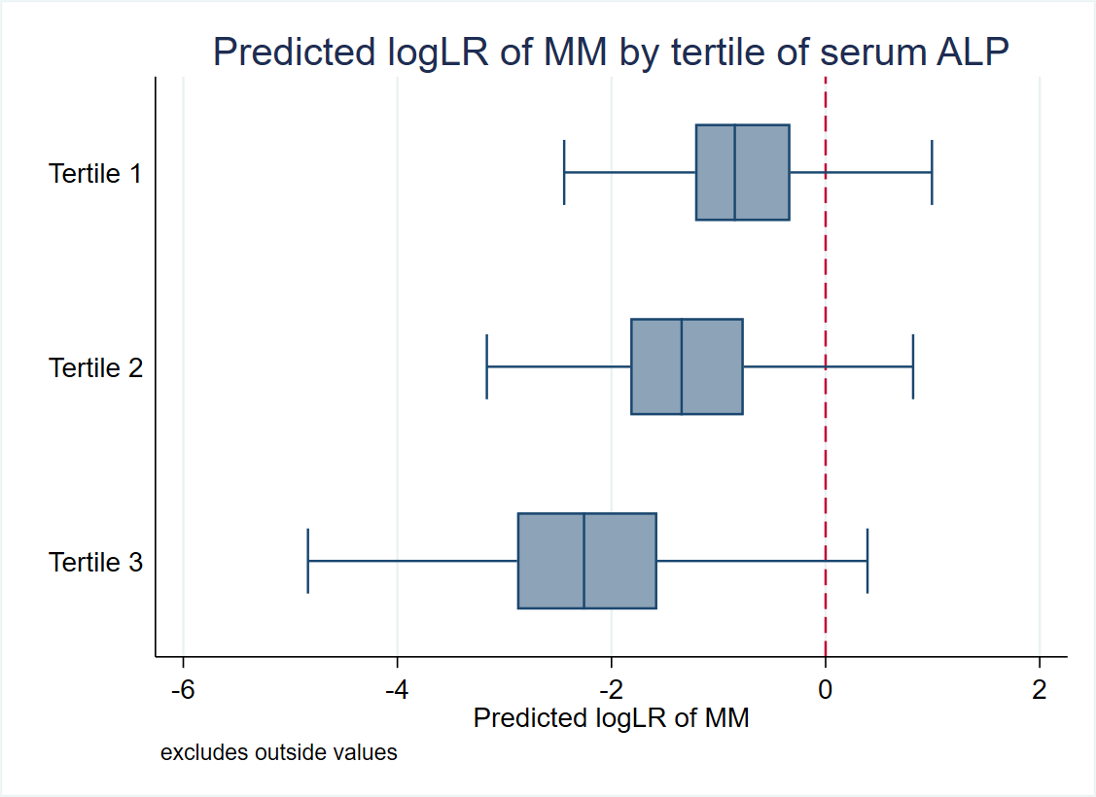(ISS)
Figure S5 The distribution of model’s predicted log likelihood ratio (logLR) of multiple myeloma (MM) for each tertile of serum alkaline phosphatase (ALP)

