Table S1
Results of the multivariable COX regression in MACE

 | HR (95%CI) | P*- value
Age | 1.01 (0.99, 1.03) | 0.209
Prior PCI | 1.07 (0.63, 1.84) | 0.783
History of stroke | 1.08 (0.56, 2.06) | 0.816
Hypertension | 1.03 (0.64, 1.67) | 0.875
in-stent restenosis | 1.58 (0.74, 3.36) | 0.232
ESC risk criteria | 2.44 (1.54, 3.87) | ＜0.001

Notes: * Cox proportional-hazards model was done.

Table S2
The comparison of number of risk factors between low/moderate thrombotic risk and high thrombotic risk

 | Low/moderate thrombotic risk (n=306) | High thrombotic risk (n=183) | P*
Number of risk factors | 3.45±1.62 | 0.97±1.18 | ＜0.001

Notes: Data are shown as the mean ± standard deviation. * Student's t-test was done when appropriate.

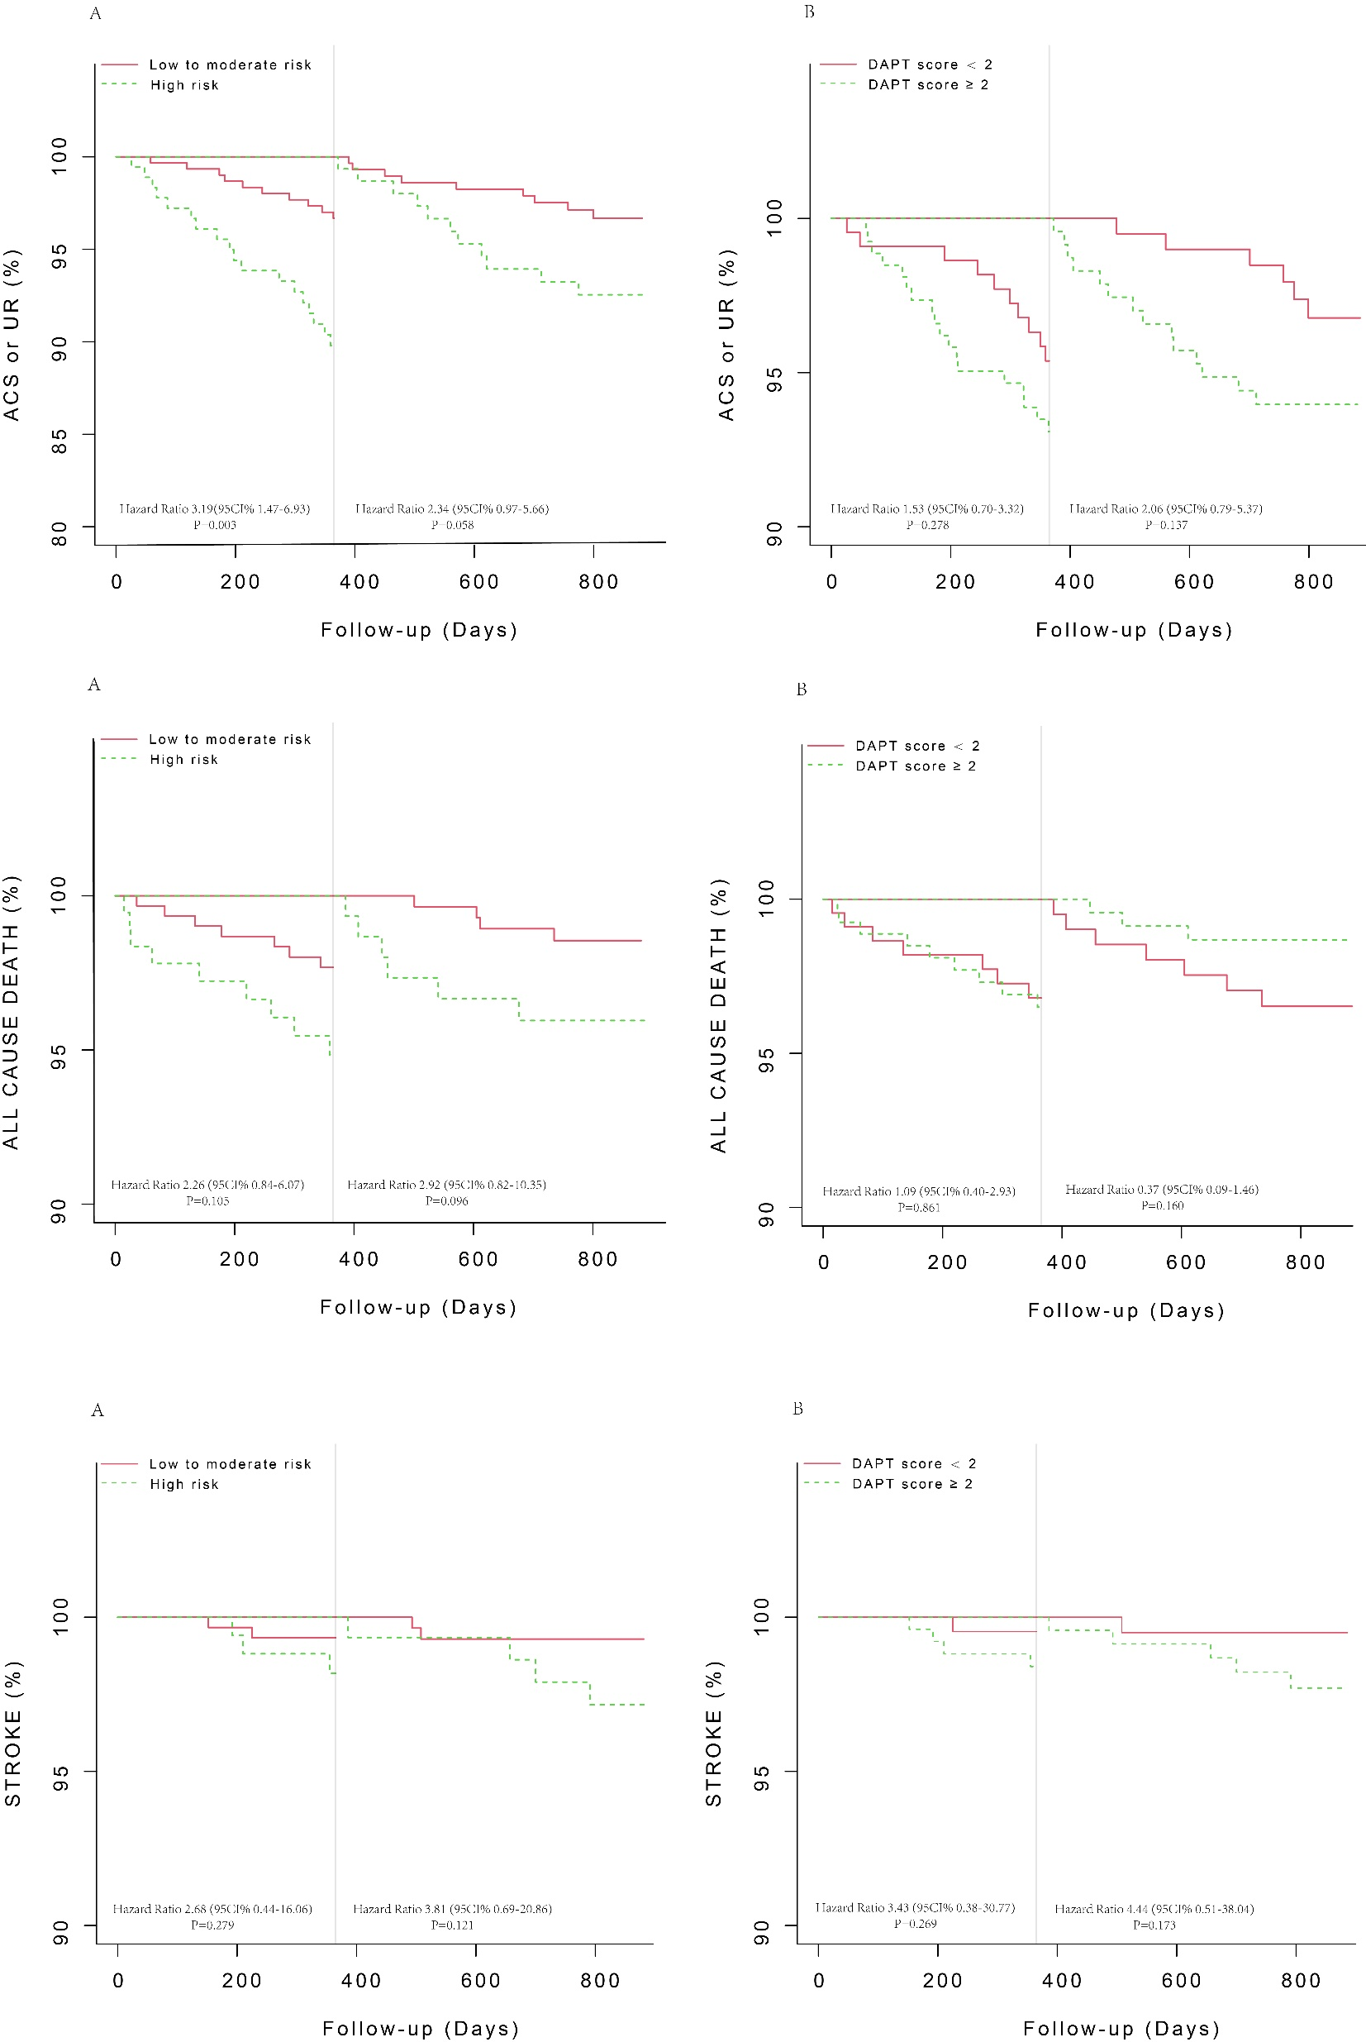

Figure S1
Landmark analysis of the Kaplan–Meier estimates of clinical outcomes within one year and after one year.
(A) Event rates of clinical outcomes in the ESC-defined high-risk and ESC-defined low/medium-risk groups and landmark analysis within and after one year. (B) Event rates of clinical outcomes in the DAPT score ≥ 2 and DAPT score < 2 groups and landmark analysis within and after one year.

