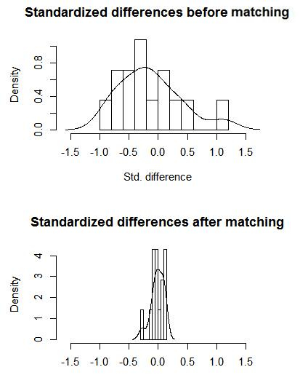
Figure S1 Standard deviation distribution histogram before and after propensity score matched

