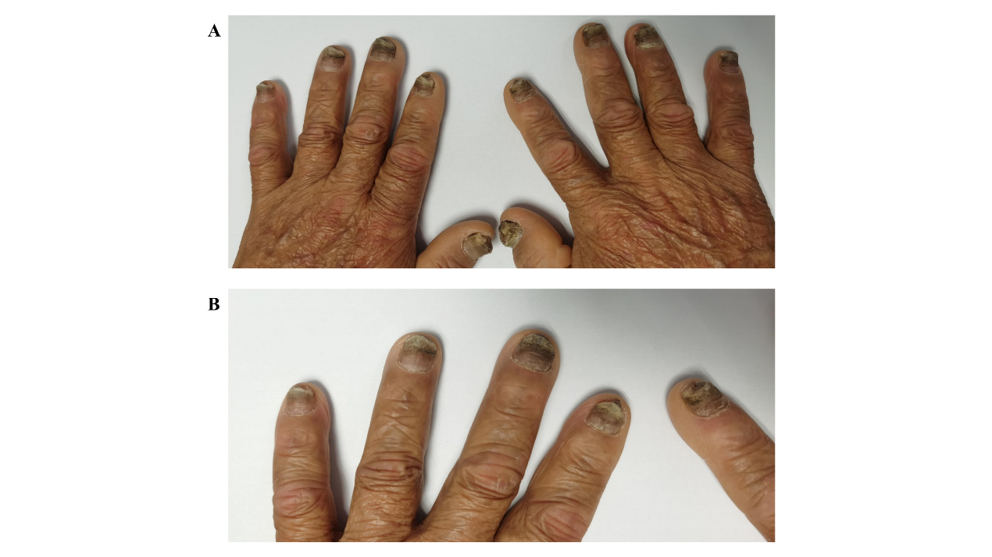

Figure S1. In April 2023, we photographed and documented changes in the patient's nails after the patient had used an antifungal cream and lubricant. (A) The ten fingers of both hands. (B) The fourth finger of the left hand and the index finger of the right hand.

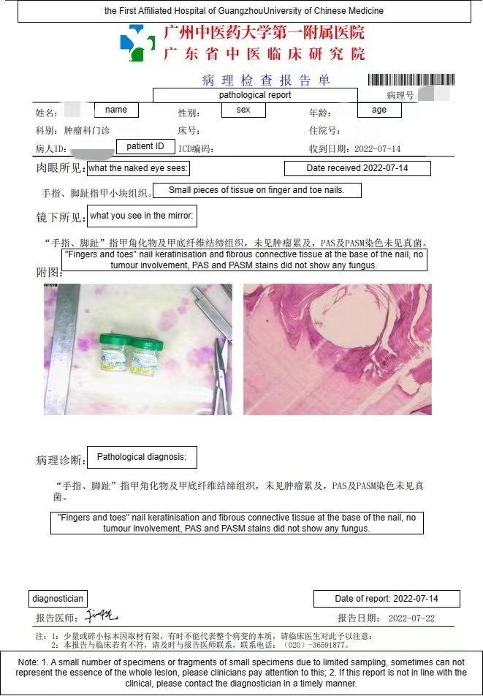
Figure S2. Pathological report of the patient's onychopathy.

