Supporting information for:

Defeating Melanoma Through a Nano-Enabled Revision of Hypoxic and Immunosuppressive Tumor Microenvironment
Wenzhe Yang^{1,2,*}, Xue Pan^{2,*}, Peng Zhang², Xue Yang^{1,2}, Huashi Guan^{1,2}, Huan Dou³, Qian Lu^{1,2}

¹Key Laboratory of Marine Drugs of Ministry of Education, School of Medicine and Pharmacy, Ocean University of China, Qingdao, Shandong Province, People’s Republic of China
²Marine Traditional Chinese Medicine R&D Laboratory, Marine Biomedical Research Institute of Qingdao, Qingdao, Shandong Province, People’s Republic of China
³Jiangsu Key Laboratory of Molecular Medicine, Medical School, Nanjing University, Nanjing, Jiangsu Province, People’s Republic of China
*These authors contributed equally.

Corresponding to author: Qian Lu, Key Laboratory of Marine Drugs of Ministry of Education, School of Medicine and Pharmacy, Ocean University of China, 5 Yushan Road, Qingdao, Shandong Province, China, Tel: +86 15850672529, Fax: +86 532 8506779, E-mail: lq7080@ouc.edu.cn; Huan Dou, Jiangsu Key Laboratory of Molecular Medicine, Medical School, Nanjing University, 22 Hankou Road, Nanjing, Jiangsu Province 210093, China, Tel: +86 13913832488, Fax: +86 025 83686441, E-mail: douhuan@nju.edu.cn

Table S1 The encapsulation efficiency and drug loading of Ato and cabo
 | Encapsulation efficiency | Drug loading
Ato | 80.12% | 13.3%
Cabo | 82.36% | 3.4%

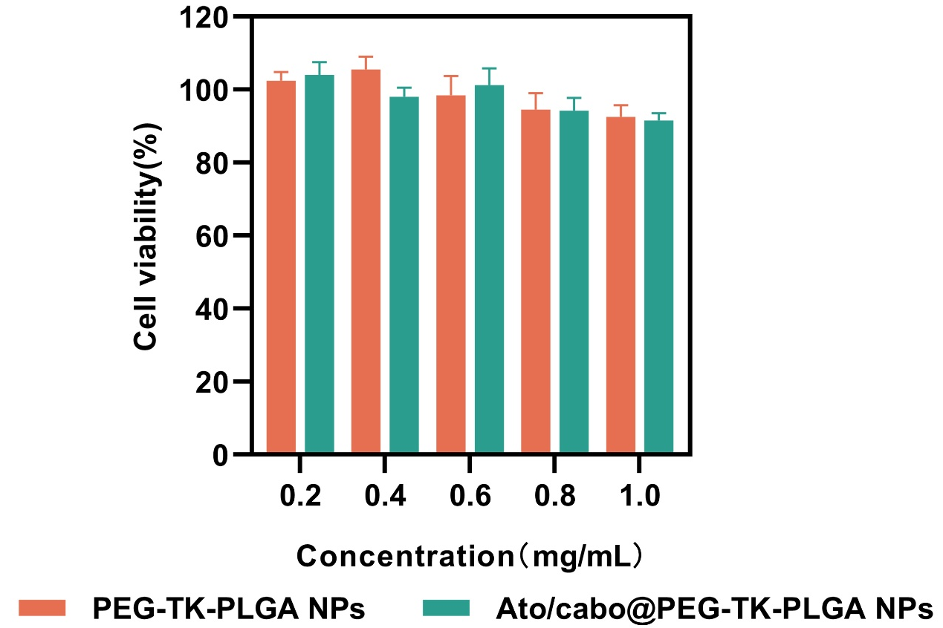
Figure S1 The cell viability of PEG-TK-PLGA NPs and Ato/cabo@PEG-TK-PLGA NPs

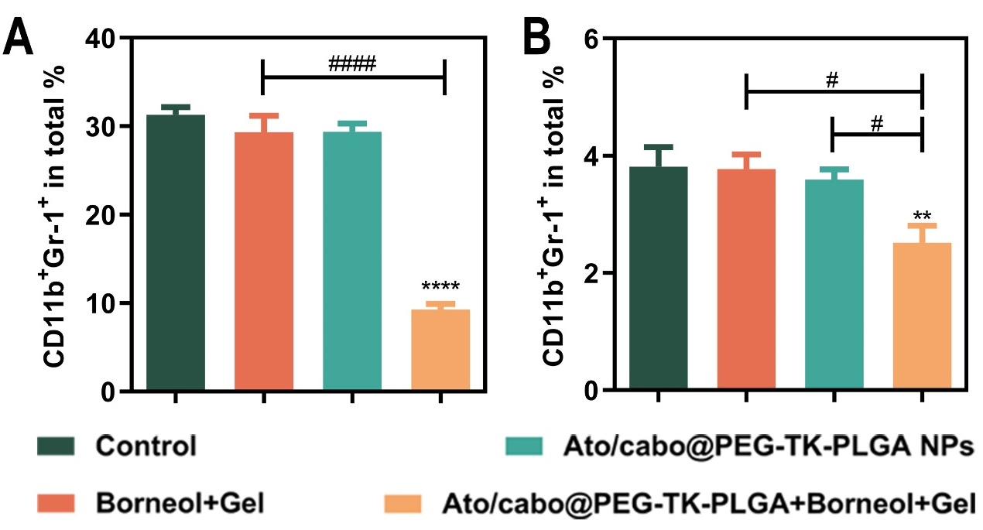
Figure S2 Proportion of MDSCs with different treatment in blood (A) and spleen (B). (**P < 0.01, ****P < 0.0001 compared with control group, n = 6) (#P < 0.05, ####P < 0.0001, compared with other groups, n = 6)

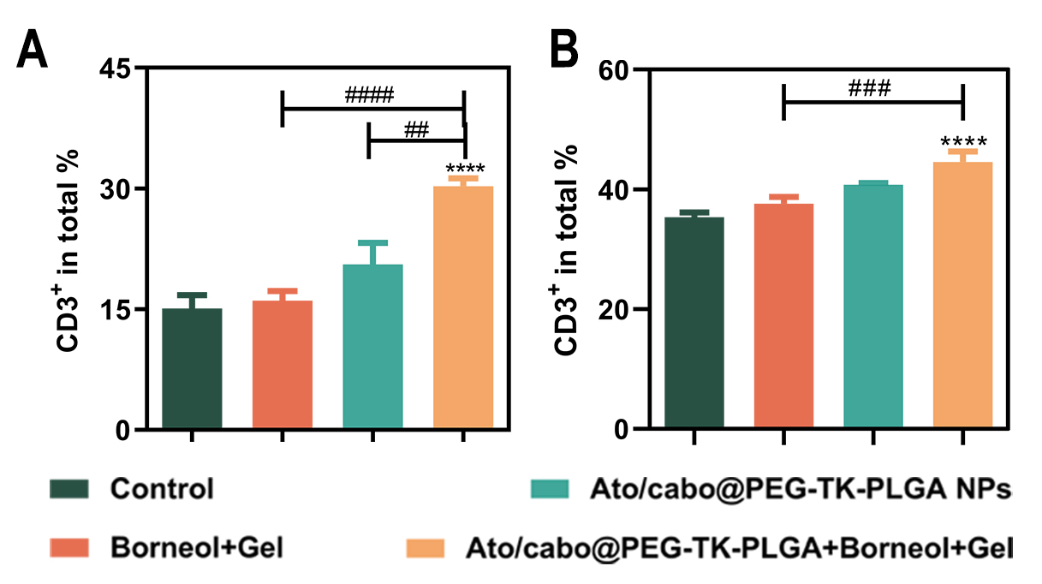
Figure S3 The CD3+ T cells in blood (A) and spleen (B) during treatment. (****P < 0.0001 compared with control group, n = 6) (##P < 0.01, ###P < 0.001 ####P < 0.0001 compared with other groups, n = 6)

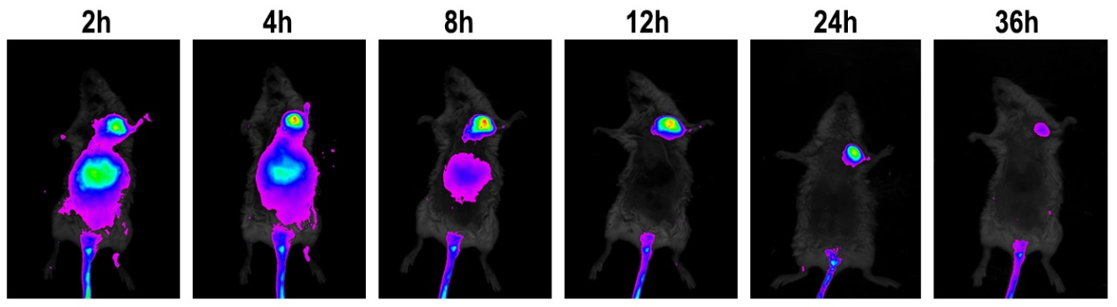
Figure S4 Bio-distribution of ICG

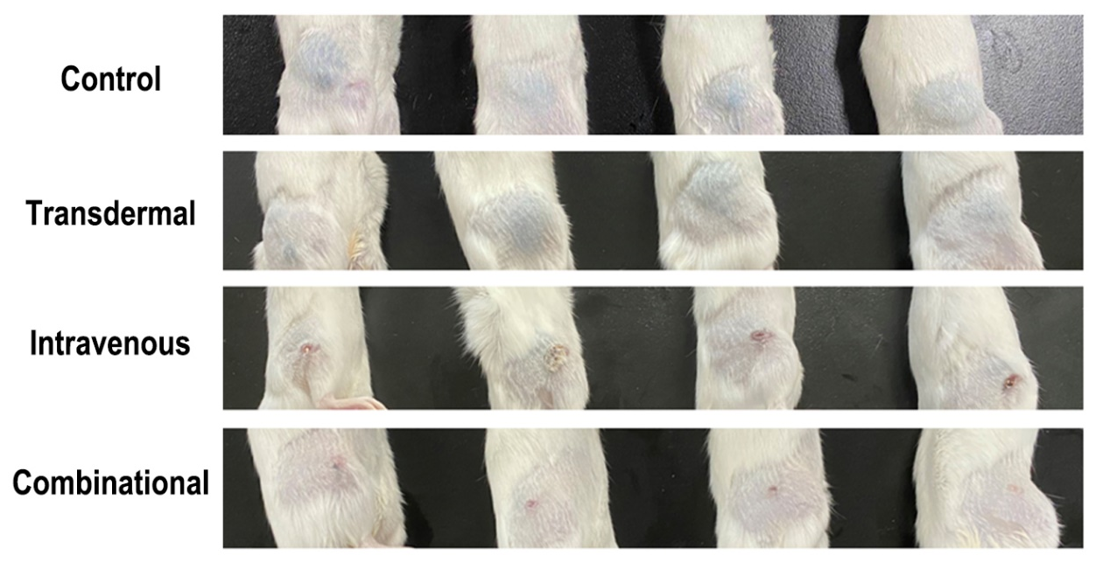
Figure S5 Representative photographs of mice and tumors collected from the different groups of mice at the end of treatments

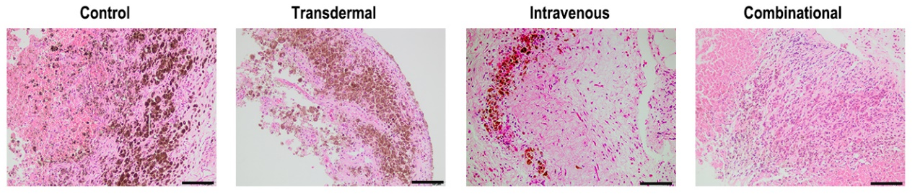
Figure S6 Representative histology H&E staining of tumor slices after different treatment (Scale bars: 100 μm)

