Supplementary Material

Short-term intravenous administration of carbon nano-onions is non-toxic in female mice

Yi Zhen Tan¹, Lucy R Thomsen¹, Nensi Shrestha¹, Adalberto Camisasca², Silvia Giordani², Rhonda Rosengren¹ *

¹ Department of Pharmacology and Toxicology, University of Otago, Dunedin 9016, New Zealand.
² School of Chemical Sciences, Dublin City University, Glasnevin, D09 NA55 Dublin, Ireland.

*Correspondence:
Rhonda Rosengren
Department of Pharmacology and Toxicology, 18 Frederick Street, Dunedin 9016, New Zealand.
Tel: +64 3 479 9141
Fax: +64 3 479 9140
Email: rhonda.rosengren@otago.ac.nz

Methods

Size characterization
Dynamic light scattering was performed on the Zetasizer® Nano ZS (ZEN3600, Malvern Instrument) with an He-Ne laser (wavelength, λ= 633 nm) and measurement angle of 173° (non-invasive blackscatter, NIBS® system). The oxi-CNO dispersion was transferred (without filtration) to a disposable acrylic semi-micro cuvette. A refractive index of 1.333 and viscosity of 1.0 cP were set for ultrapure water, while a refractive index of 1.400 and viscosity of 32.0 cP were set for 50% w/v PEG. The samples were allowed to equilibrate for a duration of 120 s at 20°C prior to measurement. All samples were analyzed by the Zetasizer® software (version 7.03, Malvern Instrument) to determine the hydrodynamic diameter (Z-average size) and intensity-weighted size distribution. Each sample was examined in triplicate consecutively, with an average of 14 runs per measurement.

Table S1: Body weight and organ weight of the mice following treatment with oxi-CNOs
 | Unt | Veh | 125 µg | 250 µg | 500 µg
Single-dose
∆ Body weight ª | 0.76$±$0.22 | -0.06$±$0.26 | -0.28$±$0.21 | 0.08$±$0.38 | 0.14$±$0.22
∆ Body weight | 3.94$±$1.23 | -0.29$±$1.37 | -1.56$±$1.21 | 0.41$±$1.97 | 0.69$±$1.12
Liver | 4.40$±$0.13 | 4.70$±$0.18 | 4.60$±$0.09 | 4.60$±$0.04 | 4.60$±$0.04
Spleen | 0.35$±$0.01 | 0.37$±$0.02 | 0.39$±$0.01 | 0.37$±$0.01 | 0.37$±$0.01
Lungs | 1.57$±$0.11 | 1.65$±$0.05 | 1.48$±$0.11 | 1.37$±$0.03 | 1.61$±$0.15
Kidneys | 1.33$±$0.08 | 1.30$±$0.04 | 1.25$±$0.05 | 1.32$±$0.02 | 1.25$±$0.04
Multiple-dose
∆ Body weight ª | 1.16$±$0.16 | -0.36$±$0.29 * | -0.02$±$0.17 * | -0.68$±$0.13 * | -0.62$±$0.41 *
∆ Body weight | 5.82$±$0.83 | -1.71$±$1.40 * | -0.08$±$0.96 * | -3.65$±$0.63 * | -2.71$±$1.74 *
Liver | 4.94$±$0.05 | 4.65$±$0.15 | 4.79$±$0.16 | 4.92$±$0.10 | 5.08$±$0.05
Spleen | 0.37$±$0.02 | 0.37$±$0.02 | 0.41$±$0.02 | 0.41$±$0.01 | 0.40$±$0.01
Lungs | 1.50$±$0.04 | 1.37$±$0.18 | 1.51$±$0.05 | 1.54$±$0.05 | 1.41$±$0.13
Kidneys | 1.21$±$0.03 | 1.33$±$0.02 | 1.27$±$0.04 | 1.33$±$0.04 | 1.34$±$0.05
Notes: Data are presented as the mean ± SEM of values expressed as % body weight unless stated otherwise, with n=5 mice per group. ªValues expressed as g. Significance was determined with a one-way ANOVA coupled with a Tukey’s post-hoc test. *significantly decreased compared to untreated mice, p<0.05.
Abbreviations: Unt, untreated; Veh, vehicle control.

Table S2: Hydrodynamic diameter obtained from DLS measurements of oxi-CNOs dispersed in ultrapure water
Dispersant | Concentration  (µg/mL) | Z-average size  (d. nm)
50% w/v PEG | 125 | 47.3±1.84
 | 250 | 73.5±1.40
 | 500 | 54.8±1.82
Ultrapure water | 50 | 136.8±0.26
Ultrapure water | 100 | 138.1±0.38
Ultrapure water | 200 | 143.6±0.33

Notes: Hydrodynamic diameter is expressed in terms of Z-average size ± SEM. Each sample was run in triplicate consecutively, with the accumulation of an average of 14 runs per measurement.

Figure S1: Intensity-weighted size distribution of oxi-CNOs dispersed in 50% w/v PEG or ultrapure water. Each sample was run in triplicate consecutively, with the accumulation of an average of 14 runs per measurement.

Figure S2: Quantification of CNO aggregates accumulated in the organs following treatment with a single dose of oxi-CNOs. Data are presented as the mean ± SEM, with n=5 mice per group. Significance was determined with a two-way ANOVA coupled with a Tukey’s post-hoc test. ¤significantly increased compared to all other organs at the same concentration, p<0.01. #significantly increased compared to the lung at the same concentration, p<0.001. ^{ϕ}significantly different from all other concentrations in the same tissue, p<0.05.
Abbreviations: Unt, untreated control; Veh, vehicle control.

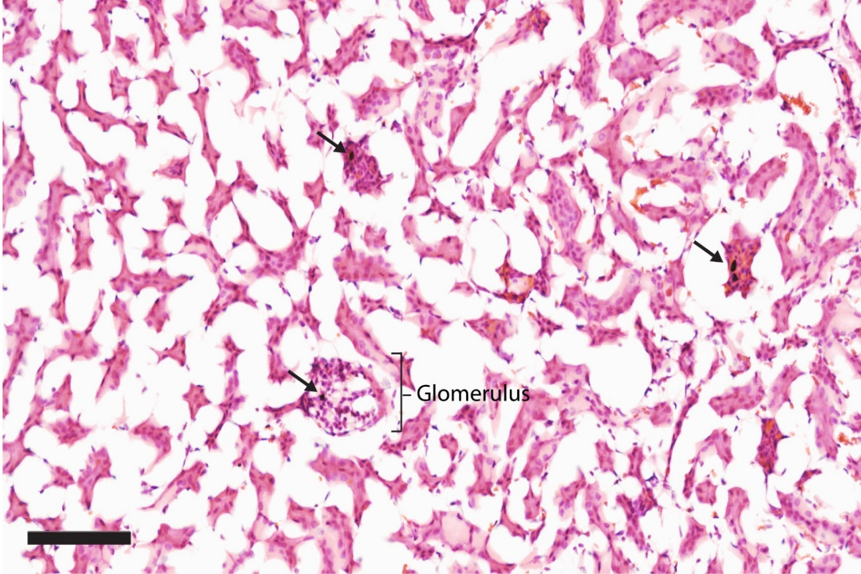
Figure S3: H&E staining of kidney section. Kidney section (12 µm) from mice following treatment with three iv doses of 500 µg oxi-CNOs. The accumulation of CNO aggregates is indicated with black arrows. The representative images from n=5 mice per group are shown. Images are shown at 20x magnification. Scale bar, 100 µm.

