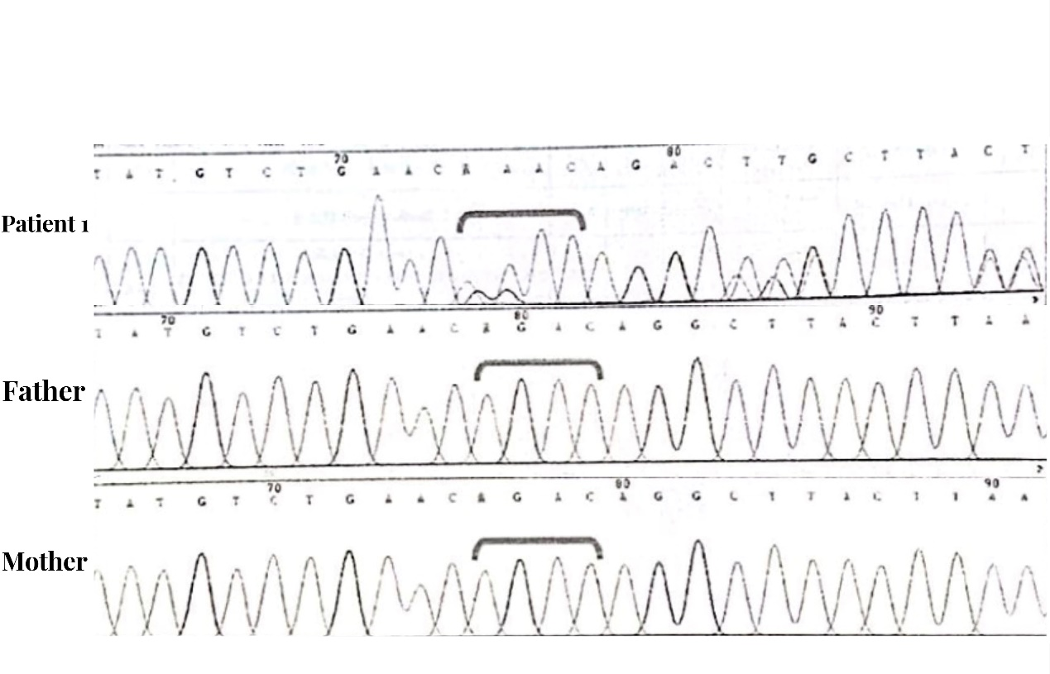
Supplementary Figure 1: Sanger sequencing of patient 1, mutation site is marked by the bar in the figure.
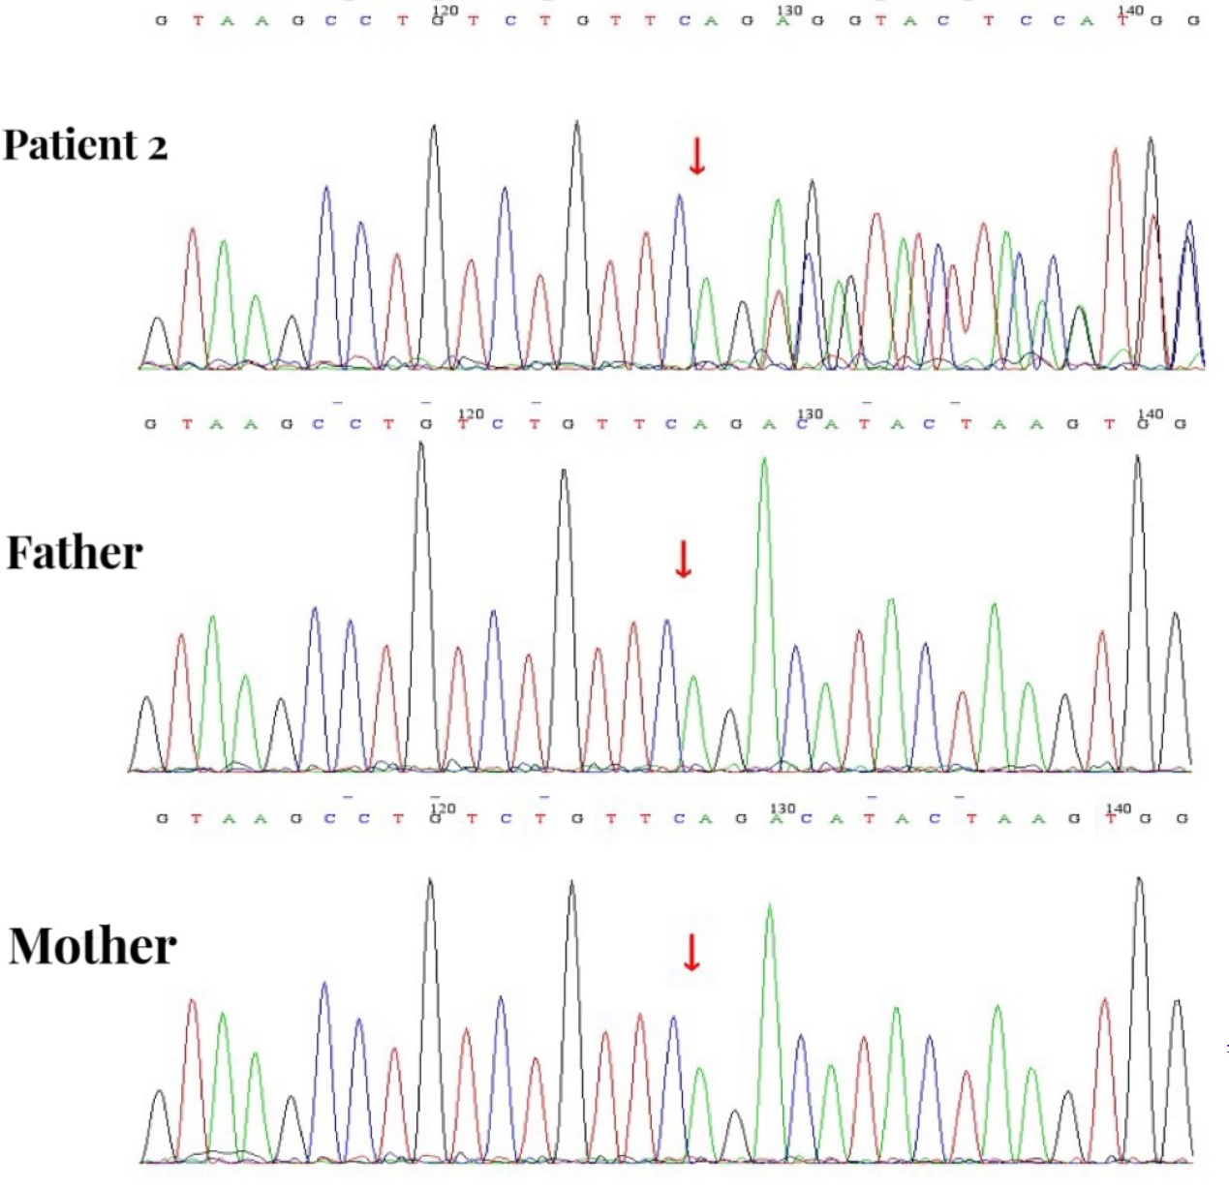

Supplementary Figure 2: Sanger sequencing of patient 2, the black, green, red, and blue colours represent the G, A, T, and C base sequences respectively, and the mutation site is marked by the red arrow.

