Supplementary materials
Table S1 Compounds identified from the QBD by UPLC-Q/TOF-MS/MS in positive- and negative-ion modes.
NO. | T_{R} (min) | Molecular  formula | Characteristic ion fragments(m/z) |  | Error  (ppm) | Identified compounds
NO. | T_{R} (min) | Molecular  formula | Precursor | Selective ion | Error  (ppm) | Identified compounds
1 | 0.77 | C₆H₁₄N₄O₂ | 174.11168 | 175.1189 [M+H]⁻ | -0.1 | Arginine
2 | 0.79 | C₁₈H₃₂O₁₆ | 504.16903 | 543.1339 [M+K]⁺ | 1.7 | Raffinose
3 | 0.81 | C₅H₉NO₄ | 147.05316 | 148.0606 [M+H]⁺ | 0.1 | Glutamic acid
4 | 0.82 | C₅H₁₁NO₂ | 117.07898 | 118.0860 [M+H]⁺ | -0.2 | Valine
5 | 0.82 | C₉H₁₁NO₃ | 181.07389 | 182.082 [M+H]⁺ | 0.8 | Tyrosine
6 | 0.82 | C₁₅H₁₈O₄ | 262.12051 | 307.1175 [M+HCOO]⁻ | -1.2 | Artemisinin
7 | 0.82 | C₅H₁₀O₅ | 150.05282 | 195.0521 [M+HCOO]⁻ | 1.1 | Arabinose
8 | 0.83 | C₅H₉NO₂ | 115.06333 | 116.0708 [M+H]⁺ | 0.2 | Proline
9 | 0.84 | C₁₂H₂₂O₁₁ | 342.11621 | 341.1108 [M-H]⁻ | 1.9 | Saccharose
10 | 0.91 | C₃₀H₃₂O₁₃ | 600.18429 | 645.1821 [M+HCOO]⁻ | -0.4 | Benzoyl paeoniflorin oxide
11 | 1.03 | C₂₇H₄₂O₂₀ | 686.22694 | 731.2268 [M+HCOO]⁻ | 1.7 | Digitalis glycosides D
12 | 1.19 | C₁₀H₁₃N₅O₄ | 267.09675 | 268.1039 [M+H]⁺ | -0.2 | Adenosine
13 | 3 | C₁₅H₂₀O₈ | 328.11582 | 373.1152 [M+HCOO]⁻ | 1.2 | Paeonoside isomer
14 | 5.15 | C₂₅H₂₈O₁₆ | 584.13773 | 585.1453 [M+H]⁺ | 0.3 | New mangiferin
15 | 5.23 | C₂₃H₂₈O₁₂ | 496.15808 | 495.1525 [M-H]⁻ | 1.7 | Oxypaeoniflorin
16 | 5.34 | C₁₆H₁₈O₉ | 354.09508 | 399.0949 [M+HCOO]⁻ | 1.7 | Scopolin
17 | 5.34 | C₁₀H₈O₄ | 192.04226 | 193.0489 [M+H]⁺ | -0.6 | 6-methoxy-7-Hydroxycoumarin
18 | 6.15 | C₁₉H₁₈O₁₁ | 422.08491 | 421.0795 [M-H]⁻ | 1.8 | Mangiferin
19 | 6.79 | C₉H₁₀O₂ | 150.06808 | 151.075 [M+H]⁺ | -0.4 | Benzyl acetate
20 | 6.79 | C₁₅H₂₀O₈ | 328.11582 | 327.109 [M-H]⁻ | 0.5 | Paeonoside
21 | 7.48 | C₁₀H₈O₄ | 192.04226 | 193.0489 [M+H]⁺ | -0.6 | 6-methoxy-7-Hydroxycoumarin isomer
22 | 7.69 | C₃₀H₃₂O₁₅ | 632.17412 | 677.1718 [M+HCOO]⁻ | -0.6 | Galloylpaeoniflorin
23 | 7.69 | C₂₇H₃₀O₁₆ | 610.15338 | 611.1625 [M+H]⁺ | 1.9 | Rutin
24 | 7.71 | C₂₃H₂₈O₁₁ | 480.16316 | 525.1633 [M+HCOO]⁻ | 2 | Paeoniflorin
25 | 8.08 | C₂₂H₂₂O₁₃ | 494.10604 | 495.1133 [M+H]⁺ | 0 | Marigold-3-O-glucoside
26 | 8.08 | C₁₆H₁₂O₈ | 332.05322 | 333.0607 [M+H]⁺ | 0.2 | 5,6,7,3',4'-5-OH-3-methoxy flavone
27 | 8.48 | C₃₀H₃₂O₁₄ | 616.17921 | 661.177 [M+HCOO]⁻ | -0.4 | Mudanpioside H
28 | 9.02 | C₄₅H₇₄O₁₉ | 918.48243 | 919.4894 [M+H]⁺ | -0.3 | Anemarrhenosaponin D
29 | 9.02 | C₃₉H₆₄O₁₄ | 756.42961 | 757.4355 [M+H]⁺ | -1.4 | Anemarrhenosaponin A-2
30 | 9.23 | C₅₀H₈₂O₂₃ | 1050.52469 | 1095.5241 [M+HCOO]⁻ | 1.2 | Anemarsaponin F
31 | 9.56 | C₄₅H₇₄O₁₉ | 918.48243 | 919.4877 [M+H]⁺ | -2 | Anemarrhenosaponin D isomer
32 | 9.56 | C₃₉H₆₄O₁₄ | 756.42961 | 757.4353 [M+H]⁺ | -1.6 | Anemarrhenosaponin A-2 isomer
33 | 9.88 | C₃₀H₃₂O₁₃ | 600.18429 | 599.1789 [M-H]⁻ | 1.9 | Benzoyloxypaeoniflorin
34 | 10.08 | C₄₅H₇₄O₁₉ | 918.48243 | 963.4825 [M+HCOO]⁻ | 1.9 | Anemarrhenosaponin D isomer
35 | 10.21 | C₃₉H₆₄O₁₃ | 740.43469 | 741.443 [M+H]⁺ | 1 | Anemarrhenosaponin A-3
36 | 10.37 | C₁₃H₁₈O₂ | 206.13068 | 251.13 [M+HCOO]⁻ | 1.2 | Artemisinin A
37 | 10.38 | C₄₅H₇₄O₁₈ | 902.48752 | 903.4949 [M+H]⁺ | 0.1 | Anemarrhenosaponin C
38 | 10.38 | C₃₉H₆₄O₁₃ | 740.43469 | 741.4421 [M+H]⁺ | 0.1 | Anemarrhenosaponin A-3 isomer
39 | 10.38 | C₃₃H₅₄O₈ | 578.38187 | 579.3892 [M+H]⁺ | 0 | Anemarrhenosaponin A-1
40 | 10.56 | C₃₁H₃₄O₁₄ | 630.19486 | 629.1889 [M-H]⁻ | 1.3 | Mudanpioside J isomer
41 | 10.71 | C₄₅H₇₆O₁₉ | 920.49808 | 965.4979 [M+HCOO]⁻ | 1.6 | Anemarrhenosaponin B-2
42 | 10.73 | C₈H₈O₂ | 136.05243 | 181.0511 [M+HCOO]⁻ | 0.5 | Phenyl acetate
43 | 10.82 | C₄₅H₇₆O₁₉ | 920.49808 | 965.498 [M+HCOO]⁻ | 1.8 | Anemarrhenosaponin B-2 isomer
44 | 10.97 | C₄₅H₇₄O₁₉ | 918.48243 | 963.4821 [M+HCOO]⁻ | 1.4 | Anemarrhenosaponin D isomer
45 | 11.15 | C₄₆H₇₈O₁₉ | 934.51373 | 979.5111 [M+HCOO]⁻ | -0.9 | Anemarrhenosaponin B-1
46 | 11.28 | C₄₆H₇₈O₁₉ | 934.51373 | 979.5114 [M+HCOO]⁻ | -0.6 | Anemarrhenosaponin B-1 isomer
47 | 11.68 | C₃₉H₆₄O₁₅ | 772.42452 | 817.4246 [M+HCOO]⁻ | 1.8 | Anemarrhenosaponin F isomer
48 | 11.71 | C₃₁H₃₄O₁₄ | 630.19486 | 629.1889 [M-H]⁻ | 1.3 | Mudanpioside J
49 | 11.98 | C₁₅H₁₄O₆ | 290.07904 | 335.0775 [M+HCOO]⁻ | 0.2 | D-catechin
50 | 12.27 | C₃₃H₅₄O₈ | 578.38187 | 579.3884 [M+H]⁺ | -0.7 | Anemarrhenosaponin A-1 isomer
51 | 12.38 | C₄₅H₇₄O₁₈ | 902.48752 | 903.4937 [M+H]⁺ | -1.1 | Anemarrhenosaponin C isomer
52 | 12.38 | C₃₉H₆₄O₁₃ | 740.43469 | 741.4407 [M+H]⁺ | -1.3 | Anemarrhenosaponin A-3 isomer
53 | 12.38 | C₃₃H₅₄O₈ | 578.38187 | 579.3885 [M+H]⁺ | -0.6 | Anemarrhenosaponin A-1 isomer
54 | 13.25 | C₃₉H₆₄O₁₅ | 772.42452 | 817.4239 [M+HCOO]⁻ | 1.2 | Anemarrhenosaponin F isomer
55 | 13.85 | C₁₅H₂₂O₃ | 250.15689 | 251.1644 [M+H]⁺ | 0.3 | Artemisilactone
56 | 14.02 | C₃₉H₆₄O₁₃ | 740.43469 | 741.4421 [M+H]⁺ | 0.1 | Anemarrhenosaponin A-3 isomer
57 | 14.02 | C₃₃H₅₄O₈ | 578.38187 | 579.3894 [M+H]⁺ | 0.2 | Anemarrhenosaponin A-1 isomer
58 | 14.02 | C₂₇H₄₄O₃ | 416.32905 | 417.336 [M+H]⁺ | -0.3 | Epi-Smilagenin
59 | 14.22 | C₅₀H₈₂O₂₃ | 1050.52469 | 1095.5243 [M+HCOO]⁻ | 1.4 | Anemarsaponin F isomer
60 | 14.83 | C₃₉H₆₄O₁₄ | 756.42961 | 801.4294 [M+HCOO]⁻ | 1.6 | Anemarrhenosaponin G
61 | 15.14 | C₁₅H₂₀O₃ | 248.14124 | 271.13 [M+Na]⁺ | -0.5 | Artemisinin B
62 | 15.58 | C₃₉H₆₄O₁₄ | 756.42961 | 801.429 [M+HCOO]⁻ | 1.2 | Anemarrhenosaponin G isomer
63 | 16.36 | C₅₀H₈₂O₂₃ | 1050.52469 | 1095.5246 [M+HCOO]⁻ | 1.7 | Anemarsaponin F isomer
64 | 16.85 | C₁₅H₂₂O₄ | 266.15181 | 289.1415 [M+Na]⁺ | 0.5 | Artemisinin III
65 | 17.48 | C₃₃H₅₄O₈ | 578.38187 | 579.3892 [M+H]⁺ | 0 | Anemarrhenosaponin A-1 isomer
66 | 17.50 | C₃₉H₆₄O₁₃ | 740.43469 | 785.4347 [M+HCOO]⁻ | 1.8 | Anemarrhenosaponin A-3 isomer
67 | 19.57 | C₁₅H₂₀O₂ | 232.14633 | 233.1535 [M+H]⁺ | -0.1 | Superdeoxy artemisinin B
68 | 20.88 | C₁₅H₂₂O₂ | 234.16198 | 235.169 [M+H]⁺ | -0.3 | Artemisinic acid
69 | 20.95 | C₁₀H₁₀O₂ | 162.06808 | 163.0752 [M+H]⁺ | -0.1 | Methyl cinnamate
T_{R:} retention time.

Table S2 In vitro cytotoxicity screening of chemical components from QBD on lung cancer cells based on preliminary experiments and literature
No. | Compounds | Cells  IC₅₀ | No. | Compounds | Cells  IC₅₀
1 | Artemisinin B | H1299/25.8 μM* | 25 | Benzyl acetate | /
2 | Rutin | A549/559.8 μM¹ | 26 | Paeonoside | /
3 | D-catechin | A549/40 μM² | 27 | Marigold-3-O-glucoside | /
4 | Galloylpaeoniflorin | A549/50 μM;  H1299/100 μM³ | 28 | 5,6,7,3',4'-5-OH-3-methoxy flavone | /
5 | Paeoniflorin | H1299/200 μM⁴ | 29 | Mudanpioside H | /
6 | Mangiferin | H1299/350 μM⁵ | 30 | Anemarrhenosaponin D | /
7 | Artemisinic acid | H1299/450 μM* | 31 | Anemarrhenosaponin A-2 | /
8 | Adenosine | A549/10 mM⁶ | 32 | Anemarsaponin F | /
9 | Arginine | / | 33 | Benzoyloxypaeoniflorin | /
10 | Raffinose | / | 34 | Anemarrhenosaponin A-3 | /
11 | Glutamic acid | / | 35 | Artemisinin A | /
12 | Valine | / | 36 | Anemarrhenosaponin C | /
13 | Tyrosine | / | 37 | Anemarrhenosaponin A-1 | /
14 | Artemisinin | / | 38 | Anemarrhenosaponin B-2 | /
15 | Arabinose | / | 39 | Phenyl acetate | /
16 | Proline | / | 40 | Anemarrhenosaponin B-1 | /
17 | Saccharose | / | 41 | Mudanpioside J | /
18 | Benzoyl paeoniflorin oxide | / | 42 | Artemisilactone | /
19 | Digitalis glycosides D | / | 43 | Epi-Smilagenin | /
20 | Paeonoside isomer | / | 44 | Anemarrhenosaponin G | /
21 | New mangiferin | / | 45 | Superdeoxy | /
22 | Oxypaeoniflorin | / | 46 | Artemisinin III | /
23 | Scopolin | / | 47 | Methyl cinnamate | /
24 | 6-methoxy-7-Hydroxycoumarin | /
*: IC50 determined by cell counting kit-8 assay in this study.

Reference
1. Ben Sghaier M, Pagano A, Mousslim M, Ammari Y, Kovacic H, Luis J. Rutin inhibits proliferation, attenuates superoxide production and decreases adhesion and migration of human cancerous cells. Biomedicine & pharmacotherapy. Dec 2016;84:1972-1978. doi:10.1016/j.biopha.2016.11.001
2. Bhardwaj V, Mandal AKA. Next-Generation Sequencing Reveals the Role of Epigallocatechin-3-Gallate in Regulating Putative Novel and Known microRNAs Which Target the MAPK Pathway in Non-Small-Cell Lung Cancer A549 Cells. Molecules (Basel, Switzerland). Jan 21 2019;24(2)doi:10.3390/molecules24020368
3. Gao J, Song L, Xia H, Peng L, Wen ZJRr. 6'-O-galloylpaeoniflorin regulates proliferation and metastasis of non-small cell lung cancer through AMPK/miR-299-5p/ATF2 axis. 2020;21(1):39. doi:10.1186/s12931-020-1277-6
4. Hung J, Yang C, Tsai Y, et al. Antiproliferative activity of paeoniflorin is through cell cycle arrest and the Fas/Fas ligand-mediated apoptotic pathway in human non-small cell lung cancer A549 cells. 2008;35(2):141-7. doi:10.1111/j.1440-1681.2007.04795.x
5. Chi X, Meng J, Lin C, et al. Mangiferin Inhibits Human Lung Adenocarcinoma by Suppressing MiR-27b and MiR-92a. 2021;2021:2822950. doi:10.1155/2021/2822950
6. Tatur S, Kreda S, Lazarowski E, Grygorczyk RJPs. Calcium-dependent release of adenosine and uridine nucleotides from A549 cells. 2008;4(2):139-46. doi:10.1007/s11302-007-9059-x

Supplementary Figure S1

Identification of targets and pathways of QBD-mediated lung cancer therapy by network pharmacology
113 components and 2454 targets of QBD were screened from TCMSP database, and 18258 lung cancer-related targets were obtained from GeneCards, TTD, OMIM, PharmGKB, and DrugBank databases. As shown in Supplementary Fig S1 A, B, Venn analysis showed that there were 205 overlapping targets between QBD targets and lung cancer-related targets, which could be used as candidate targets for QBD to treat lung cancer. Using Cytoscape 3.8.0, a composite target network between QBD and lung cancer is constructed, which consists of 240 nodes (32 active components and 206 targets) and 544 edges. The GO and KEGG functional enrichment analyses were carried out based on the potential targets of QBD. The results of GO analysis showed that the 205 genes were enriched in 2583 GO entries (P < 0.05), including 2287 biological progress (BP), 79 cellular components (CC), and 217 molecular functions (MF), and the top 10 entries of BP, CC, and MF are shown in Supplementary Fig. S1 C. In the KEGG pathway analysis, a total of 179 significantly enriched signaling pathways were obtained (P < 0.05), and the most significant KEGG signaling pathways closely related to lung cancer were listed in Supplementary Fig. S1 D, including apoptosis, PI3K-Akt signaling pathway, TNF signaling pathway, IL-17 signaling pathway, etc. Among these enriched pathways, apoptosis acted an important role in lung cancer.

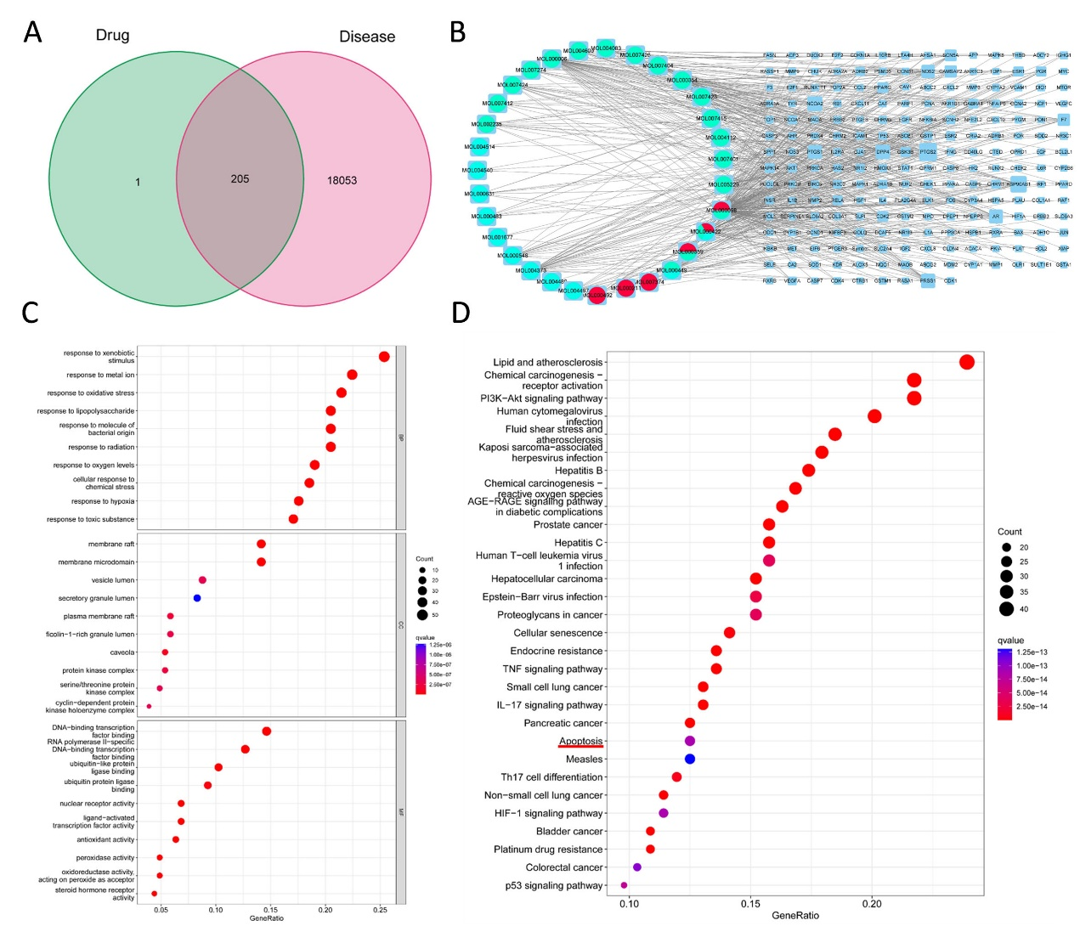
Supplementary Figure S1 Network pharmacology of QBD in lung cancer. (A) Venn diagram summarizing the intersection of targets of the QBD and lung cancer. (B) The network of ingredient-target-disease. The circle on the left, green, red, blue, and yellow represent the effective components of Qing Hao, Mu Dan Pi, Zhi Mu, and Bie Jia, respectively. The grid on the right represents the target of QBD, and the larger and more edges represent the stronger connectivity between the target and the active components. (C) The top 30 of GO enrichment analysis. (D) The top 30 of KEGG enrichment analysis. BP, Biological progress of core targets; CC, Cellular components of core targets; MF, The molecular function of core targets.

