Supplementary Appendix

Supplementary Results R1: Absolute Risk of Moderate COPD Exacerbation

At MRC dyspnea grade 1, there was an 11.4% absolute risk of moderate exacerbation at 1 year, which increased across the scale to a 17.9% absolute risk at MRC grade 5 (Supplementary Figure S3A). CAT score 0–9 was associated with an 11.7% absolute risk of moderate exacerbation at 1 year, which increased across scores to a 19.7% absolute risk of moderate exacerbation at CAT score 30–40. For FEV₁% predicted values, at the highest level (≥80%) there was an 11.9% absolute risk of moderate exacerbation at 1 year; the absolute risk increased as FEV₁% predicted values decreased (17.8% absolute risk at FEV₁% predicted <30%). The presence of all examined comorbidities was associated with an increased risk of exacerbation at 1 year (Supplementary Figure S3B). At each risk factor level, the 1-year absolute risk of moderate COPD exacerbation was largely comparable between ICS non-users and ICS users. The absolute risk patterns of moderate exacerbation across risk factor levels remained generally similar at 3 years and 5 years of follow-up (Supplementary Figure S3A).

Supplementary Results R2: Hazard ratio of moderate COPD exacerbation
After adjustment for risk factors, the Cox proportional hazards modeling showed that most potential risk factors were associated with an increased rate of moderate exacerbation at 1 year of follow-up (Supplementary Figure S4A). FEV₁% predicted values ≥30–<50% and <30% were associated with a 15.4%, and 16.8% increased rate of moderate COPD exacerbation, respectively; FEV₁% predicted ≥50–<80% showed a non-significant increase in moderate exacerbation compared with the reference group (FEV₁% predicted ≥80%). Patients with MRC dyspnea grade 2, 3, 4, and 5 showed an increased rate of moderate COPD exacerbation of 7.3%, 18.8%, 23.6%, and 31.7%, respectively, compared with patients with an MRC grade 1 (reference group). Eosinophil levels of ≥300 cells/μL were associated with a significantly higher rate of moderate COPD exacerbation compared with eosinophils <150 cells/μL (reference group; HR: 1.06, 95% CI: 1.00–1.13). In the model restricted to patients with available CAT score, CAT score 30–40 was associated with 39.1% higher rate of moderate COPD exacerbation when compared with the lowest CAT score level of 0–9 (reference group). Comorbid depression (HR: 1.08, 95% CI: 1.02–1.14), GERD (HR: 1.07, 95% CI: 1.01–1.14), myocardial infarction (HR: 1.09, 95% CI: 1.01–1.17), and congestive heart failure (HR: 1.13, 95% CI: 1.04–1.23) were associated with a higher risk of moderate COPD exacerbation. The remaining examined comorbidities were not associated with an increased risk of moderate exacerbation. Largely consistent association patterns were observed between each risk factor and moderate COPD exacerbation at 3 years and 5 years of follow-up (Supplementary Figure S4B and 4C).

Supplementary Table S1 Risk factors predictive of a first COPD exacerbation
Variable | Parameterization | Timing
MRC dyspnea scale measurement | A single question instrument measuring severity of dyspnea related to exercise, which is a part of the Quality Outcomes Framework recommended investigations. The following read codes are recorded in the CPRD, corresponding with each of the grades:  Grade 1: No dyspnea except on strenuous exercise  Grade 2: Short of breath when walking up a short hill  Grade 3: Dyspnea limits walking pace (slower than others) and stops to catch breath  Grade 4: Stops to catch breath after walking 100 meters (328 feet) on level ground  Grade 5: Dyspnea prevents leaving house and performing activities of daily living  Additionally, a category of unknown/unavailable was defined if no record available within the 24 months prior to index date | Most recent measurement in 24 months prior to index date
CAT score | CAT is an eight-item, patient-completed instrument designed to quantify the health-related quality of life and COPD symptom burden. Patients self-rate the severity of cough, phlegm, chest tightness, breathlessness going up hills/stairs, activity limitations at home, confidence leaving home, sleep and energy on a 6-point likert scale  (0–5), corresponding to the symptom manifestation from the best to the worst. The total CAT score ranges from 0 to 40, with  0–10, 11–20, 21–30, and 31–40 classified as mild, moderate, severe, and very severe symptomatic COPD status, respectively | Most recent measurement in 24 months prior to index date

Variable | Parameterization |  | Timing
COPD GOLD grade of airflow limitation measurement | Modified according to GOLD-defined lung obstruction-based classification  GOLD 1: FEV₁% predicted ≥80%  GOLD 2: FEV₁ % predicted ≥50–<80%  GOLD 3: FEV₁% predicted ≥30–<50%  GOLD 4: FEV₁% predicted <30% |  | Most recent measurement in 24 months prior to index date
GOLD 2020 group |  |  | Most recent measurement in 24 months prior to index date  The most recent MRC score within the 24 months prior to index date were used. If MRC was missing, the variable was set as “missing”
  Category | Exacerbations per year | MRC
  A | ≤1 moderate | 1–2
  B | ≤1 moderate | ≥3
Baseline moderate-severe AECOPD history | AECOPDs were identified from the CPRD-AURUM and HES-APC based on a validated algorithm.¹ Exacerbations in primary care were defined as the presence of a record for one of the four following events: (1) prescriptions for ATB and OCS for a length of 5 to 14 days each (both prescriptions must have the same start date but each can last for a different number of days); (2) presence of respiratory symptoms (codes suggesting an increase in two or more of: breathlessness, cough, or sputum volume and/or purulence recorded on the same date) and a prescription for ATB or OCS (or both) on the same day; (3) lower respiratory tract infection medical code; (4) AECOPD specific medical code.¹ As GP records lack sufficient sensitivity and positive predictive value to ascertain hospitalized exacerbation events, HES data was used to identify exacerbations which required a hospitalization using ICD-10 codes. Exacerbations resulting in hospitalization were considered severe (ie recorded in HES-APC), while exacerbations managed only in primary care (ie only recorded in CPRD-AURUM) were considered moderate |  | Within 24 months prior to the index date. AECOPD on index date were excluded
Eosinophil levels | Eosinophil level in 12 months prior to index date, closest to index date. Eosinophil levels within +/- 14 days of an AECOPD or prescription of OCS will be excluded.  Eosinophil was counted in cells/µl and modeled as a binary variable (<150, ≥150; <150, ≥150–300, >300 cells/ µl) |  | 12 months prior to index date
Comorbidities in patient history |  | Patients were classified (separately for each comorbidity) as having a history of the following comorbidities anytime in CPRD history preceding the index date:  - Depression  - Anxiety  - GERD  - Acute myocardial infarction  - Congestive heart failure  - Stroke  - Bronchiectasis  - Dementia/cognitive impairment  - Rheumatoid/osteo arthritis  - Lung cancer | Any time in patient history prior to index
Current asthma diagnosis |  | Asthma was defined according to a validated algorithm consisting of a set of validated specific codes²  The positive predictive value of this algorithm has been estimated at PPV=0.86; 95% CI: 0.77–0.95, with validation against a reference standard of physician review of patient notes.  Current asthma was defined as current asthma medical diagnosis record (=1) vs no current asthma (=0) in the CPRD over the past 12 months prior to index date | In 12 months prior to index
Historical asthma diagnosis |  | Historical asthma was defined as asthma medical diagnosis record (=1) vs no current asthma (=0) in the CPRD >12 months prior to index date, but no asthma code in the previous 12 months  Historical asthma diagnosis was defined using the same diagnostic codes as current asthma diagnosis | Any time in patient history up until 12 months prior to index
Abbreviations: AECOPD, acute exacerbation of COPD; ATB, antibiotics; CAT, COPD Assessment Test; COPD, chronic obstructive pulmonary disease; CPRD, Clinical Practice Research Datalink; FEV₁, forced expiratory volume in 1 second; GERD, gastroesophageal reflux disease; GOLD, Global Initiative for Chronic Obstructive Lung Disease; HES (APC), Hospital Episode Statistics (Admitted Patient Care); MRC, Medical Research Council; OCS, oral corticosteroids; PPV, positive predictive value.

Supplementary Table S2 Comorbidities of patients included in cohort 1 and cohort 2, overall and stratified by ICS use at baseline

 | Cohort 1 (no prior severe exacerbations) |  |  | Cohort 2 (no prior moderate/severe exacerbations)
 | Total  N=194,948 | ICS users  N=14,002 | ICS non-users  N=180,546 | Total  N=148,396 | ICS users  N =10,864 | ICS non-users  N=137,532
Comorbidities anytime in patient history pre-index, n (%)
Depression | 58,072 (29.79) | 3962 (27.51) | 54,110 (29.97) | 43088 (29.04) | 2877 (26.48) | 40,211 (29.24)
Anxiety | 35,054 (17.98) | 2490 (17.29) | 32,564 (18.04) | 25,766 (17.36) | 1801 (16.58) | 23,965 (17.43)
GERD | 26,029 (13.35) | 1931 (13.41) | 24,098 (13.35) | 19,094 (12.87) | 1417 (13.04) | 17,677 (12.85)
Acute myocardial infarction | 13,100 (6.72) | 940 (6.53) | 12,160 (6.74) | 9902 (6.67) | 688 (6.33) | 9214 (6.70)
Congestive heart failure | 11,054 (5.67) | 777 (5.40) | 10,277 (5.69) | 8156 (5.50) | 564 (5.19) | 7592 (5.52)
Stroke | 17,939 (9.20) | 1250 (8.68) | 16,689 (9.24) | 13,497 (9.10) | 922 (8.49) | 12,575 (9.14)
Bronchiectasis | 6952 (3.57) | 539 (3.74) | 6413 (3.55) | 4849 (3.27) | 387 (3.56) | 4462 (3.24)
Dementia / cognitive impairment | 16,790 (8.61) | 1096 (7.61) | 15,694 (8.69) | 12,457 (8.39) | 817 (7.52) | 11,640 (8.46)
Rheumatoid/osteo arthritis | 54,514 (27.96) | 4025 (27.95) | 50,489 (27.96) | 40,485 (27.28) | 2954 (27.19) | 37,531 (27.29)
Lung cancer | 5049 (2.59) | 309 (2.15) | 4740 (2.63) | 3636 (2.45) | 214 (1.97) | 3422 (2.49)
Current asthma diagnosis | 40,216 (20.63) | 5541 (38.47) | 34,675 (19.21) | 29,327 (19.76) | 4213 (38.78) | 25,114 (18.26)
Historical asthma diagnosis | 42,151 (21.62) | 4021 (27.92) | 38,130 (21.12) | 31,105 (20.96) | 3021 (27.81) | 28,084 (20.42)
Abbreviations: GERD, gastroesophageal reflux disease; ICS, inhaled corticosteroid.

Supplementary Table S3 Distribution of potential risk factors for COPD exacerbation among patients included in cohort 1 and cohort 2, overall and stratified by ICS use at baseline
 | Cohort 1 (no prior severe exacerbations) |  |  | Cohort 2 (no prior moderate/severe exacerbations)
 | Total  N=194,948 | ICS users  N=14,002 | ICS non-users  N=180,546 | Total  N=148,396 | ICS users  N=10,864 | ICS non-users  N=137,532
MRC Dyspnea Scale, n (%)
Grade 1 | 40,431 (20.74) | 3134 (21.76) | 37,297 (20.66) | 32,631 (21.99) | 2480 (22.83) | 30,151 (21.92)
Grade 2 | 74,958 (38.45) | 5751 (39.93) | 69,207 (38.33) | 57,243 (38.57) | 4325 (39.81) | 52,918 (38.48)
Grade 3 | 42,874 (21.99) | 2819 (19.57) | 40,055 (22.19) | 31,288 (21.08) | 2045 (18.82) | 29,243 (21.26)
Grade 4 | 18,097 (9.28) | 1107 (7.69) | 16,990 (9.41) | 12,745 (8.59) | 792 (7.29) | 11,953 (8.69)
Grade 5 | 2905 (1.49) | 156 (1.08) | 2749 (1.52) | 1969 (1.33) | 107 (0.98) | 1862 (1.35)
Unknown/missing | 15,683 (8.04) | 1435 (9.96) | 14,248 (7.89) | 12,520 (8.44) | 1115 (10.26) | 11,405 (8.29)
CAT score, n (%)
0–9 | 15,619 (8.01) | 873 (6.06) | 14,746 (8.17) | 12,385 (8.35) | 705 (6.49) | 11,680 (8.49)
10–19 | 16,670 (8.55) | 875 (6.08) | 15,795 (8.75) | 12,589 (8.48) | 647 (5.96) | 11,942 (8.68)
20–29 | 7748 (3.97) | 354 (2.46) | 7394 (4.10) | 5544 (3.74) | 246 (2.26) | 5298 (3.85)
30–40 | 2201 (1.13) | 114 (0.79) | 2087 (1.16) | 1510 (1.02) | 76 (0.70) | 1434 (1.04)
Unknown/missing | 152,710 (78.33) | 12,186 (84.61) | 140,524 (77.83) | 116,368 (78.42) | 9190 (84.59) | 107,178 (77.93)
COPD GOLD grade of airflow limitation, n (%)
GOLD 1 (FEV₁% predicted ≥80%) | 33,680 (17.28) | 2656 (18.44) | 31,024 (17.18) | 26,666 (17.97) | 2072 (19.07) | 24,594 (17.88)
GOLD 2 (FEV₁% predicted ≥50–<80%) | 86,281 (44.26) | 6051 (42.02) | 80,230 (44.44) | 65,684 (44.26) | 4490 (41.33) | 61,194 (44.49)
GOLD 3 (FEV₁% predicted ≥30–<50%) | 29,952 (15.36) | 1877 (13.03) | 28,075 (15.55) | 21,718 (14.64) | 1387 (12.77) | 20,331 (14.78)
GOLD 4 (FEV₁% predicted <30%) | 4457 (2.29) | 254 (1.76) | 4203 (2.33) | 3204 (2.16) | 177 (1.63) | 3027 (2.20)
Unknown/missing | 40,578 (20.81) | 3564 (24.75) | 37,014 (20.50) | 31,124 (20.97) | 2738 (25.20) | 28,386 (20.64)
COPD GOLD 2020 category, n (%)
GOLD A | 130,922 (67.16) | 10,310 (71.59) | 120,612 (66.80) | 102,271 (68.92) | 7913 (72.84) | 94,358 (68.61)
GOLD B | 64,026 (32.84) | 4092 (28.41) | 59,934 (33.20) | 46,125 (31.08) | 2951 (27.16) | 43,174 (31.39)
Not A or B | 0 | 0 | 0 | 0 | 0 | 0
Primary Care consultations in 12 months before index (mean, SD) | 8.72 (8.86) | 8.99 (9.19) | 8.70 (8.83) | 8.32 (8.56) | 8.52 (8.82) | 8.30 (8.54)
Primary Care consultations in 12 months before index, n (%)
0 | 29,222 (14.99) | 2161 (15.00) | 27,061 (14.99) | 22,520 (15.18) | 1665 (15.33) | 20,855 (15.16)
1–2 | 16,882 (8.66) | 1111 (7.71) | 15,771 (8.74) | 13,956 (9.40) | 926 (8.52) | 13,030 (9.47)
3–4 | 23,002 (11.80) | 1641 (11.39) | 21,361 (11.83) | 18,773 (12.65) | 1336 (12.30) | 17,437 (12.68)
5+ | 125,842 (64.55) | 9489 (65.89) | 116,353 (64.45) | 93,147 (62.77) | 6937 (63.85) | 86,210 (62.68)
Respiratory Medication in 12 months prior to index date, n (%)
ICS | 22,572 (11.58) | 14,402 (100) | 8170 (4.53) | 16,844 (11.35) | 10,864 (100) | 5980 (4.35)
ICS/LABA | 94,488 (48.47) | 3797 (26.36) | 90,691 (50.23) | 67,098 (45.22) | 2726 (25.09) | 64,372 (46.81)
ICS/LAMA/LABA | 48,952 (25.11) | 1330 (9.23) | 47,622 (26.38) | 33,573 (22.62) | 907 (8.35) | 32,666 (23.75)
ICS/SABA | 18,157 (9.31) | 12,191 (84.65) | 5966 (3.30) | 13,422 (9.04) | 9100 (83.76) | 4322 (3.14)
LABA | 13,683 (7.02) | 2828 (19.64) | 10,855 (6.01) | 10,250 (6.91) | 2055 (18.92) | 8195 (5.96)
LAMA | 80,006 (41.04) | 3937 (27.34) | 76,069 (42.13) | 57,829 (38.97) | 2833 (26.08) | 54,996 (39.99)
LAMA/LABA | 11,032 (5.66) | 1040 (7.22) | 9992 (5.53) | 8312 (5.60) | 716 (6.59) | 7596 (5.52)
Rofulmilast | 23 (0.01) | 1 (0.01) | 22 (0.01) | 13 (0.01) | 1 (0.01) | 12 (0.01)
SABA | 141,712 (72.69) | 12,661 (87.91) | 129,051 (71.48) | 103,792 (69.94) | 9457 (87.05) | 94,335 (68.59)
SAMA | 11,470 (5.88) | 1446 (10.04) | 10,024 (5.55) | 8310 (5.60) | 1054 (9.70) | 7256 (5.28)
SAMA/SABA | 8639 (4.43) | 1173 (8.14) | 7466 (4.14) | 6076 (4.09) | 851 (7.83) | 5225 (3.80)
Theophyllines | 4743 (2.43) | 424 (2.94) | 4319 (2.39) | 3193 (2.15) | 296 (2.72) | 2897 (2.11)
None of the above | 28,233 (14.48) | 0 | 28,233 (15.64) | 24,500 (16.51) | 0 | 24,500 (17.81)
Most recent treatment strategy prior to index date, n (%)
ICS | 4156 (2.13) | 3093 (21.48) | 1063 (0.59) | 3291 (2.22) | 2444 (22.50) | 847 (0.62)
ICS/LABA | 40,540 (20.80) | 1654 (11.48) | 38,886 (21.54) | 29,755 (20.05) | 1223 (11.26) | 28,532 (20.75)
ICS/LAMA/LABA | 30,157 (15.47) | 647 (4.49) | 29,510 (16.34) | 20,774 (14.00) | 437 (4.02) | 20,337 (14.79)
ICS/SABA | 9093 (4.66) | 7378 (51.23) | 1715 (0.95) | 6868 (4.63) | 5560 (51.18) | 1308 (0.95)
LABA | 2570 (1.32) | 77 (0.53) | 2493 (1.38) | 2059 (1.39) | 60 (0.55) | 1999 (1.45)
LAMA | 15,617 (8.01) | 739 (5.13) | 14,878 (8.24) | 12,265 (8.27) | 556 (5.12) | 11,709 (8.51)
LAMA/LABA | 5995 (3.08) | 65 (0.45) | 5930 (3.28) | 4674 (3.15) | 46 (0.42) | 4628 (3.37)
Rofulmilast | 2 (0.00) | 0 | 2 (0.00) | 0 | 0 | 0
SABA | 53,144 (27.26) | 544 (3.78) | 52,600 (29.13) | 40,159 (27.06) | 399 (3.67) | 39,760 (28.91)
SAMA | 2086 (1.07) | 87 (0.60) | 1999 (1.11) | 1634 (1.10) | 56 (0.52) | 1578 (1.15)
SAMA/SABA | 2666 (1.37) | 84 (0.58) | 2582 (1.43) | 1961 (1.32) | 58 (0.53) | 1903 (1.38)
Theophyllines | 689 (0.35) | 34 (0.24) | 655 (0.36) | 456 (0.31) | 25 (0.23) | 431 (0.31)
None of the above | 28,233 (14.48) | 0 | 28,233 (15.64) | 24,500 (16.51) | 0 | 24,500 (17.81)
Moderate/Severe AECOPD history in 12 months prior to index date
Patients with any moderate/severe AECOPD, n (%) | 22,931 (11.76) | 1795 (12.46) | 21,136 (11.71) | 0 | 0 | 0
Patients with Moderate AECOPD, n (%) | 22,931 (11.76) | 1795 (12.46) | 21,136 (11.71) | 0 | 0 | 0
Patients with Severe AECOPD, n (%) | 0 | 0 | 0 | 0 | 0 | 0
Moderate/severe exacerbations, mean (SD) | 0.12 (0.32) | 0.12 (0.33) | 0.12 (0.32) | 0 | 0 | 0
Moderate exacerbations, mean (SD) | 0.12 (0.32) | 0.12 (0.33) | 0.12 (0.32) | 0 | 0 | 0
Severe exacerbations, mean (SD) | 0 | 0 | 0 | 0 | 0 | 0
Eosinophil levels (cells/ul) in 12 months prior to index date, mean (SD) | 174.27 (2.95) | 169.01 (3.01) | 174.69 (2.95) | 173.63 (2.95) | 169.99 (2.99) | 173.92 (2.95)
Max Eosinophils ≥150 cells/ul in 12 months before index, n (%)
Eosinophils ≥150 | 65,890 (33.80) | 4676 (32.47) | 61,214 (33.90) | 49,718 (33.50) | 3495 (32.17) | 46,223 (33.61)
Eosinophils <150 | 33,044 (16.95) | 2596 (18.03) | 30,448 (16.86) | 25,273 (17.03) | 1916 (17.64) | 23,357 (16.98)
No Eosinophil values | 96,014 (49.25) | 7130 (49.51) | 88,884 (49.23) | 73,405 (49.47) | 5453 (50.19) | 67,952 (49.41)
Max Eosinophils ≥300 cells/uL in 12 months before index, n (%)
Eosinophils ≥300 | 31,125 (15.97) | 2220 (15.41) | 28,905 (16.01) | 23,463 (15.81) | 1635 (15.05) | 21,828 (15.87)
Eosinophils <300 | 67,809 (34.78) | 5052 (35.08) | 62,757 (34.76) | 51,528 (34.72) | 3776 (34.76) | 47,752 (34.72)
No Eosinophil values | 96,014 (49.25) | 7130 (49.51) | 88,884 (49.23) | 73,405 (49.47) | 5453 (50.19) | 67,952 (49.41)
Abbreviations: AECOPD, acute exacerbation of COPD; CAT, COPD Assessment Test; COPD, chronic obstructive pulmonary disease; FEV₁, forced expiratory volume in 1 second; GOLD, Global Initiative for chronic obstructive lung disease; LABA, long-acting β₂-agonist; LAMA, long-acting muscarinic antagonist; SABA, short-acting β₂-agonist; SAMA, short-acting muscarinic antagonist; SD, standard deviation.

Supplementary Figure S1 Absolute risk of severe exacerbation across different comorbidities among patients in cohort 1.
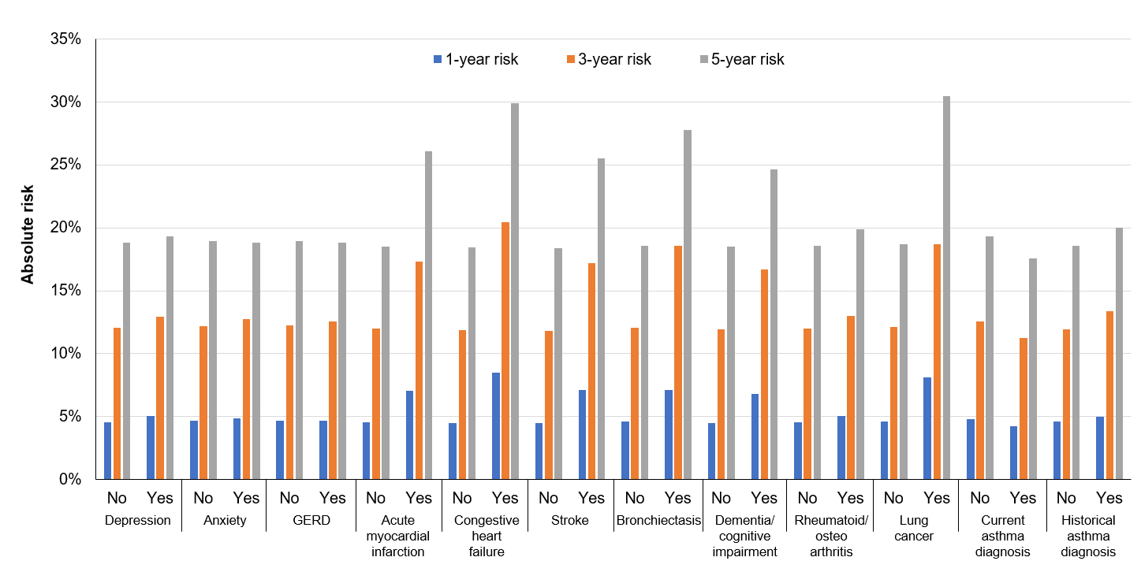

Abbreviations: GERD, gastroesophageal reflux disease.

Supplementary Figure S2 Absolute risk of moderate or severe exacerbation across different comorbidities among patients in cohort 2.
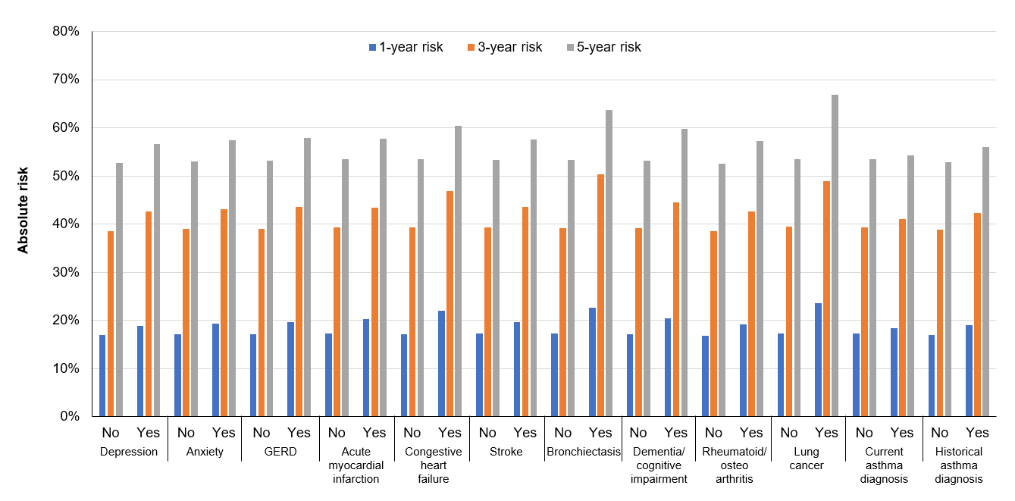
Abbreviations: GERD, gastroesophageal reflux disease.

Supplementary Figure S3 Absolute risk of moderate exacerbation (A) across different levels of risk factors and (B) across different comorbidities among patients in cohort 2

A)
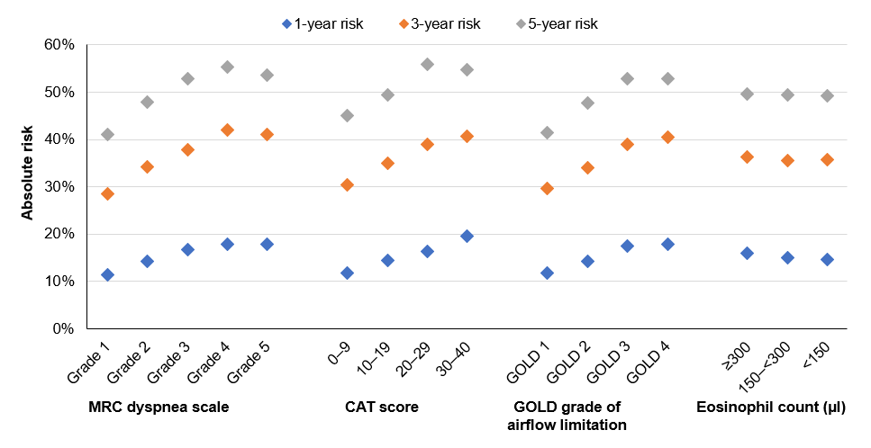
B) 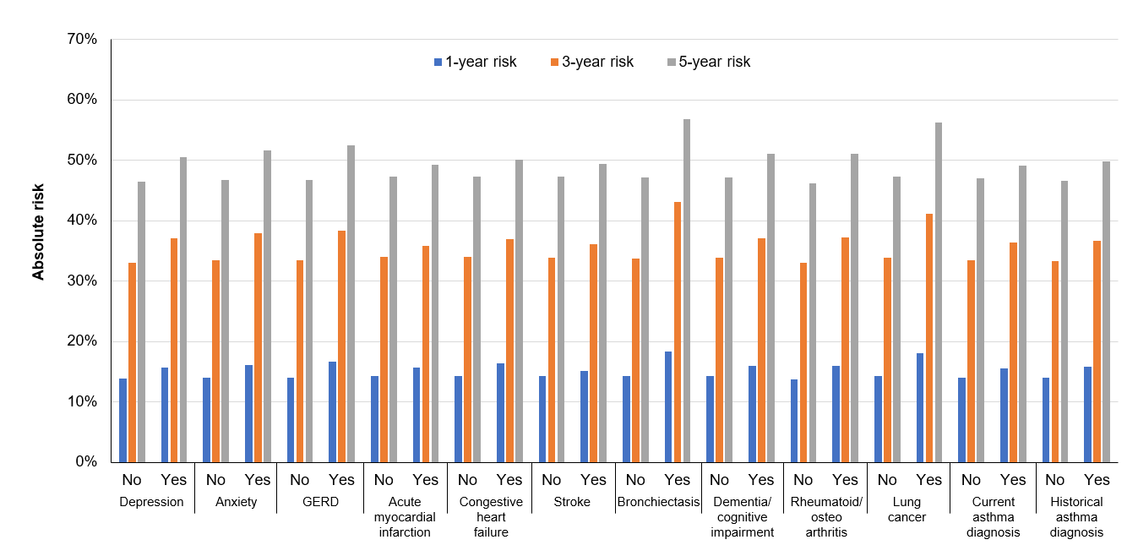
Abbreviations: CAT, COPD Assessment Test; GERD, gastroesophageal reflux disease; GOLD, Global Initiative for Chronic Obstructive Lung Disease; MRC, Medical Research Council.

Supplementary Figure S4 Hazard ratio of moderate exacerbation at (A) 1 year, (B) 3 years, and (C) 5 years post-index by risk factors.

A)
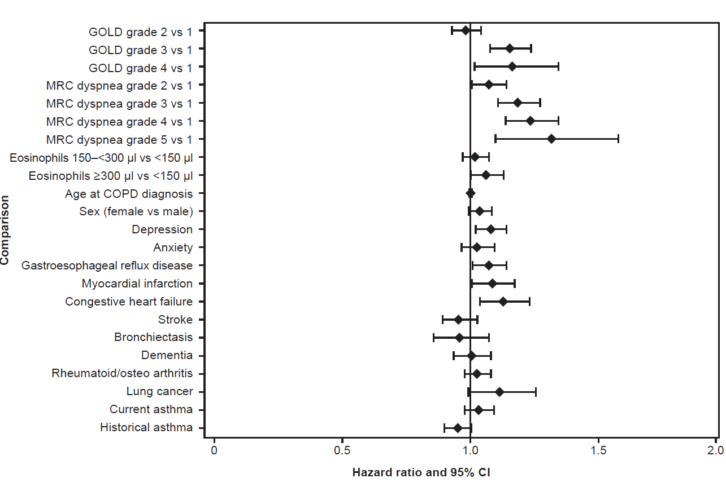

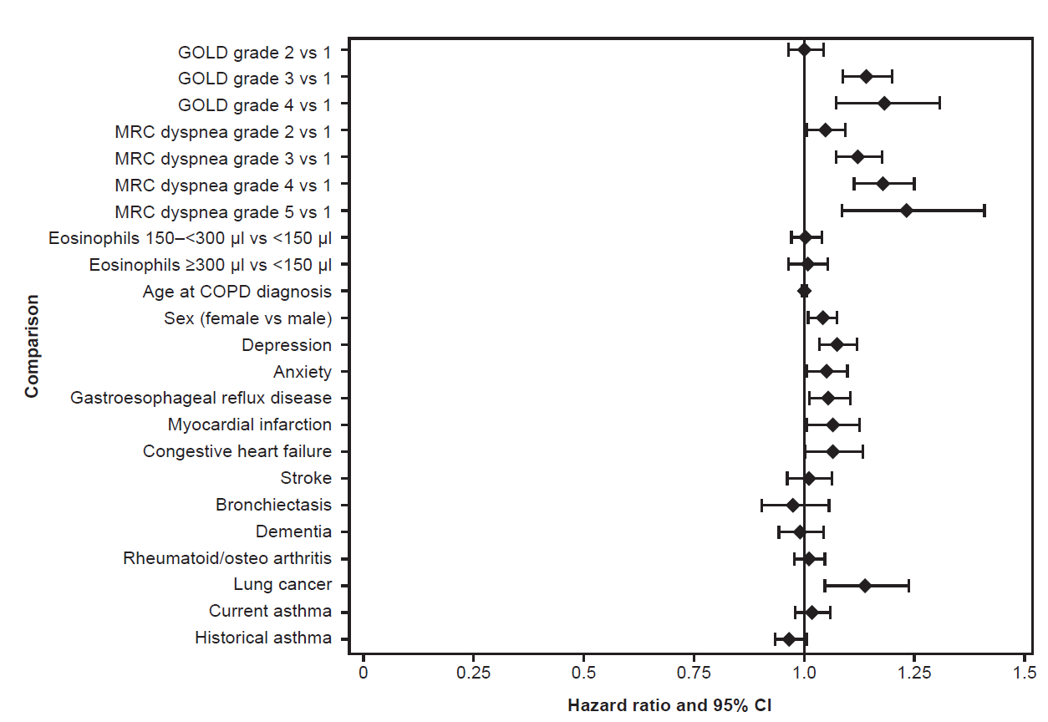
B)

C)
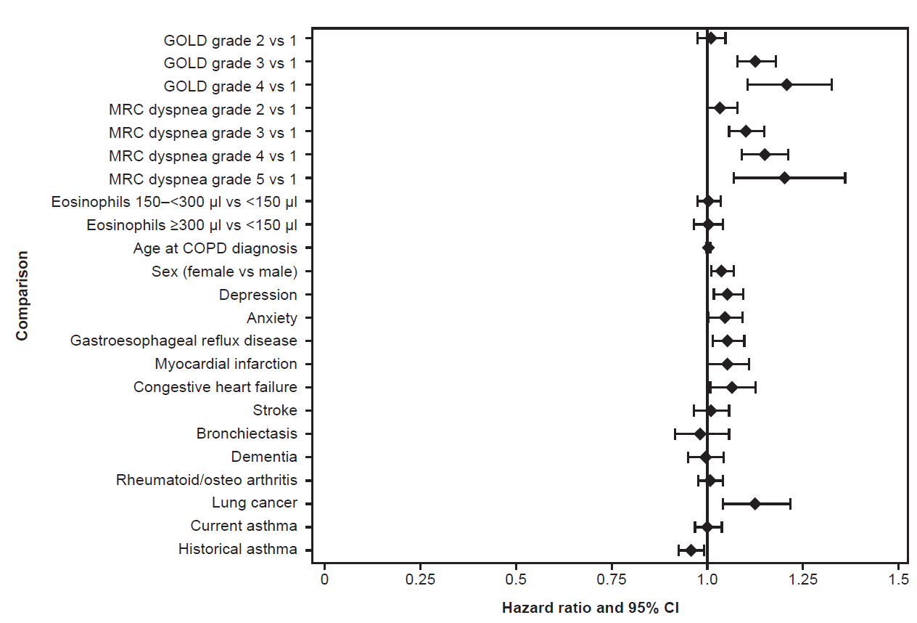

Abbreviations: CI, confidence interval; COPD, chronic obstructive pulmonary disease; GOLD, Global Initiative for Chronic Obstructive Lung Disease; MRC, Medical Research Council.

Supplementary references
1. Rothnie KJ, Müllerová H, Hurst JR, et al. Validation of the recording of acute exacerbations of COPD in UK primary care electronic healthcare records. PloS One. 2016;11(3):e0151357. doi:10.1371/journal.pone.0151357
2. Nissen F, Morales DR, Mullerova H, Smeeth L, Douglas IJ, Quint JK. Validation of asthma recording in the Clinical Practice Research Datalink (CPRD). BMJ Open. 2017;7(8):e017474. doi:10.1136/bmjopen-2017-017474

