Supplementary Information
Glutathione programmed mitochondria targeted delivery of lonidamine for effective against triple negative breast cancer
Zhongjie Wang^{a#}, Yanru Qin^{a#}, Xueyuan Wang^{b}, Tianyu Zhangª, Yixue Hu^{b}, Dongna Wangª, Liefeng Zhangª*, Yongqiang Zhu^{ab}*
ª School of Food and Pharmaceutical Engineering, Nanjing Normal University, Nanjing 210023, China
^{b} College of Life Science, Nanjing Normal University, Nanjing 210023, China
# These authors contributed equally to this work
* Corresponding authors.
Liefeng Zhang, Wenyuan Road 1#, Qixia district, Nanjing Normal University, Nanjing 210023, People’s Republic of China, Tel: 86-25-85898184, Fax: 86-25-85898184,
Email: lfzhang@njnu.edu.cn.
Yongqiang Zhu, Wenyuan Road 1#, Qixia district, Nanjing Normal University, Nanjing 210023, People’s Republic of China, Tel: 86-25-85891591, Fax: 86-25-85891591, zhyqscu@hotmail.com.

A
B
D
C
Figure S1: The synthetic route of (A) DSPE-S-S-COOH and (B) NH₂-PEG₂₀₀₀-R6RGD, which will further synthesize the DSPE-S-S-PEG₂₀₀₀-R6RGD. (C) TPP-COOH and (D) TPP-COCL are the reactants of TPP-TPGS.
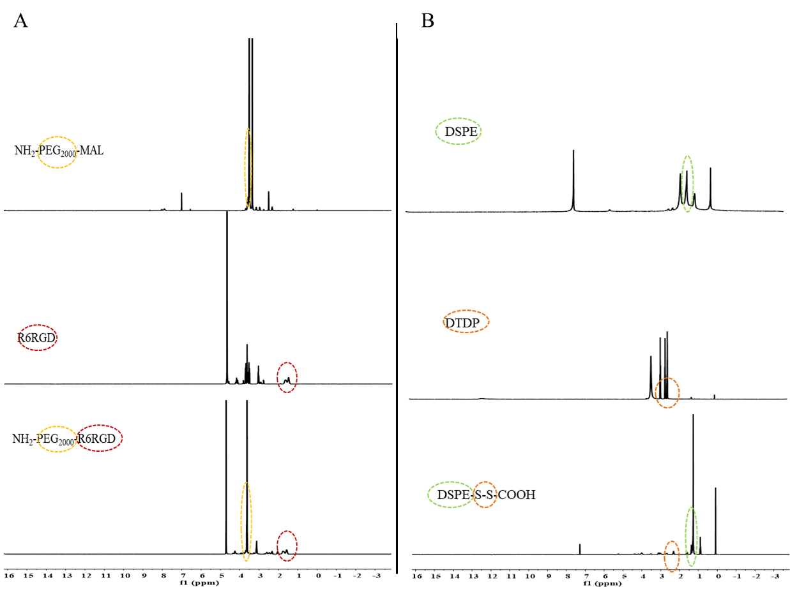
Figure S2: The ¹H NMR spectra of (A) NH₂-PEG₂₀₀₀-MAL, R6RGD, NH₂-PEG₂₀₀₀-R6RGD and (B) DSPE, DTDP and DSPE-S-S-COOH compound.

Figure S3: The ¹H NMR spectra of TPP-COOH, TPGS and TPP-TPGS compound.

Figure S4: The (A) size distribution, (B) PDI and (C) zeta potential of the LND-loaded NPs.

Figure S5: The LND-loaded NPs stability in water (A) and in PBS (B) for a week.

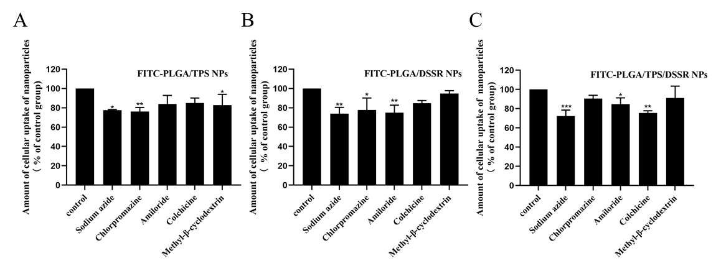
Figure S6: Mechanism of cellular uptake of (A) FITC-PLGA/TPS NPs, (B) FITC-PLGA/DSSR NPs, and (C) FITC-PLGA/TPS/DSSR NPs. *p＜0.05，**p＜0.01，***p＜0.001.
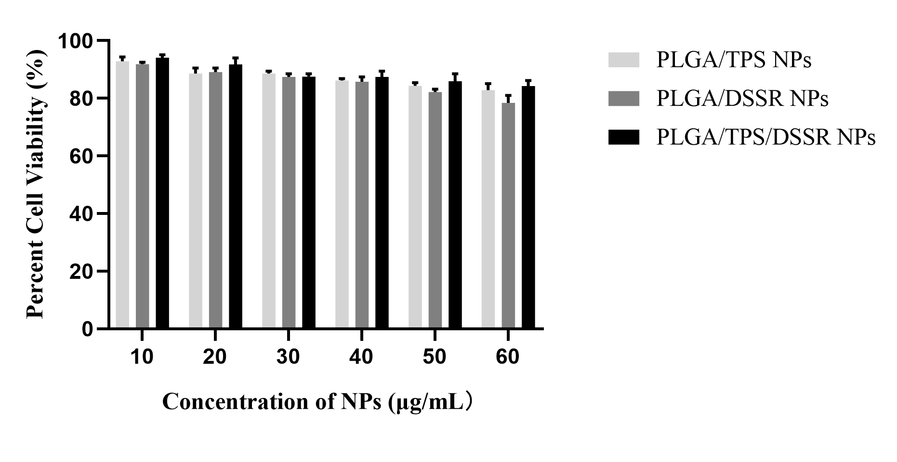
Figure S7 In vitro cell viability of MDA-MB-231cells treated with PLGA/TPS NPs, PLGA/DSSR NPs and PLGA/TPS/DSSR NPs after incubation for 24h.
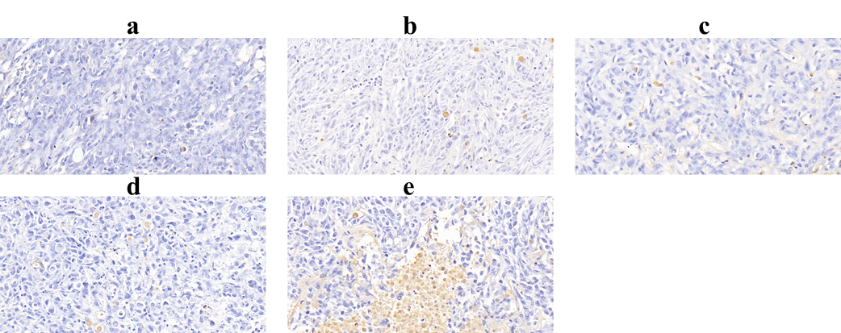
Figure S8: Tunnel staining form tumor tissues of treated with (a) saline, (b) LND, (c) LND-PLGA/TPS NPs, (d) LND-PLGA/DSSR NPs and (e) LND-PLGA/TPS/DSSR NPs (40×).

Figure S9: Analysis of blood routine of tumor-bearing mice treated with saline, LND and different LND-loaded group (n=3).

Table S1: The encapsulation efficiency and drug loading of LND-loaded NPs (n=3).
 | LND-PLGA/TPS NPs | LND-PLGA/DSSR NPs | LND-PLGA/TPS/DSSR NPs
EE% | 78.48 ± 6.41 | 85.24 ± 3.36 | 87.51 ± 1.87
LD% | 16.98 ± 1.52 | 18.42 ± 0.55 | 18.82 ± 1.65

Table S2: IC₅₀ values of LND, LND-PLGA/TPS NPs, LND-PLGA/DSSR NPs, and LND-PLGA/TPS/DSSR NPs towards MDA-MB-231 cells.
 | LND | LND-PLGA/TPS NPs | LND-PLGA/DSSR NPs | LND-PLGA/TPS/DSSR NPs
IC₅₀ (μM) | 408.42 ± 17.79 | 130.71 ± 6.65 | 115.90 ± 0.81 | 106.07 ± 7.24

