Appendix A
Table 1. Interviewee photo interview metaphor analysis and researcher reflections
Resource | Representative photos | Interview (Theme Plots) | Photo | Researcher Reflections
 | 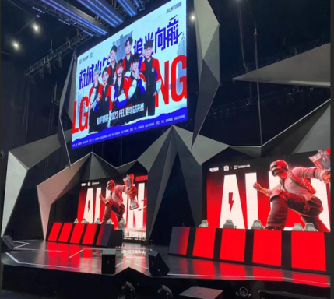 | I am an avid follower of e-sports events, freelancing brings me freedom of time but also pressure and anxiety about life, but every time there is an e-sports event, I will be there, feeling my life rekindled with hope, but also that life should be more positive because the surprise will come spontaneously. | The subjects of the photographs provided by the interviewees represent enthusiasm and exuberance, the attractiveness of the festival and the positive emotions it brings. | The interviewee, as a fan of e-sports events, follows the tournament and generates travel mobility, which is driven by the ability to feel a sense of travel happiness.
  R1
 | 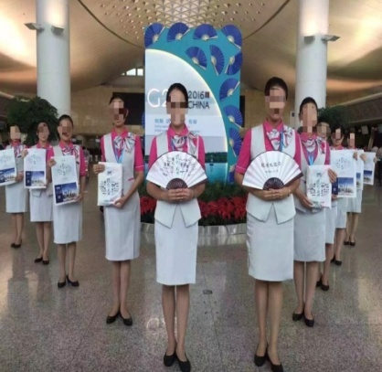 | This is a photo of my participation in Hangzhou G20 volunteers. I always like festival travel and have participated in many festival receptions. This is the most impressive one for me, in which I felt the depth of experience as a participant. | Photos provided by interviewees demonstrate the depth of engagements in the FSE tourism activities. | Interviewees have been involved as individuals in multiple festival programs and have a clearer sense of their own presence and experience.
  R5
R3 | 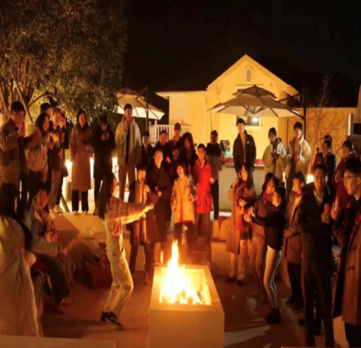 | This is a photo of me celebrating with fellow travelers at the site after attending a sporting event. We lit a bonfire, sang, and danced together, feeling warm and inviting. Although we were strangers, after a short time of interaction and familiarity, I felt the empathy and warm relationship of people with the same hobbies and experiences. | Interviewees provided photos in warm tones, suggesting the effect of festival tourism, which can provide new contexts in terms of relationship construction. | Interviewees' experiences of positive relationships were deepened and experienced in post-festival tour interactions.
Z2 | 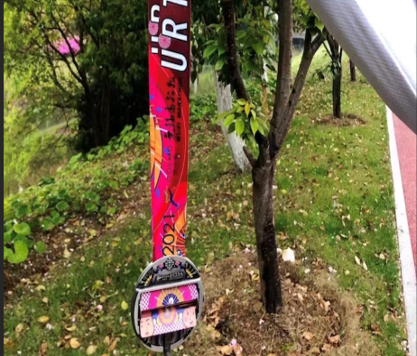 | This is a winning medal of an e-sports group competition we organized. As organizers, we also often participate in this type of tournament travel. This is a medal with a different meaning. Many of my colleagues joined this company because they love this industry. Changing roles to really participate in this event created deep and monumental memories. | The photos provided by the interviewees show the psychological meaning and the organizational behavior meaning of being a festival organizer and planner. | Interviewees' construction of the significance of the tournament tourism industry workplace is clear. For the first time, the organizers of the Hangzhou Asian Games have included e-sports in their official program, which will promote event tourism and enhance the traveler experience.
Z4 | 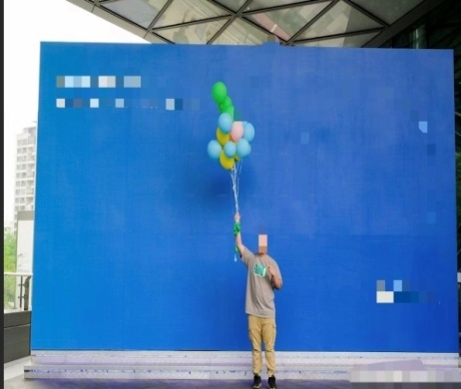 | This is my photo after breaking through the bottleneck of work. As a practitioner in this industry, many people are under great pressure, especially to face thousands of tourists. I have also encountered many difficulties, but precisely because I love this industry, I am an expert, so I found a sense of belonging and want to continue to fight for this industry. | Interviewees who provided photos reflected their recognition and affiliation with this company and industry through the light blue background color. | Interviewees have very strong professional recognition in the workplace, can develop a strong sense of affiliation, and consistently maintain a positive mindset and mood.

