Supplementary table 1. The standardized mean differences of the matched variables before and after propensity score matching
 | SMD before PSM | SMD after PSM
Propensity | 0.77 | 0.05
Sex - Male | -0.10 | 0.01
Sex - Female | 0.10 | -0.01
Age | 0.39 | 0.01
APACHE II | 0.74 | 0.03
Glasgow Coma Scale | -0.16 | -0.06
Abbreviations: SMD: Standardized Mean Differences; PSM: Propensity Score Matching; APACHE II: Acute Physiology and Chronic Health Evaluation II.

Supplementary table 2. Cox regression of the patients with acute pancreatitis after propensity score matching
 | Univariate Cox regression |  |  | Multivariate Cox regression
 | B | p | HR (95% CI) | B | p | HR (95% CI)
Hemoglobin (g/L) | 0.001 | 0.75 | 1.001(0.995,1.01)
WBC (10^9/L) | 0.03 | 0.02 | 1.03(1.01,1.06) | 0.04 | 0.01 | 1.04(1.01,1.06)
Neutrophil (10^9/L) | 0.03 | 0.03 | 1.03(1.003,1.07)
Lymphocyte (10^9/L) | 0.16 | 0.31 | 1.17(0.86,1.59)
Platelet (10^9/L) | -0.003 | 0.01 | 0.997(0.99,0.999) | -0.003 | 0.01 | 0.997(0.99,0.999)
TB (umol/L) | 0.002 | 0.30 | 1.002(0.998,1.01)
DB (umol/L) | 0.002 | 0.46 | 1.002(0.997,1.01)
ALT (IU/L) | 0.00 | 0.76 | 1(1,1)
AST (IU/L) | 0.00 | 0.61 | 1(1,1)
Creatin (umol/L) | 0.001 | 0.28 | 1.001(0.999,1.002)
Albumin (g/L) | -0.03 | 0.11 | 0.97(0.94,1.006)
AG > 14.5mmol/L ª | 0.68 | 0.01 | 1.93(1.20, 3.10)
ACAG>17.14 mmol/L | 0.935 | <0.001 | 2.55(1.55,4.20) | 0.79 | 0.002 | 2.20（1.33,3.65）
Abbreviations: WBC: White Blood Cell; TB: Total Bilirubin; DB: Direct Bilirubin; ALT: Alanine aminotransferase; AST: Aspartate aminotransferase; AG: Anion Gap; ACAG: Albumin Corrected Anion Gap.
ª Anion Gap was divided into two groups based on its median value of 14.5.

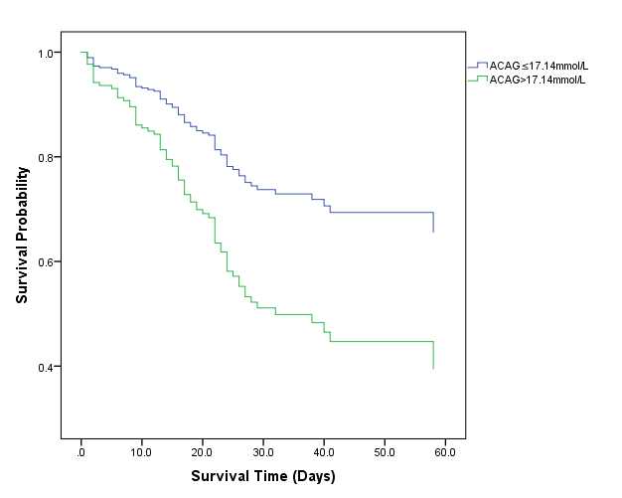
Supplementary figure. Kaplan-Meier survival curves of in-hospital survival in acute pancreatitis patients with two ACAG groups after propensity score matching
Abbreviations: ACAG: Albumin Corrected Anion Gap.

