Supplemental Material

Initiation of medical therapy for heart failure patients according to kidney function: A Danish nationwide study

Authors: Deewa Zahir Anjum, Jarl Emanuel Strange, Emil Fosbøl, Caroline Hartwell Garred, Mariam Elmegaard Malik, Charlotte Andersson, Pardeep S Jhund, John J V McMurray, Mark C Petrie, Lars Kober, Morten Schou

Corresponding author
Deewa Zahir Anjum, MD
Department of Cardiology
Copenhagen University Hospital Herlev and Gentofte
Gentofte Hospitalsvej 8., 3.sal, 2900 Hellerup
Tel: 0045 22951918
E-mail: deewa.zahir.anjum@regionh.dk

List of content
Supplemental Figure 1: Study design
Supplemental Figure 2: Initiation of MRA in a cohort with HFrEF patients
Supplemental Figure 3: Initiation of HF therapy according to plasma potassium at baseline
Supplemental Table 1: List of HF medication and corresponding ATC codes
Supplemental Table 2: List of 109 ICD-10 codes included in the Hospital Frailty Risk Score and number of points awarded for each ICD-10 code to create the score
Supplemental Table 3: Diagnoses with corresponding ICD-10 codes, and medication with corresponding ATC-codes

Supplemental Figure 1: Study design
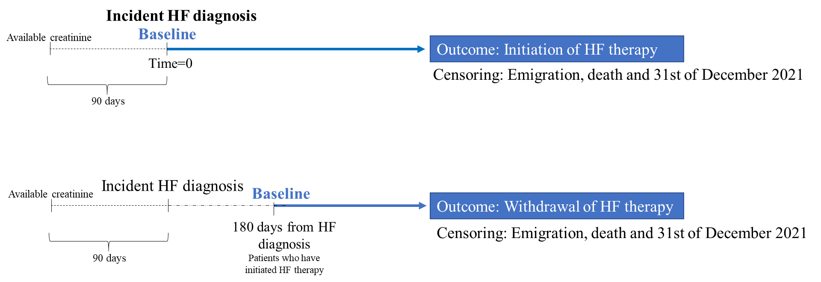

Diagram of the confounding role of frailty stage and advanced age on the association between kidney function and initiation of GDMT
Kidney function
Frailty stage
Advanced age
Initiation of GDMT

Legend: HF=heart failure, GDMT=guideline-directed medical therapy
Supplemental Figure 2: Initiation of MRA in a cohort with HFrEF patients
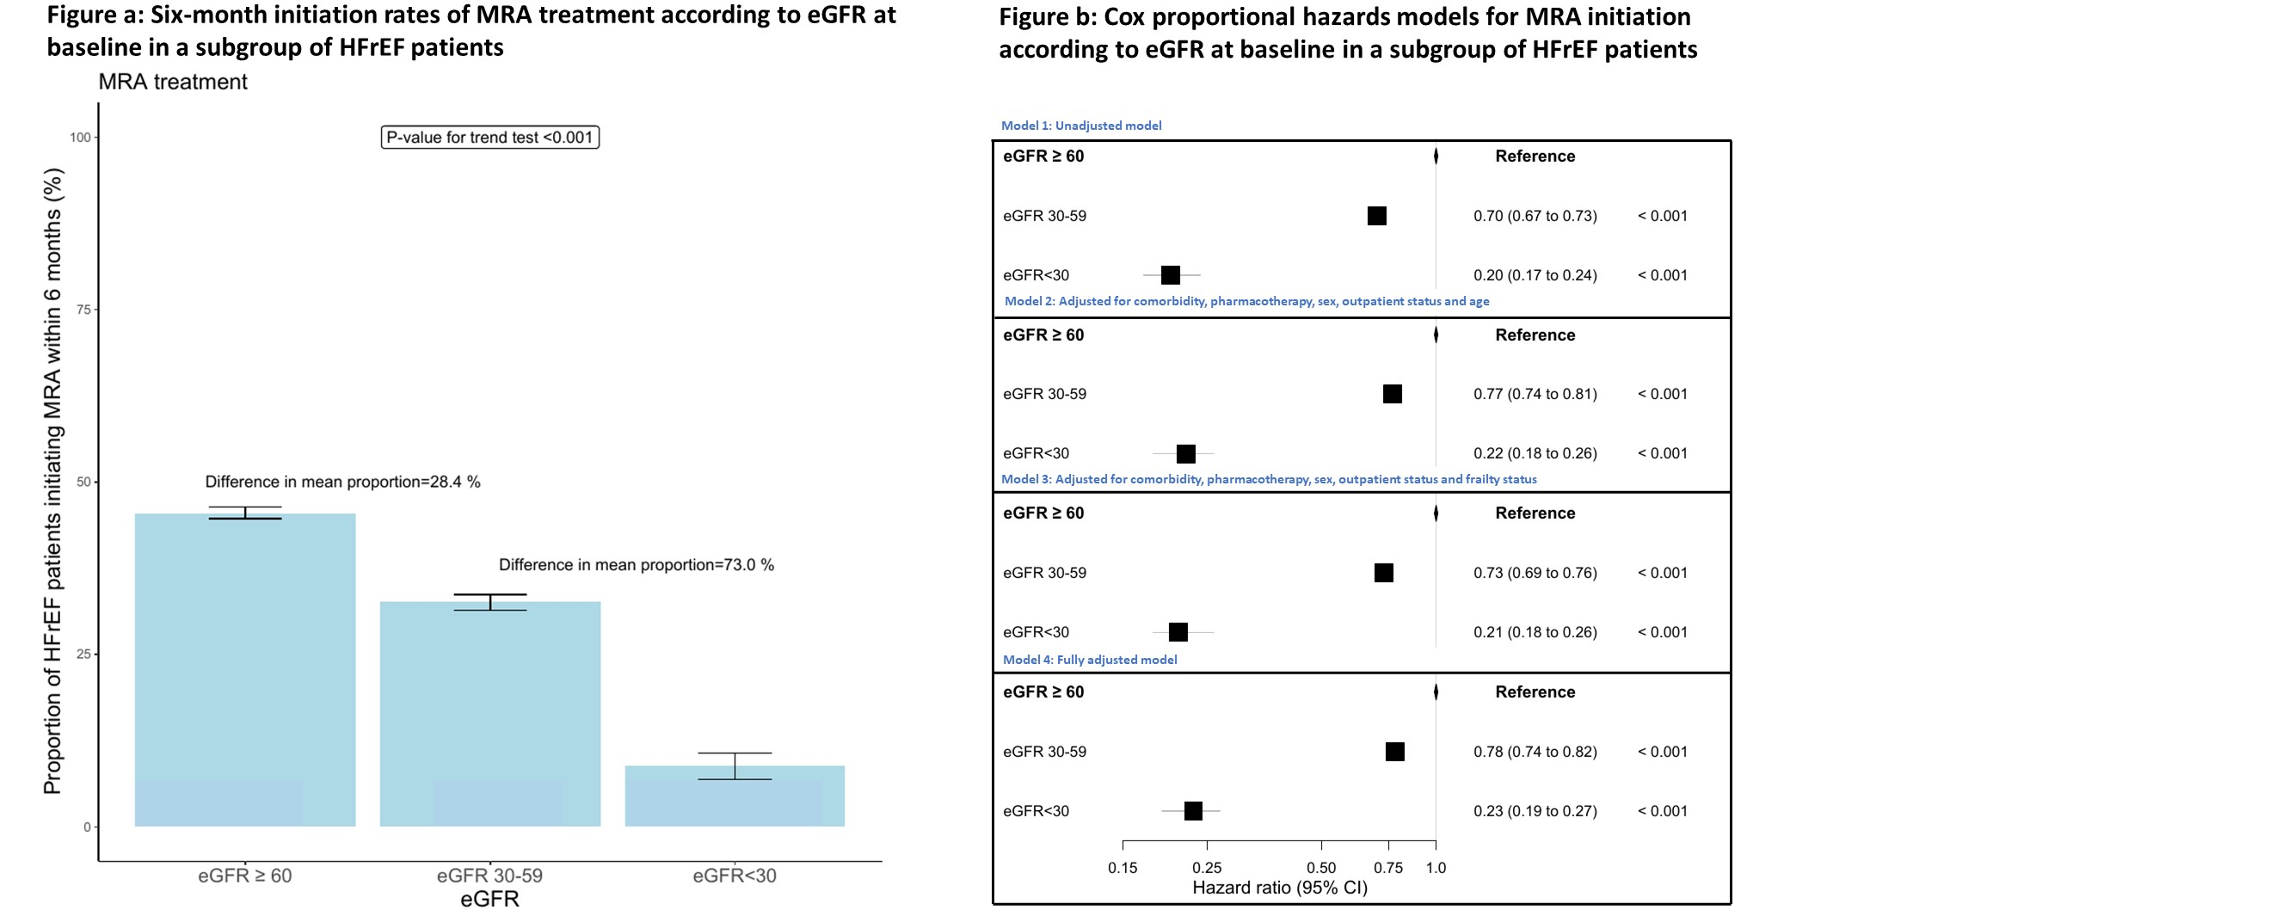
Figure 2a
Figure 2b
Legend: Figure 2a: Six-month initiation rates of MRA treatment according to eGFR at baseline in a subgroup of HFrEF patients. Figure 2b: Cox proportional hazards models for MRA initiation according to eGFR at baseline in a subgroup of HFrEF patients. Abbreviations: MRA=mineralocorticoid receptor antagonist, HFrEF=heart failure with reduced ejection fraction, eGFR=estimated glomerular filtration rate
Legend: Figure 2a: Six-month initiation rates of MRA treatment according to eGFR at baseline in a subgroup of HFrEF patients. Figure 2b: Cox proportional hazards models for MRA initiation according to eGFR at baseline in a subgroup of HFrEF patients. Abbreviations: MRA=mineralocorticoid receptor antagonist, HFrEF=heart failure with reduced ejection fraction, eGFR=estimated glomerular filtration rate

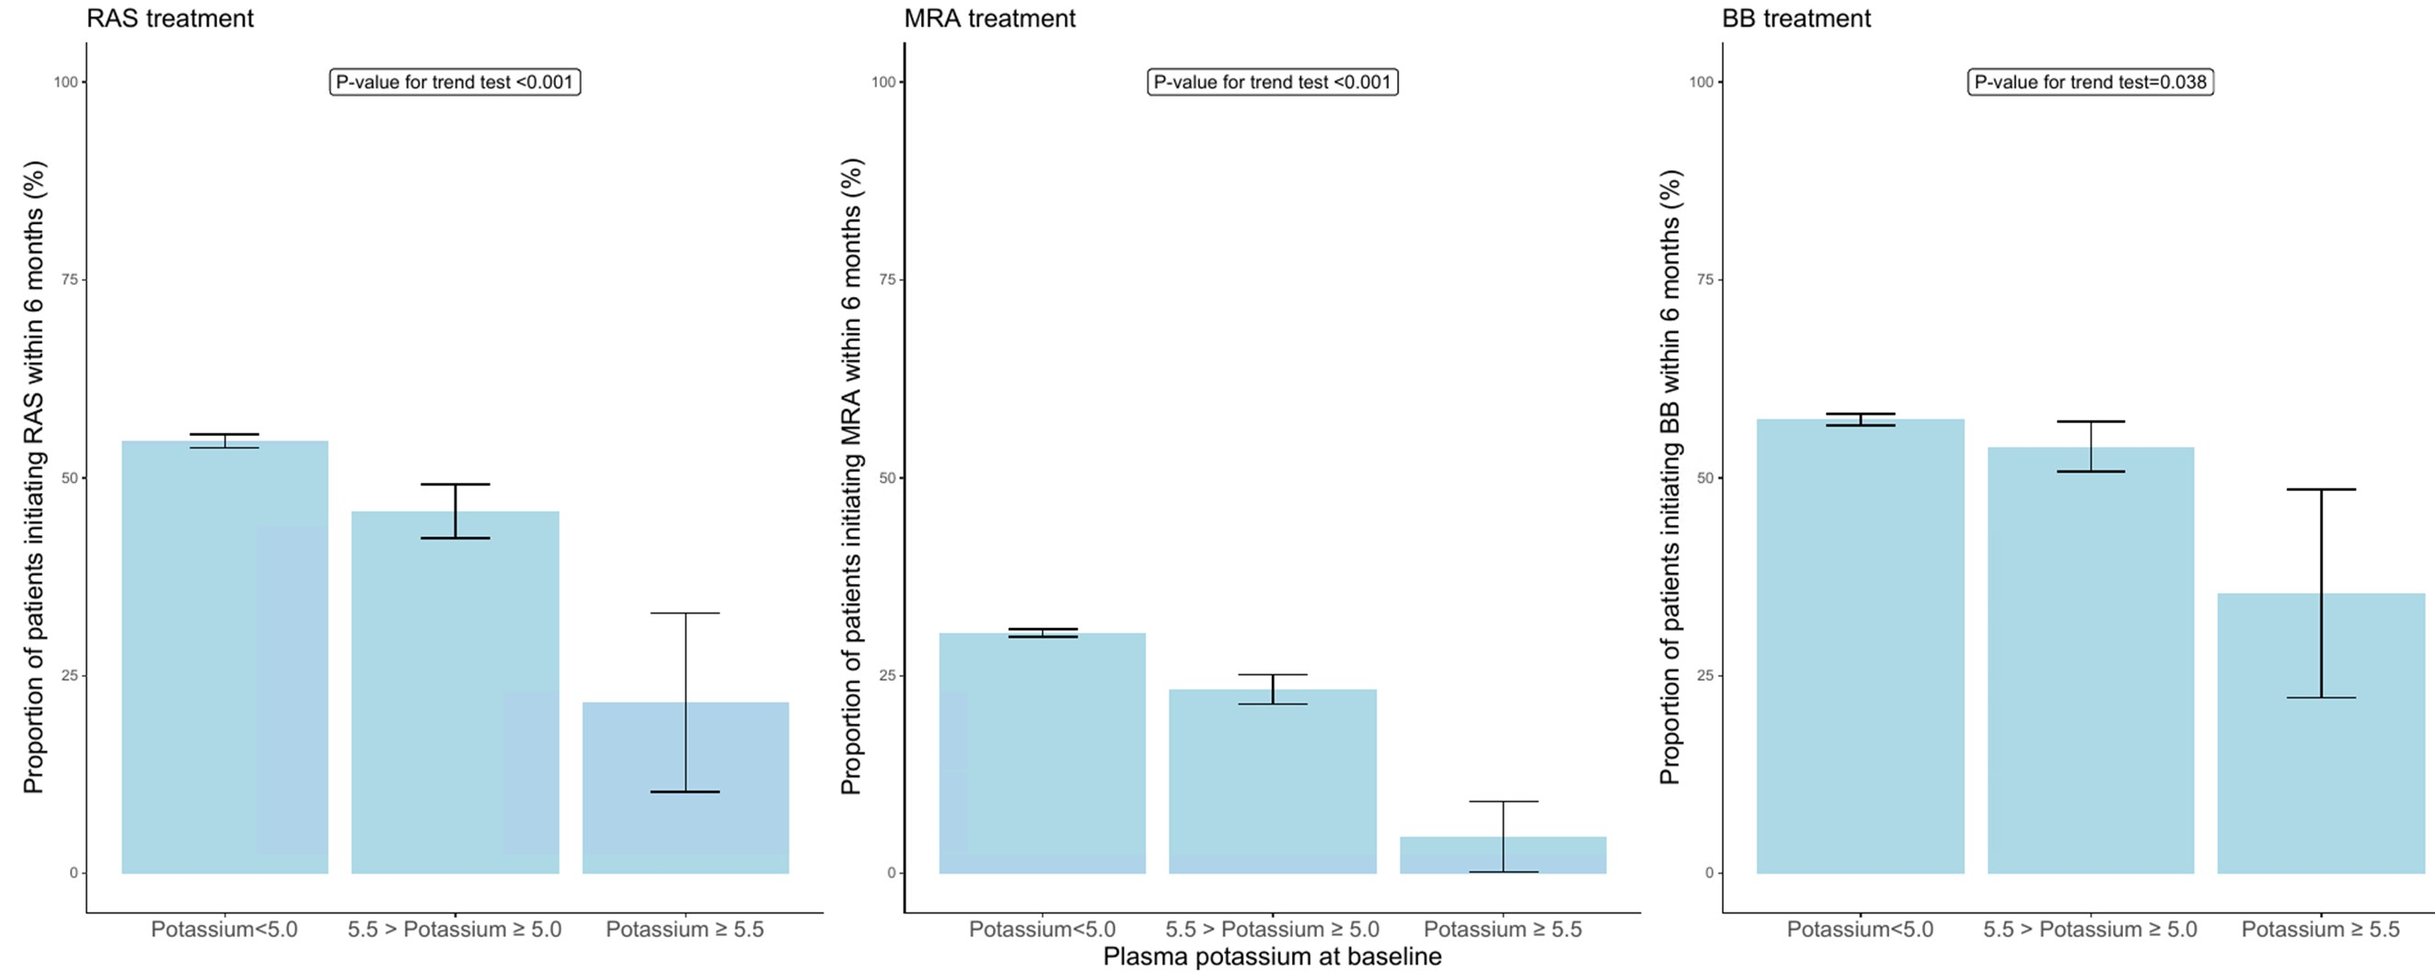
Supplemental Figure 3: Initiation of HF therapy according to plasma potassium at baseline
Figure 3a
Figure 3b
Figure 3c

Legend: Supplemental Figure 3a: RAS inhibitor treatment. Supplemental Figure 3b: MRA treatment. Supplemental Figure 3c: BB treatment. Abbreviations: RAS=renin-angiotensin receptor antagonists, MRA=mineralocorticoid receptor antagonist, BB=betablocker

Supplemental Table 1: List of HF medication and corresponding ATC codes
 | ATC codes
Renin-angiotensin-aldosterone system inhibitors
Captopril | C09AA01
Enalapril | C09AA02
Lisinopril | C09AA03
Perindopril | C09AA04
Ramipril | C09AA05
Trandolapril | C09AA10
Losartan | C09CA01
Valsartan | C09CA03
Candesartan | C09CA06
Betablockers
Metoprolol | C07AB02
Bisoprolol | C07AB07
Nebivolol | C07AB12
Carvedilol | C07AG02
Mineralocorticoid receptor antagonists
Spironolactone | C03DA01
Eplerenone | C03DA04

Supplemental Table 2: List of 109 ICD-10 codes included in the Hospital Frailty Risk Score and number of points awarded for each ICD-10 code to create the score

ICD-10 code | Description | Points awarded
F00 | Dementia in Alzheimer's disease | 7.1
G81 | Hemiplegia | 44
G30 | Alzheimer's disease | 4.0
I69 | Sequelae of cerebrovascular disease (secondary codes) | 3.7
R29 | Other symptoms and signs involving the nervous and musculoskeletal systems (R29·6 Tendency to fall) | 3.6
N39 | Other disorders of urinary system (includes urinary tract infection and urinary incontinence) | 3.2
F05 | Delirium, not induced by alcohol and other psychoactive substances | 3.2
W19 | Unspecified fall | 3.2
S00 | Superficial injury of head | 3.2
R31 | Unspecified haematuria | 3.0
B96 | Other bacterial agents as the cause of diseases classified to other chapters (secondary code) | 2.9
R41 | Other symptoms and signs involving cognitive functions and awareness | 2.7
R26 | Abnormalities of gait and mobility | 2.6
I67 | Other cerebrovascular diseases | 2.6
R56 | Convulsions, not elsewhere classified | 2.6
R40 | Somnolence, stupor and coma | 2.5
T83 | Complications of genitourinary prosthetic devices, implants and grafts | 2.4
S06 | Intracranial injury | 2.4
S42 | Fracture of shoulder and upper arm | 2.3
E87 | Other disorders of fluid, electrolyte and acid- base balance | 2.3
M25 | Other joint disorders, not elsewhere classified | 2.3
E8 | Volume depletion | 2.3
R54 | Senility | 2.2
Z50 | Care involving use of rehabilitation procedures | 2.1
F03 | Unspecified dementia | 2.1
W18 | Other fall on same level | 2.1
Z75 | Problems related to medical facilities and other health care | 2.0
F01 | Vascular dementia | 2.0
S80 | Superficial injury of lower leg | 2.0
L03 | Cellulitis | 2.0
H54 | Blindness and low vision | 1.9
E53 | Deficiency of other B group vitamins | 1.9
Z60 | Problems related to social environment | 1.8
G20 | Parkinson's disease | 1.8
R55 | Syncope and collapse | 1.8
S22 | Fracture of rib(s), sternum and thoracic spine | 1.8
K59 | Other functional intestinal disorders | 1.8
N17 | Acute renal failure | 1.8
L89 | Decubitus ulcer | 1.7
Z22 | Carrier of infectious disease | 1.7
B95 | Streptococcus and staphylococcus as the cause of diseases classified to other chapters | 1.7
L97 | Ulcer of lower limb, not elsewhere classified | 1.6
R44 | Other symptoms and signs involving general sensations and perceptions | 1.6
K26 | Duodenal ulcer | 1.6
I95 | Hypotension | 1.6
N19 | Unspecified renal failure | 1.6
A41 | Other septicaemia | 1.6
Z87 | Personal history of other diseases and conditions | 1.5
J96 | Respiratory failure, not elsewhere classified | 1.5
X59 | Exposure to unspecified factor | 1.5
M19 | Other arthrosis | 1.5
G40 | Epilepsy | 1.5
M81 | Osteoporosis without pathological fracture | 1.4
S72 | Fracture of femur | 1.4
S32 | Fracture of lumbar spine and pelvis | 1.4
E16 | Other disorders of pancreatic internal secretion | 1.4
R94 | Abnormal results of function studies | 1.4
N18 | Chronic renal failure | 1.4
R33 | Retention of urine | 1.3
R69 | Unknown and unspecified causes of morbidity | 1.3
N28 | Other disorders of kidney and ureter, not elsewhere classified | 1.3
R32 | Unspecified urinary incontinence | 1.2
G31 | Other degenerative diseases of nervous system, not elsewhere classified | 1.2
Y95 | Nosocomial condition | 1.2
S09 | Other and unspecified injuries of head | 1.2
R45 | Symptoms and signs involving emotional state | 1.2
G45 | Transient cerebral ischaemic attacks and related syndromes | 1.2
Z74 | Problems related to care-provider dependency | 1.1
M79 | Other soft tissue disorders, not elsewhere classified | 1.1
W06 | Fall involving bed | 1.1
S01 | Open wound of head | 1.1
A04 | Other bacterial intestinal infections | 1.1
A09 | Diarrhoea and gastroenteritis of presumed infectious origin | 1.1
J18 | Pneumonia, organism unspecified | 1.1
J69 | Pneumonitis due to solids and liquids | 1.0
R47 | Speech disturbances, not elsewhere classified | 1.0
E55 | Vitamin D deficiency | 1.0
Z93 | Artificial opening status | 1.0
R02 | Gangrene, not elsewhere classified | 1.0
R63 | Symptoms and signs concerning food and fluid intake | 0.9
H91 | Other hearing loss | 0.9
W10 | Fall on and from stairs and steps | 0.9
W01 | Fall on same level from slipping, tripping and stumbling | 0.9
E05 | Thyrotoxicosis [hyperthyroidism] | 0.9
M41 | Scoliosis | 0.9
R13 | Dysphagia | 0.8
Z99 | Dependence on enabling machines and devices | 0.8
U80 | Agent resistant to penicillin and related antibiotics | 0.8
M80 | Osteoporosis with pathological fracture | 0.8
K92 | Other diseases of digestive system | 0.8
I63 | Cerebral Infarction | 0.8
N20 | Calculus of kidney and ureter | 0.7
F10 | Mental and behavioural disorders due to use of alcohol | 0.7
Y84 | Other medical procedures as the cause of abnormal reaction of the patient | 0.7
R00 | Abnormalities of heart beat | 0.7
J22 | Unspecified acute lower respiratory infection | 0.7
Z73 | Problems related to life-management difficulty | 0.6
R79 | Other abnormal findings of blood chemistry | 0.6
Z91 | Personal history of risk-factors, not elsewhere classified | 0.5
S51 | Open wound of forearm | 0.5
F32 | Depressive episode | 0.5
M48 | Spinal stenosis (secondary code only) | 0.5
E83 | Disorders of mineral metabolism | 0.4
M15 | Polyarthrosis | 0.4
D64 | Other anaemias | 0.4
L08 | Other local infections of skin and subcutaneous tissue | 0.4
R11 | Nausea and vomiting | 0.3
K52 | Other noninfective gastroenteritis and colitis | 0.3
R50 | Fever of unknown origin | 0.1

Supplemental Table 3: Diagnoses with corresponding ICD-10 codes, and medication with corresponding ATC-codes
Diagnosis | ICD-10 codes
Heart Failure | I50, I42
Diabetes Mellitus | E10-E14
Ischemic Heart Disease | I20-I25, I70
Atrial Fibrillation | I48
Renal disease | N18
Peripheral vascular disease | I70-I73, R02
Cerebrovascular disease | I60-I69
Chronic Obstructive Pulmonary Disease | J44
Cancer | C1-C8, C90-C96
Medication | ATC-codes
Loop diuretics | C03C
Glucose-lowering drugs | A10
Thiazide diuretics | C03A
Anticoagulants | B01AE, B01AF, B01AA
Antiplatelets | B01AC04, B01AC06, B01AC07, B01AC22, B01AC24,

