CODE | SEX | AGE | NATIONALITY | CITY | ETHNIC GROUP | HEALTH CENTER | GENOTYPE | VIRAL LOAD | AST | ALT | GGT | ALP | TOTAL BILIRUBIN | DIRECT BILIRUBIN | INDIRECT BILIRUBIN
OC0917 | M | 41 | ECU | SIMON BOLIVAR/ GUAYAS | MESTIZO | HOSPITAL GUAYAQUIL | 2B
RG0912 | F | 51 | ECU | GUAYAQUIL/ GUAYAS | MESTIZO | CS SIMON BOLIVAR | 2B | 50.866 | 36 | 27 | 16,3 | 158 | 0,31 | 0,18 | 0,13
CM0909 | F | 58 | ECU | QUITO/ PICHINCHA | MESTIZO | EUGENIO ESPEJO | NO AMPLIFICATION | 135.967 | 179 | 275 | 29 | 100 | 0,76 | 0,31 | 0,45
JM1704 | M | 65 | ECU | QUITO/ PICHINCHA | MESTIZO | EUGENIO ESPEJO | NO AMPLIFICATION | 1.315.320 | 162 | 145 | 28 | 81 | 1,46 | 0,94 | 0,52
EPH431 | F | 75 | CU | QUITO/ PICHINCHA | MESTIZO | EUGENIO ESPEJO | 1A | 2.211.600 | 41 | 53 | 25 | 71 | 0,56 | 0,21 | 0,35
JE1707 | M | 57 | ECU | QUITO/ PICHINCHA | MESTIZO | EUGENIO ESPEJO | NO AMPLIFICATION | 11,814 | 32 | 46 | 27,6 | 85 | 0,63 | 0,28 | 0,35
BP1759 | M | 29 | VNZ | QUITO/ PICHINCHA | MESTIZO | EUGENIO ESPEJO | 2B | 44.000 | 26 | 22 | 16 | 60 | 0,42 | 0,18 | 0,26
MR1002 | F | 65 | ECU | QUITO/ PICHINCHA | MESTIZO | EUGENIO ESPEJO | 4D
LU1758 | F | 48 | ECU | QUITO/ PICHINCHA | MESTIZO | EUGENIO ESPEJO | 1B | 4.818 | 67 | 96 | 61,1 | 66 | 0,82 | 0,28 | 0,54
LG1722 | F | 29 | ECU | QUITO/ PICHINCHA | MESTIZO | EUGENIO ESPEJO | 2B
MZ0915 | F | 48 | ECU | GUAYAQUIL/ GUAYAS | MESTIZO | HOSPITAL DE INFECTOLOGIA | 2B
GATE1706 | M | 61 | ECU | QUITO/ PICHINCHA | MESTIZO | CARLOS ANDRADE MARIN | NO AMPLIFICATION
LERE1314 | M | 29 | ECU | GUAYAQUIL/ GUAYAS | MESTIZO | HOSPITAL GUAYAQUIL | 4D
ROFA0912 | F | 54 | ECU | GUAYAQUIL/ GUAYAS | MESTIZO | HOSPITAL GUAYAQUIL | 2B
DEZA1316 | F | 26 | ECU | GUAYAQUIL/ GUAYAS | MESTIZO | HOSPITAL GUAYAQUIL | 2B

Supplementary Table 1: Information obtain from the 1A form and data provided by the MSP

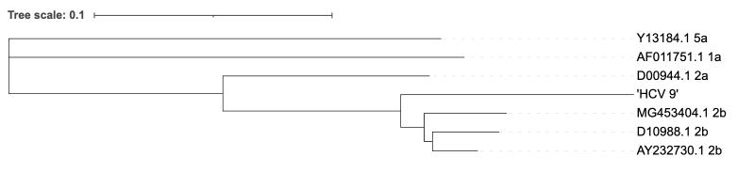

Supplementary Figure 1: Phylogenetic tree based on fragments F2-R2 forward and reverse, determination of genotypes and subgenotypes.
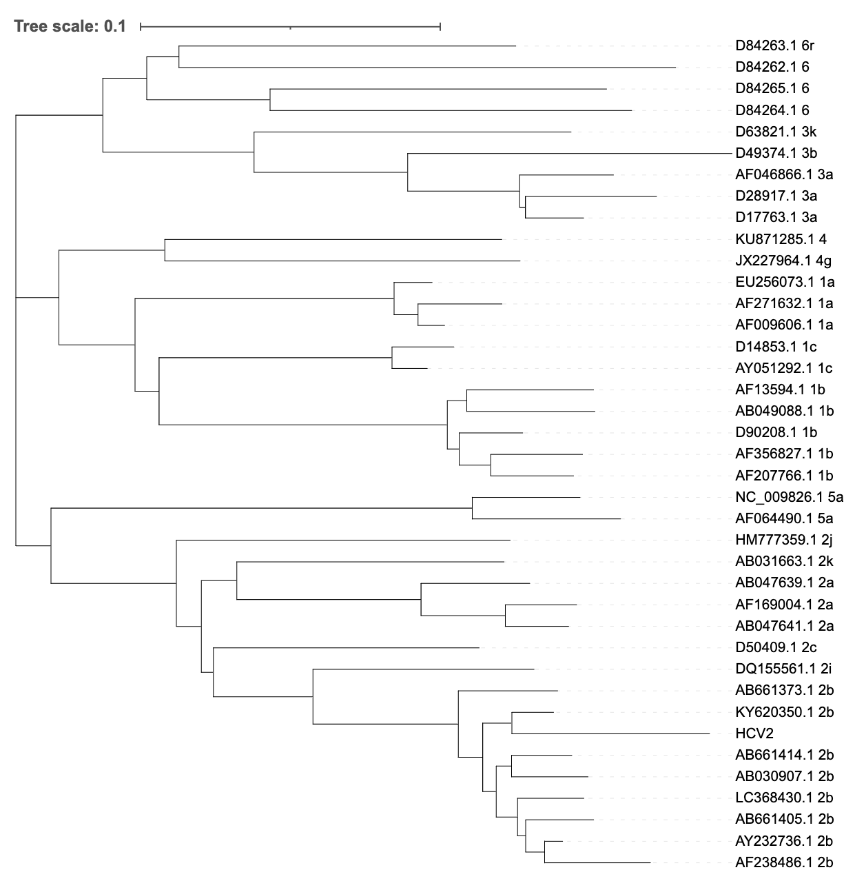

Supplementary Figure 2: Phylogenetic tree based on fragments F1-R1 (forward strand), determination of genotypes and subgenotypes.
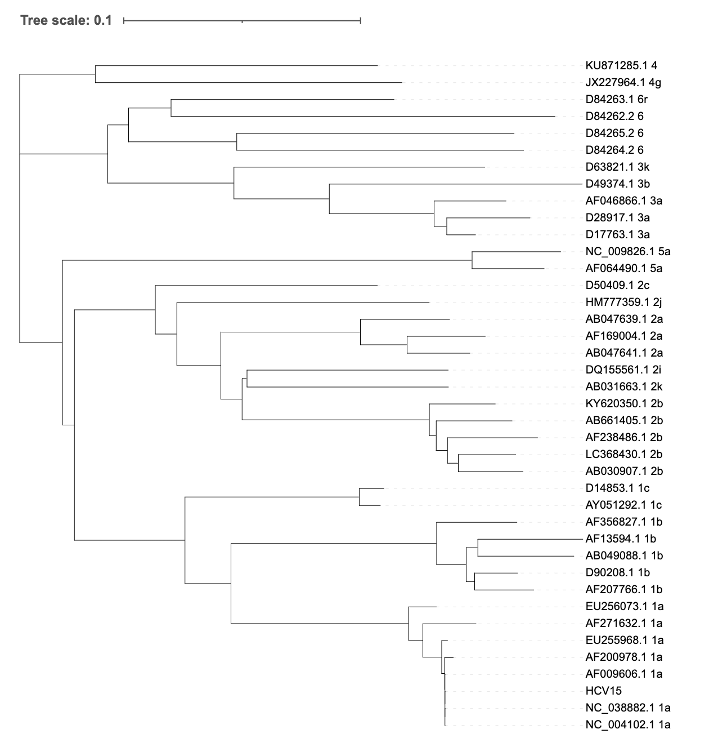

Supplementary Figure 3: Phylogenetic tree based on fragments F1-R1 (reverse strand), determination of genotypes and subgenotypes.

