Supplementary A Sample size formula.

$$n=\frac{{Zα}^{2}×p×q}{\begin{aligned}e^{2} \\ \\ {Zα}^{2}={1.96}^{2} \\ p=0.27 \\ q=1-p=0.73 \\ e=0.05 \\ \end{aligned}} n'=\frac{n}{\begin{aligned}1-d \\ \\ n=203 \\ d=0.30\end{aligned}}$$
Abbreviations: N, initial sample size to be calculated; P, percentage or presence of the study characteristic; Q, 1−p; E, accepted margin of error; Zα², 95% confidence level; N′, definitive sample size; D, expected proportion of losses expressed as a fraction.

Supplementary B Flow Diagram following the Strengthening the Reporting of Observational studies in Epidemiology (STROBE) guidelines.
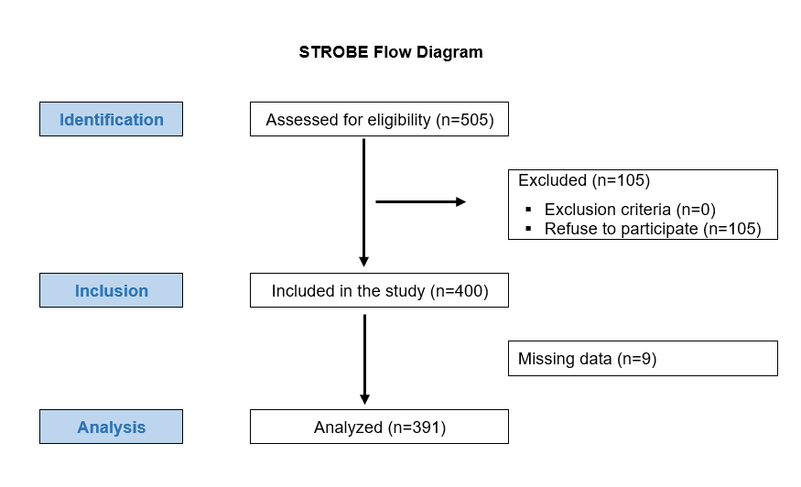

SUPPLEMENTARY C Excluded variables of regression models of the PHQ-9 scores and GAD-7 scores.
C.1. Excluded variables of regression model of the PHQ-9 scores with MULTICAGE-ICT and personal factors as predictors.
 | Standardized coefficients | t-value | p-value | Collinearity statistics
 | β | t-value | p-value | Tolerance | VIF
Municipality (urban) | -0.017 | -0.364 | 0.716 | 0.961 | 1.041
Gender (woman) | 0.091 | 1.789 | 0.074 | 0.824 | 1.214
Age | -0.066 | -1.405 | 0.161 | 0.950 | 1.053
Marital status (married) | -0.096 | -1.1761 | 0.079 | 0.963 | 1.038
Education (secondary/terciary) | 0.012 | 0.259 | 0.796 | 0.967 | 1.034
Ocupation (working) | -0.071 | -1.494 | 0.136 | 0.925 | 1.081
CD_Risc | -0.042 | -0.757 | 0.449 | 0.705 | 1.419
BFI-10 Extraversion | 0.041 | 0.876 | 0.382 | 0.950 | 1.052
BFI-10 Agreeableness | 0.038 | 0.807 | 0.420 | 0.979 | 1.021
BFI-10 Conscientiousness | 0.006 | 0.137 | 0.891 | 0.980 | 1.020
BFI-10 Openness | 0.045 | 0.963 | 0.336 | 0.961 | 1.041
MULTICAGE-ICT Total Score | 0.040 | 0.853 | 0.394 | 0.982 | 1.018
MULTICAGE-ICT Internet | 0.035 | 0.753 | 0.452 | 0.984 | 1.016
MULTICAGE-ICT Mobile phone | 0.035 | 0.744 | 0.457 | 0.969 | 1.032
MULTICAGE-ICT videogames | 0.065 | 1.417 | 0.157 | 0.999 | 1.001
MULTICAGE-ICT Instant messaging | -0.004 | -0.083 | 0.934 | 0.979 | 1.021
MULTICAGE-ICT Social networks | 0.031 | 0.681 | 0.497 | 0.997 | 1.003
Notes: Significant differences (p≤0.05) are highlighted in bold font; Dependent variable: patient health questionnaire
Abbreviations: β, standardized regression coefficient; BFI-10, big five personality inventory; CD-RISC-10, connor-davidson resilience scale; CI, confidence interval; ICT, information and communications technologies; MULTICAGE-ICT, multicage-ict questionnaire; P, p-value; PHQ-9, patient health questionnaire; T, t-value; VIF, variance inflation factor.

C.2. Excluded variables of regression model of the GAD-7 scores with MULTICAGE-ICT, and sociodemograhic and personal factors as predictors.
 | Standardized coefficients | t-value | p-value | Collinearity statistics
 | β | t-value | p-value | Tolerance | VIF
Municipality (Urban) | 0.053 | 1.129 | 0.260 | 0.995 | 1.044
Gender (Female) | 0.061 | 1.289 | 0.198 | 0.920 | 1.087
Age | -0.055 | -1.106 | 0.269 | 0.839 | 1.193
Marital status (married) | -0.028 | -0.603 | 0.547 | 0.962 | 1.040
Education (secondary/terciary) | 0.000 | 0.004 | 0.996 | 0.932 | 1.073
Ocupation (working) | -0.001 | -0.020 | 0.984 | 0.877 | 1.141
CD_Risc | -0.004 | -0.072 | 0.942 | 0.702 | 1.425
BFI-10 Extraversion | -0.034 | -0.728 | 0.467 | 0.960 | 1.041
BFI-10 Agreeableness | 0.054 | 1.167 | 0.244 | 0.979 | 1.022
BFI-10 Conscientiousness | 0.013 | 0.288 | 0.773 | 0.985 | 1.015
BFI-10 Openness | 0.021 | 0.455 | 0.649 | 0.946 | 1.057
MULTICAGE-ICT Internet | -0.054 | -0.650 | 0.516 | 0.303 | 3.297
MULTICAGE-ICT Mobile phone | -0.057 | -0.684 | 0.495 | 0.297 | 3.369
MULTICAGE-ICT videogames | 0.025 | 0.472 | 0.637 | 0.720 | 1.388
MULTICAGE-ICT Instant messaging | 0.008 | 0.113 | 0.910 | 0.398 | 2.515
MULTICAGE-ICT Social networks | 0.057 | 0.835 | 0.404 | 0.457 | 2.189
SOC-13 | 0.015 | 0.303 | 0.762 | 0.826 | 1.211
Notes: Significant differences (p≤0.05) are highlighted in bold font; Dependent variable: Generalized Anxiety Disorder (GAD-7)
Abbreviations: β, standardized regression coefficient; BFI-10, big five personality inventory; CD-RISC-10, connor-davidson resilience scale; CI, confidence interval; GAD-7, generalized anxiety disorder; ICT, information and communications technologies; MULTICAGE-ICT, multicage-ict questionnaire; P, p-value; SOC-13, sense of coherence questionnaire; T, t-value; VIF, variance inflation factor.

