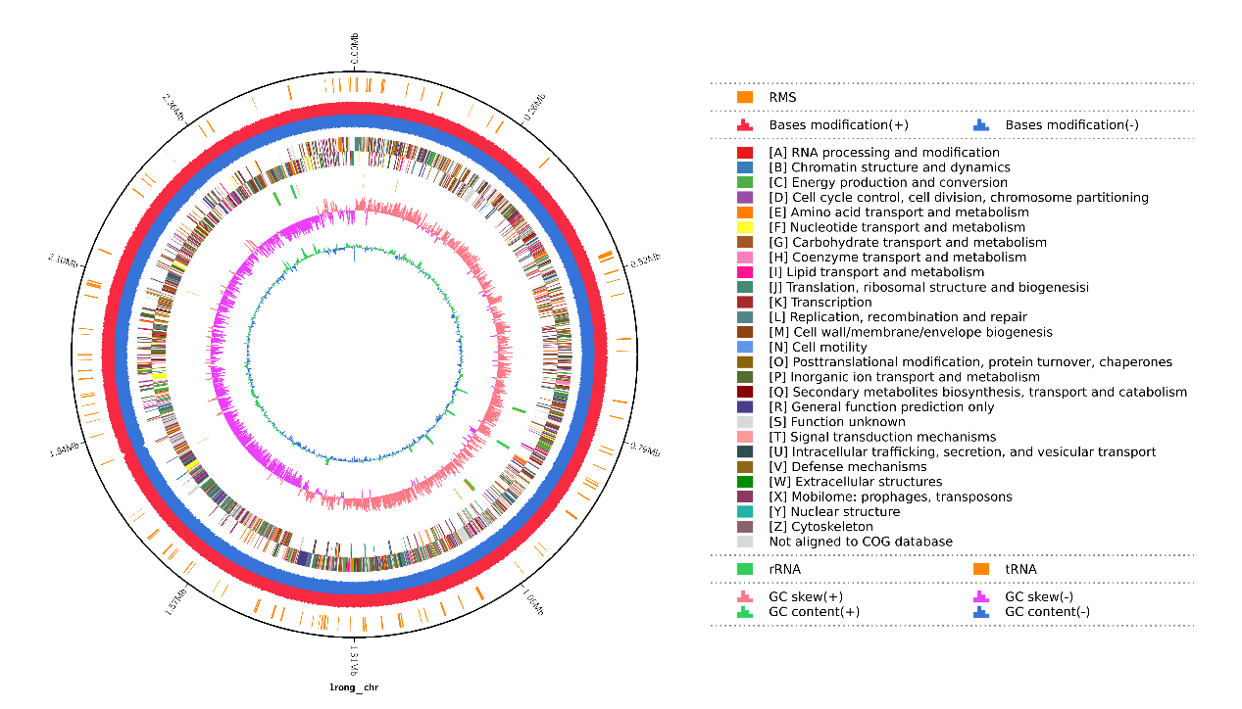
Figure S1 Chromosome circle diagram of Staphylococcus haemolyticus SH-1.

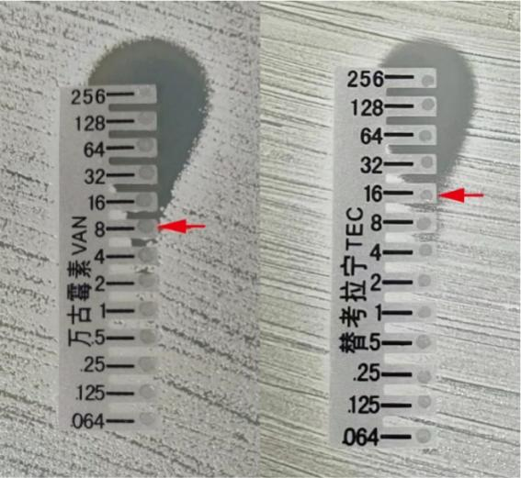
Figure S2 Vancomycin and teicoplanin susceptibilities of S.haemolyticus strain SH-1 determined by E-test.

Table S1 Antibiotic susceptibility of Staphylococcus haemolyticus SH-1.
Antibiotics | MIC (μg/ml) | Sensitivity
Teicoplanin | 16 | I
Quinupristin/Dalfopristin | 0.5 | S
Moxifloxacin | 4 | R
Linezolid | 4 | S
Cefoxitin Screen | Pos | +
Trimethoprim/Sulfa | >= 320 | R
Penicillin-G | >= 0.5 | R
Rifampin | <= 0.5 | S
Tetracycline | 4 | S
Vancomycin | 8 | I
Levofloxacin | >= 8 | R
Inducible Clindamycin Resistance | Pos | +
Ciprofloxaxin | >= 8 | R
Clindamycin | <= 0.25 | R
Oxacillin | >= 4 | R
Erythromycin | >= 8 | R
Gentamicin | >= 16 | R
Notes: Tested by VITEK 2 COMPACT automatic microbiological analysis system and Test Kit GP67.

Figure S3 (A) Schematic representation of WalK protein operon structure. The mutation sites of SH-1 were shown above the domains. White regions of WalK represent membrane spanning regions. (B) Alignment of the WalK protein sequence between SH-1 and VB19458. Indicated by star and gray shadow is the differential protein that occurs in SH-1.

